
Assignment Cover Sheet

Student Name: | DIMITRIS KAMBERIS
Student Number: | 5486
Course: | Certificate in Forensic Accounting (Level 3)
Assignment NO: | 04

Marking Criteria:
We expect the learners to write minimum one well expressed point in three lines against each allocated mark. This means one needs to write 15 lines with 5 well expressed points to get high grades for a 5 marks question.
For high grades use examples and illustrations where appropriate.
Please insert your completed assignment ( in word format) here:

Case Investigation Procedures
Assessment 4

Q:1. Short questions:

- I. What is the difference between proactive and reactive investigations?

Criminal, non-criminal or financial crime Investigations are formulated to collect data and evidence, through a systematic and thorough examination and recording of this examination for identifying, perceiving, and sentencing criminal or financial crime offenders.In general, there are two types of investigation resulted from a complaint: the reactive and the proactive:
Reactive investigation is the one that is incited on the basis of a complaint recorded by a victim or client, in other words, is the investigation occur after a crime has been discovered. The proactive investigation is conducted in contemplation of a crime being committed, so as to prevent it from occurring or to perceive offenders involved in ongoing criminal, illegal or wrongdoing activities.The proactive investigation takes place before the crime occurs while the reactive investigation takes place after the crime occurs. Proactive investigations differ from reactive investigations in two major regards: (1) The investigation is conducted before the crime is committed (rather than after) and (2) the suspect is identified before he or she commits the crime¹. There is no agreed definition of proactive investigations or how these differ from the more traditional reactive investigations. Maguire (2003) highlighted a number of ways in which proactive investigations might be defined. These can relate to the focus of the investigation (reactive investigations tending to be case specific, with proactive being offender-specific). Alternatively, it might be possible to distinguish them in terms of the way in which the investigation is initiated (reaction tends to be through a report from the public; proactive through the acquisition of intelligence) ^{2a}. Arguably, the most helpful way of distinguishing between these two styles of investigating crime, however, appears to be in terms of the approach to using resources^{2b}. For example, a cashier was arrested and accused of pocketing money from the cash drawer. Larceny is a theft of cash from a cash drawer after an employee has rung up a sale.The accused cashier created false refunds, voided several sales and destroyed in several days the cash register tape. The local law enforcement agency (police) for financial crime incidents, commenced the investigation in order to report and record the theft. The cashier admitted in writing of his illegal action, arrested and charged with theft.. This is an example of reactive investigation. An example of a proactive investigation is the following: the manager of an outlet, realized an unusual act; several cashiers did not close the cash drawer when they rung a sale. The manager suspected that the cashiers might have taken cash out of the cash drawers and implemented sound written policies, which included also the followings:
- Conducted a thorough background check on all cashiers and in general for all employees who would have handled cash.
- Installed CCTV cameras over the cash register area.
- Distribute a written zero tolerance for theft policy.
- Encourage anonymous reporting of suspicious activities by providing an incentive for reporting theft, including employee theft.
An investigation was planned and commenced,focusing mainly in cash theft and other abnormal and illegal actions of all employees in order to deter and prevent possible thefts.

- Outline the major goals of an investigative plan.

The investigation plan objectives vary for each investigation since all incidents are different. The objective of an investigation is to get the facts so that a resolution of the complaint and the situation can be achieved. For example, in an anti-corruption investigation possible objectives for this specific investigation may be;
- - Aim the company to evaluate allegations of corruption fast^{3a}.
- - Remediate any identified problems ^{3b}.
- - Inform the company’s calculus regarding cooperation with regulators
and law enforcement^{3c}.

When an investigator receives a complaint or allegation, he/she in the first place, sets goals/ objectives of the investigation process. By setting the goals of an investigation the qualified investigator set the direction to go in. Needless to mention that the investigation goals should be set prior to the investigation commences.However, as the investigation process may be in progress, new information may be considered as a result the scope and the purpose of an investigation to be updated or changed.Several investigations endure due to poor planning and inefficient objectives. An effective investigation starts with strong planning and preparation, setting in advance the goals and has an explicit understanding of the parameters of the investigation. The investigations designate what actually happened with respect to a specific incident; whether suspected conduct did or did not take place, what the occasions were, who was involved, whether a violation of law or company policy occurred ⁴. Investigation goals include, but not limited to, the following:
- - Identification of involved individuals:(Complainant, locate and identify suspects in
- crimes).
- - Fundamental causes of the incident: (Lack of training,unsafe working conditions).
- - Law break (Misconduct i.e. theft, detect crime).
- - Determine real and unreal facts: (Distinguishing honesty/dishonesty when an
- individual is lying.
- - Taking remedies/correction actions: (What needed to be done to prevent an
- incident from occurring again).
- - Erect a case through a legitimate process to develop an investigation with a
- successful outcome: (Recover stolen property, arrest suspects in crimes, prepare a
- sound criminal case for prosecution).
- - Provide a sound, factual basis case, producing reliable documentation that can be
- used by the management for further action in order to stop further wrongful actions
- within the company of the suspected employees: (update, re-design and reform
- existing fraud prevention policies).
The objective/s of an investigation is to get the facts so that a resolution of the complaint and the situation can be achieved.

- Briefly describe the stages involved in preparing an investigative plan.

The investigation plan is a living document that should be continually evaluated and revised as unexpected developments in the complaint investigation alter the theories that are controlling the investigation⁵. It outlines how the investigator intends to conduct the investigation. It is a directional tool for any investigation, that is based on a detailed complaint analysis, the known facts and the provisions of the corresponding Act. It aims the investigator to eliminate and avoid deadlocks in the investigation process, keeps the investigation ongoing and on time limits. It is the cornerstone to ensure efficient and effective completion of the investigation. The investigation plan should be considerably comprehensive to ensure the proper and suitable evidence gathering, essential for the investigator to conclude any violation or wrongdoing action. A proper investigation-planning process supports the investigator to focus on the allegation or the investigated incident and secures that the investigation process stays on course.

Once the investigative goals are set, the investigator shall develop the plan for the specific investigation. The investigation plan, contains, but is not limited to, the following:

- - Financial planning: costings and any ancillary costs such as transcripts, flights,
- travel expenses. The investigator should determine in advance the cost of his/her
- investigation process and consider alternatives to costly investigation tools.
- - Personnel planning: prediction of the number of qualified individuals needed to
- conduct the investigation, i.e. experts in Law enforcement, auditors, accountants
- with specialized tasks and skills – who is responsible to perform each task. Defines
- the scope and parties involved in the investigation.
- -Technology planning: the technological resources are very important for the
- effective conduct of the investigation with the technological expertise needed to
- carry out the technological part that of the investigation that will provide accurate
- digital evidence for the case to be examined.
- - Legislative authority and policies to be used (this allows the allegations to be
- placed against the correct policies)
- - Investigation summary (based on information from the complainant, inside the
- company or external resources)
- - Dates, investigation activities and deadlines.
- - Consideration and outline risk factors to the investigation.
- - Person or individuals subject to the allegation.

The investigation plan is the best way to ensure the investigation stays on track, keeps all involved parties/individuals/expertise accountable and follows a logical process.

Q:2. Describe the three main areas of intelligence gathering process.

Typically, the investigator should first use the most basic investigative techniques (simple data checks) before implementing more complex techniques (wiretaps). In addition, investigators should use covert techniques (e.g., surveillance, public information search, information from other government agencies, trash run) before moving to overt techniques (e.g., search warrant) to avoid tipping-off the target ⁶.
Surveillance: A useful technique (physical or electronic surveillance) performed to gain a general overview, in depth information on individuals and/or businesses, their practices and the relationships of suspects. For example a physical surveillance is a covert observation of the suspected targets of the investigation, so as to obtain information about them. Surveillance technique is a useful aim in financial investigations in cases involving the movement of bulk currency, that is involved in money laundering or terrorist – financing schemes. The use of this technique often leads investigators to identify where financial and related records are stored and other forms of assets and provide a useful tool for developing decisions.
Database Searches: Database searches are the starting point for any investigation, but it is important to know that these searches, and the underlying data, have numerous benefits and downfalls⁷. The data that one may collect from any database may include the following: addresses, telephone numbers, emails, social security numbers, dates of birth, associates, vehicles, professional licenses and affiliations, court liens, court records, even arrest records and presumed relatives. The databases, are consisted of private and public; public databases are those that an investigator or individual may have access with low or no cost at all and are available over the internet and they are reachable at anytime and anywhere. On the other hand, the private databases are those with commercial and governmental sources with limited or preferential access; access to these databases is permitted to the users that created the database and to those who pay a log in fee in order to have access.
Trash runs: By conducting trash runs, an investigator is trying to surface target’s garbages which are relevant data to a specific investigation,for example, discarded bank statements,old or expired bills, contact details of business partners, etc. These “garbage” information can be used to support applications for search warrants.(i.e., searching the suspect’s discarded trash for evidence): This technique can be an effective way of obtaining leads where assets are maintained, as well as help develop probable cause for more coercive measures and evidences for use at trial. Suspects frequently discard evidence, including financial records and correspondence that may be valuable to a financial investigation.
.
The Investigative Approach Diagram below, in which the Intelligence gathering of information in the 3 circles is interrelated and intersected to the “Primary Objective” of an investigation. The top blue circle, refer to the public database search, with the online available sources which are cost efficient but may be outdated and needed further verification in order to consider the information valid. In the bottom left pink circle, the database source information from a private source which provides more in depth data but are not available to all and the right bottom grey circle, in which the physical or electronic surveillance,third party interviews and the trash runs information, are gathered, examined and analysed by human prowess to develop credible data through the investigation but there is a risk for not surfacing the truth about a suspect or the whole information relating to the suspect.
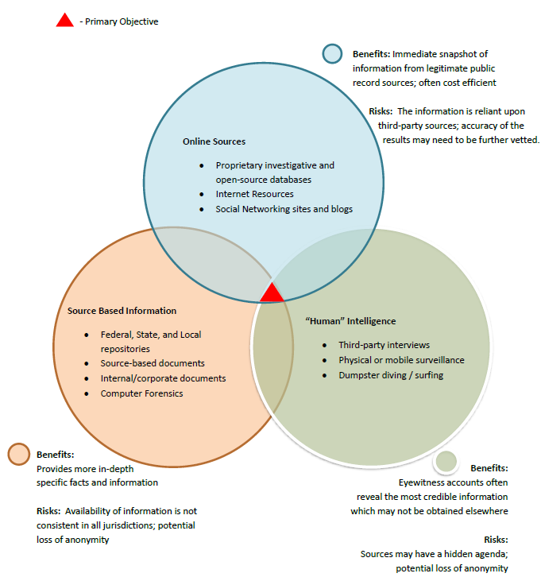
Diagram 1 (Investigative Approach to Intelligence Gathering⁸).

1 https://www.pearsonhighered.com/assets/samplechapter/0/1/3/2/0132570920.pdf [Online] [Accessed : 23 December 2017]

2^{a,b} http://library.college.police.uk/docs/hordsolr/rdsolr4405.pdf [Online] [Accessed : 23 December 2017]

3^{abc} https://files.apks.com/the%20fcpa%20report_how%20to%20conduct%20an%20anti-corruption%20investigation-%20developing%20and%20implementing%20the%20investigation%20plan%20(part%20two%20of%20two)_01.08.2014.pdf [Online] [Accessed : 23 December 2017]

4 https://i-sight.com/resources/investigation-tips-setting-objectives/ [Online] [Accessed : 23 December 2017]

5 https://www.hud.gov/sites/documents/80241C7FHEH.PDF [Online] [Accessed : 23 December 2017]

6 http://pubdocs.worldbank.org/en/220301427730119930/AML-Module-4.pdf [Online] [Accessed : 27 December 2017]

7 https://asginvestigations.com/attorney-services/database-searches-part1/ [Online] [Accessed : 27 December 2017]

8 https://www.magconfidential.com/pi-knowledge/2017/4/17/intelligence-gathering [Online] [Accessed : 27 December 2017]

Student Statement:

By submitting this assignment, I confirm that this is my own work.

Student Signature | DIMITRIS KAMBERIS | Date | 27/12/2017

For Tutor / Assessor Use Only
Total Marks
Marks Obtained
Percentage / Grade

