
Assignment Cover Sheet

Student Name: | Lydia Johnson
Student Number: | 4996
Course: | Level 4 travel and tourism
Assignment NO: | 11

Marking Criteria:
We expect the learners to write minimum one well expressed point in three lines against each allocated mark. This means one needs to write 15 lines with 5 well expressed points to get high grades for a 5 marks question.
For high grades use examples and illustrations where appropriate.
Please insert your completed assignment ( in word format) here:

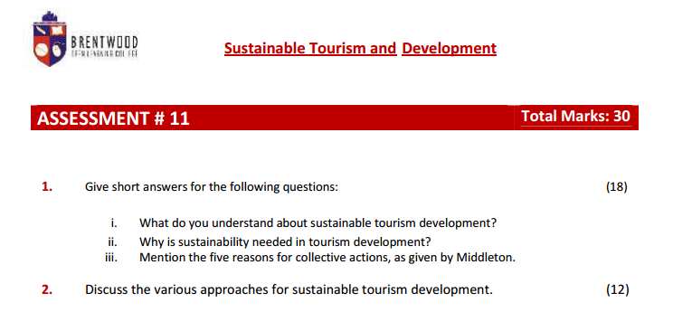
- 1. What do you understand about sustainable tourism development?
Sustainable development focuses on ‘being green’ and to ensure that any development is continued in the future whether effecting the environment in a severe manner. This celebrates the community and the wildlife. If any development occurs then it needs to be constructed in a manner that means do not rebuilding within a few years. It is using the current resources and technology to present a development for the present as well as the future. It needs to can provide for future generations.
Sustainable tourism development focuses on the establishment of different tourist attractions which retain the custom authenticity as well as embracing the future and current demands. A poor example of this is Abu Dhabi where many of the traditional market areas and building have been demolished to build malls. There are many hotels and western type attractions to attract tourism to the area. This is at the sacrifice of local heritage and traditions. Even though the country is attracting many tourists it has come at a cost. Another example is Bangkok. The local market food stalls which serve food at the road side are being asked to leave by the local government This will put the locals at risk of their livelihood as the large malls will not cater for small independent stall holders. This is part of the Thai heritage and is at risk due to the large tourist demands of modern requirements. Neither of these examples are sustainable tourism development as it seems to be deleting the old to replace with the modem, very often bringing in large organisations rather than celebrating the local values and traditions. A sustainable tourist development is one that celebrates the local traditions with the modern and ensure it is future proofed. It celebrates the natural resources, local economy, society and cultural this will ensure that the tourist receives a holistic experience.
The concept of sustainable tourism development also focuses on preserving conservation. This focuses on natural resources e.g. hills or forests and ensuring that these are kept as tourist attractions are built to enhance the environment and in partnership with it, rather than destroying it.
Examples of this around the world include the Ice hotel in Sweden and the Fogo Island Inn. Both of which celebrate the environment and use it to attract tourists to the area. They have built the accommodation to enhance the environment and this in turn promotes suitable tourism and development.
11. why is sustainability needed in tourism development?
Sustainability is needed in tourism development to ensure that natural resources, local economy, society, and guttural are celebrated and embraced. This will enable the tourist development to offer the tourist a complete experience. Environment conservation and the management of visitor usage and services businesses are all interlinked concepts. The sustainable development is developed or maintained in an area in a way which at a scale that remain viable over an indefinite period and does not even degrade or change the environment.
Sustainability is needed in the tourism development as it effects the following areas: natural resources and attractions, economy, society, and culture. One key area is that local people benefit from tourism so it celebrates their traditions and ensures that they are that cultures are sustained in the future. It is important that many stakeholders are involved in the process to part of a global market and to ensure that a foreign exchange crisis occurs in a country.
The mixture of economic, social, political, cultural, and environmental factors that all contribute to the sustainability of tourism development it will help bring an all-inclusive model of tourism that characterises the ethics and culture.
111. mention the five reasons for collective actions, as given by Middleton.
The five reasons for collective actions are:
  - Size and growth potential
This depends on the quality of environment of tourism areas and increasing responsibility must be shared. The physical environment and culture are core of the tourism needs and it needs continuous maintenance, refurbishment, and investment.
  - Prosperity
Tourism can reduce poverty in developing countries. But tourism growth is not universally inclusive of the poor. It can support a range of different groups of societies that brings about financial growth for all locals.
  - Global reach
The NGO’s play an important part to ensure the conduct and attitudes of the patrons of the tourism products are kept to a standard. The links to the global arena are necessary and desirable for the effective development of rural economies.
  - The market’s demand
Middleton focuses on the market demand is for products that only offer clean air, beaches, bathing water, pristine mountain slopes, uncongested, crime and pollution-free destinations. In addition, there is a demand for local authenticity crafts and customs. It is with a collective action that supply can meet demand and that the local areas can produce what the market demands.
  - The competitive business advantage
There are many tourism industry relations that are making their member conscious and accepting codes of conducts that contribute towards the sustainable practices. When they ensure all aspects are in place then they have the advantage over their computers and in turn have the competitive business advantage.

- Discuss the various approaches for sustainable tourism development.
The various approaches for sustainable tourism development are varied and can depend on the needs of the local areas and traditions that they hold. However, with different companies working together and following the NGO guidelines then sustainable tourism development can be achieved. There are many approaches and the right way will depend on many different factors.
  - An environmental planning approach
It considers all elements of the environment before considering growth. When planning for sustainable tourism development it is essential that the local environment is taken in to consideration so the natural wildlife for example are preserved. There are many developments in the past that have ignored the locality and focused on building hotels whilst demolishing the area. However due to different environmental groups who have fought for the area to be enhanced with the tourist development. There are many examples e.g. the Ice hotel in Sweden and the Fogo Island Inn. Both of which celebrate the environment and use it to attract tourists to the area. This approach will involve a clear plan being created that celebrates the local environment as well as making sure it is sustained and developed around the tourist development.
Community’s involvement in the planning process.
The locals feel that it is not a them against us approach if the community is involvement in the planning process. As China develops to welcome more tourists, local villages are being demolished. This will bring Western influences on the area at the suffice of the locals. The locals could feel demoralised. If the community were involved in the planning process they would understand the bigger picture and have a say in the process then the two parties would work cooperate to create a welcoming tourist development.
The concept of quality tourism
During each stage of the process it is essential that the facilities meet the vision of the development. This will avoid the development being demolished and rebuilt within a short time scale. They need to offer tourist attractions, facilities, services for a good quality and value for money. This in turn will protect tourism resources and attract the kinds of tourist who would respect the local environment and society. In 1988, the WTO were “envisaged as leading to management of all resources in such a way that economic, social, and aesthetic needs can be fulfilled while maintaining cultural integrity, essential ecological processes, biological diversity and life support systems.”
Allocate roles and responsibilities
To ensure sustainable tourism development organisations and groups need to have roles and responsibilities to ensure that the economy, environmental issues for example are addressed and are accounted for. Richard W Butler 1993 wrote “Ignorance, politics, and economics seems to work contrary to the attainment of the goal of sustainable development as far as tourism is concerned.” If groups don’t work together this will result in many loses e.g. tourism itself, resources, conflict of interests.
The product approach
An approach for sustainable development focuses on the product. Sustainability is viewed as an alternative to or standby of conformist mass tourism by making new green products.

The industry approach
This approach focuses on the reform of tourist founding and figure from within the industry. Mass tourism is unavoidable due to the ease of travel and globalisation for example, it is important to make all forms of tourism more maintainable.
The Marxist approach
This approach focuses on class structure. It has a way to distribute power and wealth and sees that global tourism has seeds of neo-colonialism. This approach core group is the bulk of people and is promotes social trade or state subsidies to have admission to tourism.
Alternative development approach
This is founded on basic needs fulfilment. It addresses the core factors of a resort in partnership with local requirements. Do the locals have core basic needs e.g. food, clothing, housing, health, and education? Would the tourism development effect these for the locals? The main aim of this approach provides a grass roots outlook where local requirements and people are in control of major development.

There is no one single approach to address the sustainable issue. It does include other factors which include the fragility, toughness and other natural structures of the tourism region, areas or sites which are embattled for sustainable growth.

Student Statement:

By submitting this assignment, I confirm that this is my own work.

Student Signature | L.Johnson (e-signature) | Date | 25/5/17

For Tutor / Assessor Use Only
Total Marks
Marks Obtained
Percentage / Grade

