
Assignment Cover Sheet

Student Name: | Sean Ellam
Student Number: | 29994
Course: | Supply Chain Management
Assignment NO: | 2

Marking Criteria:
We expect the learners to write minimum one well expressed point in three lines against each allocated mark. This means one needs to write 15 lines with 5 well expressed points to get high grades for a 5 marks question.
For high grades use examples and illustrations where appropriate.
Please insert your completed assignment ( in word format) here:

Sean Ellam

29994

Assignment : #2

Page 1

1:1 Logistics within the Supply chain covers a wide range of activities:
Procurement / Purchasing this area is responsible for buying/ordering and arranging transport for all requirements within the manufacture / distribution of goods.
Transport/Traffic this area along with Procurement need to assess the best and most cost effective that goods required are delivered to the organization in a timely schedule to meet production times.
Receiving, this is effectively GOODS IN which in nearly all organizations is a function within the warehouse, where goods are unloaded/checked and booked in the organization via normally WMS (Warehouse Management System).
Warehousing/Stores, once goods in registered the goods into the organization they are moved into the warehouse/stores where they are located accordingly where they will stay until required either by production or for dispatch. Within this area goods are moved around either by hand or mechanical machinery (Plt truck, Flt Truck etc).
Distribution, the finished goods leave the warehouse via the transport department or external couriers to major distribution centres and retailers.
The above is just a few departments/areas that are integral to the logistics of any organization. Larger organizations have a wider range of areas involved such as sales, marketing, customer services which play their role to make the logistics run smoother.
Basic overview is a simple Logistic Plan
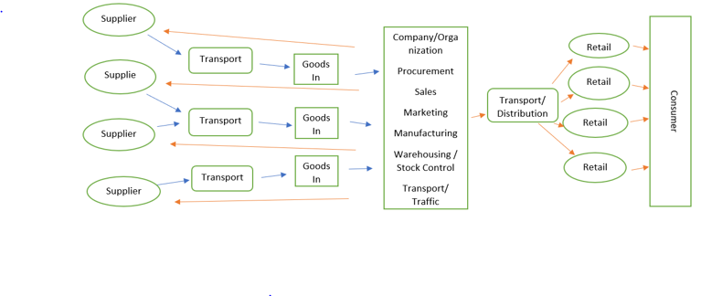

Sean Ellam

29994

Assignment : #2

Page 2

1:2 Cross docking is the term used when the company and warehousing
departments consolidate shipments either at source or in situ by ways of transferring incoming shipments straight onto outgoing shipments. In doing this it minimizes the length of time goods are held in storage which in turn reduces costs.
1:3 Aims of logistics is to increase the efficiency from the start of the supply chain through to the consumer. With the aim to keep costs low by ensuring the operation runs as smoothly and timely as possible. This will enable less goods to be stored in warehouses meaning consumers will always have access, so demand does not out way availability.
1:4 As the name suggests Stock Control is the control and management of stock within the organization. Minimum stock levels are created, and new stock will be orders if levels encroach on this. How and where the goods are stored is also controlled. This is all controlled according to budgetary figures set within the organization.
1:5 Communication within the supply is very important and must always be maintained. If communication falls between departments then costs, forecasting and availability of goods may become more expensive due to longer lead times for raw materials and products, which could lead to retailers and consumers sourcing from competitors.
1:6 Not all companies have the same capabilities to control all logistics from within house, smaller companies may outsource areas such as transport and customer services, others may have departments that do multi roles (sales, customer service or warehousing, transport). Larger organizations will have individual departments covering all areas of logistics. Whichever method the organization uses the communication spoke about earlier enables every process to run efficiently and within budget.
1:7 Logistics within all companies / organization is one of the highest expenditures so to have a smooth unhindered supply chain enables costs to keep within budget. This then ensures that stock is readily available from retailers/distributors to the consumer.
2: Logistics to all companies is one of the most integral parts. From the start of the supply chain to the end .All links within in should work together ensuring the flow of either raw materials or finished products arrive on time and within budget to meet the needs of the business and the consumer the logistic process is managed correctly at all stages then as previously stated costs are kept low turnover is continuous allowing the company to keep growing and keeping the consumer happy. Having noted all this the cost of logistics is also one of the most expensive within the organization , larger organizations are able to budget for this as all is controlled within house ,smaller operations outsource parts of its logistics such as transport and storage (known as 3rd parties) this could entail extra costs . So, when deciding on a location for a business the costs of logistics plays a major role.
3: With the turn of 21st century also came more awareness of the environment and
Sean Ellam

29994

Assignment : #2

Page 3

what we are doing to it. Logistic areas such as transport and large-scale warehousing create large carbon footprints with emissions and power usage and disposal of waste all damaging to the environment. The work environment has took note off all this and work alongside environment agencies to limit the damage caused .Warehousing can be built on more brown field sites as opposed to green field sites but this also comes at a cost as it may mean higher transports costs and having to store more products for longer periods. New builds also use a lot of more renewable energy such as solar and wind power to run offices and operations. With the introduction of lower emissions from vehicles transport operations have had to look at using more fuel-efficient vehicles and where possible could possible use electric.
Costs are rising in all departments due to lack of communication and planning, no one department is aware of how the others are controlled. The ordering of bulk products obviously gives a better price on the purchase price but if the products ordered are for products occasionally put through production then costs are going to rise on storage so in the end no costs are saved. Transports problem that if the loads are not large enough to justify a specific vehicle then the cost for the collection will outweigh the purchase.
The basic problems in my opinion is no one department has an understanding of how the others fit in the logistics chain and to what cost they are to the company, so with this they all think they are saving the company money.
I would suggest that there should be a head of departments meeting every week to discuss current production and future orders. Along with this production should have daily consultation with stock control and goods in to see what stock is available and when goods will be available. Procurement should also have multiple suppliers in the event that one may not be able to supply for issues of their own

Student Statement:

By submitting this assignment, I confirm that this is my own work.

Student Signature | Sean Ellam | Date | 25/04/2019

For Tutor / Assessor Use Only
Total Marks
Marks Obtained
Percentage / Grade

