
Assignment Cover Sheet

Student Name: | Christopher Anim
Student Number: | 1821
Course: | Diploma in Forensic Accounting
Assignment NO: | Unit 9 – Fraud Risk Assessment

Contents
1. Give brief answers for the followings 3
i. Outline the factors on which fraud risk assessment depends. 3
ii. What are the main concepts about risk assessment? 4
iii. What are the internal factors that should be considered for fraud risk assessment? 5
iv. What is ‘inherent risk’? 5
v. Define the term ‘residual risk’. 6
2. Prepare a fraud - risk assessment check list for any business of your choice. 6
Appendix 9

Give brief answers for the followings

Outline the factors on which fraud risk assessment depends.
Risk assessment will have to be built into organizations ongoing assessment of business risks. Once the fraud guidance starts to get embedded into daily operations it will then be backed by various policies. Such policies and action plans will find its way to the front-line workforce and this will be far more effective than an approach that deals with the corporate overview. Nevertheless, there are several factors that can be considered when undertaking any risk assessment.

Corporate Environment Factors: According to Singleton et al (2006) employee fraud, theft and embezzlement are increasingly higher in some industries than others. The ACFE states that industries that are more likely to hire a Certified Fraud Examiner indicate a high level of fraud in those industries. Thus during risk assessment, the level of assessed fraud risk should also be taken into account.

Another factor is that during good time people steal however during bad times people steal more. Thus due to the added financial pressure in recession they are more likely to commit fraud. This is part of the fraud triangle referred to as the unbearable financial need.

Finally organizations with weaker management, accounting and security controls are more susceptible to fraud

Internal Factors: This should also be considered during risk assessment. Internal factors such as inadequate management controls, or monitoring activities are contributing factors to embezzlement.

Fraud factors: For the anti-fraud team to concentrate in the area fraud is likely to occur it is imperative that the risk assessment conducted should highlight those areas. This will enable detective and preventative counter measures to be put into place. For example, in a financial statement fraud it is more likely to be the executives that will be the fraudsters thus the risk assessment will focus or include those individuals.

What are the main concepts about risk assessment?
For management to be able to defend itself a formal way of risk assessment should be implemented rather than ad-hoc approach. Nevertheless the concepts that supports risk assessments are

Leader(s): it is quite important that a leader is chosen and it should be someone who has extensive independence and more appropriately from the internal audit team if it exist. This person should have the capability of fully supporting the risk assessment. This is the basis of a successful risk assessment as if the person lacks any experience or independence then the assessment can be compromised.

Team: This co-workforce team that forms the risk assessment team should be chosen carefully. It is advisable that the team should include all the different business units and especially areas like Finance where fraud is more likely to occur. Furthermore, regardless of position certain individuals who think creatively, understand the business and are capable of playing devil’s advocate should be included in the team.

Frequency and Alignment with Finance: Preferably every 12 to 24 months in line with the financial planning or reporting time frames a risk assessment should happen. The financial planning involves future plans and considerations whilst on the other hand the reporting considers adjustments, disclosures and control deficiencies and in some cases will rely on the risk assessment information.

It should be concluded that risk assessment will constantly evolve with the changing nature of the frauds and as such it should be constantly monitored.

What are the internal factors that should be considered for fraud risk assessment?
Ongoing monitoring should form part of the internal controls that an organization should implement. Singleton et al (2006) lists out the following as examples of inadequate controls:

- Absence of a culture that encourages honesty.
- Inability to set and communicate performance standards and standards for personal conduct.
- Inadequate legal, ethical, fraud detection and security-related training.
- Absence of company policy regarding sanctions for financial crime and breach of security.
- Failure to provide counsel or take action against unsatisfactory levels of performance or questionable personal behaviour that violates organizational principles.
- Lack of clarity in job roles, accountability, duties and responsibilities.
- Irregular audits, inspections and follow-throughs to monitor compliance with organizational goals, policies, procedures, priorities and government regulations due to which there is a general lack of accountability in key positions.

What is ‘inherent risk’?
The characteristics of the transactions and the nature of the account balance determine the inherent risk. Beasley et al (2009) quotes the SAS-107 for the definition of inherent risk as “the susceptibility of a relevant assertion to a misstatement that could be material, either individual or when aggregated with other misstatements, assuming that there are no related controls”.
There are various factors that is considered as part of inherent risk and they include technological development, the complex nature of the accounting being analysed, any external economic forces that impacts the organization and mainly the characteristics of the industry that the organization operates. Nevertheless the general rule on inherent risk is that there is more inherent risk associated with accounts based on estimates than with accounts based on actual transactions.

Define the term ‘residual risk’.
After the appropriate controls have been designed and implemented, risks will then have to be managed. Some risks due to the costly nature of mitigating the risk or there is insubstantial evidence. This is all part of the risk management. The aim of the risk management is to prevent any fraud from occurring. Thus residual risk can be defined as the risk that still remains after all the controls have been put into place.

- Prepare a fraud - risk assessment check list for any business of your choice.
The organization that I prepared the risk assessment check list is IKEA and I interviewed one of their risk managers when I was completing the check list. IKEA is a Swedish-origin founded in 1943 with the headquarters in the Netherlands. The organization designs and sells ready-to-assemble furniture, kitchen appliances and home accessories, among other things. The following information is the results of the interview that I conducted.

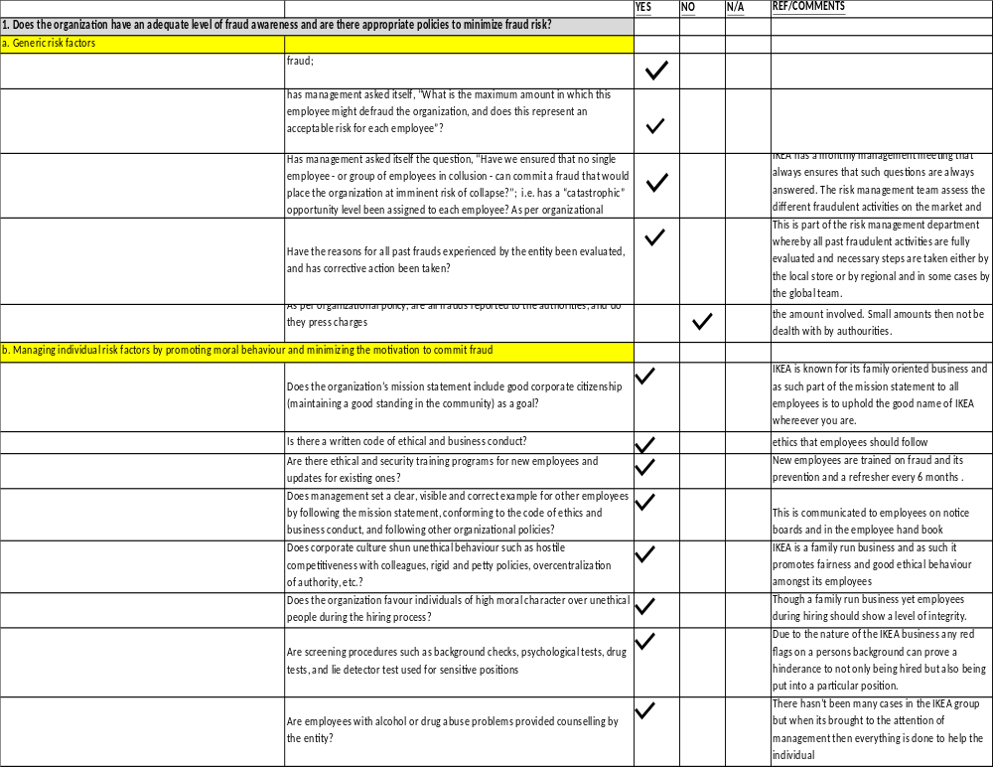
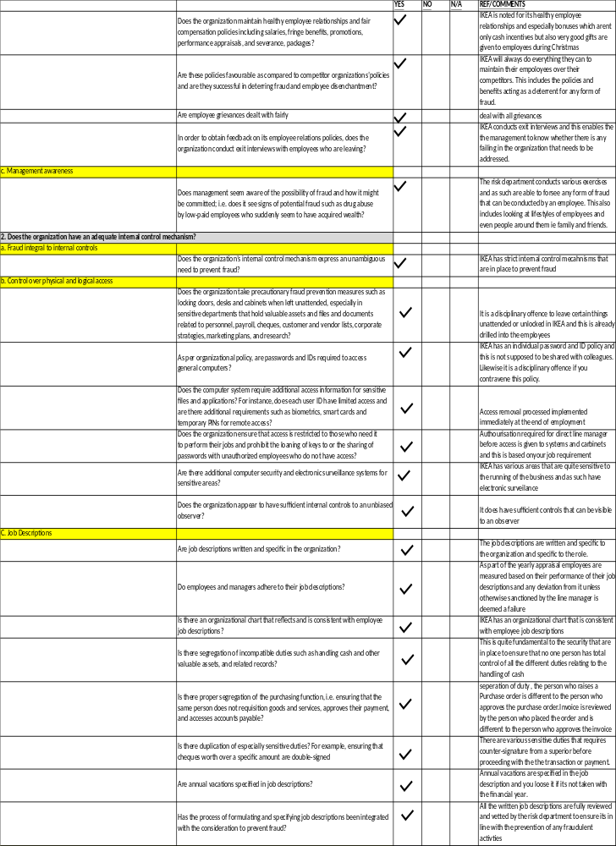

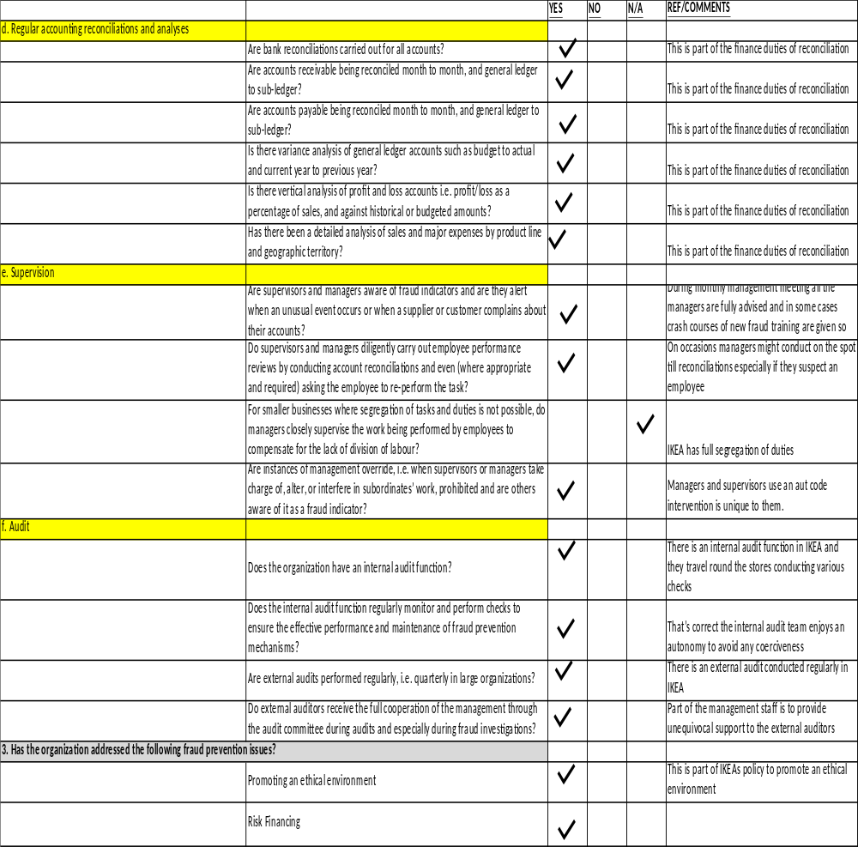

Appendix

- Beasley M. S., Carcello J.V., (2009), GAAS Guide 2009: A Comprehensive Restatement of Standards for Auditing
- Singleton W. T., Singleton J. A. (2010), Fraud Auditing and Forensic Accounting, John Wiley and Sons

