Logistics and Supply Chain
Management Level 4
Brentwood Open Learning College Page: 1
Market Distribution in Supply Chain

1. Give short answers for the following questions: (15)

i. What is distribution in a supply chain? What are the channels of distribution? And
how do they work?

Distribution is the action what allows to deliver a particular product to satisfy customer demand. Channels of distribution are intermediaries which at some point become in contact with manufactured products in the supply chain before reaching the consumer and working at every level of the distribution process, understanding that a product can be sold in different ways.

ii. Who are the channel participants in a distribution process?

Channels to be considered are: Producer, Wholesaler, Retailer, and end Consumer. Producer is the most comprehensive channel as it includes all of them.

iii. What is the importance of market coverage decisions in a distribution process?

Market coverage wrong approach / decisions could lead in the medium term to situations where the producer lost control of customer satisfaction as they will be unable to provide after sales essential services, i.e. if at intensive distribution level where some retailers decide to sell products at low prices causing disturbance among the ones do not implement that tactic.

iv. How would you differentiate between conventional channels and single transaction
channels?

Single transaction channels include active retail and/or wholesale outlets, that sell a specific brands’ products in a certain market through only one distribution option whereas the activity in a conventional channel is carried out on a transaction-to-transaction basis. It comprises a producer, wholesalers and retailers all acting independently and being coordination among them their biggest challenge.

v. How can logistics operations affect the pricing?

A main development in price strategy has been to de package the price of products and materials so that services like transportation, which were usually included in price, are now recognized as separate items. Pricing practices have a straight impact on the timing and steadiness of logistical operations. F.O.B. source and delivered pricing are the two most widespread methods. Additional ways to determine pricing are: Single-Zone Pricing, Multiple-Zone Pricing and Base-Point Pricing.

2. Discuss the fundamentals of pricing strategy in supply chain management. (7)

Pricing is an important subject of marketing plan that actively interacts with logistical operations. The terms and conditions of pricing decide which party has liability for performing Logistics activities. A primarily pricing strategy is cost plus pricing, which take into account calculating costs and adding on a margin for profit. However, as the identification of product or service costs requires multiple choices, such as the way in which overheads are allocated, even this approach is not as simple as it may seem. There are many other pricing strategies such as, F.O.B. Pricing, Delivered Pricing, Single-Zone Pricing, Multiple-Zone Pricing and Base-Point Pricing. Zone pricing could be considered discriminatory that is way Zone pricing schemes are against the law. Furthermore pricing should be considered such as Quantity Discounts (incentives to customers targeting orders boost) this practice also could be discriminatory if not applied to all buyers. Promotional pricing pressurizes logistical operations consisting in short-term promotions aiming an increase in sales.

3. “Channel mapping and matrix approach are of significant importance for a channel design
process.” Discuss this here. (8)
Channel mapping is a method that is more than simply listing the ways customers are contacted by a company to explore what a company’s brand value signify to a particular customer.
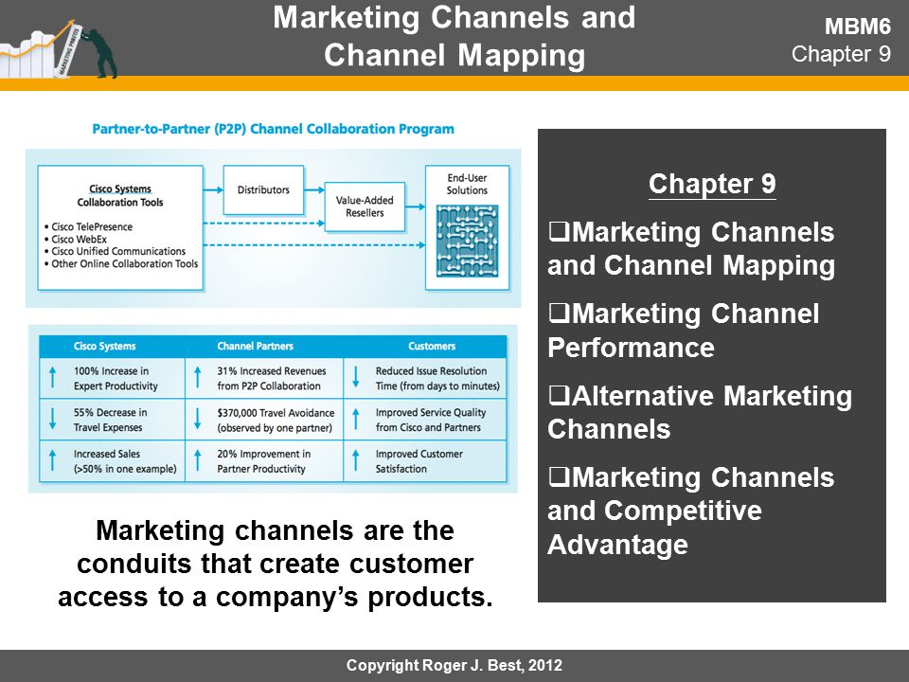
Source J. Best, 2012
A matrix approach allows to build a supply chain strategy for an enterprise. Let’s say on the Y axis can be placed attributes that describes the availability objectives of the company and on the X axis the elements for developing the supply chain such as:
- Improving relationships between customers and suppliers
- Supply network capacity available
- Supply chain organization and structure including resources and capabilities
- Developing human resources

