
Assignment Cover Sheet

Student Name: | Rebecca Aldridge
Student Number: | 22121
Course: | Certificate in Fashion Design (Level 1)
Assignment NO: | 2

Marking Criteria:
We expect the learners to write minimum one well expressed point in three lines against each allocated mark. This means one needs to write 15 lines with 5 well expressed points to get high grades for a 5 marks question.
For high grades use examples and illustrations where appropriate.
Please insert your completed assignment ( in word format) here:
Relationship between principles and elements of design

The elements of design include: line, shape, space, colour and texture. The line of design includes the way a product is outlined and embellished with

a series of different lines which include curved, straight, full curve, jagged line, restrained and the direction of lines(vertical, horizontal and diagonal.) furthermore lines create optical illusions within the garment and how the model is perceived within the product. Lines can also be structural and decorative meaning that the lines within a garment present personality through ruffles, fringing and piping and can also create a structural effect through hems, pleats and gathers. Within the elements of design shapes of the model need to be considered so the garments suits the figure and the principles of design highlight the right parts of the body to create a flattering look. Shapes include: rectangle, inverted triangle, circle, oval and hourglass. Space if further considered with the principles and this element of design is the area between shapes and needs to b balanced so the garment is appealing in the way of which the eye travels and ensures the look on the shape of the body is effective. For example the closer vertical lines are the more slender a figure looks as the lines are closer together .The principles of designs also link to colour and texture and these depend on the specific theme and overall look desired; colour and texture need to be balanced and emphasized in particular areas so the garment is in proportion. Texture includes the way the fabric feels and the way it is manipulated to create effects such as soft draping or a stiffened area on the garment. This creates a visual effect along with the colour and glorifies the models appearance.

This further relates to the principles of design as this includes: balance, emphasis, harmony and proportion. The principles of design are guidelines for the elements of design and create the overall effect of the garment. The principles express the elements of fashion design and create individual ways to style a garment and decide the way the theme is presented. Within the principles of design balance measures the weight of the elements on one product and desires to create a symmetrical or asymmetrical placement of shapes. Formal balance (symmetrical) creates a dignified and mirror image over the garment and ensure and even appearance of the elements of design. Asymmetrical balance is more exciting and uses the elements of design equally but not in the same place either side of the garment and instead ensures that both sides have equal attraction using different elements on each side. Emphasis concentrates the eye on a particular flattening part of the garment and one singular detailed point stops confusion and over decoration on the garment. Harmony within a garment ensures the product is visually pleasing and holds the attention of the consumer. Harmony uses the elements of design to create positive, pleasing images and ensure the garment includes elements that work well together such as the pockets suiting where they are placed with the other elements of design. Finally proportion ensures the elements of design are the correct size for the garment and don’t create an overcrowded displeasing look.

​
Rhythm in dress designing
Rhythm can be created through repetition with either a regular repetition of shapes, buttons, edgings, textures and disposal of fullness such as pleats. These can be scalloped, straight or curved and creates a bold image from a simplistic idea. The repetition creates a peaceful warm feeling with soft curves and smooth lines whereas lines with sharp, pointed lines create a dramatic, interesting, eye-catching effect. A variety of repetitions are used in one garment to balance out each other. Pleats may be used with a trim of the skirt to balance out the dramatic effect the pleats provide. Colour repetition is also used within garment making as they can be arranged in patterns or used with harmonious or complementary colour to create many different effects.
Progression is another way rhythm can be created in dress designing. Progression can also be known as graduation and is the increase or decrease of elements within design such as colour, embellishments, size or patterns. For example the size of shapes could change, gradually, from small to big throughout the dress the create a dramatic exciting effect. The distance between lines of pattern can also create a bold and sensational effect giving the feel of moment and swiftness throughout the garment. Progression of rhythm can also be created with trims, ruffles and colour intensity. These can create a warm and cosy affect or exciting and busy atmosphere.
Rhythm can also be created through radiation. This means that the dress creates feels of movement in many different directions. The movement is organised and starts from a central point such as gathers, darts, pleats, tucks and lines. The direction of radiation may be in one direction to the point or may spread out in a range or directions or all could oppose the direction of the point but flow in the same direction. Radiation of rhythm can be shown through a fan design on a dress as there is a central point where lines around the point spread out in many different directions to create a very dramatic and detail design on the garment.
Principles of design helping to analyse the effect of a design
The principles of design include: balance, harmony, rhythm, proportion and emphasis. By the designer analysing the balance of a design they can investigate whether the garment has formal or informal balance. Formal balance is not as interesting and creative as informal balance and creates an arranged, structured effect where the garment is symmetrical on both sides so the two sides of a garment are exactly the same to create a balanced, easy wearing garment. Informal balance ensures the garment is balance but may be created in different ways so the two halves are not exactly the same but the top left may have a flower whereas the bottom right has a decorative pocket. The two embellishments on each side equalise each other and share out the design weight equally through different embellishments. The balance of the design allow the designer to evaluate how well the weight of detail is shared throughout a garment and allows them to check that one side is not too heavy leaving the design looking off putting and unappealing on a model.
Emphasis concentrates detail in one area of a garment creating a centre of interest to stoop all areas being detail and creating confusing look. Emphasis allows the garment to have planned, figure benefiting style and enables the eye to focus on the more appealing aspects of the body, highlighting these and taking the attention of the unappealing self conscious areas. Emphasis is most commonly used to reveal a particular personality or mood and is placed in coordination to this. Emphasis can be created through patterns such as stripes or shapes, pleats, beading, appliqués, hand embroidery, neckline, cut of garment or buttons. This allows the designer to check that the garment has one or two main eye-catching areas to create a detailed and elegant look that is not over crowded. Also a different texture or colour contrast can create a simple but modern emphasis on the garment.
Harmony is analysed by the designer on the garment design to ensure that the overall design is visually pleasing and all the aspects of the design work well together and complements each other and blend better to create a peaceful, continuous look through the one design. Harmony also ensures that the product is breathable, moveable and suits its function. The designer must analyse the design to check that each element harmonises with each other to express a particular mood or theme without being confusing and off putting. Pockets, shapes, necklines, sleeves and other elements similar to these must all be similar. E.G. they must all create a smooth, soft effect or a sharp, defined and more jagged look to stop the garment from being boring.
The proportion of the garment must be evaluated by the designer to ensure the design complements the figure and use so the product looks eye-catching and extenuates the better parts of an individual shape. For example the designer must ensure that the design suits the body shapes that it is ideal for so it looks flattering. They must consider how broad they want the shoulders to look, how long they want to make the model, the length of the legs and bodice desired by the body shape, whether they want to look similar or bigger and other specifications like this. The designer wants to ensure that each part of the design works well and is in correct proportion to create a harmonious design. The designer should consider whether the garment will best fit medium, small or large scale figures as this will determine how the designer looks and the amount of scale given to each part of the design to best fit the desired figure.
Finally rhythm needed to be evaluated by the designer to ensure the design creates an interesting overall look. The designer should look at what rhythm has been used, whether this is through repetition, graduation, radiation, transition or movement in lines the designer should make sure the colours, embellishments, disposal of fullness and cut of the fabric have been used appropriately and meet the desired agenda. The designer should look at whether the constant repletion of an element is beneficial or whether a graduation or radiated pattern or colour better suits the theme. This will ensure the garment is most appealing and attractive to the consumer and will best suit the designer’s goal with the design/product.

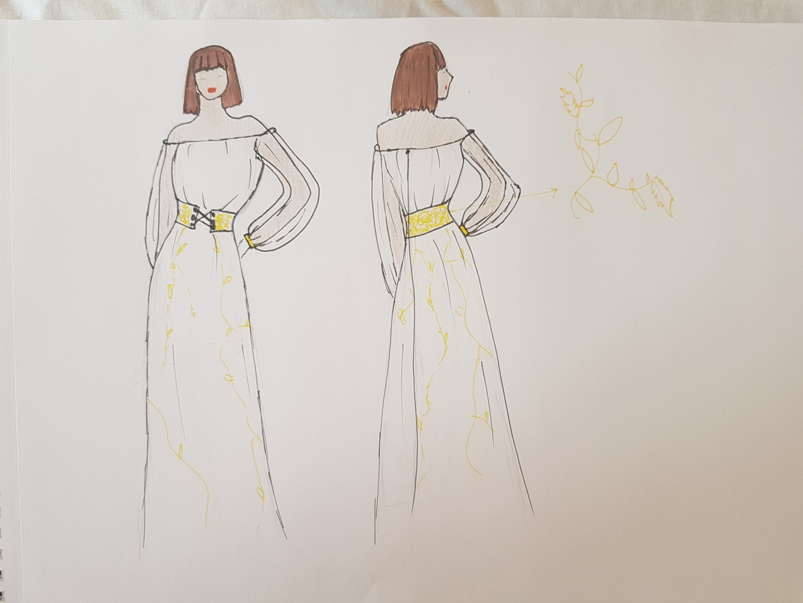
Project: designing a dress from historic dress inspiration

The dress designed by me was mainly inspired by the Greek dresses; with the loose fitting clothes in a snow white. I used this inspiration and mixed it with the historic use of a corset and designed it to be more fashionable. Working our way down the dress is off the shoulder style with gathered fabric for the traditional Greek look, this then changes from a loose but complementing style when a golden coloured embroidered corset has been added to define a flattering body shape and also refer back to historic garments. The corset ties at the centre front of the dress for the extra detail. The embroidery on the skirt and corset would be completed by free machine embroidery and had taken inspiration from the Greeks golden head pieces that would often have leaf details ( a close up of the embroidery has been shown on the right of both designs. The dresses skirt loosely flows, out suiting today’s current lifestyle and reaches the floor gracefully. The different shapes within the dress make it comfortable for most body types and allow a flattering look for all sizes and heights.
The gathers used on the bodice of the dress are vertical and give the illusion that the body is slimmer than in reality and the use of gathers here are beneficial for big and small busts making the all look better proportion with the rest of the models figure. Structural lines used in the dress will include side seams and the centre back seam however the side seams will be a closed seam whereas the back will have an open seam as this allows easy insertion of a concealed zip. This zip keeps the Greek them continually running through and enables an easy accessibility to the garment. The bottom of the dress, although not drawn the reflect the easy of movement and lightness of the skirt would be neatened by an overlocked hem to stop bulkiness and create a neat, professional finish without taking too much time, reducing costs perfect for our lifestyle today.
The sleeves of the dress will involve a closed seam and are long sleeved and neatened by a cuff at the wrist, of which is in an interfaced golden cotton fabric to further link the whole dress together. Cotton is renewable, cheap, breathable and fairly easy to care for perfect for society today and doesn’t irritate the skin which is beneficial for everyone. This provides a comfortable, long duration use. Long bishop style sleeves have been used on the garment to suit today trends and provide a unique look. Furthermore the sleeves are made from a white organza fabric adding a little luxury to the dress and allow the sleeves to be see-through which will be very appealing to people in today’s society. The fabric used for the skirt and bodice will be a white cotton as this flows easily and suits the shape of dress designed.

Student Statement:

By submitting this assignment, I confirm that this is my own work.

Student Signature | Rebecca Aldridge | Date | 10/7/18

For Tutor / Assessor Use Only
Total Marks
Marks Obtained
Percentage / Grade

