
9688
Assignment Cover Sheet

Student Name: | Kevin Fitzpatrick
Student Number: | 9688
Course: | Business Admin. Level4 Diploma
Assignment NO: | 11

Marking Criteria:
We expect the learners to write minimum one well expressed point in three lines against each allocated mark. This means one needs to write 15 lines with 5 well expressed points to get high grades for a 5 marks question.
For high grades use examples and illustrations where appropriate.
Business Communication & Report Writing

Assessment 11 Total Marks: 30
Q.1. Short Questions: (20)
i. Discuss the appropriateness and effectiveness of different communication channels and tools within organizations.
Answering question with a typical list of business communication tools.

Type of communication within an organization | Effectiveness of communication method
Face to face (Job interview) | Oral and observation as the interviewer can assess the job candidate in person
Internal Memo | Used to convey a more complex response than oral communication and can be filed for future reference. Not appropriate for external reading.
Electronic mail or E-mail | Much quicker than sending a letter e-mails can be transmitted in a matter of minutes or seconds. . Also capacity to send attachments like word documents and excel spreadsheets.  One wouldn’t send a very long document or loads of photographs as it could be out of its storage capacity
Induction process | Used as a welcoming of new staff and instructing in the company’s ethos and values and description of the firms operating practices. Used only at the start of an employee’s career.
Code of practice (printed Manual}  Job description | A more in depth information package but kept in an employees’ reference throughout one’s time at a business or organization unless it is updated.
Power point presentation | Software tool for presenting information on slides and for giving formal or informal talks uses visual and oral methods to deliver data.

ii. How appropriate communication channels and tools should be selected within an organization?
I would like to answer this question with a synopsis of communications which are really important for conveying information such as: social-media, e-commerce, advertising and the press.
Organizations such as amazon and e-bay, are online businesses who want you to use social media like face-book and twitter to rate and promote their merchandise. Many other top firms are online and want you to rate and recommend their wares and ask you to leave feed -back.
However there is still a big place for television advertising for many top businesses such as Cadburys or car manufacturers will pay a lot of money to advertise and promote their new products especially on peak times such as when the soap operas are being televised and sports events as well.
The local press is often used for the smaller concerns and there is a lot of adverts still placed in the national press for larger firms. There is a lot of ways to do advertise and promote a firms products and services it is picking the right ones to be effective for the business.

iii. What is report writing? Which type of statements these are? Which type of information they contain?


Compiling and inputting of information in textual format, nowadays word processed and printed out on copy paper. It could be a report by an admin. Worker requested from a manager concerning a business topic. I would like to write about a project I had to do for my boss when I was training to be a supervisor and the subject was: weed control for the southern area of Waltham forest and It had terms of reference to comply with and an outcome that had recommendations to follow or not when it was read by my manager.
Report statements could be financial data and other business subjects: namely codes of practice, job description, health and safety documents and mission statements for the organization.
The information contained could include be word processed data using word software , financial which could be a spreadsheet using excel , dynamic databases formed by database software like Access or even presentation formats such as Power point.

iv. What are the key points to remember when writing reports?
Keep it short and simple = acronym KISS don’t ramble on with the report.
Try not to use jargon make the report easy to read for the layman as well as the experts.
Make the document pleasing to the eye; as a picture paints a thousand words, try to include graphics and relevant diagrams and charts and tables. This is especially important with financial data.
Make sure that the information you put in is accurate and up to date as it could make the business reputation down grade when people read the data which is not what you want.
Make sure the report is proof checked and make sure someone else checks the text as you may not notice your own mistakes.
Three major elements should be adhered to when starting off with your work is to have an introduction that is the aims and the objectives of the project and the terms of reference and to explain why the report needs to be produced.
Secondly the middle part of the text is the main body of what you are conveying that contains the subject matter of what you are working on.
And finally the end of the work which is the conclusion and the recommendations you are proposing to your firm to take on board



An example of financial or statistical data.

v. Name three ways in which ICT has changed workplace communication.
Electronic mail or E-mail.


E mail is a major change in sending messages it is usually conveyed through electronic devices such as computer networks that is the internet but as well this one can send e-mails on tablet pc’s and SMART mobile phones. It is far quicker than letters and one can send attachments with the email as well. It can be sent all over the world in a matter of minutes.

Word processing is another major tool for business before word processors everything had to typed on a typewriter and if one made a mistake you would have to start all over again which is a nuisance. If one makes a mistake when one is keying in data in Word one can simply delete the error or type straight over the text without messing up the input.
One can also produce manuals or business reports, even ones’ Resume as well. And can include photographs and other images to enhance a document or t with borders and bullets to emphasize text and add personalized styles on the software to use at any-time you want.

Word Software


Thirdly there is desk top publishing using Microsoft Publisher and that has transformed workplace communication as well.
One of the ways that publisher is different to word is that it is more graphic based than textual it sets out to make a visual statement with photos, charts , tables and is often used to produce brochures , catalogues , newsletters and greeting cards. Not so long ago if a business wanted to produce these type of publications one would have to commission a desk top publisher to do this for you. But with training a competent admin. worker can produce results to a required standard and be more cost effective.

Microsoft Publisher
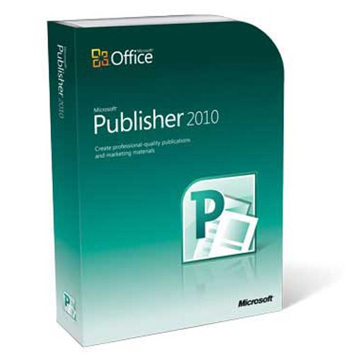

Case study

i. What are the communication challenges and barriers David faces?
There are three main areas of concern, first is the age range of his employees some are young and some are lot older, there is also differing cultural and ethnic background and for many employees, English is not their first language. There is also a high turnover of staff which could be disheartening as the manager has to start all over again with training his new staff.

ii. David should be a role model for his staff? Are there any areas he should improve on himself?
David should deal with what is happening with his home-life as it is affecting him at work. I would say that he needs to bed early and get a good night sleep. He needs to wear smart and clean clothes as befits a food service manager, if he continues to wear scruffy clothing , customers could think if he cannot keep himself clean and tidy his work could be not up to scratch either. This is not a good way to present yourself to your staff and can affect morale. He also could get himself a haircut and thoroughly clean his hands and have a good shower or a bath.

iii. What are some ways David might use effective communication as a motivator for employees to follow safe food handling practices?
It is written in the case study that Dave was getting into a bit of a state about the food safety and handling of his staff. One way to effectively communicate with the staff could be to gather his team and lay it on the line to them how vital this subject is to the restaurant business. If a customer gets food poisoning or health and safety officers come to check their kitchen and find it a hazard to health the restaurant could get closed down and they would all be out of a job.
Another possible effective communication tool I considered was to do a presentation in power point of course this depends on whether David or one his staff have the expertise to do this task but this food handling and safety issue is so important; paying out for such a form of communication to be delivered by a freelance IT specialist could be an option.

I would like to show a list of slides for a food handling and safety presentation to be shown to his staff and I have selected a more visual than textual mode of delivery.

Slide 1 food safety hazards

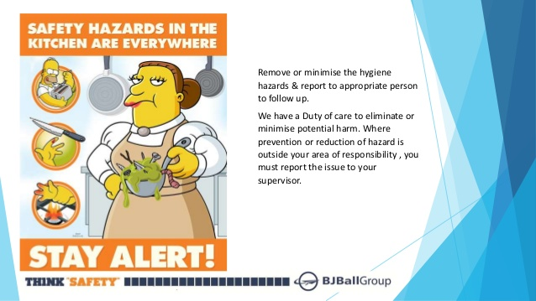

Slide 2 safe or dangerous food temperature diagram.

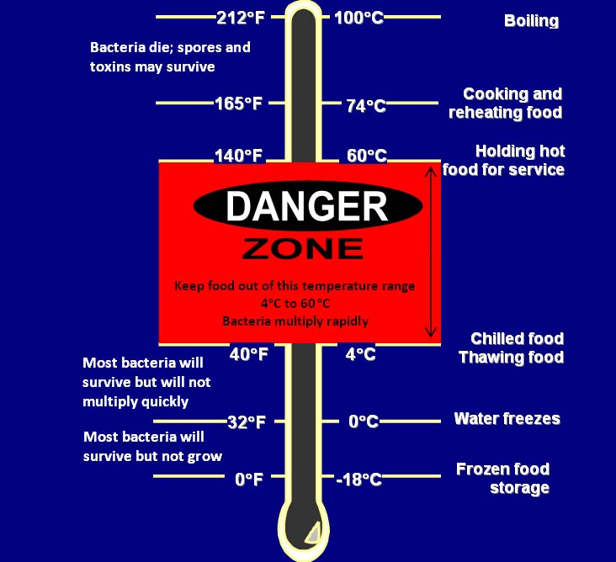

Slide 3 Personal hygiene

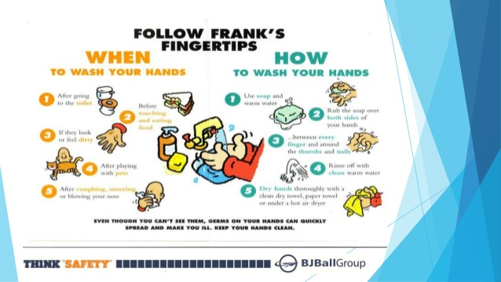

Slide 4 Dealing with Germs

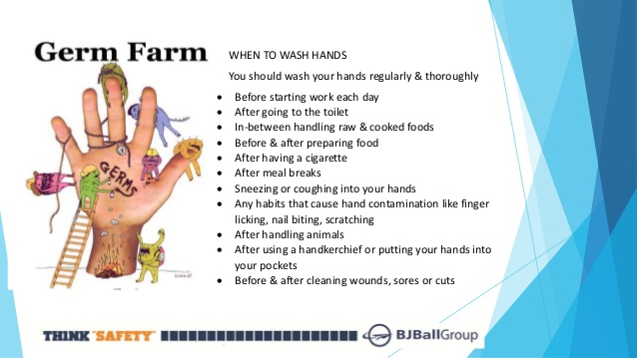

Slide 5 Pest Control
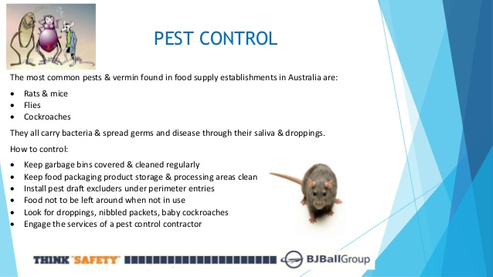

Student Statement:

By submitting this assignment, I confirm that this is my own work.

Student Signature | Kevin Fitzpatrick | Date | 30/04/2018

For Tutor / Assessor Use Only
Total Marks
Marks Obtained
Percentage / Grade

