
Assignment Cover Sheet

Student Name: | Miriam Terhune
Student Number: | 23569
Course: | Diploma in Wedding Planning Level 4
Assignment NO: | 2

Marking Criteria:
We expect the learners to write minimum one well expressed point in three lines against each allocated mark. This means one needs to write 15 lines with 5 well expressed points to get high grades for a 5 marks question.
For high grades use examples and illustrations where appropriate.
Name: Miriam Terhune
Student Number: 23569
Assignment Number: 2
Page: 1.
1.
i. The greatest benefit of a double wedding is the division of the financial resources which can lead to a bigger and more extravagant celebration, and possibly a longer elaborate honey moon. In case of siblings and/ or relatives getting married at the same time, the extended family would be able to cut down on travel and accommodation expenses. Unfavorable factors in a double celebration relate to synchronizing all the elements of a wedding day including the date, venue and colour schemes for both parties. A great number of newlywed women want to be the centre of attention on their wedding day throughout the event, which could be a challenge with two brides.

ii. Many couples are choosing a themed wedding because it will set them apart from any other celebration, creating their own style and making it a memorable event for
everybody involved. A distinctive design that will transform the entire wedding
Name: Miriam Terhune
Student Number: 23569
Assignment Number: 2
Page: 2.

festivities will be treasured through the years of their lives together. Handed-down
traditions and rituals can still be integrated in any particular situation. It might even be more significant to include family customs in a themed wedding.

iii. The wedding invitation will give the guests the first clue of the mood for the wedding day; it will also make it easier for the guests to decide on their wardrobe, for instance, a black tie affair, medieval costumes or a garden party. The chosen theme should be carried thru out all the wedding festivities. Music selection can play a very important role in the outcome of your celebration and can set the mood, from romantic to vibrant. The style of the menu needs to be reflected in the theme, as well as the flower arrangements which can bring the concept of a celebration to a different level.

v. The choosing of the wedding venue is one of the most important decisions a wedding couple must make. Location and accessibility from roads, trains and airports are to be considered and will be key to selecting a venue. Lodging and transport from and to the ceremony/ reception site has to be decided during initial planning. Is the venue itself a full service facility or are outside vendors needed? If so, are there sufficient suppliers in the area? Travel time for photographers, officiate, make-up and hair personal need to be arranged and might affect the budget. Friends and Family travelling by car should be provided with ample parking and facilities to freshen up at the chosen location. With all this considered, the perfect wedding venue has been found.

2.
The challenge for planning a themed wedding is to set the mood that will transform every guest into a magical setting. The wedding couple must decide on a concept that will guide their whole wedding day. Will the wedding date and season affect the
Name: Miriam Terhune
Student Number: 23569
Assignment Number: 2
Page: 2.

theme? Does the wedding couple have a very definite style about their special day or are they open to other recommendations? The more insight a consultant has about the couples preferences and personalities, the easier it will be to execute the concept of their celebration. A budget and size of the party has to be set; from there a consultant can start developing and organising the event. The venue selection not only should be considered by size, but also by out of town guest accommodations and travel. Are there hotels in the area? How accessible is the location by car, train or air travel? Wedding invitations have to be sent out after setting the wedding date. The invitation should include all details including the theme of the wedding, date, time and location. Sending a separate note with hotels and travel arrangements in
that area might be helpful. Is the venue an all-inclusive establishment? What kind of outside suppliers are needed? Every detail needs to be managed by the consultant, including arranging tastings for the wedding menu and cake selections. Does the couple prefer a seated plated dinner or rather have a buffet? Cupcakes or a tiered wedding cake? All this needs to be carefully organised. Always in keeping with the style of the wedding in mind, decorations and flower arrangements will play a big part in the event. Are candles permitted at the venue or are only battery operated lights an option. Are the desired flowers in season? Is the couple willing to settle on artificial flowers which could be used later on and kept as a memento? Entertainment throughout the festivities can transform any event using a string quartet, band or DJ; the mood of the wedding needs to be reflected in the music. Will the couple take dance lessons and choreograph their first dance? Are there family traditions that will influence the style of the music? Should there be any other customs to be considered during the wedding day? A table with pictures and candles of lost loved ones might be a meaningful touch or a slideshow with pictures of the couple throughout their lives. With creativity and attention to detail a wedding consultant synchronises and manages all the responsibilities to create a memorable event no matter what theme the wedding couple desires.
Name: Miriam Terhune
Student Number: 23569
Assignment Number: 2
Page: 4.

3.
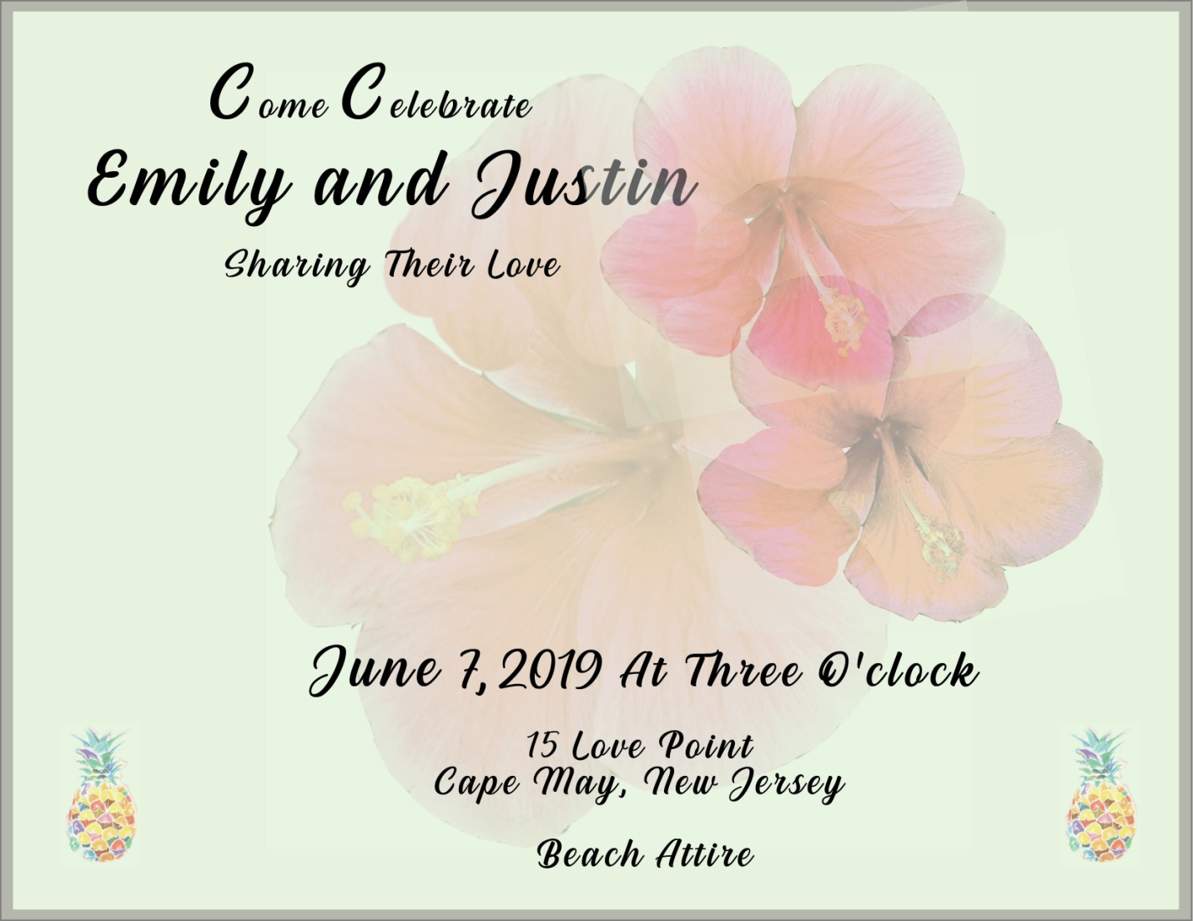

Case Study
The initial conversation with the wedding couple will determine the likes and dislikes of their lifestyle. They might prefer a stroll along the beach and snorkeling. It might be a BBQ in the back yard with family and friends that they enjoy most. Do they like to go hiking and skiing in the mountains or exploring historic places? The more information the consultant can gather about their preferences, the easier it will be to find a suitable wedding location. The season of their wedding date will also play a big factor in selecting a venue. For instance, if the bride and groom decide on a Caribbean destination, the rainy season has to be taken in consideration. Snow covered mountain for a winter wonderland wedding would be a beautiful backdrop,
Name: Miriam Terhune
Student Number: 23569
Assignment Number: 2
Page: 5.

but mother-nature will not guarantee snow.
The desire of wedding couples to have a destination wedding has immensely grown over the past decades; from exotic beaches to snow filled mountains, the possibilities are endless. Historic sites and resorts in every country have caught on and offer inclusive packages that wedding couples are unable to resist. With the cost of travel, the wedding party could be much smaller, immediate family and close friends might be the only ones willing to travel and share such an important event. It can result in a more private and personal wedding, becoming one of the most important family gatherings. Wedding guests can turn it into a mini getaway and newlyweds are already at their honeymoon location and avoiding additional travelling. Many wedding destination venues partner up with airlines and other travel companies to make it even more convenient to ensure easier and hassle free travelling. With backdrops like white sandy beaches, castles or a mountain range, money can be saved on decorations and flowers and spent on other important elements on their wedding day.
Many destination venues nowadays are fully inclusive, meaning the resort or hotel will provide lodging, food and drinks for the entire celebration, and it may even include travel options. Does the wedding couple have many choices for their menu and cake selection? What are the colour selections for flowers and decorations? It might be limited, but the destination location will provide the backdrop and beautiful photo opportunities of its own. A hometown/formal wedding will require more extensive planning from the consultant. Venue, accommodation, food and flowers etc. have to be selected from different suppliers and paid individually. Air and train travel are usually more expensive when purchased separate and might restrict some out of town guest to attend. Destination weddings are popular since all inclusive packages have made it affordable for every wallet.

Name: Miriam Terhune
Student Number: 23569
Assignment Number: 2
Page: 6.

When a couple is planning a destination wedding, with the excitement of the aesthetics and travel, they may overlook the legal and political considerations. A wedding planner with an understanding of local laws and customs will help the couple make informed decisions about their destination. For example, the Mexican government requires a chest x ray and blood sample before anyone can get married. Visas and Passports are a must in most destinations, some countries ask for a translation and notarisation of the birth certificate. In Japan parent’s approval is required if under the age of twenty, the license requires a fee and is only valid for three months. American relatives and friends will not be able to attend a wedding in Cuba, since the government only allows visas for students and work related circumstances. The wedding couple will receive all required forms and regulations from Embassies and Consulates; it is the responsibility of the wedding planner to ensure everything is in order and submitted in a timely matter. Wedding consultants have to consider local politics as well as local wedding laws. Crime rates should be reviewed when selecting a destination venue to ensure the safety of the wedding party. All wedding guests should have an understanding of the areas, safe and unsafe parts of town and follow any guidelines the local enforcement and wedding resorts provide. In summary, with an acute awareness of the climate, culture and politics the consultant will achieve a seamless travelling experience for all guests.

Student Statement:
By submitting this assignment, I confirm that this is my own work.

Student Signature | Miriam Terhune | Date | 15.10.2018

For Tutor / Assessor Use Only
Total Marks
Marks Obtained
Percentage / Grade

