
Assignment Cover Sheet

Student Name: | Darren Holtom
Student Number: | 29173
Course: | Importance of Estimation in Construction Work
Assignment NO: | 3

Marking Criteria:
We expect the learners to write minimum one well expressed point in three lines against each allocated mark. This means one needs to write 15 lines with 5 well expressed points to get high grades for a 5 marks question.
For high grades use examples and illustrations where appropriate.
1.
i.
Estimating is the process of working out what the cost of the job should roughly be. This will include pricing the materials, plant/tool hire or purchase, and the labour costs. Also included will be an estimate of when the project will be completed. All estimates will be calculated to be as accurate as possible to enable the client to assess if the project would be worth carrying out( financially and practically). All estimates should be as near to true figures as possible, but cannot always be accurate as ther could be a number of elements that change throughout the job ( prices, hidden extras etc)

ii.

A bill of quantities is a document that will list all the details of costs involved, i.e the items required, the cost of each item, and the quantity required. This bill is normally put together but a cost consultant ( normally a quantity surveyor). Before the bill of quantities can be made, the design and specification have to be fully complete so that all information can be accurate. Once complete this will help ensure that all contractors tender for exactly the same thing.

iii.

An approximate estimate ( also known as preliminary or rough estimate) is an estimate which prepared fairly quickly, normally without the final plans and specifications. An estimate is made for 1 unit ( 1 property, 1 square metre etc) and then the price is multiplied by the number of units require.
iv. A project budget is a list of all costs that will occur during the length of the project. The project manager will regularly check this alongside current cost to ensure that the project is not going over budget . Normally a template is used ( as shown below) to chart the initial estimated costings and the existing costs, showing what money is outstanding in the budget or if it is already overspent.
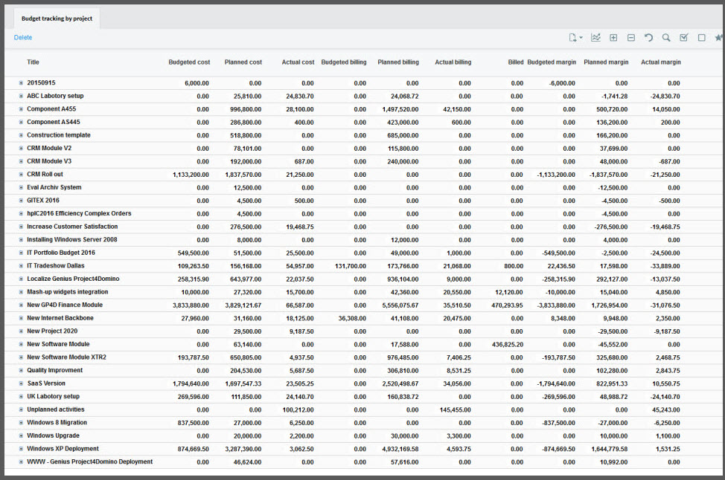

v.

Administrative approval is a term used for the formal acceptance for the project from the relevant authorities ( i.e the Public works Department) . The authority will be provided with the costs, plans and specifications by the owner of the project for their approval. Once all is agreed, the project can start. Once this has been agreed, a further, more detailed estimate is then supplied, this is called ‘technical sanction’.

2. How are estimates made for the following? (10)
a) A material rate can be worked out once the specifications of the materials has been decided. Then the supplier can supply a rate that each material will cost. This can then be multiplied by the number required. The transportation, handling and storage of the materials also needs to be taken into consideration when pricing the materials. It is wise to include enough materials to cover any waste ( normally a 2-10% allowance covers for this).

b) A labour rate has many elements that influence it. Each trade could have a different basic salary. Depending on the contractor, sick pay and holiday pay may be included. It also has to be decided if the operatives will be paid when the weather affects their working environment. A rate of overtime will need to be agreed, normally time and a half or double time when working extra hours. There is a possibility that an insurance will need to be purchased to cover the workers on site.

c) An Equipment rate shows the costs of running any equipment purchased/hired for the project. An initial purchase price will be established ( or hire price worked out by the price of hire per week times by the number of weeks required). A fuel cost would need to be added as well as maintenance costs. There is a possibility that a specialist operator may need to be employed to use the equipment, so their wages will need to be taken into consideration. The equipment may need to be insured which will be needed to be included in the costs. If purchased, the equipment could depreciate over time or usage, so the loss would need to be considered.

3.
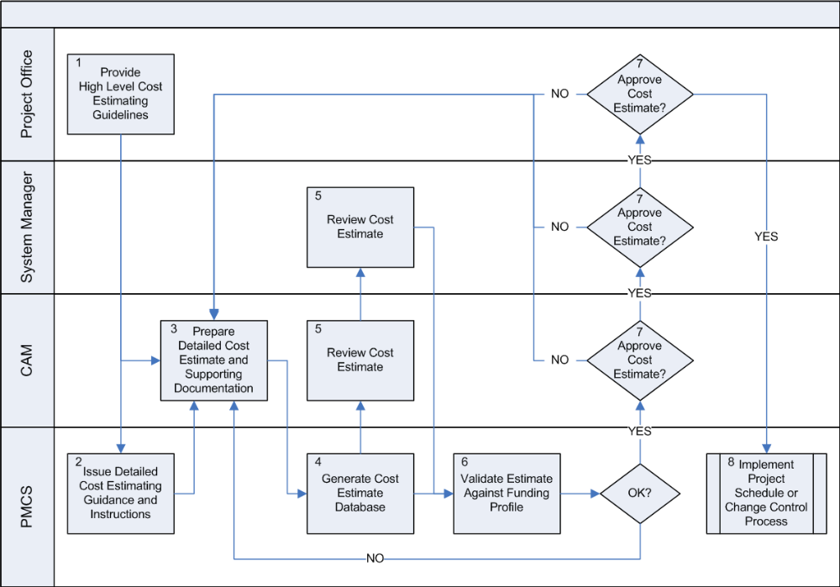

The estimating process comprises of many elements. At the beginning a rough estimate may be provided to see if the project will viable. This will be a high-end figure as the full details and specification will not be known at the time. If the client still wishes to proceed they will then issue a full specification. From this document the coat consultant can provide a detailed estimate showing the costs of each section of the project. This will be broken down into materials, equipment and labour. And then each section will be broken down to detail each individual elements ( a full description will be required for each elements listing such things as size, material used, brand, product code etc). The costs will then be evaluated by the client. The client will check to see that everything is included in the estimate and comes within budget. Once all is agreed the project can start. During the project the costs will be looked at regularly to make sure they are being kept to. If something starts to go over budget ( this could be because of many things including unforeseen circumstances, weather, increase in material costs) a new estimate for that element will be presented to the client for their approval. At the end of the project, all final estimates will be handed over to the client to keep on file.
.
Student Statement:

By submitting this assignment, I confirm that this is my own work.

Student Signature | Darren Holtom | Date | 20.2.19

For Tutor / Assessor Use Only
Total Marks
Marks Obtained
Percentage / Grade

