
Assignment Cover Sheet

Student Name: | Darren Holtom
Student Number: | 29173
Course: | Specialized buying and vendor management
Assignment NO: | 10

Marking Criteria:
We expect the learners to write minimum one well expressed point in three lines against each allocated mark. This means one needs to write 15 lines with 5 well expressed points to get high grades for a 5 marks question.
For high grades use examples and illustrations where appropriate.
1. Answer the following questions: (20)
i. Vendor management is the process of selecting the right source for materials and plant. There are many elements which all need to be undertaken in order for the project to run smoothly;

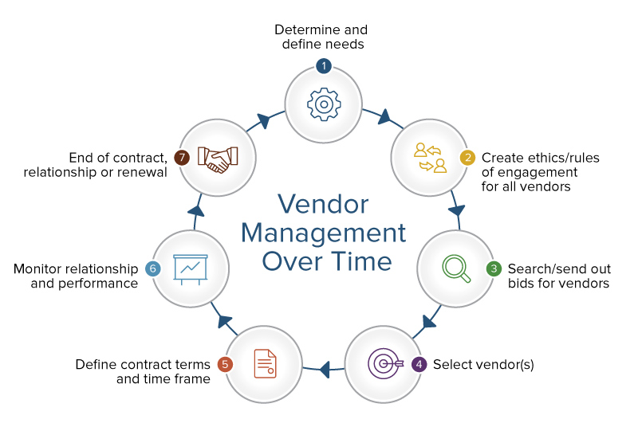
Determine and define needs; it’s important to understand who or what a vendor is in the context of business projects and goals. Vendors can provide a small, one-time need for a single project, or can be an ongoing business partner over various projects. Quantity and quality of product needs to be decided to enable the vendors the correct information to be able to tender for the contract.

Create ethics of engagement; This refers to how, when , where ,what and who needs to be included in any correspondence. It outlines the procedures required for any communications from the prospective vendors.

Search/send out bids to vendors ; Once all specifications have been agreed, the bid can be sent out to prospective vendors. This could be a selective group, ( as in vendors that have been specially selected due to past experience or knowledge of the project) or can be put out into the public domain to allow all vendors to see the specification and bid for the vendor contract.

Select vendor; Once all bids have been received , a vendor will then be chosen. This will be decided due to price, quality, timing etc

Define contract and timeframe; The finer details will be decided with the winning vendor, this will include payment plan, targets required from the vendor to be met, a time frame for when materials etc are to be delivered

Monitor relationship and performance; it is essential to keep a record of how the vendor is performing. If they are not keeping to the contract agreements, the project may suffer. In the contract there should be an item which relates to this, meaning a fine or cancelation of the contract may be implicated if the contract agreement is not meant.

End of contract, Once the project is completed , the vendor contract will be looked at and assessed to make sure that it has been a success. If it has then there will be a possibility for the company to be considered for future contracts.

ii. Micro and macro levels of identifying the source are important to ensure the correct vendor is selected. Macro level means looking at the bigger picture of what is to be ordered. Can the product be sourced nationally or will it need to be sourced internationally using a single source, Knowing this means procurement times can be adjusted to suit. Identifying alternative suppliers to enable stock to be order if the original vendor fails to deliver. Assessing if there are any likely events that could affect the vendor in the years ahead( shortage of materials, environmental law changes etc which could affect the running of their business). Will the be any likely price changes which could affect manufacturing costs.
Micro Points refers to the smaller details required to be able to assess which vendor is the best for the job. This can include obtaining past records of the supplier, this will show the history of contracts they have worked on and how reliable etc they have been. Looking at the financial stability of the vendor ( from balance sheets etc) Records on delivery lead times and delays to assess the vendors reliability. The suppliers capacity to accommodate emergency orders, as we know, the project will not always run smoothly and materials may need to be purchased quickly.

iii. Once a vendor has applied for the contract, they will all be rated to see which supplier is suitable. Normally a points system will be added and the vendor with the highest score should win the contract. The vendor will be assessed on some of the following items, has the vendor agreed to specification in full, does the company have a good quality control system, is their system up to date ( to ensure stock is always knows) does the supplier sell reputable brands, has there been a trend in rejection for other contracts, how effective is their delivery system……
Once all companies have been rated using the same system, a final supplier will be selected. The chosen vendor will be the one that supplies quality materials and the best price and is able to fulfill all their obligations ( deliveries etc)

iv. ISO 9000 is defined as a set of international standards on quality management and quality assurance developed to help companies effectively document the quality system elements needed to maintain an efficient quality system. They are not specific to any one industry and can be applied to organizations of any size. It ensures that the listed company achieve all standards with exception. ISO 9000 can help a company satisfy its customers, meet regulatory requirements, and achieve continual improvement. It should be considered to be a first step or the base level of a quality system. Companies need to code all items they stock for a number of reasons including :to make it easier for the items to be identified; reduction in lead time; promotes orderly arrangement on similar items

v. Those in charge of the stores need to be aware of the legal aspects of purchasing and storing materials to ensure everything is done correctly and safely. Purchasing certain items require being a licensed company to ensure that the materials are only used by qualified/competent people. Certain materials need to be stored correctly ( gases, fuel, paints etc need to be stored in a well ventilated storage area/ away from naked flames etc). The more people that know the rules and regulations for purchasing and storing materials, the more likely it is that the materials will be kept in good order.

2. The learning curve is a diagram showing the time spent on a task in relation to how many times the task has been carried out. The time spent on the task should shorten as the number of times the task is carried out increases. This is due to the operative learning how to carry out certain elements of the task. The first time of attempting the job, a lot of time will be spent assessing what is needed and working out the best way to do it. After a number of attempts, the task will become like second nature .
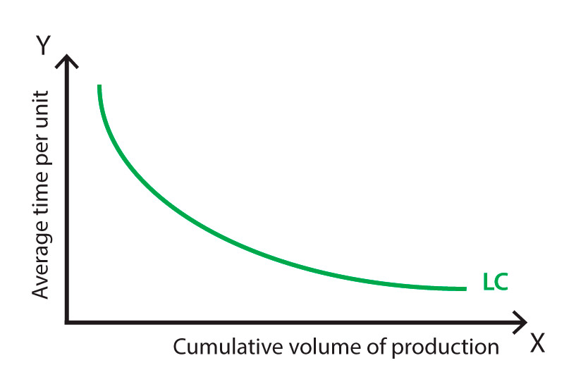
Another way of reducing the time per task is to supply various trainings to the operative. This could be manual handling to help them reduce the chance of injuries and improve the way items are moved, or training in using machinery to aid the task ( fork lift, abrasive wheel etc). It has been found that task specific training has the most influence in improving the learning curve. It may mean that time is taken out from the task at the beginning of the job due to the operative carrying out the training, but in the long run it reduces the time of the task due to it taking less time to complete each time.
.
Student Statement:

By submitting this assignment, I confirm that this is my own work.

Student Signature | Darren Holtom | Date | 18/6/19

For Tutor / Assessor Use Only
Total Marks
Marks Obtained
Percentage / Grade

