
Assignment Cover Sheet

Student Name: | FLORENCIA CALCAGNI
Student Number: | 3557
Course: | DIPLOMA IN BUSINESS ADMINISTRATION
Assignment NO: | 8

Marking Criteria:
We expect the learners to write minimum one well expressed point in three lines against each allocated mark. This means one needs to write 15 lines with 5 well expressed points to get high grades for a 5 marks question.
For high grades use examples and illustrations where appropriate.
Florencia Calcagni
Student #3557
Assessment #8
Page 1

Team Management

Assessment 8 Total Marks: 30
1. Give short answers to the following questions: (15)
i. What is the difference between a group and a team?
The words such as group and team can be used interchangeably. Modern managers sometimes use the word teams to the point that it has become a cliché; they talk about teams while sceptics perceive no real teamwork.
Thus, making a distinction between groups and teams can be useful. A working group is a collection of people who work in the same area or have been drawn together to undertake a task but do not necessarily come together as a unit and achieve significant performance improvements.

Florencia Calcagni
Student #3557
Assessment #8
Page 2

A real team is formed of people with complementary skills who trust one another and are committed to a common purpose, performance goals, and approach for which they hold themselves mutually accountable.
Organizations have been using groups for a long time, but today’s workplaces are different. Teams are used in many different ways than in the past. Ideally, people are far more involved in team building.
Most employees are well trained to do team work. Hence, cooperation is higher, and the culture of learning has improved today.
ii. What is meant by the term “Team Management”?
Team management is the ability of an individual or an organisation to administer and coordinate a group of individuals to perform a task. Team management involves teamwork, communication, objective setting and performance appraisals.
Moreover, team management is the capability to identify problems and resolve conflicts within a team.
It is necessary to hire an individual who would overlook the activities of the team as a whole as well as the performance of the individuals within the team. This is known as team management.
iii. Describe the role of a team manager.
Leadership is about managing change through the use of power to get people to work together for their benefit and for those of their clients. In team leadership all the processes that are key for team membership apply but with additional standards of excellence. As well as managing the team, the leader needs to be able to have client focus and a sense of strategic clarity, i.e. knowing what the team’s role is with the rest of the organisation.
A team manager will provide direction, instructions, and guidance. An effective leader will know the team members’ strengths, weaknesses and motivations.
The manager often works within the team, as a member, carrying out the same roles but with additional “leader” responsibilities.

Florencia Calcagni
Student #3557
Assessment #8
Page 3

In order for a team to function successfully, the team manager must also motivate the team to use their knowledge and skills to achieve shared goals. When a manager motivates a team, group members can function in a goal oriented manner.
Team managers utilise their expertise, their peers, influence and/or creativeness to formulate an effective team.
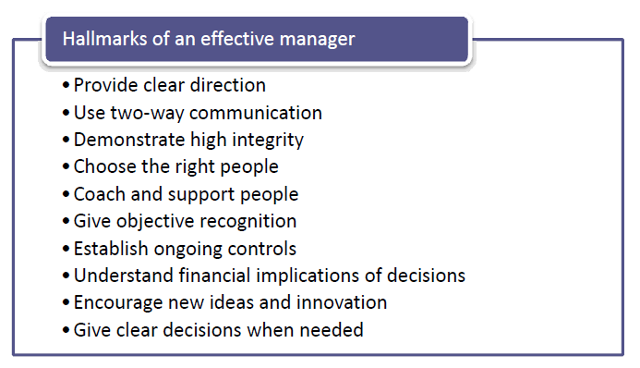
iv. What are the five stages of team development according to Bruce Tuckman?
The five stages of team development (B. Tuckman) are:
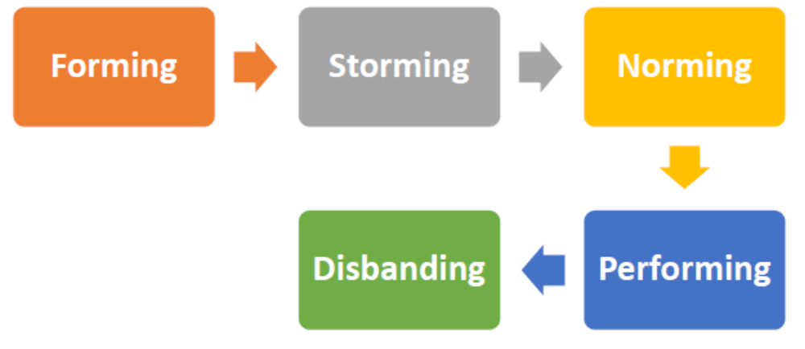

Florencia Calcagni
Student #3557
Assessment #8
Page 4

- Forming: This is the first stage. In this stage, the members of the team are only acquainted with the team leader and in most cases only prefer speaking to him and not to the other members.
In this stage the relationship is filled with distrust and uncertainty as the members are not properly acquainted with the others. As per Bruce Tuckman, a team can get stuck in this stage and create problems in the future stages of development.
It is the job of the team leader to create a comfortable environment between the members so they can learn to trust each other and work to produce the results.
- Storming: Storming means two things – the storming of ideas or the storming of the members of the team due to their tempers. This is a simple way to put it. Such things do not actually occur in the overly friendly settings of the business organization.
Storming is the second stage of the development model. In this stage the team members begin to wonder if they can actually work together to produce results.
It is natural that some of the team members would disagree with the others and there would be conflicts in the ideas and suggested approaches. Stage is marked, therefore, with conflicts and debates. In this stage the team tries to sort out their differences with the leadership of the team manager.
- Norming: Norming is the third stage in this model by Bruce Tucker. In this stage, the team starts to put aside their differences from the storming stage and then creates norms for working and codes of conduct and procedure.
It starts planning for ways to implement the decisions and creates programmes and makes plans and strategies to achieve their objective.
They start to view the team as a team, and put aside their own personal gains and interests to attain the goal at hand.
- Performing: If all the above stages are executed properly, it makes way for this fourth stage which is the performance stage. As per Bruce Tucker, the members of the team are now more comfortable in their interactions with

Florencia Calcagni
Student #3557
Assessment #8
Page 5

each other. They have formed the strategies, now they must employ them to achieve their ends.
In this atmosphere, it is easier for the team to perform together, make decisions, take risks, and work to eliminate any problems or barriers along the way. They aim to finally deliver on the objective and work in a positive and harmonious environment.
- Disbanding: The team is created for a temporary period, therefore after it has accomplished its goal and achieved success, it can be disbanded, or split up.
Even if the team works together to create a major landmark, it would still be disbanded. The members might again be put through this process in a new team for the accomplishment of a new objective. It becomes the job of the team leader to safely navigate his team through these stages. The success of the team leader depends upon the success of his team.
If the team manages to accomplish its goal without too many hesitations, it is a clear indication of the skill of the team leader and the quality of management. A team is firstly formed by analysing the personalities of each team member as per the requirements. A team leader or project manager first decides the number of members required and then the skills that the members must possess and chooses the available employees for a group of members who he thinks can cohabit well together.
v. Outline the factors contributing to the successful development and performance of a team.
In order to function properly, any team requires a certain level of trust and respect amongst its members.
A good team creates an environment at work that is fun to enter and one that every employee embraces.
It motivates all the members of the team to contribute to the goal at hand and the cheerful relationship between the members creates a feeling of family.

Florencia Calcagni
Student #3557
Assessment #8
Page 6

On the other hand, if a team constantly has its members at cross ends, fighting and struggling to gain superiority over the other, then the atmosphere will be that of ill will. There would be distrust amongst the members.
They would be constantly competing and trying to top the other, sacrificing the quality of the work due to their petty issues. It is the job of a team manager to resolve these issues and to create a harmonious working environment.
A good environment within the team can help the members of the team achieve more goals. In the process, one can learn more and create friendships through the organization which would increase their morale. As they make friends, they would feel comfortable among the other members of the team to be themselves and thus enjoy their work.
As a part of a team, if any mistakes occur, they would feel safer and through the accomplishments they earn the profits and share them together.
As a member of a team, each member also gets a chance to project their skills as a leader when it comes to handling certain jobs or fulfilling some particular objectives.
This creates a team spirit that is welcoming and reduces stress between the members of the team.
- be interested in others, ask questions, listen, acknowledge
- give compliments, praise
- clarify what you want from the relationship, what the issues are
- learn practical skills, dealing, show affection
- use positive body language, facial signals, voice, to show liking
- be open, use self-disclosure, trust and confide in others
- always consult before deciding
Key Skills
- Listening: Listen actively and with empathy to the other person's feelings and take the cause of those feelings seriously. It is not easy and cannot be done successfully without empathy.

Florencia Calcagni
Student #3557
Assessment #8
Page 7

Winning yourself a hearing by describing and explaining your own feelings will help in getting others to listen to you. The route to success is to avoid being aggressive, judgmental, appeasing or sarcastic but to concentrate on an assertive approach which clearly and firmly states your feeling. It is a powerful technique in its own right, but when used together with active listening it forms an even more persuasive combination.
- Work to a Joint Solution: Three clear stages should be apparent. First, make other people feel that you understand their point of view. Second, make sure they understand your point of view. Finally, come to an agreement. The key to reaching agreement is an open mind and mutual respect. Without mutual respect and understanding one or both parties are likely to be on the defensive.
Problem Solving skills are essential in persuasion. With the effective use of power, influence over key issues can be substantially increased.
vi. Explain the nature and importance of team work for an organization.
“Coming together is a beginning. Keeping together is progress. Working together is success”.
Henry Ford
Every employee is dependent on his fellow employees to work together and contribute efficiently to the organisation. No employee can work alone; he has to take the help of his colleagues to accomplish the tasks efficiently.
It has been observed that the outcome comes out to be far better when employees work in a team rather that individually as every individual can contribute in his best possible way.
Team work is essential in corporates for better output and a better bonding among employees.
- No organization runs for charity. Targets must be met and revenues have to be generated. Tasks must not be kept pending for a long time and ought to be completed within the desired timeframe. A single brain can’t always come
Florencia Calcagni
Student #3557
Assessment #8
Page 8

with solutions or take decisions alone. He needs someone with whom he can discuss his ideas. In a team, every team member has an equal contribution and each team member comes out with a solution best suited to the problem. All the alternatives can be explored to come out with the best possible solution. Thoughts can be discussed among the team members and the pros and cons can be evaluated.
- Tasks are accomplished at a faster pace when it is done by a team rather than an individual. An individual will definitely take more time to perform if he is single handedly responsible for everything. When employees work together, they start helping each other and responsibilities are shared and thus it reduces the work load and work pressure. Every team member is assigned one or the other responsibility according to his specialization, level of interest and thus the output is much more efficient and faster.
- Work never suffers or takes a backseat in a team. Mike was taking care of an important client and was the only one coordinating with them. Mike took a long leave and there was no one else who could handle the client in his absence. When he joined back after a long vacation, the organization had already lost the client. Had Mike worked in a team, others could have taken the charge when he was not there. In a team, the other team members can perform and manage the work in the absence of any member and hence work is not affected much.
- There is always a healthy competition among the team members. Competition is always good for the employee as well as the organization as every individual feels motivated to perform better than his other team member and in a way contributing to his team and the organization.
Team work is also important to improve the relations among the employees. Individuals work in close coordination with each other and thus come to know each other better. Team work also reduces the chances of unnecessary conflicts among

Florencia Calcagni
Student #3557
Assessment #8
Page 9

the employees and every individual tries his level best to support his team member. The level of bonding increases as a result of team work.
- Team members can also gain from each other. Every individual is different and has some qualities. One can always benefit something or the other from his team members which would help him in the long run. Everyone is hungry for recognitions and praises. One feels motivated to work hard in a team and to live up to the expectations of the other members. Each member is a critic of the other and can correct him whenever the other person is wrong. One always has someone to fall back on at the time of crisis.
Team and team work must be encouraged at workplace as it strengthens the bond among the employees and the targets can be met at a faster pace. Workload is shared and individuals feel motivated to perform better than his team members. (Source: managementstudyguide.com)
2. “A good environment within the team can help the team members to achieve their set goals.” Discuss (7)
Aside from the job scope itself, one factor that significantly influences how employees feel about work is the environment.
A positive work environment makes employees feel good about coming to work, and this provides the motivation to sustain them throughout the day.
Some of the key elements of this environment are:
1. Transparent & Open Communication: In essence, a transparent and open form of communication addresses the employee’s need to feel that what they have to say has value. It is what makes employees feel that they belong in the organization. Work then becomes meaningful because the employees know that what they contribute affects the organization that they are affiliated with.
It is thus essential for staff to discuss the organization’s philosophy, mission and values, from time to time during retreats, meetings, etc. to ensure that everyone knows what they’re working for other than their pay checks. Having open discussions get people involved and allow them to share their views and
Florencia Calcagni
Student #3557
Assessment #8
Page 10

perspectives on how to achieve company goals. After which, the management side will give their own perspectives on how to fulfil the organization’s mission.
Such two-way open communication will eventually break down the hurdles present in hierarchical or bureaucratic organizations. At the end of it all, it promotes trust in day-to-day interactions between co-workers, as well as between subordinates and supervisors.
Everyone becomes more united with the organization’s mission in their mind. There is mutual respect among all employees, regardless of their official statuses.
This is when employees will not be afraid to suggest ideas to improve the work processes, thus benefiting everyone in the organization in return.
2. Work-Life Balance: There has to be some sort of balance between work and personal life. In general, having that sense of balance will improve job satisfaction among employees because they will feel that they’re not overlooking the other areas of their lives that are, if not more, important to them than work.
When employees fulfil their various needs and goals in life, such as those of family, friends, spiritual pursuits, self-growth, etc., they can then feel more confident about themselves and perform their best at work. Apart from that, employees that are exposed to more experiences in life outside of work can use what they’ve gained and apply that to their work.
In other words, work-life balance can promote creativity and out-of-the-box thinking.
‘Good’ employees or workers are often defined as those who put in loads of effort and sacrificed their personal time in order to perform well in their work. Some employees are simply workaholics who would rather neglect other aspects of their life for work.
Managers have a responsibility to show that this is not right, by rewarding employees who maintain good work-life balance habits (e.g. leave work on time) and can still perform well.

Florencia Calcagni
Student #3557
Assessment #8
Page 11

In this case, the organization may adopt a firm stance on work-life balance by educating employees on the benefits of having such balance in their lives or even include it under their mission statement.
3. Training & Development-Focused: In a time when change is more rampant than ever before, it is necessary for organizations to be keep abreast with the changes and train their employees accordingly. For instance, technology is evolving so rapidly that what organizations commonly used ten years ago could be made obsolete today (e.g. zip drives, dial-up modems, etc.).
Adapting to change is never more crucial in this era because those who don’t, get replaced. This applies to both the individual and the organization itself.
A training and development-focused organization has a clear roadmap for training their employees to sustain and enhance the productivity of the organization as a whole. Essentially speaking, there are two kinds of skills that can be developed: hard skills and soft skills.
- Hard skills: impact work productivity directly e.g. knowledge of a new database management system
- Soft skills: interpersonal skills which could affect the morale of the organization.
A positive work environment would have routine trainings to improve efficiency and instill positive attitudes among employees.
4. Recognition for Hard Work: Rewards are necessary to encourage certain behaviours in persons. This is known as positive reinforcement under operant conditioning in the field of psychology. It is used in organizational behaviour management as well: by rewarding employees who put in effort for their work, this will promote similar behaviours in the future.
A reward here doesn’t have to be monetary in nature; sometimes even a simple verbal recognition by the supervisor is all that is necessary to spur the employees’ motivation.

Florencia Calcagni
Student #3557
Assessment #8
Page 12

When hard work is appropriately rewarded and duly recognized by the management, employees will naturally feel valued by the organization for what they put in. Such mentality is healthy for the organization because employees will be willing to go the extra mile without worrying about not getting anything in return.
Apart from having a system of monetary rewards in place to award those who perform at work, daily interactions can also be a good means of recognizing efforts. Managers ought to verbalize their appreciations for simple little things when employees go the extra mile. However, these should be made specific and personal for the employee to feel that what they do are being taken seriously and appreciated.
5. Strong Team Spirit: As social beings, we naturally seek support from our peers and seek to belong to a group. Come tough times, the team should come together to deal with whatever problems are out there. This is where a sense of unity is evoked in the team and employees will no longer just feel that they’re working for themselves. They are now working towards something bigger than themselves, and as a team.
Instilling a strong team spirit is not easy because it involves the acceptance and tolerance of differences in perspectives and working styles between teammates. There is a need for them to see that they’re working towards a common goal before they can look beyond the differences.
Other ways of promoting a good environment could be:
- Having team-bonding activities that let the team focus on the positive sides of each member and negate the negative ones.
- Celebrate events like birthdays for each member of the team to show the exclusivity.
- Deal with issues together. Basically, whatever it is that you do, do it as a team.
One pitfall to look out for when team spirit is high is the groupthink phenomenon. This psychological phenomenon occurs when the group cohesiveness gets so strong that judgments or decision-making get clouded. (Source: hongkiat.com)
Florencia Calcagni
Student #3557
Assessment #8
Page 13

Case Study (8)
Byron is a bakery manager and manages a team of 17 in a super store bakery. One of the key challenges of Byron’s job is to ensure his team produces the right products to meet demand at key times. His usual management approach is to allow the team to take responsibility for achieving the desired result. In this way, the team not only buys into the activity, but also develops new skills. For example, when the bakery expanded its product range and Byron needed to ensure that all the products would be on the shelves by 8.00 am, rather than enforce a solution, he turned to the team for ideas. The team solved the problem by agreeing to split break times so that productivity could be maintained. Byron’s approach produced a positive outcome and increased team motivation.
The super stores’ leadership framework sets out not just the skills and competencies but also the personal characteristics and behaviours it expects of its leaders. The store looks for managers who are positive, confident and genuine, with the capacity to inspire and encourage their teams. A key part of stores’ programme for building leaders is encouraging self-review and reflection. This allows staff to assess their strengths and find ways of demonstrating the characteristics that are vital to the long-term development of the business.
i. Is Byron’s team motivated? If so, which approach he used to keep their motivation up?
ii. Is Byron a successful team leader in your view? If so, which types of special leadership qualities he possess? And how do these qualities help him?

- I believe Byron’s team is highly motivated. The approach used to keep his team motivation up is the Behavioural one. In this approach, managers get things done by working with people. They motivate, lead, build trust, and manage conflict.

Florencia Calcagni
Student #3557
Assessment #8
Page 14

This theory moved management from a production orientation (classical leadership theory) to a leadership style focused on workers’ human need for work-related satisfaction and good working conditions.
This approach relies in the notion that managers will better understand the human aspect of workers and treat employees as important assets to achieve goals. Management takes a special interest in workers and makes them feel part of a special group.
Management spends time, expresses interest in workers' personal well-being, and rewards them for a job well done. In this way, workers feel motivation to work harder. In fact, behaviour towards work is positive.
Behaviour is defined as the way a person conducts themselves towards others. When workers are treated as humans rather than machines, they respond to their particular work situation in a positive way - by increasing individual productivity.
Motivation is the internal process that directs enduring behaviour. It comes from many factors:
- Position in the company
- Pay and stability
- Benefits
- Incentives and rewards
- Interesting work assignments
- Common beliefs and values
- Etc.
This theory discovered that people work for inner satisfaction and not materialistic rewards, shifting the focus to the role of individuals in an organization's performance.
Having said this, we can affirm that Byron has managed to get very positive outcomes from his team. Not only in terms of productivity, but also in teamwork spirit.
- Byron motivates, leads, builds trust and knows how to manage conflict. These qualities have helped him improve the work environment, his team’s motivation, his staff wellbeing and the store’s productivity as well. Since this
Florencia Calcagni
Student #3557
Assessment #8
Page 15

is a direct consequence of the improvement in all the factors mentioned before.
By following this approach, Byron has help his team develop their self-fulfilment, autonomy and empowerment, improve personal relationships among co-workers. Unity is another direct consequence of this method, which encourages the team to improve and be more productive.

Student Statement:

By submitting this assignment, I confirm that this is my own work.

Student Signature | FLORENCIA CALCAGNI | Date | 06/08/2017

For Tutor / Assessor Use Only
Total Marks
Marks Obtained
Percentage / Grade

