
Assignment Cover Sheet

Student Name: | Ana Marie Buison
Student Number: | 10242
Course: | Diploma in Logistics & Supply Chain Managment
Assignment NO: | 1

Marking Criteria:
We expect the learners to write minimum one well expressed point in three lines against each allocated mark. This means one needs to write 15 lines with 5 well expressed points to get high grades for a 5 marks question.
For high grades use examples and illustrations where appropriate.
1. Give short answers for the following questions.
i. Outline the main benefits of a supply chain.
= it is the flow of goods and services which an integral part of most businesses and essential to company success and customer satisfaction.

ii. Companies in any supply chain can make their decisions individually and collectively in five areas. What are these areas?
= Production
=Inventory
=Location
=Transportation
=Information
iii. How is a modern supply chain different from that of the past?
= Modern supply chain it’s a distribution based on proper feedback methods and accurate customer demands which more progressive than the past.
iv. What is Inventory Management?
= it’s about minimizing the total cost of inventory while maximizing the ability to provide customers with product in a timely manner which the finish goods / stock of raw materials.

v. ‘Information’ is one of the five drivers of supply chain. Discuss the purpose of
Information in a supply chain.
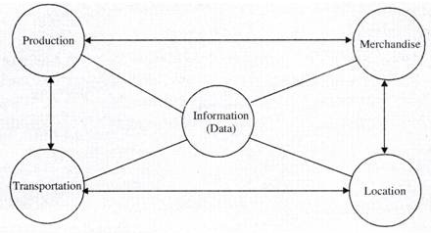
= Information it’s related to the need and wants of customers, a way of exchanging information such as forecasting data, inventory levels, more orders quickly, customer service and improve forecast accuracy, transportation, funds and facilities.
vi. Name various types of inventory
=cycle inventory
=safety inventory
=seasonal inventory

2. “Location decisions have strong impacts on the cost and performance characteristics of asupply chain.” Discuss
= where to locate such facilities mainly factory, warehouse, storage and it’s consists of decisions that are related to the activities that should be carried out in every facility.

3. Write short notes on the following participants of supply chain: (5)
a. Producers = Make
b. Distributers = Move
c. Retailers = Sell

Case Study (8)
PE Dairies gives a home delivery service for milk, dairy products, and a range of related goods. Simon Hull has run the dairy for the past 10 years. His product is a combination of goods (the items he delivers) and services (the delivery and associated jobs he does for customers). There are several specific problems facing PE Dairies. There is, for example, some variation in daily demand, so Simon has to carry spare stock. He cannot carry too much, as dairy products have a short life and anything not delivered quickly is thrown away. Simon aims at keeping this waste down to two percent of sales. There are also problems maintaining a service during holidays or when PE has difficulties with their deliveries. Perhaps Simon’s main concern is maintaining his sales over the long-term. Demand for doorstep deliveries is declining, as people buy more milk at supermarkets. The number of milkmen in his area has declined from ten in 1990 to three in 2007. Most of Simon’s customers have been with him for many years, but he generates new custom by canvassing, delivering leaflets, special offers, and a variety of other products, etc.
• Describe the supply chain for milk.
= The situation caused that supply chain to be inefficient and unresponsive to customer needs.
• Where does PE Dairies fit into this? What specific activities form the logistics in PE Dairies?
= this is old supply chain consider as individual company.
• What are the main problems that PE Dairies has with logistics?
= lack of inventory
= lack of location
= lack of transportation
= lack of information

Student Statement:

By submitting this assignment, I confirm that this is my own work.

Student Signature | 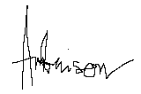 | Date | 14th Aug 2017

For Tutor / Assessor Use Only
Total Marks
Marks Obtained
Percentage / Grade

