
Assignment Cover Sheet

Student Name: | Maria Areias da Silva
Student Number: | 10035
Course: | Diploma in Environmental Management (level 4)
Assignment NO: | 2

Marking Criteria:
We expect the learners to write minimum one well expressed point in three lines against each allocated mark. This means one needs to write 15 lines with 5 well expressed points to get high grades for a 5 marks question.
For high grades use examples and illustrations where appropriate.
Q: 1: Give short answers to the following questions:

1.I. What is Ozone Layer?
The Ozone Layer is a belt encircling the Earth in lower stratosphere that contains high concentrations of ozone in relation to other parts of the atmosphere, although its thickness varies seasonally and geographically.
Ozone is a molecule containing three oxygen atoms. It usually forms when some type of radiation or electrical discharge separates the two atoms in an oxygen molecule (O₂), which can then individually recombine with other oxygen molecules to form ozone (O₃).
The ozone layer acts as a filter that absorbs 97 to 99 percent of the Sun’s medium-frequency ultraviolet light, which otherwise would potentially damage exposed life forms near the surface (Figure 1).
Since the 70’s it has been observed that the total ozone volume has been decreased in the stratosphere and that in the Polar Regions that depletion is even higher (called the Ozone Hole). This can severely affect the life on earth.
It was found that the major cause for that depletion is anthropogenic, related to the released of gaseous compounds that contain carbon, chlorine, fluorine, and sometimes hydrogen named chlorofluorocarbons (CFCs and HCFCs), halons and methyl bromide, to the atmosphere. When CFCs reach the upper atmosphere, they are exposed to ultraviolet rays, which cause them to break down. The chlorine atoms react with the oxygen atoms in ozone and rip apart the ozone molecule.
These substances are used in the manufacture of plastic foams, refrigerators, cleaning solvents, aerosol propellants, pesticides and fire extinguishers, etc.

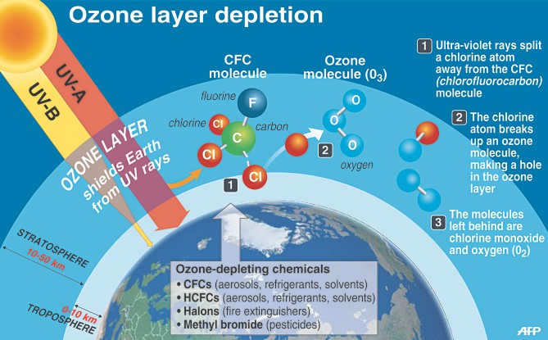
Figure 1 – UV Protection from the Ozone Layer.

1.II. Outline the effects of Ozone layer depletion on the health of humans and animals
Reduced ozone levels as a result of ozone depletion mean less protection from the sun’s rays and more exposure to UVB radiation at the earth surface. The harmful effects of UV-radiation on live organisms constitute a danger to the health of the whole human population [1]. The adverse effects of UV radiation are primarily on the eye and the skin, namely:
- For the skin, the most common harmful outcome is skin cancer, including melanoma and the non-melanoma skin cancers, basal cell carcinoma and squamous cell carcinoma [2], sunburns and premature ageing of the skin.
- UV radiation can damage several parts of the eye, including the lens, cornea, retina and conjunctiva, A strong cataractogenic effect of UV radiation has been evidenced [1] and also effects on ocular melanoma and macular degeneration [2].
- It is also known that the increase of UV radiation may be capable of activating viruses and reduce immunological response [1], weakening the human immune system (immunosuppression).
UV rays affect other animals too and also have an adverse effect on the marine ecosystem. It adversely affects the development and mobility of phytoplankton, and naturally, the fish that feed on them and all the related chain food. It adversely affects the different species of amphibians and is one of the prime reasons for the declining numbers of the amphibian species. UV radiation is also known to have affected the development stages of fish, shrimp, crab and other animals. When this happens, animals in the upper food chain that feed on these tiny fishes are all affected.

III. What is global warming? How can it affect agriculture output?

"Global Warming" refers to the increase in global average temperature due to excessive amounts of greenhouse gases. The most abundant greenhouse gases responsible for the greenhouse effect in the atmosphere are water vapor, carbon dioxide, methane, nitrous oxide, and ozone. There is a scientific consensus on the reality of anthropogenic climate change [4]. Most of the scientific researchers consider that greenhouse gas emissions from human activity and livestock are a significant driver of climate change, trapping heat in the earth's atmosphere and triggering global warming [6]. The main man-made production of greenhouse gases results from 1) combustion of fossil fuels in cars, factories and electricity production; 2) methane released from landfills and agriculture (especially from the digestive systems of grazing animals); 3) nitrous oxide from fertilizers; 4) gases used for refrigeration and industrial processes, and 5) the loss of forests that would otherwise store CO₂.
Current levels of greenhouse gas concentrations have led to an increase in average global temperature of 0.75°C since the mid-twentieth century, and because of the lag between an increase in concentrations and the trapping of heat, the planet is due for an equal amount of temperature increase by 2100, even if greenhouse gas emissions were to cease immediately [5] (Figures 2 and 3).
Some scientists believe that climate change will lead to more extreme weather events. Extreme weather events include heat waves, droughts, strong winds, and heavy rains [2]. In response to global warming, the hydrological cycle is expected to accelerate as rising temperatures increase the rate of evaporation from land and sea. Thus rainfall is predicted to rise in the tropics and in higher latitudes but decreases in the already dry semi-arid to arid mid-latitudes and in the interior of large continents. Water-scarce areas of the world will generally become drier and hotter. Both rainfall and temperatures are predicted to become more variable, with a consequent higher incidence of droughts and floods, sometimes in the same place [4].
The food and agricultural sectors are facing great challenges in adapting to climate change. Climate change is already affecting the food and agriculture sectors, and these effects are projected to grow, along with global average temperatures. While some positive effects of climate change are foreseen in certain contexts, for example in some parts of countries in northern latitudes, the majority of anticipated climate impacts give cause for serious concern [5]. Climate change has both direct and indirect effects on agricultural productivity, namely [2,4,5]:
- May impact the water availability and water needs for agriculture;
- While crops are expected to respond to increased CO₂ with strong vegetative growth, other plants are also thought to respond in a similar fashion. Weeds have become more prolific and are expected to invade new habitats as global warming increases;
- It is expected that increased air temperatures will cause more stress on livestock.
- Insect pests, some of which carry plant diseases, could become more prolific and widespread as temperatures increase;
- Although forest ecosystems are inherently dynamic, the speed of predicted climate change is likely to far exceed the natural capacity of many forest species and ecosystems to adapt;
- The fate of pollinators with potentially devastating implications for systems reliant on pollinators those are unable to adapt to rising temperatures;
- Soils, the basis for plant growth, degrade and are lost at high rates as a consequence of climate change impacts on landscapes.
The climate change will have repercussion on the food availability, access, utilization and stability, directly affecting the nutrition of millions of people, mostly in the poor countries.
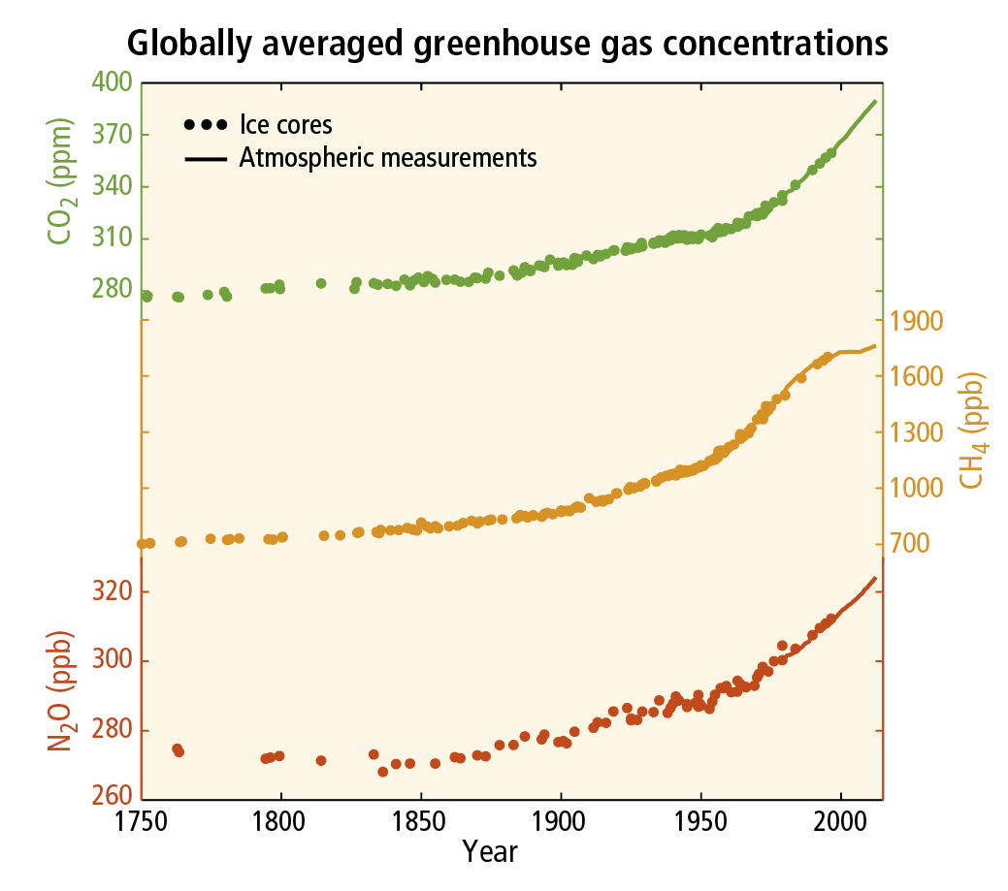
Figure 2 –Globally average greenhouse gas concentrations, from atmospheric measurements and Ice cores (Source: http://www.ipcc.ch).
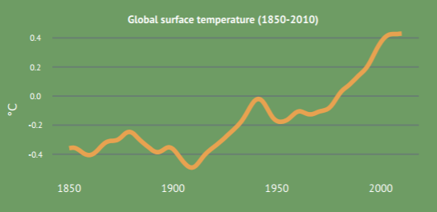
Figure 3 – Global Surface temperature from 1850 until 2010 (Source: www.fao.org/climatechange).

IV. What is meant by biodiversity?
Biodiversity refers to the variety of living beings present in an Ecological Systems. Each species has an important role in the function and preservation of the ecosystem. Various plant, animal and microorganisms depend on each other for what each offer and these diverse species ensure natural sustainability for all life forms. Biodiversity is unevenly distributed. It varies globally and within regions. For instance, ocean biodiversity is 25 times lesser than terrestrial diversity. Biodiversity also increases as it moves from the poles towards the tropics.
Biodiversity has three essential elements: i) genetic diversity, that is the total number of genetic characteristics in the genetic makeup of a specie; ii) Eco system diversity or the variation in the ecosystems found in a region or the variation in ecosystems over the whole planet and iii) species diversity that embodies the number of different species that are represented in a given community.

V. What is the link between biodiversity and climate change?
Many studies in recent years have investigated the effects of climate change on the future of biodiversity. Climate change affects biodiversity in many ways. Impacts on species include changes in distribution and abundance, the timing of seasonal events and habitat use and, as a consequence, there are likely to be changes in the composition of plant and animal communities. Climate change over the past ∼30 years has produced numerous shifts in the distributions and abundances of species and has been implicated in one species-level extinction. Considerable impacts on biodiversity are predicted for the next decades [7]. Using projections of species' distributions for future climate scenarios, was predict, on the basis of mid-range climate-warming scenarios for 2050, that 15–37% of species will be committed to extinction [9].

Q: 2: The fast growth of the human population and its distribution patterns have created environmental problems'. What are these?
The world population is growing by approximately 74 million people per year. The United Nations estimates that the world population will reach 9.2 billion by 2050. In the mind of many of us who are concerned about sustainable development, it’s obvious that as the world population continues to grow, the limits of essential global resources such as potable water, fertile land and forest devastation are becoming more apparent (Figure 4).
The impact of so many people on the planet has resulted in some scientists coining a new term to describe our time - the Anthropocene epoch, named for the dominant influence humans and their activities are having on the environment.
However, we know that is not only a question of population size but also the consumption patterns and distribution of people that directly affect the environment. On a global scale, not all humans are equally responsible for environmental harm. Consumption patterns and resource use are very high in some parts of the world, while in others - often in countries with far more people - they are low (Figure 5). For example, a person living in the USA has an ecological footprint almost 9 times larger than an Indian - so while the population of India far exceeds that of the United States, in terms of environmental damage, it is the American consumption of resources that is causing the higher level of damage to the planet.
The biggest problem in the future is that the people of the developing countries aim to have the same consumption level and living conditions as have the people in the developed countries. A legitimate aspiration that will lead to an unbearable level of demand for natural resources, pollution and emission of greenhouse gases. People need food, houses, transports, comfort and other considered basic needs in the occidental world.
Thus, how do we solve the delicate problem of population growth and environmental limitations? Laws, technology and education!
First, we low the population growth. How? Incentives for small families and contraception health education. As last resort, laws and health programs forcing the number of children reduction. Women education and empowering are very important for solving this global problem.
At the same time, we use improving technology and energy efficiency to reduce the environmental impact of production. Advances in food production technologies such as agriculture, water purification and genetic engineering may help to feed the masses while moving away from fossil fuels to renewable power sources such as wind and solar will go some way to reducing climate change. We need also laws that implementing the new green technologies. As an example, a recent UK journal announces that “China, the world’s biggest vehicle market, is considering a ban on the production and sale of fossil fuel cars in a major boost to the production of electric vehicles”; and they are followed by other countries. This is hope!
And finally, we educate people. We talk about environment and nature, and pollution and climate change… But how many of us are willing to lower the heat in our homes, to use public transport, to turn out the lights, to recycle, to reuse? Why do we think we can wear short sleeves in our homes in the winter when it's snowing outside?
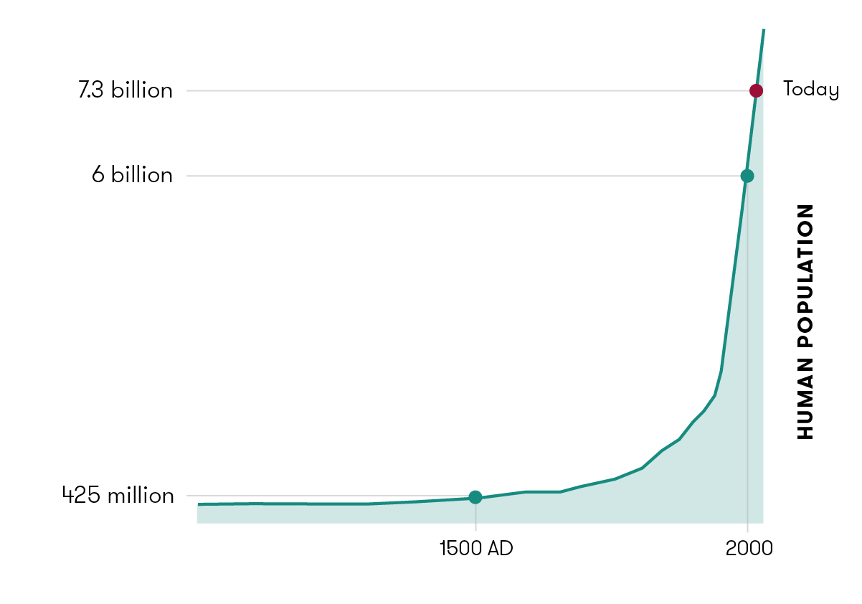
Figure 4 - Human population has seen exponential growth over the past few hundred years. Data source: Our World in Data.

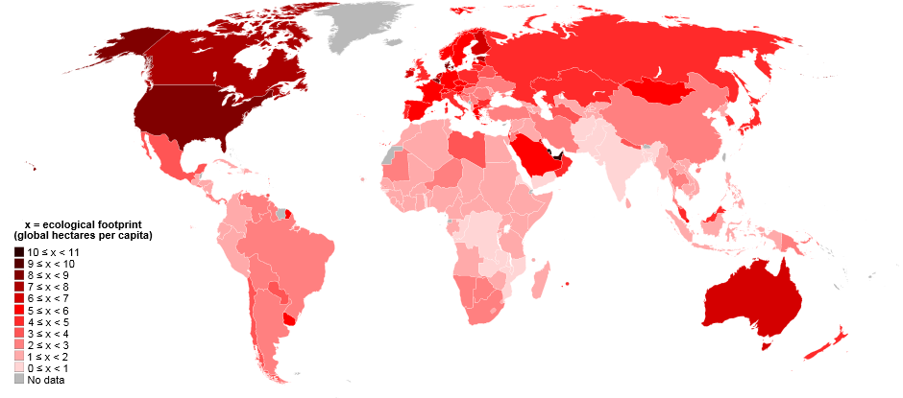
Figure 5 - World map of countries by ecological footprint (2007) Source: https://ipfs.io/ipns/QmdJiuMWp2FxyaerfLrtdLF6Nr1EWpL7dPAxA9oKSPYYgV/wiki/List_of_countries_by_ecological_footprint.html

Q:3: Outline the efforts that have been made to address the environmental problems at international level.
Great achievements always start with great challenges. The current state of our environment undoubtedly creates an urgent need for international solutions.
There are many international environmental conventions, treaties and protocols, which may be ratified by individual countries. All require international co-operation and action to address issues of both global and regional concern.
In general, Conventions provide the framework within which the more specific Protocols are built. Conventions outline intentions and set the limits of co-operation (which may be global), while the Protocols identify the actions to be taken and, where appropriate, the species, substances etc. to be controlled.
The first international Conventions were about the depletion of the Ozone Layer, aiming a global treaty to tackle ozone depletion; and established a framework for the adoption of measures to protect human health and the environment. Is the case of the Vienna Convention in 1985 and the Montreal Protocol on Substances that Deplete the Ozone Layer in 1987.
One of the most important international Conventions is related to gas emissions and climate changes. The United Nations Framework Convention on Climate Change (UNFCCC) is the main international agreement on climate action. To date, it has been ratified by 195 countries. It started as a way for countries to work together to limit global temperature increases and climate change and to cope with their impacts and sets as its ultimate objective the “stabilization of greenhouse gas concentrations in the atmosphere at a level that would prevent dangerous anthropogenic human-induced interference with the climate system”.
In the mid 1990s, the UNFCCC signatories realized that stronger provisions were needed to reduce emissions. The parties to the convention have met annually from 1995 in Conferences of the Parties (COP) to assess progress in dealing with climate change.
In 1997, they agreed the Kyoto Protocol, which introduced legally binding emission targets for developed countries to reduce their greenhouse gas emissions in the period 2008-2012.
The main weakness of the Kyoto Protocol is that it only requires developed countries to take action. As the United States has never signed up to the Kyoto Protocol, Canada pulled out before the end of the first commitment period and Russia, Japan and New Zealand are not taking part in the second commitment period, it also only applies to around 14% of the world's emissions.
On 12 December, the parties reached a new global agreement on climate change. The Paris climate conference took place in 2015. The agreement presents a balanced outcome with an action plan to limit global warming 'well below' 2°C. The Paris Agreement entered into force on November 4, 2016.
The work on implementation tools for the Paris Agreement continued at the COP23 conference in November 2018, in Bonn.
Biodiversity is a global concern as well. Several Conventions on Biodiversity, the conservation and sustainable use of natural resources took place since 1971, like the Ramsar Convention, focused in the Wetlands of International Importance especially as Waterfowl Habitat, and CITES in 1973, aiming the control of International Trade in Endangered Species of Wild Fauna and Flora and the Bonn Convention on the Conservation of Migratory Species of Wild Animals, in 1979. UN Convention on Biological Diversity, in 1992, recognizes that states have sovereign rights over their own biological resources, and has three main objectives: i) to conserve biodiversity; ii) to use biological resources sustainably, and iii) to ensure equitable distribution of the benefits of using genetic resources.
Land degradation is now accepted as a worldwide problem. Thus UN Convention to Combat Desertification (UNCCD) occurred in 1994. UNCCD is closely linked to poverty eradication, rural development and the management of natural resources. The UNCCD sets out to ameliorate the processes of desertification. A global mechanism based in Rome and linked to a variety of international organizations have been put in place to support the UNCCD.
The growth in world trade of chemicals led to increasing concerns about the risks of using them, both to humans and to the environment. The Basel Convention on the Control of Transboundary Movements of Hazardous Wastes and Their Disposal, adopted in 1989, aimed to provide policy guidance to governments, international organizations and NGOs involved in the risk assessment and environmentally sound management of chemicals. At the same time, the concern with chemical and organic pollutants lead to international conventions, aiming the regulation on production, use and trade of damaging substances and to phase in alternatives which do not share the same harmful characteristics (Rotterdam Convention, 1997 and Stockholm Convention, 2001).
Finally, UNECE Convention on Access to Information, Public Participation in Decision-Making and Access to Justice in Environmental Matters (the Aarhus Convention), adopted 1998, that recognises the public’s right to live in a healthy environment. It emphasizes two concepts: i) environmental rights as human rights; ii) the importance of three essential indicators of democracy: access to information, public, participation and access to justice for environmentally sound management
If international cooperation is possible, what are the keys to carry out such cooperation? International cooperation is likely to happen when countries are limited since (a) there tend to be other cooperation mechanisms, (b) the benefit of cooperation is clearer, and (c) it is easier to recognize each country’s efforts and it may be easier to carry out cooperation when countries have similar cultures or backgrounds [9]
Anyway, all the efforts are valuable, all the steps lead to a better word were the respect for the environment is no longer an exception but a concern to every single person in this overcrowded world.

References:
[1] Jankowski J, Cader AB (1994).The effect of depletion of the earth ozone layer on the human health condition.
[2] Norval M, Lucas RM, Cullen AP, de Gruijl FR, Longstreth J, Takizawa Y, van der Leun JC (2011). The human health effects of ozone depletion and interactions with climate change. Photochem Photobiol Sci.
[3] North Carolina State University - http://climate.ncsu.edu (10/2017).
[4]Food and Agriculture Organization of the United Nations - http://www.fao.org (10/2017)
[5] Manning M., Solomon S., Qin D., Marquis M., Averyt K., Tignor M., Miller H.L. & Chen Z. (eds) (2007). Climate change 2007: the physical science basis. Cambridge University Press, Cambridge.
[6] Naomi Oreskes (2004). The Scientific Consensus on Climate Change. Science, Vol 306, Issue 5702.
[7] Cryptic biodiversity loss linked to global climate change M. Bálint1,2, S. Domisch1,3, C. H. M. Engelhardt3 , P. Haase1,3, S. Lehrian3 , J. Sauer1 , K. Theissinger4,5 , S. U. Pauls1 * † and C. Nowak. Published online: 21 august 2011 | doi:10.1038/nclimate119.
[8] Chris D. Thomas, Alison Cameron, Rhys E. Green, Michel Bakkenes, Linda J. Beaumont, Yvonne C. Collingham, Barend F. N. Erasmus, Marinez Ferreira de Siqueira, Alan Grainger, Lee Hannah, Lesley Hughes, Brian Huntley, Albert S. van Jaarsveld, Guy F. Midgley, Lera Miles, Miguel A. Ortega-Huerta, A. Townsend Peterson, Oliver L. Phillips & Stephen E. Williams (2004). Nature volume 427, pages 145–148 doi:10.1038/nature02121
[9]Robert Falkner (2003). Private Environmental Governance and International Relations: Exploring the Links. Global Environmental Politics Volume 3, Issue 2 p.72-87

Student Statement:

By submitting this assignment, I confirm that this is my own work.

Student Signature |  | Date | 17.08.2017

For Tutor / Assessor Use Only
Total Marks
Marks Obtained
Percentage / Grade

ecological footprint would be the impact of human activities measured in terms of the area of biologically productive land and water required to produce the goods consumed and to assimilate the wastes generated.

