
Assignment Cover Sheet

Student Name: | Anita Lewandowska
Student Number: | 29040
Course: | Certificate in Beauty Therapy and Management Level 3
Assignment NO: | Assessment 2

Marking Criteria:
We expect the learners to write minimum one well expressed point in three lines against each allocated mark. This means one needs to write 15 lines with 5 well expressed points to get high grades for a 5 marks question.
For high grades use examples and illustrations where appropriate.

Student Statement:

By submitting this assignment, I confirm that this is my own work.

Student Signature | Anita Lewandowska | Date | 19/02/2019

For Tutor / Assessor Use Only
Total Marks
Marks Obtained
Percentage / Grade
Miss Anita Lewandowska
Student ID 29040
Assessment 2
Page 1

- Explain the different stages of the hair growth cycle?

Hair grows from the follicle, or root underneath the skin. The hair is fed by blood vessels at the base of the follicle, which gives it the nourishment it needs to grow. Between starting to grow and falling out years later, each hair passes through four stages, anagen, catagen, telogen and exogen. Every hair can be at a different stage of the growth cycle at any given time.

The hair cycle is made up of four stages:
- Anagen (growth) stage
- Catagen (transition) stage
- Telogen (resting) stage
- Exogen (new hair) stage

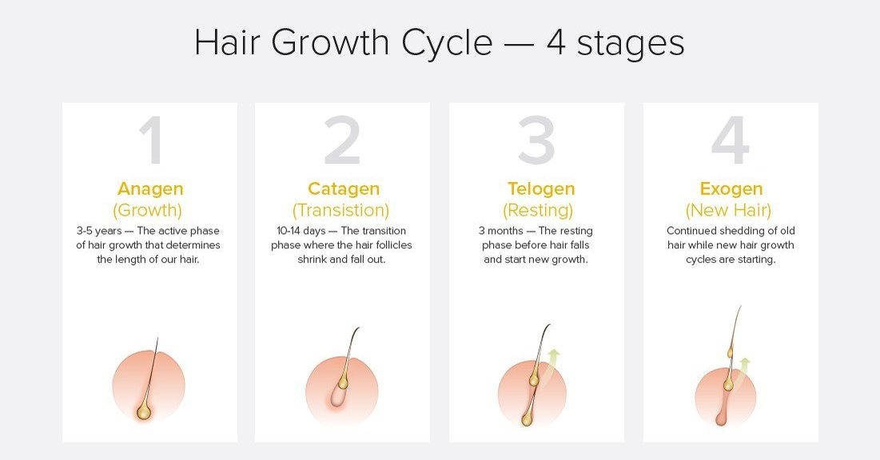

- Anagen (growth) stage
The anagen or growing stage is the first part of the hair growth cycle. During the anagen stage, cells of the bulb divide rapidly, resulting in new hair growth. Eighty to 90% of hair follicles are in the anagen stage at any given time. The anagen stage lasts somewhere between two and seven years. The length of the anagen stage determines the maximum hair length.
- Catagen (transition) stage
The catagen stage follows the anagen phase and is made up of a 2-3-week transitional period in which the hair is no longer growing. During this stage, a club hair is formed. A club hair occurs when the section of the hair follicle attaches to the hair shaft, cutting the follicle off from its blood supply and the cells that produce new hair. This club hair leads to the next stage of the hair growth and shedding cycle.
- Telogen (resting) stage
The telogen, or resting, phase follows the catagen phase. During the telogen phase, the club hair rests while a new hair begins to grow beneath it. This new hair will eventually take the place of the club hair. The telogen phase lasts for 3 months, and 10-15% of all hairs are in this phase at any one time.
- Exogen (new hair) stage
The exogen, or hair shedding, the phase is the last part of the hair cycle. During the exogen phase, the resting club hair detaches and falls out. After the exogen phase, the follicle then returns to the anagen phase and the cycle repeats.

- Briefly describe different functions which the skin performs in our body.

The skin is one of the largest organs in the human body., in surface area and weight. The skin consists of two layers: the epidermis and the dermis. Beneath the dermis lies hypodermis or subcutaneous fatty tissue.
The skin has functions:
- Protection
- Regulation
- Sensation
- Endocrine function
a) Protection: As the first line of defence against the external environment, the epidermis is continuously replenishing and shedding tens of thousands of dead cells every minute to protect the body from, mechanical impacts and pressure, variations in temperature, microorganisms, radiation and chemicals.
b) Terminal regulation- is aided by the skin through the sweat glands and blood vessels in the dermis. Increased evaporation of the secreted sweat decreases the body temperature. Vasodilation (relaxing of small blood vessels) in the dermis makes it easier for the body to release some heat and lower the body temperature through the skin. In vasoconstriction (contracting small blood vessels) the dermis retains some of the internal body temperatures. The fatty subcutaneous layer of the skin also acts as an insulation barrier, helping to prevent the loss of heat from the body and decreasing the effect of cold temperatures.
The skin regulates several aspects of phycology, including body temperatures via sweat and hair, and changes in peripheral circulation and fluid balance via sweat.
c) Sensation- an important function of the skin dermis is to detect the different sensations of heat, cold, pressure, contact and pain.
d) Endocrine function- skin is one of our main sources of vitamin D, through the production of Cholecalciferol D3 in two lowermost layers of the epidermis.

3. Referring to the nail structure, briefly describe the structure of the followings:
- Matrix
- Lanula
- The nail wall
- The Cuticle

NAIL STRUCTURE

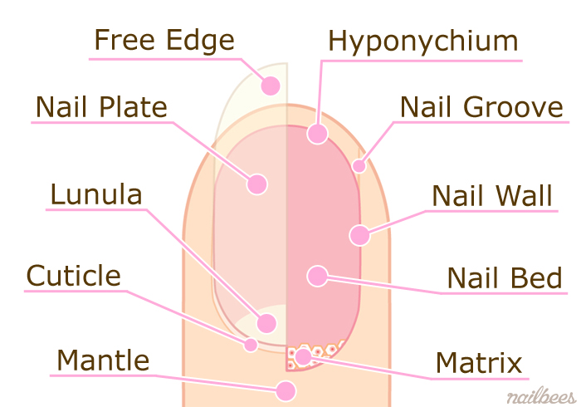

- The Matrix
This is where the nail is made. It is the only living part of the nail and contains nerves and blood vessels so that cell reproduction can occur. The nail is mainly composed of the hard nail plate arising from a matrix. The shape of the nail is very variable in different persons: it is roughly rectangular and flat in shape. The nail bed has a pink colour that can be seen because of the transparency of the plate and its extensive vascular network.
- Lanula
The half-moon shaped point where the matrix and nail be meet.
A whitish crescent-shaped lunula projecting from under the proximal nail folds is observed in the thumbs, uncommonly in the other fingers and in the large toenails. The lunula in the more distal portion of the matrix and determines the shape of the free edge of the nail plate. Its colour is due in part to the effect of light scattered by the nucleated cells of the matrix and in part to the thick layer of the epithelial cells making up the matrix.
- The nail walls
The skin on both sides of the nail plate. The nail walls are the folds of the skin overlapping the sides of the nails. When is good condition it is off and looses? Its function is to protect the matrix from infection.
- The Cuticle
The overlapping skin surrounding the nail. Its job is to protect the matrix from being invaded by bacteria and physical damage.
The cuticle is a layer of colourless skin that are constantly shed from the underside of the proximal nail fold and attaches to the nail surface as it grows out. To clarify, the true cuticle is dead skin clinging to the nail plate that acts as a plus to keep bacteria from finding its way underneath the living order of skin called the eponychium. Although some cuticle is necessary to keep the nail healthy, most of it can be safely removed during a manicure. The eponychium; must never be out.

- How does the message affect the blood flow?

Massage Therapy affects and benefits the whole body. The body system is groups of tissues and organs that work together to perform an important job for our bodies.
Circulatory massage id the most common healing method used for enhancing the proper flow of blood through the entire body and providing relaxation to the various muscles. This massage relaxes the tensed muscles in the body and relieves the stress from the body thus improving the overall health of the person. There isn’t only the blood circulatory system in the human body, but two, which are connected. The systemic circulation provides organs, tissues and cells with blood so that they get oxygen and other vital substances. The pulmonary circulation is where the fresh oxygen we breathe in enters the blood. At the same time, carbon dioxide is released from the blood.
The long- term effects of massage therapy are more than skin deep. Better blood circulation is part of the chain reaction that occurs in the body as a result of receiving massage therapy on a regular basis.
A person with poor circulation can suffer from a variety of discomforts including pooling of the fluid in the extremities, cold hands and feet, fatigue and achiness created by an accumulation of lactic acid in the muscles. Good circulation brings damaged, tense muscles the oxygen-rich blood they need to heal.
Improved blood circulation is just one more benefit of massage therapy. Combined with a balanced diet and regular exercise, massage can be a powerful, natural only for a healthier lifestyle.
Benefits of Improved Circulation:
- Enhances blood flow
- Naturally lowers blood pressure
- Improves body function.

