
Assignment Cover Sheet

Student Name: | Vivian Martins Tavares
Student Number: | 27868
Course: | Advanced Diploma in Hotel Management - Level 5
Assignment NO: | 05

Marking Criteria:
We expect the learners to write minimum one well expressed point in three lines against each allocated mark. This means one needs to write 15 lines with 5 well expressed points to get high grades for a 5 marks question.
For high grades use examples and illustrations where appropriate.
- Give short answers for the following questions:

- Outline the benefits of training, particularly in the context of business performance.
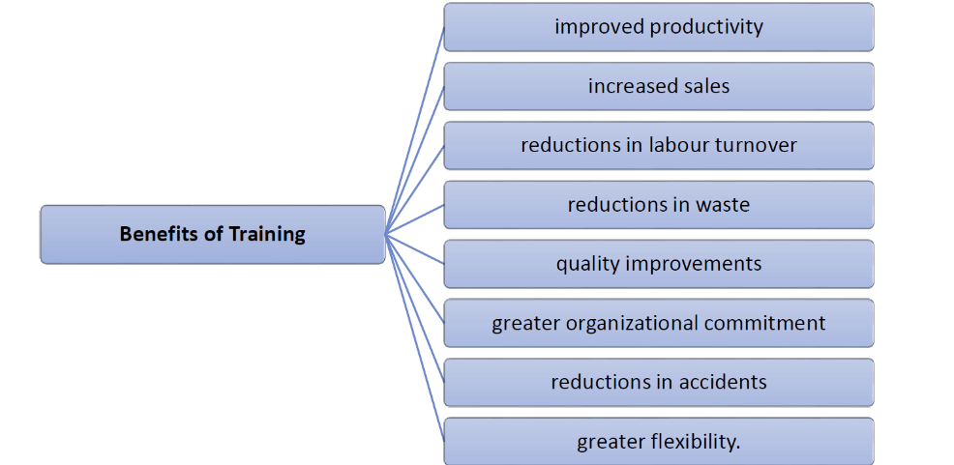

- How should a manager identify the training needs of the staff?

The recognition of training requirements normally flows from staff appraisal process. Mainly you are trying to pinpoint the knowledge, work skills, and social skills, which the workers need for both current and future jobs.

- What could be the aims of training programmes in hospitality?

The hospitality industry, including catering, has people at its core. The most successful hospitality businesses make providing top-notch customer service their highest priority. An effective training program centers on ensuring your employees have what they need to offer high levels of customer service.
- How is a training programme evaluated?

Evaluation is a process to determine the relevance, effectiveness, and impact of activities in light of their objectives. In evaluating a training and development programme, one needs to consider that most training and development activities exist in a larger context of projects, programmes, and plans.

- Outline the steps to conduct a training programme, which could be of maximum benefit for the hotel.

In the hospitality industry, a number of hotel establishments take training seriously, others discuss it at length but they have no real agenda in place. Those who develop, establish, and can continuously upgrade their training sessions think of them as great assets of Human Resources Management. They provide the management team a chance to build a team of qualified employees capable of performing duties according to preset standards. A good training program makes sure that mistakes are cut down since procedures are demonstrated and explained.
Step 1 - Assess Organizational Training & Development Needs
Step 2 – Define your training Objective
Step 3 – Training Program Design
Step 4 – Training Program Implementation
Step 5 – Evaluate the Training

Activity

Prepare a training session plan for six new employees, who have just joined your customer service team. Your aim is to train them in ‘handling customer complaints effectively.’
Training Objective
Registration and Coffee
Welcome Brief
The Importance of handling customer complaints
Complaint + satisfaction = Loyalty
Break
Rectifying the problem
Learning from your mistakes to prevent future complaints

Student Statement:

By submitting this assignment, I confirm that this is my own work.

Student Signature |  | Date

For Tutor / Assessor Use Only
Total Marks
Marks Obtained
Percentage / Grade

