Salon Management assignment by Yolanda Vargas Martin

- Discuss the procedures of hiring salon employees.
- Advertising: advertise the job vacancy on news paper, jobs website and own website.
- B. Once I have received the cv will be looking for skills and experience, if all this matches with my company/salon and team the next step will be phone the vacant to have a quick chat and be able to know better the person and give details of the position.
If both sides are happy will book a 121 interview.
- Things to look at: Well looking and good appearance, good skills with customer service and working in a team .
To know better the person and know from their experience what can they give to my business.
- IF after the interview the feeling is good for both sides the next step will be to book a trial test to see how she/he works, how are their skills with customers and at the salon.
- “If there’s a lack of knowledge or practice in any of our services, the company will provide trainings in/out house”.

- Employee motivation is important for effective customer service delivery’. Discuss this.
It is important that employee are motivated and happy.
This will reflect on the salon vibes, and how they will proceed with treatments at the salon and recommendation of products or different services. Employee is the person who treats in first person our clients so it is important that they feel comfortable and happy so guest will feel it and will have a positive experience in the salon.

- You are a salon manager, how would you attract clients for your salon?

- With a good marketing to advertise our clinic and what do we offer.
- Invite with a free consultation and even express treatment for them to taste what is the company and what do we offer.
- Get in touch with neighbours offering a special discount for them to come, if they’re happy they will share also with their clients.
- Going to local events with a banner and give some flyers inviting them to come. Maybe also some samples of products.
Activity 1
I am actually a clinic manager so I have answer all the questions above this from our company experience . My clinic is called Skinsmiths.
Activity 2
Collect promotional materials from at least two different salons and compare both of them. Which of the two is best, according to your analysis? What suggestions would you give to the others for improving their promotional materials?

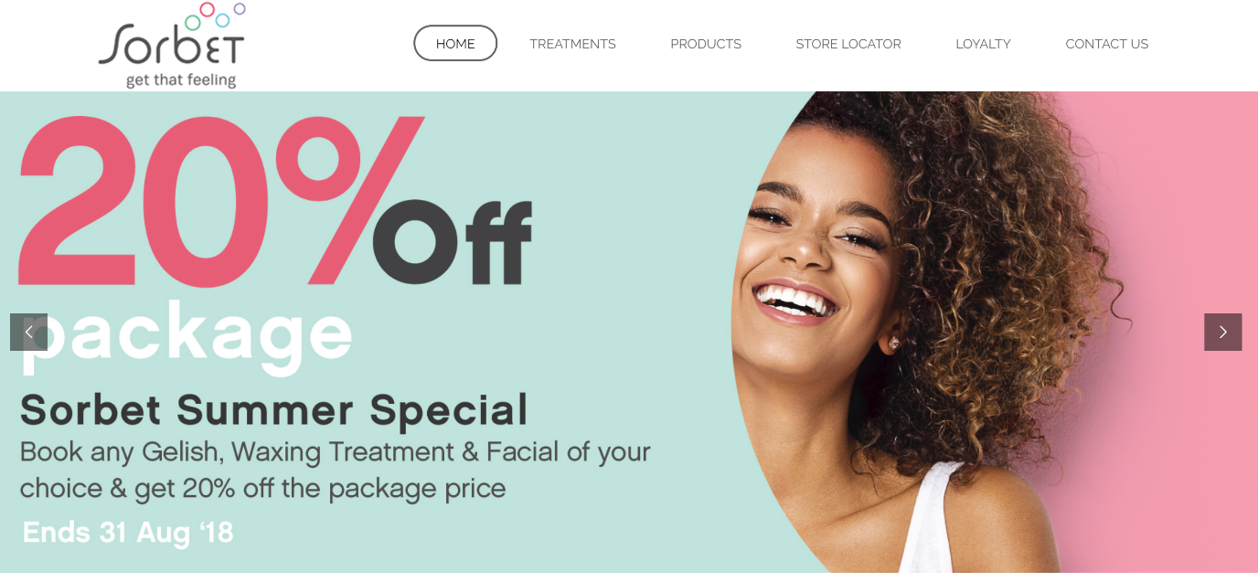
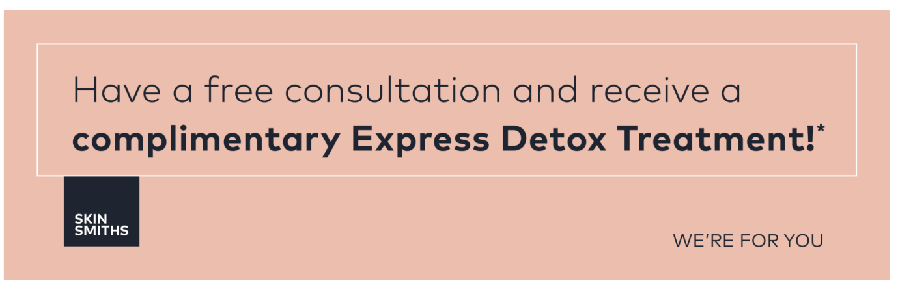

I think second option is the best , you’re not advertising discounts so you won’t get only discount clients.
They will have a full consultation and try one of the treatments providing in the clinic so they have an idea of how’s the salon , they’re professional as they want to understand if there’s any concern to focus on the treatments and from there analyse their skin and test with an express treatment.

Client will have fully understand of what is the company , how do they work and what do thei offer, instead of going to a place just for the discount they’re offering and you don’t know what to expect.

