
Assignment Cover Sheet

Student Name: | NAZIK AHMED
Student Number: | 30991
Course: | Diploma in Logistics & Supply Chain Management (Level 4)
Assignment NO: | 13

Marking Criteria:
We expect the learners to write minimum one well expressed point in three lines against each allocated mark. This means one needs to write 15 lines with 5 well expressed points to get high grades for a 5 marks question.
For high grades use examples and illustrations where appropriate.
Please insert your completed assignment ( in word format) here:
1-
I:
It’s a framework uses to illustrate the complex relation between all tiers in the supply chain operations.
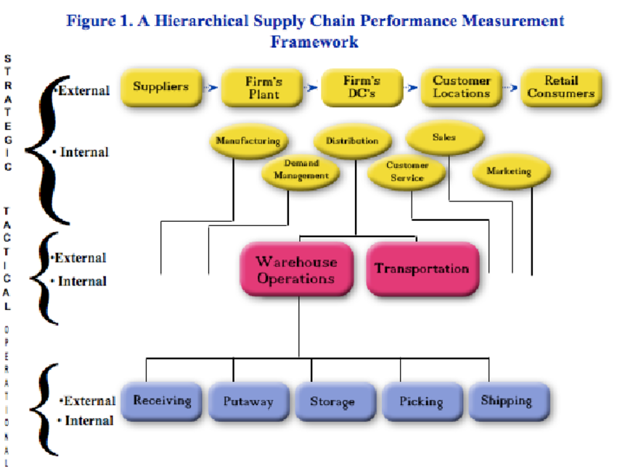

Ii:
Efficiency means the best uses of the resources (financial-human-technological or physical), internal supply chain efficiency means more concerned with internal process improvements such as sales, production, and distribution to be more profitable.

Iii:
It’s an analysis tool used for the Measurements of supply chain operations and how they meet customer and market demands. There to types used by companies (build to order –BTO- and build to stock-BTS-).

Iv:
build to order products | build to stock products
1- products build after the order received | production before demand
2- less importance on historical and future sales data | companies look to historical sales data and sales forecasts
3-is the production approach associated with highly customizable or perishable goods | Is the production approach associated with the mass production of similar goods.

V:
Data warehouse: is a system concern as a core part of business intelligent used for data collecting from different sources for reporting and analysis, also used to effective communication between companies in supply chain.

2-
There are four operations:
1-plan operations: measuring the number of stock keeping units (SKUs) carried, the number and percentage of order changes, the inventory carrying costs and production volume.
2-sources operation: all measures related to internal (raw materials) or external (suppliers) sources. This includes cost, time and numbers or percentage of these sources.
3-make operations: measurements for manufacturing operations performance(build-to-order percentage, percentage of manufacturing order changes due to intern issues, percentage of value added and the number of work in progress).
4-Delivery operations: measures considering channels, delivery locations, return orders, lead times and order entry methods.

Student Statement:

By submitting this assignment, I confirm that this is my own work.

Student Signature | NAZIK AHMED | Date | 7-6-2019

For Tutor / Assessor Use Only
Total Marks
Marks Obtained
Percentage / Grade

