
Assignment Cover Sheet

Student Name: | Dee Eve Ndombele
Student Number: | 23626
Course: | Certificate in Fashion design Level 1
Assignment NO: | 2

Marking Criteria:
We expect the learners to write minimum one well expressed point in three lines against each allocated mark. This means one needs to write 15 lines with 5 well expressed points to get high grades for a 5 marks question.
For high grades use examples and illustrations where appropriate.
Please insert your completed assignment ( in word format) here:

Q1. The Relationship between the principles and the elements in a design are a balanced combination of each other, that is shown within the context of current fashion. The principles of design are the rates that govern how elements are combined. That is presented an arrangement within the elements of design such as; line, form, shape, colour and texture.

Q2. Rhythm can be created in a garment through repetition, transition and radiation. First Rhythm by radiation creates a feeling of movement in different directions, second rhythm by repetition creates regular repeats of design, shapes, colour and textures that can be squared, rounded and scalloped. Third and Last rhythm by transition creates a curve a line that leads the eye over an angle. Transition can be achieved by using scarves, shawls, ruffles and gathers in dress designing.

Q3. The principles of a design are the main guidelines for the use of the elements of design. This involves the principles of a design to be useful by creating different forms of expression in an artistic manner, which are pretty and attractive to the eye such as; balance, emphasis, harmony and proportion. They also help a fashion designer to analyse effectiveness by knowing how to control, and use them effectively for a good design, which is an important aspect for dress designing.

Activity project: My circle round shaped
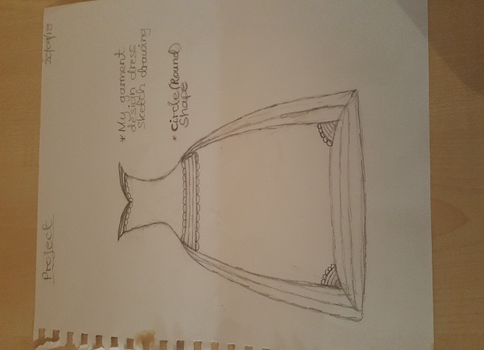
garment dress design sketch drawing.

Student Statement:

By submitting this assignment, I confirm that this is my own work.

Student Signature | Dee Eve | Date | 03/10/18

For Tutor / Assessor Use Only
Total Marks
Marks Obtained
Percentage / Grade

