
Assignment Cover Sheet

Student Name: | Nicolletta Nyagah
Student Number: | 5751
Course: | Diploma in Hotel Management
Assignment NO: | Assignment 8 – Managing Food & Beverage Operations

Marking Criteria:
We expect the learners to write minimum one well expressed point in three lines against each allocated mark. This means one needs to write 15 lines with 5 well expressed points to get high grades for a 5 marks question.
For high grades use examples and illustrations where appropriate.
- Give short answers for the following questions: (12)

- What is the importance of hygiene for a restaurant?

Avoid food contamination that comes from human contact by handling food (ensuring staff training on personal hygiene, sanitization and sterilization of equipment and all surface kitchen area as the reputation depends on hygiene standards and menu.

- What is ROL in the hotel industry and how is ROL calculated?

Reorder level of stocks that ensures right amount of stock is maintained. Determine average usage stock per week, multiply by review period plus lead time required, add average usage number per week again to get the maximum stock required.

- Which factors should be considered when purchasing equipment for food and beverage service?

Type of service to be offered, type of customer, costs & funds available, flexibility of use of equipment, design, color, shape, durability, ease of maintenance, stackability, Storage, Replacement (availability in future), delivery time, rate of breakage.

- What are the three different menu types?

Three menu types are; Static (fixed) menus that offer same items on the menu repeatedly, Cycle menus that offer different items during certain time and Single Use menus which are planned only for special occasions and not repeated.

- How does the use of computer help in Food and Beverage Operations?

Streamlines handling of paperwork, maintains sales & expense data, improves control over daily operations, generates complete & timely report, increases sales revenue, reduces clerical staff & repetitive tasks, improves service & productivity.

- What factors should be considered when planning a menu?

Consumer’s preference, appearance, quality & flavor, nutritional value of food, personality, moods, appetite, sex, age of customer, religious & cultural constricts, economic conditions, social prestige, advertising & environmental situations etc,.

- Describe various aspects of managing food service operations

Food Service Operations comprise of obtaining raw materials, creation of food, and the service to the consumers on demand.
The raw materials are the input, as well as, the preparation and cooking of the food while serving the prepared food to the consumers is the output.

Activities include transferring food and beverage products from production personnel to serving personnel, serving the guests, clearing tables etc. The procedures to carry out each activity is standardized so as to ensure guests expectation are met.
Below are some aspects of managing food service

- Food purchasing

Managing the purchasing process to facilitate purchase of food, beverages, materials, equipment required. This will include methods of storage, receiving and issues the commodities.

- Food Service Hygiene

Deals with general handling of food, personal hygiene, good safety. Applying sound practices to prevent the possibility of food poisoning, food contamination. Identifying measures & procedures that can reduce or eliminate accidents in food preparation and service areas.

- Quality of Food Preparation

Developing competence in the operation of food preparation areas to identified operational standards. Develops awareness of safe working environment and monitoring of safe practices.

- Delivery & Service of Food

This covers food production – preparation and cooking of the food, serving the prepared food to the customer. Covering all aspects of kitchen operations.

- Managing food production system

Includes all aspects of ergonomics, planning, design and layout of the kitchen and restaurant. Looking into particular problems of volume food production and service, recognize solutions adopted by management and propose alternative and effective solution.

Other aspects include layout, design & facilities planning, consumer needs and types of food service, menus and menu planning, equipment selection etc,.

- Discuss traditional stages of food delivery system.

There are eight distinct stages of the traditional food service delivery system as depicted below which are self-explanatory.

1. | Storage | refrigerated or ambient storage of material
2. | Preparation | activities, such as, peeling, cutting, and so forth
3. | Production (cooking) | methods, such as, frying, roasting, and so forth
4. | Holding | storage between production and consumption
5. | Service | style of delivering dishes/meals to consumers
6. | Dining | consumption of meal by consumer in setting
7. | Clearing | removal of equipment/food debris
8. | Dish Wash | cleansing of soiled equipment

Below is a detailed table showing all stages of food service delivery system.
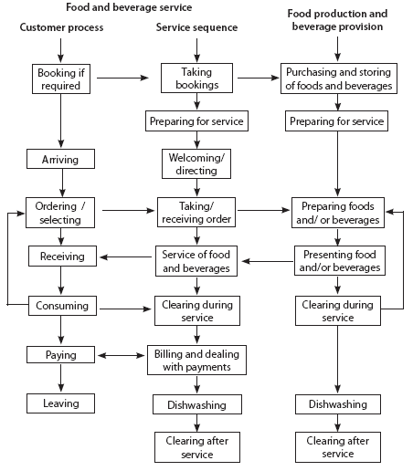

Student Statement:

By submitting this assignment, I confirm that this is my own work.

Student Signature | Nicolletta Nyagah | Date | 31 March 2017

For Tutor / Assessor Use Only
Total Marks
Marks Obtained
Percentage / Grade

