
Assignment Cover Sheet

Student Name: | Marlene Grant
Student Number: | 12435
Course: | Diploma in Forensic Accounting (Level 4)
Assignment NO: | 08

Marking Criteria:
We expect the learners to write minimum one well expressed point in three lines against each allocated mark. This means one needs to write 15 lines with 5 well expressed points to get high grades for a 5 marks question.
For high grades use examples and illustrations where appropriate.
Question 1

- How does interviewing help the financial crime investigator in his work?
Interveiwing help the financial crime investigator with the following:


Investigators at work

- To obtain and develop information.
- It provide leads in developing a case.
- It also help to decrease the time involved in determining how to conduct the investigation.
- It help to garner valuable information from interviewees
- Reduce the breadth of the investigative plan
- Increase the likelihod of overrall success in discovering and proving fraud
- It help form the scope of further analysis and identify areas to be investigated more thoroughly
- It help to uncover the full facts behind the fraud and deceit

- What is the first stage in planning the interview?

Planning and preparation
This is one of the most important phases in effective interviewing. The success of the interview could depend on it.

A planning session that takes account of all the available information and identifies the key issues and objectives is required, even where it is essential that an early interview takes place.
Interviewers should consider the following:
- Create and record the interview plan
- Characteristics of the interviewee
- Practical arrangements
- Make written interview plan.
Planning and preparation gives the interviewer the opportunity to:
- Review the investigation
- Establish what material is already available
- Decide on what the aims and objectives of the interview are.
How the material is obtained during interview helps to establish the accuracy of the matter under investigation and should be considered carefully.
The investigator needs to determine the right approach to the task which may mean thinking about:
- Who needs to be interviewed and in what order
- Why is a particular interviewee’s viewpoint so important
- What information should now be obtained
- When should the interviewee be interviewed
- Where the interview will be conducted
- How to interview the interviewee

- Which type of interviewees could be considered when investigating financial crimes?
Interviews are conducted with:
- Victims

- Co-workers
- Suppliers and vendors
- Customers
- Spouses and former spouses
- Significant other
- Relatives
- Attorney
- Accountant
- Bankers and stock brokers
- Competitors
- Industry leaders and group representatives
There are three types of interviewees:
- Friendly
- Neutral
- Hostile
Friendly interviewees goes above and beyond what is normally expected in order to be helpful. Experience investigators however take care to determine their motive. In most cases the motives are sincere. The motive could also be to direct the attention away from the interviewee as a suspect.



Friendly Interviewee

Neutral interviewees have nothing to gain or lose from the interview. They have no hidden motives or agendas and they are the most helpful of all interviewees.



Neutral Interviewee

Hostile interviewees are the most difficult to interview. They are often associated in some way with the suspect or the crime.



Hostile Interviewee

Friendly and neutral interviewees can be questioned without prior notice. Surprise interviews provide hostile interviewees with less time to prepare defense.
The type of interviewees that could be consider in a financial crime would be a hostile interviewee.

- Why is it important to record the interview?
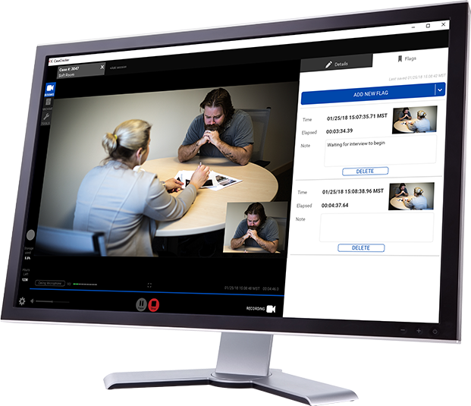
Recording System

The quality and reliability of the outcomes of an investigation depends on quality of the evidence the investigator is able to collect. The investigator should ensure that the evidence of the parties is recorded accurately.
The use of audio recordings is an effective way of collecting reliable evidence to support the investigation findings.
It is important to record interview for the following reasons:
- Accuracy
- Accountability
- Efficiency
- Oversight
- Reinforces seriousness
Accuracy

No one can dispute what was said, if you have it on tape. When a subject changes his or her story there is an indisputable record of what was originally said. An audio recording is a precise record of all that is said during the interview and can be revisited later to see whether the evidence is consistent between witnesses.

Accountability

It boost the accountability of everyone involved so investigators who don’t follow protocol or who lead suspects with unfair questions are quickly discovered. This will help to protect the investigators, no one will be able to attribute statements to the investigation that he/she did not make and any accusation can be swiftly dismissed.
It also help to protect the witness and ensure that their words are not twisted.

Efficiency

It is faster and easier to transcribe. It also eliminate the turnaround time for transcribing what you thought you heard from notes to an actual record and getting the witness to sign off on. You can have the taped interview officially transcribed and official record word for word of what was actually said, this will make our investigation process more efficient. It is also more durable and last longer than an average person’s memory.

Oversight

Recorded interview ensure that everyone is accountable for their part in the process.

Reinforces seriousness

If the parties know that they are being recorded this will reinforce the seriousness of the matter.

- What is the importance of the place where an interview is to be conducted?

The physical setting can have an effect on the establishment of the relationship between those involved. The interviewer should consider the impact the location can have on themselves and the interviewee, in particular the effect the formality of designated interview room can have on some witnesses and victims. It is important to decide on a location and prepare the room prior to the interview. Interviews are usually conducted in a neutral and private room in the workplace during office hours. If there is an issue of confidentiality the

interview may take place off-site. If the interviewee request a location other than the workplace and the request is reasonable consider accommodating the interviewee.

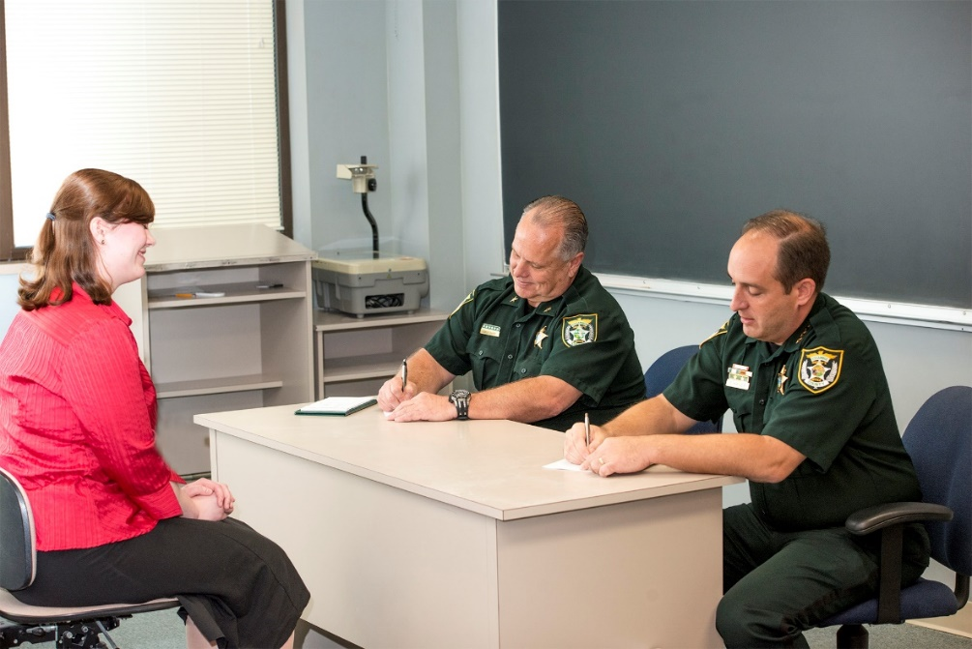

Interview Room
Fact finding interviews should be done in the office of the respondent so that there is instant access to relevant files and records.
The investigator should be conscious of the location of the windows and door in the interview room because you do not want to seat the client with his/her back to the door leading into the room, it can make them uncomfortable. The view outside the windows may prove distracting, you want to make sure that the person being interviewed can concentrate on the questions.
The investigator should select a location to minimize noise, movements, interruptions and witness anxiety. A well light place will help to enhance the interviewees focus.
The role played by the witness in the crime will determine how comfortable the investigator wants the interviewee to feel.
Example- A suspect would wan t to be interviewed on his/her own turf.
The pressure on the suspect will be considerably higher in the investigator’s office.

2. Discuss, in detail, the stages involved in the interview planning procedure.

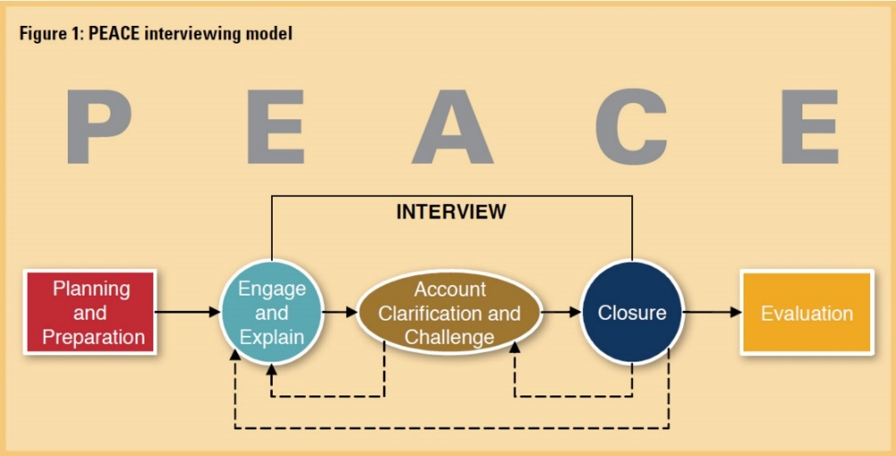

Stages of an Interview

Planning and Preparation
This is one of the most important phases in effective interviewing. The success of the interview could depend on it.
A planning session that takes account of all the available information and identifies the key issues and objectives is required, even where it is essential that an early interview takes place.
Before the interviewee is contacted and the meeting is setup there is much work to be done. The interviewer should think through why the interview is required and what they want to achieve.
The interviewers should consider the following:
- Create and record the interview plan
- Characteristics of the interviewee
- Practical arrangements
- Make a written interview plan.
Planning and preparation gives the interviewer the opportunity to:

- Review the investigation
- Establish what material is already known
- Decide on what the aims and objectives of the interview are.
The investigator needs to determine the right approach to the task which may mean thinking about:
- Who needs to be interviewed and in what order?
- Why is a particular interviewee’s viewpoint so important?
- What information should now be obtained?
- Should the interviewee be interviewed immediately or would it be more useful to wait until more information has been obtained about the circumstances of the offence from other sources?
The interviewer may need to consider a number of activities and practical considerations which may help them to understand the circumstances of the offence, and achieve the best interview from the interviewee.

These include:
- Visiting the scene
- Searching relevant premises
- Location of the interview
- Role of interviewers
- Timings
- Equipment
- Exhibits and property
- Knowledge of the offence.
There needs to be a written interview plan, this will summarize the aim of the interview and provides framework for questioning.

The plan should also record who will be the lead interviewer, and who is responsible for note-taking. It is important that interviewers understand their respective roles and maintain the role agreed. Two interviewers asking multiple questions in an unstructured manner is unlikely to achieve the interview’s objective.

Engage and explain
The first step to encouraging conversation is to engage the interviewee. This is not always easy, especially if the person is previously unknown to the police.
Active listening assists the interviewer to establish and maintain a rapport. Rapport should be established and the objectives of the interview made clear. Building rapport is all about making contact with the respondent and getting them to co-operate.
This then enables them to:
- Identify topics during the interview and, therefore, manage the conversation
- Communicate interest to the interviewee in their account
- Identify important evidential information.
Introduction of all those present should be provided.
The reason for the interview should also be clearly explained, eg, the interviewer may say:
- ‘You are here because you have been arrested for (offence)’ or
- ‘You are here because you witnessed (offence/incident).’
The interviewer should then check the interviewee has understood the explanation.
Before starting an interview, the objectives of the interview should be explained to the interviewee, and they should be provided with an outline or route map of it.
For example, interviewers may say:
- ‘During this interview I will talk to you about (list objectives).’
Then go on to explain:
- ‘I will also ask you about anything else which may become relevant during the interview in order to properly establish the facts and issues.’
It is good practice to explain to the interviewee that if they nod or shake their head the interviewer will state that they have done so. It should also be explained that notes will be taken during the interview.
It may be useful to inform the interviewee that although the police wish to establish certain facts and issues, it is the interviewee’s opportunity to explain their involvement or non-involvement in the incident under investigation.
Investigators should encourage the interviewee to voice anything which they feel is relevant, explaining that there is no time limit for the interview and that as much detail as possible is required, encouraging the interviewee to voice anything which they feel is relevant.
The interviewee should be reassured that they will not be interrupted. It may be appropriate to ask the interviewee to consider fully any question they are being asked before they answer.

Account, clarification, challenge
Obtaining an account consists of both initiating and supporting. In volume and priority crime investigations the most common way of initiating an account is simply to use an open-ended prompt, such as, ‘tell me what happened’.
Clarify and expand the interviewee’s account by:
- breaking the account down into manageable topics
- systematically probing those topics by means of open-ended and specific-closed questions until as full a picture as possible of the interviewee’s account has been obtained
- examine any information, identified during the planning phase, that has not already been covered.
The questions should be as short and simple as possible. They should not contain jargon or other language which the interviewee may not understand.

Some types of questions are useful, helping the interviewer to extract information from the interviewee, eg, open-ended. Others are not and may actually confuse the interviewee or prevent them from giving a full and accurate account, eg, multiple questions.
Five key question types
- Open-ended
- Specific-closed
- Forced-choice
- Multiple
- Leading

Open-ended
For example, ‘Tell me’, ‘Describe’, ‘Explain’.
- are useful at the beginning of an interview as they allow for a full, unrestricted account
- produce answers which are less likely to have been influenced by the interviewer.
The interviewer should avoid interrupting the interviewee when asking open questions.

Specific-closed
For example, ‘Who did that?’ ‘What did he say?’ ‘Where does he live?’ ’When did this happen?’ This type of question:
- gives the interviewer with more control
- can be used to elicit information that an interviewee has not yet provided in response to open-ended questions
- may be used to clarify and extend an account that has been elicited through open-ended questions, cover information important to the investigation that an interviewee has not already been mentioned, or to challenge
- may have the potential disadvantage of restricting an interviewee’s account.

Forced-choice
For example, ‘Was the car an estate or a saloon?’ In this situation:
- Interviewees might guess the answer by selecting one of the options given
- Interviewees might simply say ‘yes’ in response to the question, leaving the interviewer to guess which part of the question the response applies to, or needing to ask a follow-up question to clarify it
- The choice of answer given to the interviewee might not contain the correct information, eg, ‘was it dark blue or light blue’, when it could have been medium blue.

Multiple
For example, ‘Where did he come from, what did he look like and where did he go to?’ These questions may also refer to multiple concepts, eg,’What did they look like’ and confusion might arise as a result of the:
- Interviewee not knowing which part of the question to answer
- The interviewer not knowing which part of the question the answer refers to.

Leading
For example, ‘You saw the gun, didn’t you?’ implies the answer or assumes facts that are likely to be disputed. They can also:
- be used to introduce information not already mentioned, eg, ‘What did he look like?’
- have an adverse influence on interviewee’s response
- distort the interviewee’s memory
The information obtained as a result of leading questions may be less credible and in extreme cases could be ruled inadmissible. They should, therefore, be used only as a last resort.

Closure
This should be planned and structured so that the interview does not end abruptly.
Where there are two interviewers, the lead interviewer should check that the second interviewer has no further questions before closing the interview.
The interviewer should accurately summarize what the interviewee has said, taking account of any clarification that the interviewee wishes to make.
Any questions the interviewee asks should be dealt with.
The interviewer should then bring the interview to a conclusion by preparing a witness statement, where the interviewee is a suspect, by announcing the date and time before turning the recording equipment off.
They should then explain to the interviewee what will happen next.

Evaluation
Following an interview, the interviewer needs to evaluate what has been said with a view to:
- Determine whether any further action is necessary
- Determine how the interviewee’s account fits in with the rest of the investigation
- Reflect on the interviewer’s performance.

3. What is cognitive interview? Which techniques are used in this interviewing type?

Cognitive interview is a method law enforcement uses that helps victims or eye witnesses recall specific memories from a crime scene. The aim of these interviews is to help investigators find out and evaluate what happened during a crime on a step by step basis. It is basically an expansion of structured interview as it include additional strategies designed to enhance the witness’s memory.

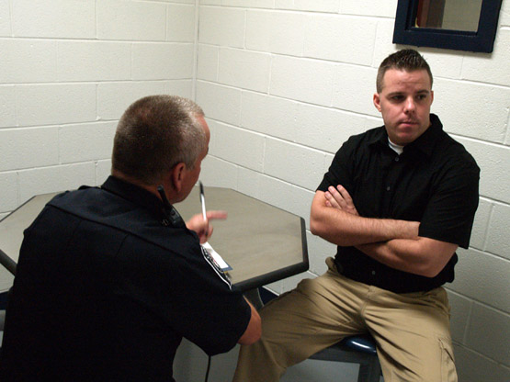

Cognitive Interview

The strategies underlying cognitive interview are based on certain theories and hypotheses. It is thought to lead to a more accurate result when trying to elicit specific information. It is methos that is developed to improve the amount of accurate recall from witnesses. It is basically a memory retrieval technique aiming to bring out more accurate information from an eye witness.

The cognitive interview involves a number of techniques such as:
- Mental Reinstatement
- Reporting all details
- Recounting the incident in a different narrative order
- Recounting the incident from a different perspective

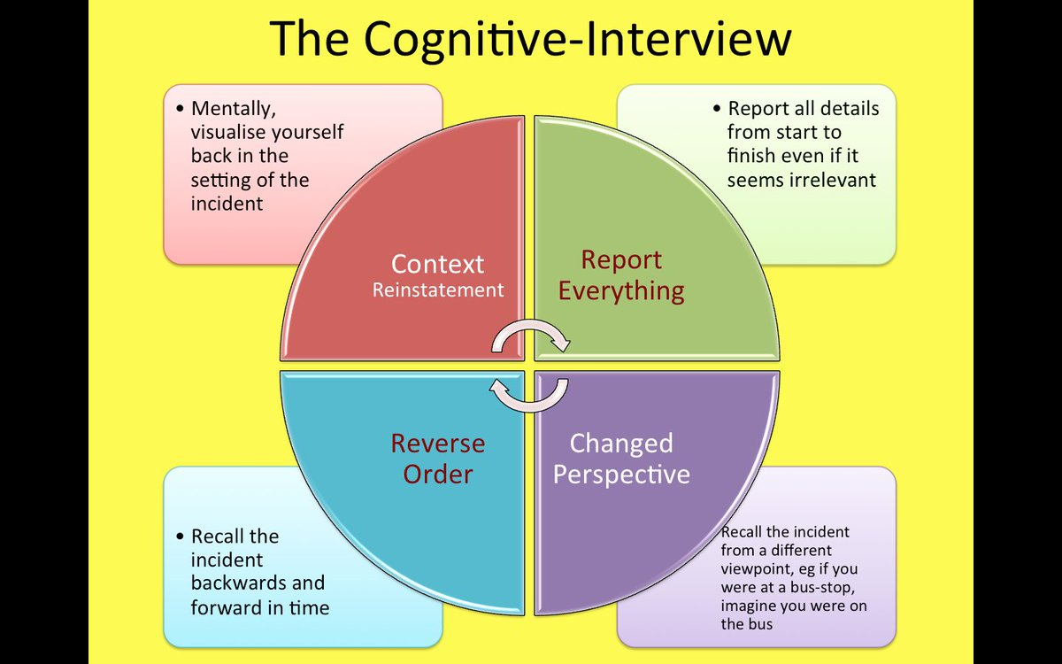

Cognitive Interview Techniques

Mental Reinstatement
This technique allows interviewees to use their five senses of taste, smell, sight, touch and hearing. It allows victims to re-experience the crime in a safe place while taking their time to remember non-pertinent information regarding the events. The interview tries to mentally reinstate the environmental and personal context of the crime for the witnesses by perhaps asking them about their general activities and feelings on that day. The witness is basically asked to mentally reconstruct the physical and personal contexts which existed at the time of the crime.
Example- An individual that witnessed a robbery may be asked to remember any sights, sound or smell they experienced before and during the crime.

Reporting all Details
Victims are encouraged to report every single detail that they remember no matter the significance. In this way unimportant detail might act as a trigger for key information about the event. The witness is asked to report everything even if it seems irrelevant, it may yield information that may be valuable in putting together details from different witnesses to the same crime.

Example – Remembering what they ate for breakfast at the café before the robbery took place may help trigger information that is pertinent to the crime.

Recounting the incident in a different narrative order

Changing the order of our narrative storyline such as working backwards from the end to the beginning increases our chances of remembering things that we might have forgotten. People tend to recall more recent events more clearly than others.
Example- Witnesses who experienced a bank robbery may be encouraged to recall information from when the robbers left the scene backwards until they entered the bank.

Recounting the incident in a different perspective

Witnesses are asked to report the incident from different perspective describing what they think other witnesses might have seen. The witness describe the event as it would have been seen from different viewpoints.

References
- Silverstone Howard, Sheetz Michael (2007) Forensic Accounting and Fraud Investigation for Non-Experts. (John Wiley & Sons Inc.).
- Thomas w. Golden, Steven L. Skalak and Mona M. Clayton (2006) A guide to Forensic Accounting Investigation. (John Wiley & Sons Inc.).
- Kass-Shraibman Frimette, Sampath S. Vijay (2011) Forensic Accounting for Dummies. (John Wiley & Sons Inc.).
- Albrecht W. Steve, Albrecht Conon, Albrecht O, Chad, Zimbelman Mark, Fraud Examination Third Edition

Student Statement:

By submitting this assignment, I confirm that this is my own work.

Student Signature | Marlene Grant | Date | January 17, 2019

For Tutor / Assessor Use Only
Total Marks
Marks Obtained
Percentage / Grade

