
Assignment Cover Sheet

Student Name: | Constanze Wagner-Lees
Student Number: | 31326
Course: | Advanced Diploma in Management & Leadership Level 5
Assignment NO: | 9

Marking Criteria:
Q1. What is a conflict and how can you avoid it?
There is a formula to explain the concept of a conflict: conflict = problem + threat
Conflicts can occur out of a difference of opinion, an imbalance of resources (incl. time), etc. Conflicts present a danger to the relationship of team members in the work place and will remain and grow larger, until they are resolved.

There is an extra layer of difficulty to conflicts: They activate our emotional reaction to threats and problems, rather than our rational approach. This has the potential to make conflicts worse and more intense.
Finally, conflicts also bear the potential of development as a result of the process of the conflict resolution. Every point of friction, once resolved, will have led both parties to a point of more maturity and personal insight into their own developments, than they were at before.

Q2. What are the three F’s of getting to the heart of the problem?
An evaluation of the 3F’s at the heart of every conflict, is worth undertaking prior to a conversation deemed necessary to resolve the conflict:

Facts: What is the core point of what needs to be discussed? Once found, don’t deviate from discussing only this and avoid conflating this with other unrelated issues. To the person at the receiving end of this conversation, it will seem like a mountain of problems/accusations. So condensing it to the facts only is a good idea if the outcome is to be a purposeful and focused conversation.

Frequency: Ensure there is a record of all the occurrences that need to be discussed. Conversations are less impactful when hard evidence is missing and issues are discussed in general observational terms. The person needing to resolve the conflict is then going to be less inclined to make changes for the better.

Frustrated relation: … are often at the core of operational issues, which function as the catalyst to bring to the fore a breakdown in a relationship in the work place. If a lack of commitment to the job is noticeable but manifests itself in poor work execution, then the latter needs to be addressed in conjunction with the former. The person needing to improve must be aware that the impact of their poor work execution cast a wider shadow over their team members’ view of their commitment than simply that of the quality of the work. Trustworthiness and reliability are important factors to be considered here as well.

Q3. Draw and explain the Conflict Resolution Model.
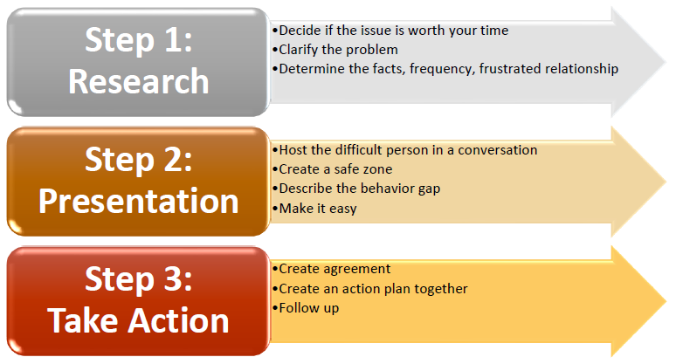

Example Conflict: An employee frequently breaks ICT rules and leaves their workplace with the computer unlocked. This allows access to sensitive files by others, who should not have this privilege.

Step 1: The decision was taken to raise it in conversation as repeated reminders have fallen on deaf ears. The computer often remains unlocked. The problem is easy to clarify as the remit of cause and effect is simple to oversee. A record is kept of all the times the breaking of the ICT rule was noticed.

Step 2: The person is invited at a pre-agreed time to speak to the line manager about the security lapse and invited into their office to avoid the presence of others or unwanted interruptions from elsewhere. The problem is laid out in simple terms without deviation.

Step 3: Both conversation partners reach an agreement that
- ICT rules and Safety Guidelines cannot be broken as they serve an understandable purpose.
- They must therefore be followed with some very simple and jointly agreed steps to achieve regular compliance, locking the computer upon leaving the room.
- The conversation is completed in an amicable understanding that in the wider scheme of things, this compliance request is easy to achieve and probably only a matter of remembering to adhere to regulations.

Student Statement:

By submitting this assignment, I confirm that this is my own work.

Student Signature | Constanze Wagner-Lees | Date | 27.04.2019

For Tutor / Assessor Use Only
Total Marks
Marks Obtained
Percentage / Grade

