
Assignment Cover Sheet

Student Name: | Sarah Storr
Student Number: | 24562
Course: | Diploma in Business Administration
Assignment NO: | 12

Marking Criteria:
We expect the learners to write minimum one well expressed point in three lines against each allocated mark. This means one needs to write 15 lines with 5 well expressed points to get high grades for a 5 marks question.
For high grades use examples and illustrations where appropriate.
Please insert your completed assignment ( in word format) here:

Question 1
i.What is meant by “risk control”?
Risk control or hazard control is a group of procedures set in place to monitor and reduce the possibility of danger. Although there is risk, perhaps to both employees and the business risk can never be totally eradicated (unless you cease to trade) but ‘control’ can significantly reduce the risk factors.
ii.What is the relationship between risk control and risk avoidance?
Although both of these methods are viable on occasion risk avoidance is the least likely in business. To avoid risk is to take no chances, e.g to fit an unsafe piece of equipment that may harm both product and staff- the risk is too great so avoidance is best, but if producing a new product with allergens in will benefit the company risk control can reduce the potential hazard to its minimum. Whether to risk control or risk avoid is a matter of assessing the benefits with the potential severity of the loss.
iii.What is the difference between “risk avoidance” and “risk prevention”?
Risk avoidance is to negate any chance of risk by not performing any acts that might bring about harm either financial or physical, e.g a company may want to heavily invest in a logistics company to cut their transport cost, but the cost would leave them unable to meet their wages bill. Risk assessment would show this as risk avoidance strategy to be best. In the same scenario, if the company looked for a partner to share the financial burden this would be risk prevention by using all available methods. Such things as forecasting, planning and budgeting can therefore reduce foreseeable risks.
iv.“Risk management can make a difference directly to profit”.
There is a popular fallacy that the more risk you take the higher the profit which might in essence be true but only if the risk is at a manageable level. To do nothing, i.e. let your business die from lack of new products is the most risk-free method of approach but some level of risk is needed to grow a company. Whether it is a loan from a bank, investment in new developments or a huge salary to tempt a progressive CEO each has a level of risk. By assessing the risk involved, can we afford to service the loan? Will the new product bring increased sales? Will the CEO prove his worth and bring new ideas and methods to the business? New investment can make significantly increase profits and a charismatic, smart CEO can take an insignificant company into the stratosphere while an ineffective one can destroy a company. So to take the carefully assessed risk can increase profits directly.
v.What is the primary objective of risk management?
- Detect the risks - identify the threats and vulnerabilities which can affect the production and profitability of the company. It is essential to have a robust system in place to identify risks as they can originate from random sources and don’t follow a fixed pattern. Detection is often the toughest part as risks can often be missed e.g No one can predict the exact effect of Brexit on industry
- Analyse the risk -Collect as much relevant data as available and calculate the effect of each individual risk both in isolation and collectively to gauge the exposure or probability, then to take appropriate decisions to manage those risks. In depth analysis of the risk helps in implementing more effective solutions and builds confidence in the business decisions
- Control the risk – This is the ongoing process of monitoring the decisions and continuing to assess the risk at various times in order to ensure that the older threats and vulnerabilities are still effectively countered and that new ones are dealt with early.

vi.How can the risk management process be developed?
- Decide who will be responsible. Perhaps Technical manager himself or a small group drawn from various departments, e.g. finance, production, HR.
- Set out the parameters of the assessment. Is it to be universal or departmental? What is the scope and range? What data will be collected. Is it an acceptable risk to leave out some areas? Look at the legalities, customer requirements, funds available, costs from profits etc.
- How will the process be undertaken? Will it be single audits or a series of investigations. Establish the type and scope of each data search and set a time limit for completion.
- Record and debate the results with the team and decide whether any clarification is needed. If any factors have changed since the initial investigation this is the time to return to the assessment.
- Report findings. Record and illustrate the results in a method suitable to the management team. Graphs, spreadsheets, etc. However, it is reported it needs to be in detail and give the decision makers all possible information but not to be obtuse but give priority to the most pressing risks.
- Assess the decisions made by the senior team and if necessary bring up anything you feel they have not given enough weight to, then set out a plan to eliminate the risk.
- Decide who will monitor the situation and who they will report to. Fix a time scale for the re assessment but establish a continual monitoring of the risk reduction factors. In an unstable environment, e.g Brexit, short periods re assessment may be needed but generally 6 monthly review would be acceptable.
vii.What are the main benefits of risk management?
- Risk Management allows the company to be sure its monitoring and legal programmes are compliant leaving them audit ready.
- It allows better financial and operative control giving a competitive advantage in the market place
- Good risk assessment allows all involved to be working as one team, saving time and resources as there is no repetition throughout departments, allowing redundant processes to be eliminated and efficiency increased.
- Continual monitoring of risk factors means the company is always aware of potential risk and are able to plan effectively to manage them.
- If everyone is bought into risk management it can promote interdepartmental co operation and build a company that has its employees bought into success.
viii.How can the risk be evaluated?
Risk can be evaluated using a risk rating square to give a score. This scores the likelihood of something happening and the severity or impact that it will have if it happens. Risk evaluation is subjective and can produce different scores dependent on the person doing the risk assessment, and so being as prescriptive as possible with the parameters makes the evaluation easier.

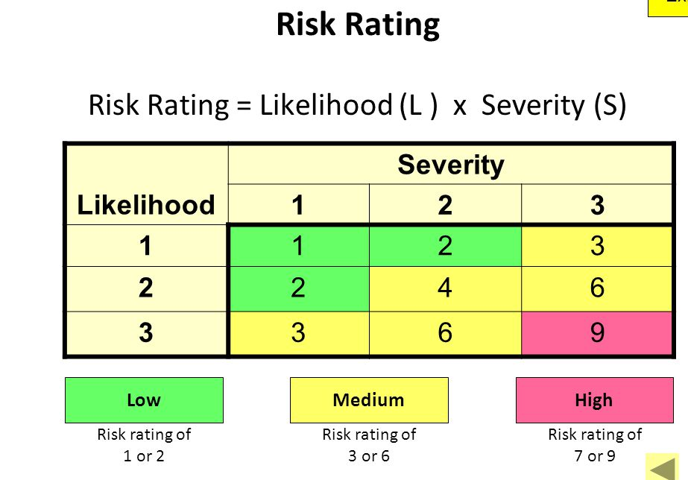

Case study

1.Where do you think William Telford made a mistake?

At the point where Tameer started to lag with payments, Telford should have re- risk assessed. This would have enabled him to put a mitigation strategy in place before the issue became worse. Leveraging the debt with finance from other places was a bad idea as his risk assessment would not be able to tell him that the company would be able to bounce back, as the GFC would be logged as a factor when assessing the risk.

2. How does the risk management strategy would have helped him?

The risk management strategy would have allowed him to look logically at the situation and put strategies in place to cover him when/ if things went wrong.

Student Statement:

By submitting this assignment, I confirm that this is my own work.

Student Signature | SARAH STORR | Date | 12.03.19

For Tutor / Assessor Use Only
Total Marks
Marks Obtained
Percentage / Grade

