
Assignment Cover Sheet

Student Name: | Bethany Mewies
Student Number: | 11528
Course: | Certificate in Fashion Design Level One
Assignment NO: | One : Introduction to Fashion Design

Marking Criteria:
We expect the learners to write minimum one well expressed point in three lines against each allocated mark. This means one needs to write 15 lines with 5 well expressed points to get high grades for a 5 marks question.
For high grades use examples and illustrations where appropriate.
Bethany Mewies
Assessment One : Fashion Design
Question One
In this assignment I will be describing the characteristic features of the twentieth century fashion. When fashion first became a big thing in the 18th century, it’s thought to be unlikely to think of fashion the way it is now. There wouldn’t have been the major fashion designers such as Calvin Klein and Giorgio Armani. French fashion was considered the trademark of the upper, richer class. The dresses were rather impractical, yet mesmerizingly beautiful. Dresses would weigh numerous kilos, the tight corsets being worn frequently made their wearers sick due to the lack of air and heat in the fixed corsets around their waists. Men’s fashion in the 18th century was rather bright, bold and feminine.
The fashion that we are familiar with in this century originated from the most famous dressmaker of the 19th century. Charles Frederick Worth. Worth came up with the idea of bringing his clients to his home to view his range of fashion, which was updated every year. Charles Frederick Worth was the first to realise that fashion was an essential social element. A fashion house (masion de couture) was then created in Paris. Fashion houses then started to hire fashion artists to sketch out designs for their customers. This saved a lot of time and money rather than producing an actual sample garment. This began to make an economy for the fashion houses because they only made the items of clothing their customer has ordered. Therefore the fashion houses began to make profit, and saved time.
In the early 20th century Paris was declared the heart of high fashion, and then to a smaller degree, London. These cities were home to most of the major fashion designers at this time. The career of a trend forecaster originated around this period when fashion magazines sent out editors and buyers to different high fashion shows in Europe where they started to write about the latest fashion emerging. The editors then used this to their advantage and created their own looks which they’d know their target audience would like. Made-to-measure and Ready-to-wear salons started to present all of the current Parisian fashion. However these styles were actually adapted to each store’s theories regarding lifestyles and the budgets of their audience.
In the 1900’s fashion continued to develop at a rapid rate. Going beyond high fashion only for the upper class, which ruled over the 18th century. The numbers of financially independent women grew, and they insisted on a new type of fashion. The public wanted a fashion which was aesthetically pleasing, but which also practical for the wearer. Many of the target audience for the High Fashion House’s favoured with Paul Poiret in abandoning the corset which dominated the 18th century. A lot of the styles which were around started to slowly changed more practical and elegant fashion. This then became the essential fashion of any well doing woman. Hats too became an essential for women in high fashion. The hats were either petite confections which just perched on the top of the head, or they were colossal, covered with ribbons, flowers sometimes even feathers. They both made a huge statement.
As the fashion industry expanded, the image of fashion became a lot more flexible. Women became a lot more independent with their style, meaning that they no longer wanted or needed help dressing from their maids. As the years went on the colours used in fashion became a lot more rich and bold. Geometric shapes were also growing more popular. Hats however were not as popular and luxurious. Simple small felt hats were the most popular at the time; others preferred little clouds of tulle. It has been noticed that the first real socially important fashions occurred in these years. The first female couturier, who made the first real fashion shows happen, also then expanded and started to open foreign offices in London, Buenos Aires and Madrid, building her ‘empire’.
As the years of the 1910’s went on women’s fashion started to change even more. As WW1 continued, more and more men had to join forces to fight in the war. This meant a lot of labouring jobs had no one to complete them. The women started to dress as men, borrowing their brother’s and father’s clothing. A lot of the garments women wore hid all of their feminine features. The bright and bold colours of the earlier 1910’s now changed to a darker, earthier tone for all of fashion. This was to mourn all the dead returning from the wars. Most of the big social events were postponed to a happier time.
In the 1920’s hair began to change a lot. A shorter, bob style came into fashion for most to all women. This new hairstyle heavily complemented the flapper style of clothing which was very fashionable. Sportswear came into fashion in a big way for mostly men. Loose fitting sleeves paired with sweaters and brief trousers made the sportswear fashion very comfortable and popular. Tuxedos were worn only at formal social events. The Lavin design was now the style of the time. It was comfortable; yet elegant. Dresses were covered with trimmings and embroidering.
Fashion houses started to feel the effects of the Great Depression in the early 1930’s. This made fashion a lot less exciting and mesmerising. Men’s fashion was a lot more informal. The garments worn were mostly for the fact that they were comfy and useless for labour work. Women’s daytime style was a lot slimmer, tighter fit, imposing yet elegant. Broad shoulders were getting more in style as the years went on.
As the time grew closer to the mid 20th century, Paris’ reputation on being the home of high fashion started to diminish. Mass manufactured fashion started to expand around the world. This meant that fashion was a lot quicker and cheaper to make. Central heating had just been invented and therefore ‘Minimal Care’ garments were created.
As the years went on, many fashion houses closed. This means that the big influence on fashion is now disappearing. The home on fashion now started to relocate to New York City. At this time WWII was now in its full swing. Meaning heavy rationing for fashion. This was a big influence on everybody’s fashion. For each garment, specific measurements were given to designers, you were not allowed to exceed this generous amount of material you were given. Else there wouldn’t be any more to use on different garments, because of the rationing for the war.
As Paris was becoming less and less involved in the high fashion environment, this gave America the chance to explore their creativity in fashion. This lead to plain and simple cut garments coming back into fashion.
Christian Dior was slightly going back in time with the fashion he started to produce for his audience. Dior loved the classic tiny, corseted waist, with a majestic bust and a full blown skirt, this style started to match with the Victorian era. However many of Dior’s audience were not too fond of his new look. This then lead to a disagreement between Dior and Chanel. Chanel was very keen on femininity in her fashion. Chanel wanted a change from the sensual kind of elegant which was difficult to wear that Dior provided. Therefore Chanel’s style became more classic and elegant, yet it was very comfortable.
As the 1950’s arrived, the Hollywood Film star glamour came with it. Fashion houses started to notice that dresses and outfits worn by actresses would get a lot more publicity from the media than normal designs that the fashion houses would create. The looks which would get the most publicity would include materials like chiffon, fur, and they would be covered in sequins. Designers found that looks with one memorable detail got a lot more exposure. These looks would contain something like a low cut back, or a noticeable accessory. Big stars like Marilyn Monroe played a big part in influencing the fashion styles of the 1950’s.
As the years went on, the style of clothing in the 1960's was very influenced by the 1920's. Separate types of fashion came around. There was a style of clothing for adults, children and the youth. This meant there was no more fashion equality. A lot of the changes that occurred in the fashion industry happened in London. Most of the upcoming fashion designers focused on making fashion for a younger audience. The designers started to make their garments a lot more futuristic. The colours were bold and bright, this started to represent the mood of the 1960's. Hats were not really big in fashion anymore. People only really wore them for special occasions such as weddings.
At the start of the 70's a countrified fashion grew very popular. Hems were dropped, shoulder lines dropped. Knitted and crocheted garments were arriving into fashion in a big way. Fashion in these times was modernised, feminine and westernised. A big designer in this time was Rykiel. This designer made her creations look different and individual, but the style could be worn anywhere. Floral prints were the epitome of fashion in this time. In the late 1970's punk started to expand in the likes of fashion. This originated from London. As the 70's went on, Italian fashion grew with it, their styles became more and more fashionable. Milan was now classed as the second hub of high fashion, even though Paris' reputation started to fall apart.
In the late 20th century, fashion shows expanded into the media. The media loved to turn these fashion shows into the biggest social events of your calendar. A lot of fashion houses and designers were turning to the past for major inspiration. This lead to the outcome of lycra and spandex, which were a must have.
When the 1980's had arrived everybody took more and more consideration in their appearance. Everybody cared about the way they looked, and of course they didn't want anyone to look better than them. The style of the working woman was big in this era. Garments were comfortable and simple so that women could easily get on with their lives and jobs without worrying about their style. The 80's also became the supermodel era. Everybody wanted to look like a supermodel, with their body and their clothes. The models in the fashion shows were a huge inspiration for the population. The Japanese fashion was rather simple but was a great hit with its audience. Their style was full of modesty, with little to no makeup, and without any accessories. However the America style was pretty much opposite, it was rather seductive and clingy. They called it casual sophistication.
A lot of ready to wear fashion was available everywhere to buy in the 1990's. The fashion style of the 90's was very comfortable and wearable. The style had steered away from the fashion guidelines that had a bigger influence in the earlier years of the 20th century. Garments tended to be very feminine, sexy and covered with bold bright colours. The fashion industry just kept growing and growing. The younger audience were still the ones to impress. With this in mind, fashion designers started using different ways of publicising their creations. Television adverts helped businesses promote their fashion massively. The whole world became more interested in fashion. It was a whole new market for everybody in places like Asia. Fashion was still big in the USA and Europe, it just kept growing, and became more and more successful.
The 2000's was the era of luxury. Most of the big fashion designers had a large circle of famous, celebrity best friends. These celebrities would help promote the fashion. Just like previous years, designers would look back on different era's to help them come up with an amazing new style which would be loved by their audience. Looking back at previous designs and then merging them with some new modernised designs would create all styles of this era. The 2000's were the years for the vintage clothing look. All designs from the 60's/70's/80's and 90's influenced the population a lot. In the early 2000's the style was very minimal, similar to the 90's. However as the years went by the styles got more and more excessive. Designs were colourful, feminine, and traditional rather than modern. Even celebrities started to launch their own clothing lines which everybody approved of.

The fashion that we see in the 2010's is like a timeline of all previous styles since the first day someone thought fashion was more than just a garment you threw on yourself. Fashion is reflection of all society and past events. The style of the decade has always been heavily influenced by the celebrities of the era. Just take Marilyn Monroe as an example. Everybody wanted to dress like her, meaning they wanted the clothes she wore and wanted. A lot of styles from previous eras are now re-enjoying the limelight, as they have come back into the fashion that everybody wants to be wearing. Fashion designers will always be looking to the past for inspiration, and then reworking all of their ideas to make a completely new style. Fashion is the main thing you notice about anyone. You can tell a lot about a person by how they present themselves with the garments they choose to wear and purchase. Fashion is an aesthetic element that plays a part in everyone's lives. Without every single fashion design from the past, or every little thing that happened to do with fashion in the previous eras, we wouldn't be half as educated as we are now on the subject of fashion and expressing yourself. The characteristic features you choose in your fashion sense show many people a lot about you.
Fashion is not used as a political tool, but as a social tool. It is a way of expression, and something that everybody knows about. Even if you only know your own style.

Question Two
The most influential fashion designers in the 1970's were most likely Giorgio Armani, Nino Cerruti, Sonia Rykiel, and Bill Blass. Giorgio Armani was mostly known for his suit wear. Armani originally specified in menswear, with his loose and weightless suits. He then adapted to womenswear, his female designs were connected to the working, suited class. The symbol of his style was effortless, and minimalistic garments. His radically different blazer first came to light in the fashion world under his own collection between 1974 and 1975. A look was created when Armani pulled of all padding and lining of these blazers, leaving out all stiffness. As the 1970's went on Armani would create the 'Wedge shaped Power suit.' Adding even more padding. This style was still comfortable and casual. The look created gave men broader shoulders and slimmer hips.
Nino Cerruti, once known as 'the madman of fashion' also started to focus on the businessperson aspect of fashion. Classic woollen suits were what Cerruti was most known for. Cerruti's fashion boutique launched their first full womenswear collection in 1976. This lead to a great expansion of the fashion house. Giorgio Armani had already formally worked with Cerruti at his first fashion label Hitman. The 1881 Diffusion Line, a ready to wear collection for men and women, (Cerruti Arte), Cerruti Jeans, Cerruti Brothers business collection, (for men), and 1881 Shapes are just a few of his lines. These were all re-categorized under the name 'Cerruti 1881'. Cerruti also created fragrances and accessories for his target audience.
Sonia Rykiel had a very clear image of what she wanted to fashion to be like. She created fashion that she would've liked to wear, not worrying about the popular trends of fashion. Her whole fashion range was very personal and individual. Her main style of garments were all elegant, sensual, yet very comfortable. Also known as the 'Queen of Knits' Sonia was the first ever designer to reverse seems on garments, and leave unfinished hems as a finished garment. Rykiel loved the fully knitted and crocheted garments. Rykiel opened a household linen boutique in Paris, 1975. Sonia was also known as 'Coco Rykiel' which was a comparison to Coco Chanel. Many Americans believe Rykiel was the true successor of Chanel.
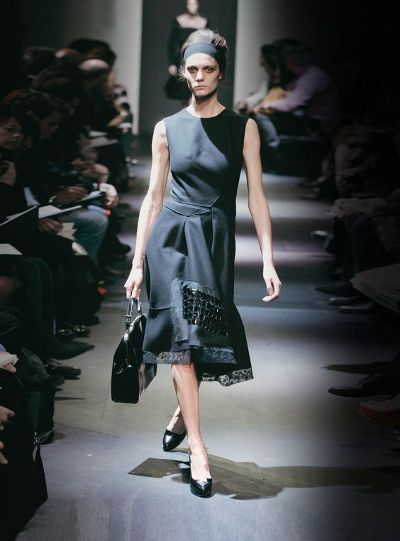
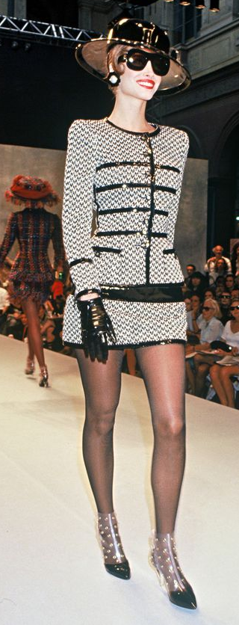
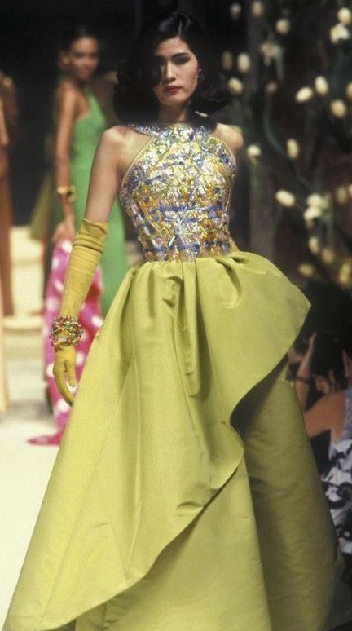
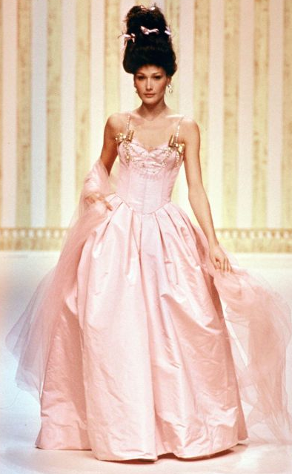
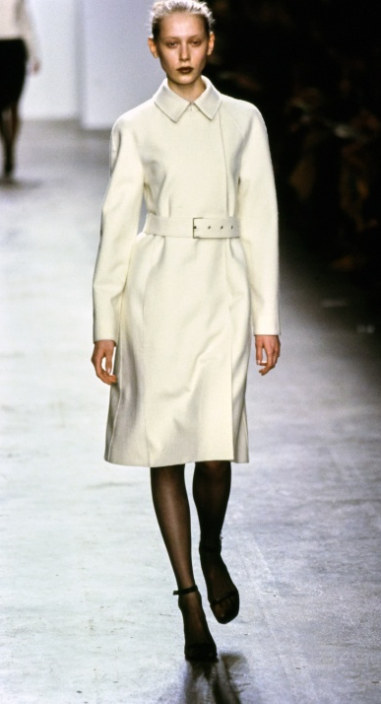
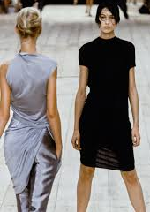
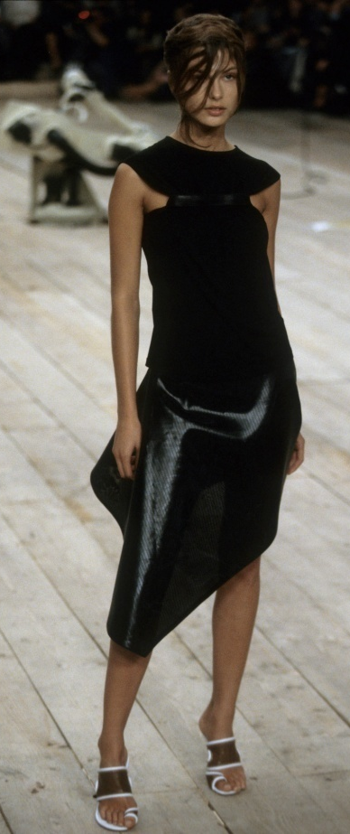
Bill Blass would travel hundreds of miles only to find out what his customers did and did not desired in a fashion line. He spent over two decades having crazy amounts of success in menswear and womenswear. He then went on to create Bill Blass Limited, which began to create swimwear, furs, luggage, perfume and even chocolate. The biggest item in fashion from the Bill Blass collection was the women's blazer, dressed up with fur trimmed wrap coats and cardigan sweaters. In 1972 Blass introduced a Ready-to-Wear sportswear collection. Then he re-created the cocktail dress, and in 1978 he also created a signature perfume. All of Bill Blass sales by licensees reached theamount of $200million by 1980.
Activity - 1999
Activity - 1999
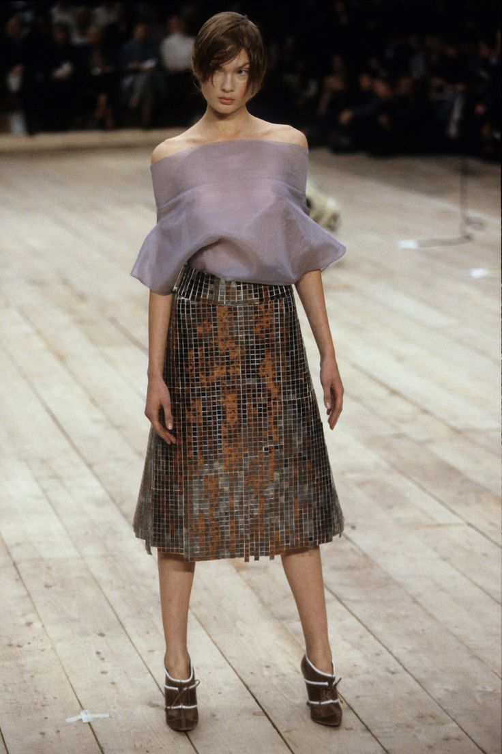
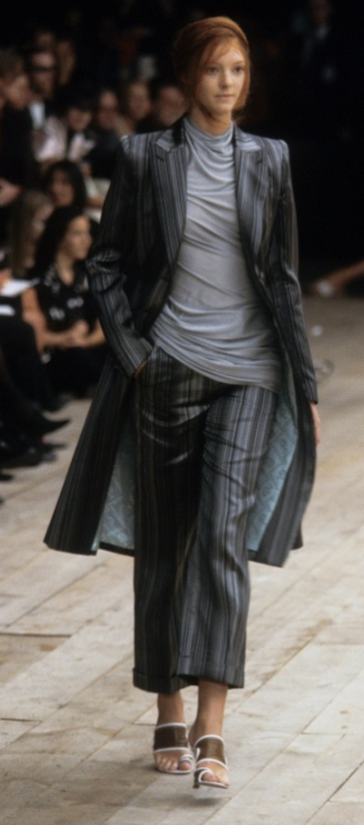
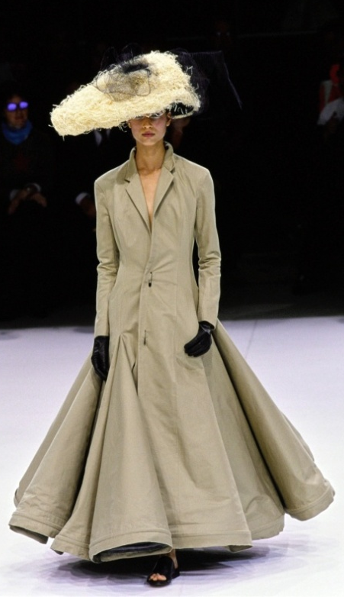
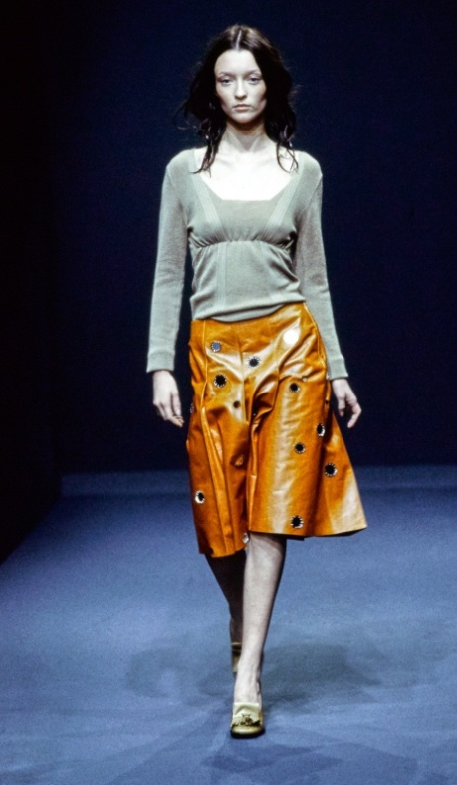
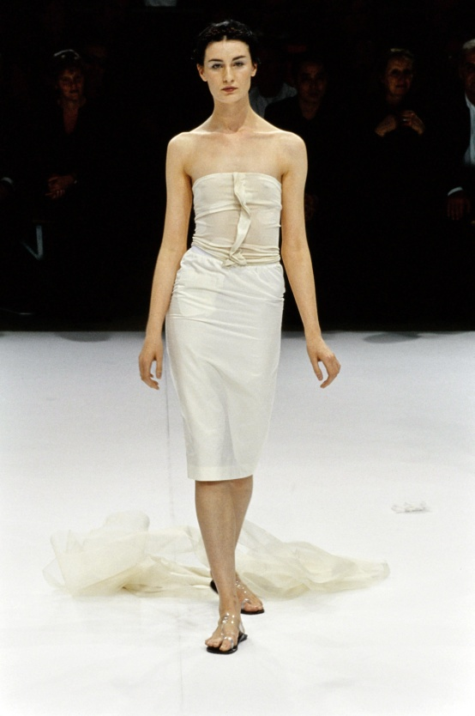
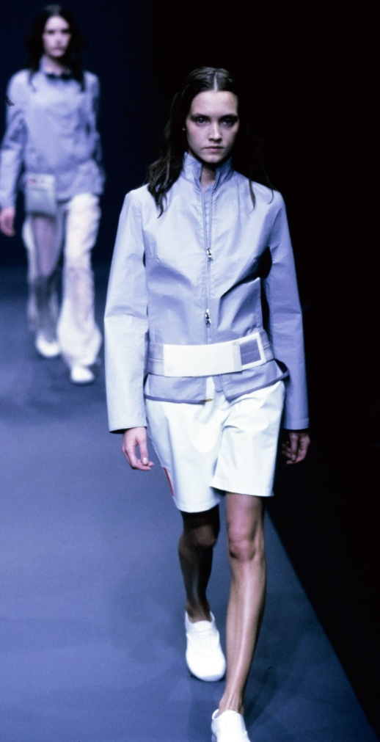
Activity - 1999
Activity - 2005
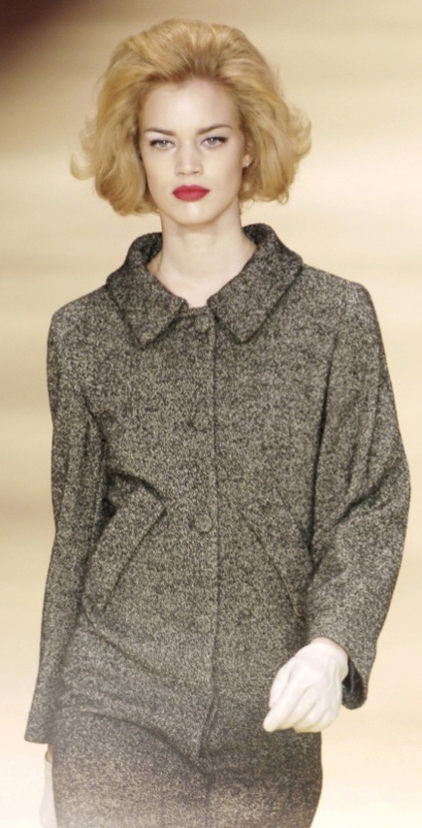
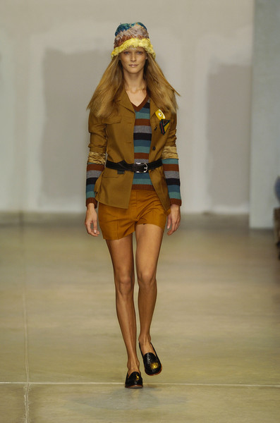
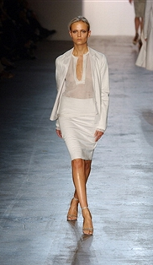
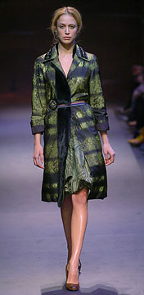
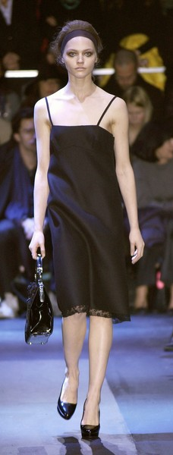
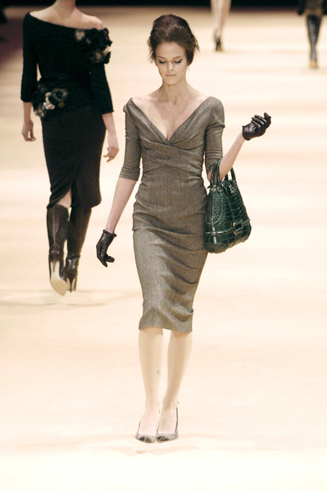
Activity - 2005

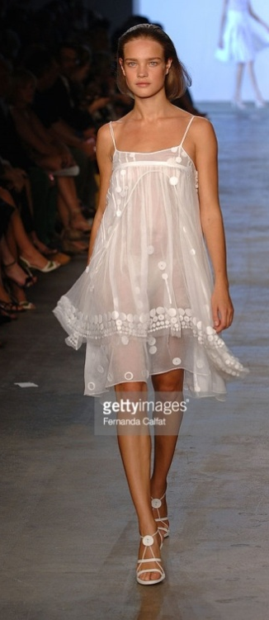
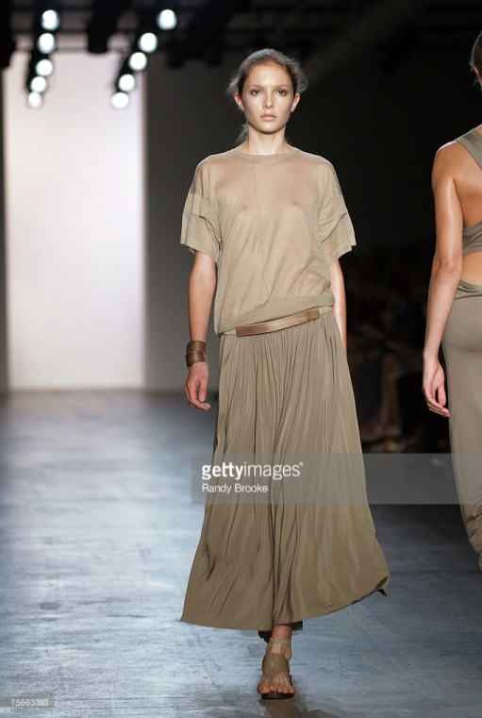
Activity - 2005
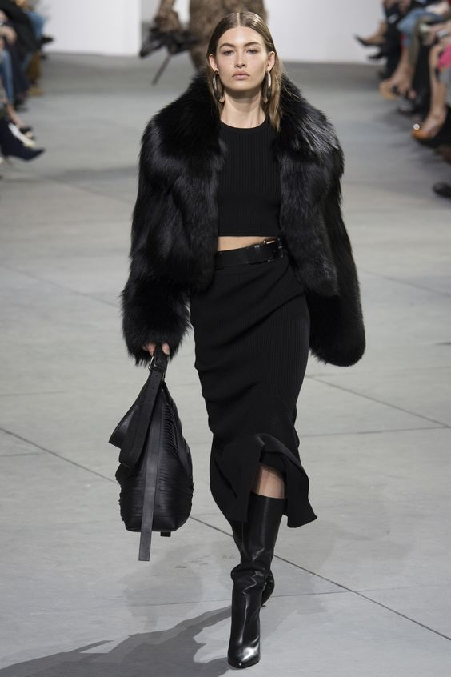
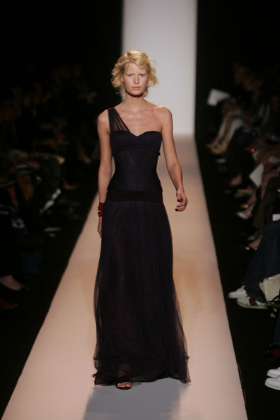
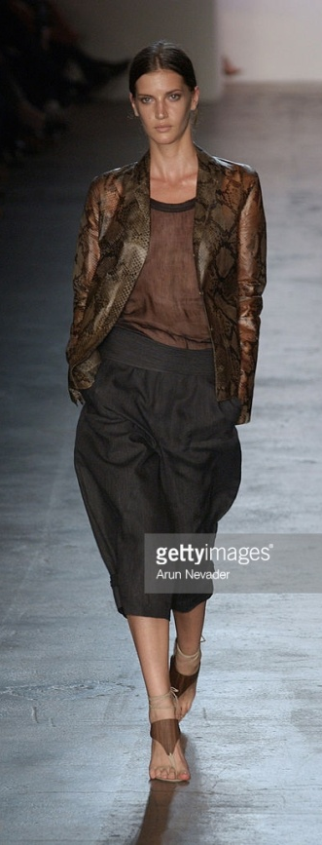
Activity - 2017
Activity - 2017

Activity - 2017

Activity : Report
Morden day fashion has came a very long way during the last two decades. Even further from the start of the revolution of style. Fashion that currently surrounds the world is much more controversial than it has ever been. Many mainstream designers use fashion as a way to portray their thoughts on certain issues across the nations.
As mentioned before, fashion is not really used as a means to promote anything political, but only rather to express people's social views.
Modern day fashion has recently became all about expressing who you are and what your stance in society is. Fashion is now meaning more to a lot to people than it has ever. It is shaping each and every generation more and more as the time goes on.
Fashion which was around in the 90's has been a big influence for the styles and trends which are around in this decade. The 90's high fashion was very sleek and elegant like high fashion is now. The pictures I have included above show a few typical high fashion runways of the year 1999. The whole picture to me is that the fashion was very simple. Rather practical. I get the impression many designers didn't like to go out of their comfort zone, in fear of the audience's reaction. Which is understandable, if your audience doesn't approve then you really have a problem. No fashion from this year really pops out to me and amazes me into wanting to research more of the looks that are shown. I think the main styles from the late 90's is rather mediocre and really just average. However if you look further back into the 90's, the fashion was a little more out there. Patterns and styles were all the rage, matching suit sets was a need for every woman of the early years in this decade. Street fashion in the 90's was a near polar opposite of high fashion. Street fashion was a lot more punk and seemed to be a little rebellious. This style was rarely found in fashion magazines over the years until only recently. I think the magazines of the past always focussed on high fashion, to make readers think that this was the only fashion allowed and approved around the world. This bought more and more publicity to the major high fashion brands.
In the years of the 2000's, fashion really started to come out of its shell. People made their daily styles more daring and controversial. Expressing yourself through your style was becoming a trend, and everybody was into it. As you can see from the fashion photos above, in the mid years of the 2000's, designers began to experiment more with different colours, shapes, and materials. It certainly paid off. These years and the trends that came with them have shaped our view of certain styles for the past decade and some. These years and designers initiated the beginning of high fashion as we know it today. Daring, courageous, full of ambition and life.
With the lower necklines, and shorter hems, and the different patterns being incorporated, you can see some resemblances between the years of 2005 and 2017. Designers in 2005 had only just began to explore the lengths of fashion they could go to. How much patience they could test. Experimenting with necklines and hems were just the start of this high fashion. Designers were no longer afraid to give their name a new modern look. Looking into the past years of street wear, the short skirts and dresses, the bold patterns and colours, designers finally realised this was something normal people wanted and could wear, so why not take advantage of that? In previous decades such as the 80's street wear was rather bold and colourful, because it was the era of discos and all that came with it. However as the years went on high fashion became less fun, less colourful. Until the mid 2000's.
There are not many differences between the fashion of the later 2000's to the fashion of today. Flattering colours, patterns and styles of garments are all very similar, but one hundred percent more modern.
High fashion in the year of 2017 was just something else. Runways were completely breath taking. All garments were eye catching, they were exquisite. Examples shown from above are truly inspiring. Many garments have the same shape as they have had in previous years, but they are accessorised to the max, making it hard for you to look away. Flowing gowns are all the rage in certain high fashion looks, and they show the hard work, thought and time put into each and every design.
In fashion magazines this year, a range of fashion has been shown to us all. Street fashion has recently became popular to most if not all celebs. Trends are making a comeback from all kinds of years, the 60's, 70's, 80's, 90's and the 2000's.
The looks of the late 90's are not so different from high fashion, formal female work wear we see today. Many females wear the classic matching suit garments. These looks were inspired by high fashion in the 90's. The patterns and bold colours really do make a statement.
Street fashion is everything these days. I even believe it is coming more and more popular than high fashion couture. Many known designers are now focusing on street fashion and bringing it into their high fashion runways. It isn't just all about the couture anymore. It is about creating a fashion for anybody, and everybody. It is about being who you really are and expressing this person for all of the world to see, not caring about what your neighbours or strangers think of you and your style. All because it is who you really are.
All in all, fashion really has not changed dramatically at all. A few little tweaks to old styles have really made a difference. Even garments from the early 1900's have came back into fashion, just more accessorised. This just shows the whole timeline of fashion. Everything has, and will make a comeback one day. It just takes one piece which catches a nostalgic designers eye, to potentially revive a whole nation of style.
Past trends are the most important. They are the key to new and improved styles which would be accepted by all. Inspiration is the key. Looking back into time, incorporating many different trends from the past decades, all to create one brand new look. This is what fashion today is all about. Taking ideas from older styles and mixing everything together. It doesn't just create a new sense of style. It creates a sense of purpose for so many people around the world.
Ask anyone what fashion means to them, it's the only way you can truly express yourself.

Student Statement:

By submitting this assignment, I confirm that this is my own work.

Student Signature | B.MEWIES | Date | 16/04/18

For Tutor / Assessor Use Only
Total Marks
Marks Obtained
Percentage / Grade

Bethany Mewies
Assessment One : Fashion Design
Question One
In this assignment I will be describing the characteristic features of the twentieth century fashion. When fashion first became a big thing in the 18th century, it’s thought to be unlikely to think of fashion the way it is now. There wouldn’t have been the major fashion designers such as Calvin Klein and Giorgio Armani. French fashion was considered the trademark of the upper, richer class. The dresses were rather impractical, yet mesmerizingly beautiful. Dresses would weigh numerous kilos, the tight corsets being worn frequently made their wearers sick due to the lack of air and heat in the fixed corsets around their waists. Men’s fashion in the 18th century was rather bright, bold and feminine.
The fashion that we are familiar with in this century originated from the most famous dressmaker of the 19th century. Charles Frederick Worth. Worth came up with the idea of bringing his clients to his home to view his range of fashion, which was updated every year. Charles Frederick Worth was the first to realise that fashion was an essential social element. A fashion house (masion de couture) was then created in Paris. Fashion houses then started to hire fashion artists to sketch out designs for their customers. This saved a lot of time and money rather than producing an actual sample garment. This began to make an economy for the fashion houses because they only made the items of clothing their customer has ordered. Therefore the fashion houses began to make profit, and saved time.
In the early 20th century Paris was declared the heart of high fashion, and then to a smaller degree, London. These cities were home to most of the major fashion designers at this time. The career of a trend forecaster originated around this period when fashion magazines sent out editors and buyers to different high fashion shows in Europe where they started to write about the latest fashion emerging. The editors then used this to their advantage and created their own looks which they’d know their target audience would like. Made-to-measure and Ready-to-wear salons started to present all of the current Parisian fashion. However these styles were actually adapted to each store’s theories regarding lifestyles and the budgets of their audience.
In the 1900’s fashion continued to develop at a rapid rate. Going beyond high fashion only for the upper class, which ruled over the 18th century. The numbers of financially independent women grew, and they insisted on a new type of fashion. The public wanted a fashion which was aesthetically pleasing, but which also practical for the wearer. Many of the target audience for the High Fashion House’s favoured with Paul Poiret in abandoning the corset which dominated the 18th century. A lot of the styles which were around started to slowly changed more practical and elegant fashion. This then became the essential fashion of any well doing woman. Hats too became an essential for women in high fashion. The hats were either petite confections which just perched on the top of the head, or they were colossal, covered with ribbons, flowers sometimes even feathers. They both made a huge statement.
As the fashion industry expanded, the image of fashion became a lot more flexible. Women became a lot more independent with their style, meaning that they no longer wanted or needed help dressing from their maids. As the years went on the colours used in fashion became a lot more rich and bold. Geometric shapes were also growing more popular. Hats however were not as popular and luxurious. Simple small felt hats were the most popular at the time; others preferred little clouds of tulle. It has been noticed that the first real socially important fashions occurred in these years. The first female couturier, who made the first real fashion shows happen, also then expanded and started to open foreign offices in London, Buenos Aires and Madrid, building her ‘empire’.
As the years of the 1910’s went on women’s fashion started to change even more. As WW1 continued, more and more men had to join forces to fight in the war. This meant a lot of labouring jobs had no one to complete them. The women started to dress as men, borrowing their brother’s and father’s clothing. A lot of the garments women wore hid all of their feminine features. The bright and bold colours of the earlier 1910’s now changed to a darker, earthier tone for all of fashion. This was to mourn all the dead returning from the wars. Most of the big social events were postponed to a happier time.
In the 1920’s hair began to change a lot. A shorter, bob style came into fashion for most to all women. This new hairstyle heavily complemented the flapper style of clothing which was very fashionable. Sportswear came into fashion in a big way for mostly men. Loose fitting sleeves paired with sweaters and brief trousers made the sportswear fashion very comfortable and popular. Tuxedos were worn only at formal social events. The Lavin design was now the style of the time. It was comfortable; yet elegant. Dresses were covered with trimmings and embroidering.
Fashion houses started to feel the effects of the Great Depression in the early 1930’s. This made fashion a lot less exciting and mesmerising. Men’s fashion was a lot more informal. The garments worn were mostly for the fact that they were comfy and useless for labour work. Women’s daytime style was a lot slimmer, tighter fit, imposing yet elegant. Broad shoulders were getting more in style as the years went on.
As the time grew closer to the mid 20th century, Paris’ reputation on being the home of high fashion started to diminish. Mass manufactured fashion started to expand around the world. This meant that fashion was a lot quicker and cheaper to make. Central heating had just been invented and therefore ‘Minimal Care’ garments were created.
As the years went on, many fashion houses closed. This means that the big influence on fashion is now disappearing. The home on fashion now started to relocate to New York City. At this time WWII was now in its full swing. Meaning heavy rationing for fashion. This was a big influence on everybody’s fashion. For each garment, specific measurements were given to designers, you were not allowed to exceed this generous amount of material you were given. Else there wouldn’t be any more to use on different garments, because of the rationing for the war.
As Paris was becoming less and less involved in the high fashion environment, this gave America the chance to explore their creativity in fashion. This lead to plain and simple cut garments coming back into fashion.
Christian Dior was slightly going back in time with the fashion he started to produce for his audience. Dior loved the classic tiny, corseted waist, with a majestic bust and a full blown skirt, this style started to match with the Victorian era. However many of Dior’s audience were not too fond of his new look. This then lead to a disagreement between Dior and Chanel. Chanel was very keen on femininity in her fashion. Chanel wanted a change from the sensual kind of elegant which was difficult to wear that Dior provided. Therefore Chanel’s style became more classic and elegant, yet it was very comfortable.
As the 1950’s arrived, the Hollywood Film star glamour came with it. Fashion houses started to notice that dresses and outfits worn by actresses would get a lot more publicity from the media than normal designs that the fashion houses would create. The looks which would get the most publicity would include materials like chiffon, fur, and they would be covered in sequins. Designers found that looks with one memorable detail got a lot more exposure. These looks would contain something like a low cut back, or a noticeable accessory. Big stars like Marilyn Monroe played a big part in influencing the fashion styles of the 1950’s.
As the years went on, the style of clothing in the 1960's was very influenced by the 1920's. Separate types of fashion came around. There was a style of clothing for adults, children and the youth. This meant there was no more fashion equality. A lot of the changes that occurred in the fashion industry happened in London. Most of the upcoming fashion designers focused on making fashion for a younger audience. The designers started to make their garments a lot more futuristic. The colours were bold and bright, this started to represent the mood of the 1960's. Hats were not really big in fashion anymore. People only really wore them for special occasions such as weddings.
At the start of the 70's a countrified fashion grew very popular. Hems were dropped, shoulder lines dropped. Knitted and crocheted garments were arriving into fashion in a big way. Fashion in these times was modernised, feminine and westernised. A big designer in this time was Rykiel. This designer made her creations look different and individual, but the style could be worn anywhere. Floral prints were the epitome of fashion in this time. In the late 1970's punk started to expand in the likes of fashion. This originated from London. As the 70's went on, Italian fashion grew with it, their styles became more and more fashionable. Milan was now classed as the second hub of high fashion, even though Paris' reputation started to fall apart.
In the late 20th century, fashion shows expanded into the media. The media loved to turn these fashion shows into the biggest social events of your calendar. A lot of fashion houses and designers were turning to the past for major inspiration. This lead to the outcome of lycra and spandex, which were a must have.
When the 1980's had arrived everybody took more and more consideration in their appearance. Everybody cared about the way they looked, and of course they didn't want anyone to look better than them. The style of the working woman was big in this era. Garments were comfortable and simple so that women could easily get on with their lives and jobs without worrying about their style. The 80's also became the supermodel era. Everybody wanted to look like a supermodel, with their body and their clothes. The models in the fashion shows were a huge inspiration for the population. The Japanese fashion was rather simple but was a great hit with its audience. Their style was full of modesty, with little to no makeup, and without any accessories. However the America style was pretty much opposite, it was rather seductive and clingy. They called it casual sophistication.
A lot of ready to wear fashion was available everywhere to buy in the 1990's. The fashion style of the 90's was very comfortable and wearable. The style had steered away from the fashion guidelines that had a bigger influence in the earlier years of the 20th century. Garments tended to be very feminine, sexy and covered with bold bright colours. The fashion industry just kept growing and growing. The younger audience were still the ones to impress. With this in mind, fashion designers started using different ways of publicising their creations. Television adverts helped businesses promote their fashion massively. The whole world became more interested in fashion. It was a whole new market for everybody in places like Asia. Fashion was still big in the USA and Europe, it just kept growing, and became more and more successful.
The 2000's was the era of luxury. Most of the big fashion designers had a large circle of famous, celebrity best friends. These celebrities would help promote the fashion. Just like previous years, designers would look back on different era's to help them come up with an amazing new style which would be loved by their audience. Looking back at previous designs and then merging them with some new modernised designs would create all styles of this era. The 2000's were the years for the vintage clothing look. All designs from the 60's/70's/80's and 90's influenced the population a lot. In the early 2000's the style was very minimal, similar to the 90's. However as the years went by the styles got more and more excessive. Designs were colourful, feminine, and traditional rather than modern. Even celebrities started to launch their own clothing lines which everybody approved of.

The fashion that we see in the 2010's is like a timeline of all previous styles since the first day someone thought fashion was more than just a garment you threw on yourself. Fashion is reflection of all society and past events. The style of the decade has always been heavily influenced by the celebrities of the era. Just take Marilyn Monroe as an example. Everybody wanted to dress like her, meaning they wanted the clothes she wore and wanted. A lot of styles from previous eras are now re-enjoying the limelight, as they have come back into the fashion that everybody wants to be wearing. Fashion designers will always be looking to the past for inspiration, and then reworking all of their ideas to make a completely new style. Fashion is the main thing you notice about anyone. You can tell a lot about a person by how they present themselves with the garments they choose to wear and purchase. Fashion is an aesthetic element that plays a part in everyone's lives. Without every single fashion design from the past, or every little thing that happened to do with fashion in the previous eras, we wouldn't be half as educated as we are now on the subject of fashion and expressing yourself. The characteristic features you choose in your fashion sense show many people a lot about you.
Fashion is not used as a political tool, but as a social tool. It is a way of expression, and something that everybody knows about. Even if you only know your own style.

Question Two
The most influential fashion designers in the 1970's were most likely Giorgio Armani, Nino Cerruti, Sonia Rykiel, and Bill Blass. Giorgio Armani was mostly known for his suit wear. Armani originally specified in menswear, with his loose and weightless suits. He then adapted to womenswear, his female designs were connected to the working, suited class. The symbol of his style was effortless, and minimalistic garments. His radically different blazer first came to light in the fashion world under his own collection between 1974 and 1975. A look was created when Armani pulled of all padding and lining of these blazers, leaving out all stiffness. As the 1970's went on Armani would create the 'Wedge shaped Power suit.' Adding even more padding. This style was still comfortable and casual. The look created gave men broader shoulders and slimmer hips.
Nino Cerruti, once known as 'the madman of fashion' also started to focus on the businessperson aspect of fashion. Classic woollen suits were what Cerruti was most known for. Cerruti's fashion boutique launched their first full womenswear collection in 1976. This lead to a great expansion of the fashion house. Giorgio Armani had already formally worked with Cerruti at his first fashion label Hitman. The 1881 Diffusion Line, a ready to wear collection for men and women, (Cerruti Arte), Cerruti Jeans, Cerruti Brothers business collection, (for men), and 1881 Shapes are just a few of his lines. These were all re-categorized under the name 'Cerruti 1881'. Cerruti also created fragrances and accessories for his target audience.
Sonia Rykiel had a very clear image of what she wanted to fashion to be like. She created fashion that she would've liked to wear, not worrying about the popular trends of fashion. Her whole fashion range was very personal and individual. Her main style of garments were all elegant, sensual, yet very comfortable. Also known as the 'Queen of Knits' Sonia was the first ever designer to reverse seems on garments, and leave unfinished hems as a finished garment. Rykiel loved the fully knitted and crocheted garments. Rykiel opened a household linen boutique in Paris, 1975. Sonia was also known as 'Coco Rykiel' which was a comparison to Coco Chanel. Many Americans believe Rykiel was the true successor of Chanel.
Bill Blass would travel hundreds of miles only to find out what his customers did and did not desired in a fashion line. He spent over two decades having crazy amounts of success in menswear and womenswear. He then went on to create Bill Blass Limited, which began to create swimwear, furs, luggage, perfume and even chocolate. The biggest item in fashion from the Bill Blass collection was the women's blazer, dressed up with fur trimmed wrap coats and cardigan sweaters. In 1972 Blass introduced a Ready-to-Wear sportswear collection. Then he re-created the cocktail dress, and in 1978 he also created a signature perfume. All of Bill Blass sales by licensees reached the amount of $200million by 1980.
Activity - 1999
Activity - 1999
Activity - 1999
Activity - 2005
Activity - 2005

Activity - 2005
Activity - 2017
Activity - 2017
Activity - 2017

Activity : Report
Morden day fashion has came a very long way during the last two decades. Even further from the start of the revolution of style. Fashion that currently surrounds the world is much more controversial than it has ever been. Many mainstream designers use fashion as a way to portray their thoughts on certain issues across the nations.
As mentioned before, fashion is not really used as a means to promote anything political, but only rather to express people's social views.
Modern day fashion has recently became all about expressing who you are and what your stance in society is. Fashion is now meaning more to a lot to people than it has ever. It is shaping each and every generation more and more as the time goes on.
Fashion which was around in the 90's has been a big influence for the styles and trends which are around in this decade. The 90's high fashion was very sleek and elegant like high fashion is now. The pictures I have included above show a few typical high fashion runways of the year 1999. The whole picture to me is that the fashion was very simple. Rather practical. I get the impression many designers didn't like to go out of their comfort zone, in fear of the audience's reaction. Which is understandable, if your audience doesn't approve then you really have a problem. No fashion from this year really pops out to me and amazes me into wanting to research more of the looks that are shown. I think the main styles from the late 90's is rather mediocre and really just average. However if you look further back into the 90's, the fashion was a little more out there. Patterns and styles were all the rage, matching suit sets was a need for every woman of the early years in this decade. Street fashion in the 90's was a near polar opposite of high fashion. Street fashion was a lot more punk and seemed to be a little rebellious. This style was rarely found in fashion magazines over the years until only recently. I think the magazines of the past always focussed on high fashion, to make readers think that this was the only fashion allowed and approved around the world. This bought more and more publicity to the major high fashion brands.
In the years of the 2000's, fashion really started to come out of its shell. People made their daily styles more daring and controversial. Expressing yourself through your style was becoming a trend, and everybody was into it. As you can see from the fashion photos above, in the mid years of the 2000's, designers began to experiment more with different colours, shapes, and materials. It certainly paid off. These years and the trends that came with them have shaped our view of certain styles for the past decade and some. These years and designers initiated the beginning of high fashion as we know it today. Daring, courageous, full of ambition and life.
With the lower necklines, and shorter hems, and the different patterns being incorporated, you can see some resemblances between the years of 2005 and 2017. Designers in 2005 had only just began to explore the lengths of fashion they could go to. How much patience they could test. Experimenting with necklines and hems were just the start of this high fashion. Designers were no longer afraid to give their name a new modern look. Looking into the past years of street wear, the short skirts and dresses, the bold patterns and colours, designers finally realised this was something normal people wanted and could wear, so why not take advantage of that? In previous decades such as the 80's street wear was rather bold and colourful, because it was the era of discos and all that came with it. However as the years went on high fashion became less fun, less colourful. Until the mid 2000's.
There are not many differences between the fashion of the later 2000's to the fashion of today. Flattering colours, patterns and styles of garments are all very similar, but one hundred percent more modern.
High fashion in the year of 2017 was just something else. Runways were completely breath taking. All garments were eye catching, they were exquisite. Examples shown from above are truly inspiring. Many garments have the same shape as they have had in previous years, but they are accessorised to the max, making it hard for you to look away. Flowing gowns are all the rage in certain high fashion looks, and they show the hard work, thought and time put into each and every design.
In fashion magazines this year, a range of fashion has been shown to us all. Street fashion has recently became popular to most if not all celebs. Trends are making a comeback from all kinds of years, the 60's, 70's, 80's, 90's and the 2000's.
The looks of the late 90's are not so different from high fashion, formal female work wear we see today. Many females wear the classic matching suit garments. These looks were inspired by high fashion in the 90's. The patterns and bold colours really do make a statement.
Street fashion is everything these days. I even believe it is coming more and more popular than high fashion couture. Many known designers are now focusing on street fashion and bringing it into their high fashion runways. It isn't just all about the couture anymore. It is about creating a fashion for anybody, and everybody. It is about being who you really are and expressing this person for all of the world to see, not caring about what your neighbours or strangers think of you and your style. All because it is who you really are.
All in all, fashion really has not changed dramatically at all. A few little tweaks to old styles have really made a difference. Even garments from the early 1900's have came back into fashion, just more accessorised. This just shows the whole timeline of fashion. Everything has, and will make a comeback one day. It just takes one piece which catches a nostalgic designers eye, to potentially revive a whole nation of style.
Past trends are the most important. They are the key to new and improved styles which would be accepted by all. Inspiration is the key. Looking back into time, incorporating many different trends from the past decades, all to create one brand new look. This is what fashion today is all about. Taking ideas from older styles and mixing everything together. It doesn't just create a new sense of style. It creates a sense of purpose for so many people around the world.
Ask anyone what fashion means to them, it's the only way you can truly express yourself.

