
Assignment Cover Sheet

Student Name: | RANA M NAEEM
Student Number:
Course: | Risk Management
Assignment NO: | 1

Marking Criteria:
We expect the learners to write minimum one well expressed point in three lines against each allocated mark. This means one needs to write 15 lines with 5 well expressed points to get high grades for a 5 marks question.
For high grades use examples and illustrations where appropriate.
Please insert your completed assignment ( in word format) here:

-BRIEFLY describe the history of risk management ?
Before we discuss the history of risk management ,we can define risk management as :the identification , analyses, and economic control of those risks can threaten the assets or earning capacity of an enterprise ,
The benefit of risk management ,is as following : it reduces the potential for loss by managing hazard ,and provide a discipline approach to quantifying risk .It help to emphasize a good reputation of a company
Risk management was established on 1956 by one of the Harvard business specialist, according to them, business managers should learn how to make an adequate low cost budget plan ,and to decide whether to buy insurance course. Company employee e are responsible of the budget.
Therefore , insurance become an important items in many budgets due to the growth of capital investment .then insurance was given to in-house specialist
On year,1950s , two Scientifics studies reports , the Gordon and Howells report said that business schools in America is out dated and ineffective in training business students.as result , some school objected to the final conclusion of the reports ,they began to teach anew operational programs to be able to make a wise decision concepts, so they are looking for the most effective option to prevent losses , using some special tools ,one of the tool is risk control measures ,and risk finance analysis , these tools is an important aspect in organization s governance , management and operation.
-how can the risk management process be developed?
Risk management is the identification , analysis and economic control of the risk , that threaten the assets of an enterprise
However, people has create a tools to cultivate food ,ans developed many researches to manage certain natural disasters , such as monitoring earthquake , changes in climate etc
Risk is the possibility that a loss or injury will occur, the loss of the house in flood ,theft and fraud is another challenge that can be managed through establishing efficient rules by the legislators
Also, risk forms parts of every decision made by business , when starting up new business , there is uncertain that a loss of assets of the office could be exposed to a theft or fire
Actually , there is no universal definition on risk ,the term found most commonly in all the detentions are : indeterminacy and loss
If we buy and new office , we are expecting loss in products subject to wear and tear. People driving a car or starting up new business are in situations that involve some risk
Quality the ability of the company to introduce a good product / service that can satisfy customers .
So we can learn certain detentions, fundamental risk is the risk that affects a huge number of people or even an entire population , e.g , unemployment earthquake , its beyond the control of human. where as particular risk
are loss that affects individual e.g a destruction of house roof , a car accident ,is an example of particular risk.
Pure risks is called absolute risk it is happening beyond the control of human , it has only one possibility out come
Also there are deferent type soft pure risk ,personal risk , property risk, and liability risk ,
On the opposite side, speculative risk refer for situation where there potential for loss or gain .so three possible out comes exists: something good gain , bad gain or nothing
In business world today ,Many business schools teach student, the key solution to create a wise plan to control risk , by using physical control measures and financial analysis programs
The efficient and wise manager will make a plan to control risk , either to buy and insurance or to reserve some money .that is called ( self insurance)
. risk management is the process of identifying , monitoring and managing potential risks in order to minimize the negative impact they may have on an organization .e.g system failure , security breaches
The component of risk are defined in three parts :risk assessment , risk analysis risk evaluation and risk treatment
First of all , risk assessment and analysis stage :employee evaluates an organizations exposure to uncertain events that could impact day to day operation and estimates the damage those events could have on an organization reputation. Second ,risk evaluation : is to study the company system associated with costs and benefits ,socio economic requirement and legal requirement
The last one , is to determine the policies and procedure that will help to avoid or minimize risk

What are the main benefit of risk management?-
-briefly describe the three general risk management techniques?-
we can define risk management as :the identification , analyses, and economic control of those risks can threaten the assets or earning capacity of an enterprise ,
The benefit of risk management ,is as following :
it reduces the potential for loss by managing hazard ,and provide a discipline approach to quantifying risk .andIt help to emphasize a good reputation of a company
Since 1950, studies and researches improved the role of the manager in the business schools , they teach quality of establishing risk plan by using the tools : risk analysis and risk control process
The main component of risk control .the risk physical control measure , and financial control measure.
There are two types of risk that can be used to control risk ,dynamic risk its the risk that emerge due to change in the economy ,such as :changing in prices consumer expectation and technology may lead to financial losses
The Dynamic risk benefit society and affect a large number of people , where as static risk shows no gain to the whole society , its losses that occur even if there are no specific changes in the economy , such as , productivity some people would still suffer financial losses they are predictable , the physical wear and tear of the assets itself or its loss due to theft or human error.
The benefit of risk management is to minimise the expense With those risk , People thinks that the best way to manage the risk is to buy insurance .therefore, they can learn to manage risk and protect the assets of the firm , there are three technique of risk planning:

RISK Avoidance
It is the service or product cost that developed high risk when using it , the decision is wise to avoid it such as a company that doses not bring out new products will probable close down as they are no longer competitive
Also , To prevent losses thru theft in jewellery shops , the jewels lock their stock in vaults at the end of the working day.
Risk reduction
When a manger know that he or she can reduce the risk of the service or product sales, a company can reduce the risk of product failure through careful marketing planning and to consider the cost of risk , and manager must learn to make a quick and deliberate decision
The strategies can be employing security guards and establishing sprinkler system ,installing equipment of alarm system . in addition to , introducing account and financial regulation , will protect a company stock and funds from theft
Risk assumption
It is the challenge and cost of marketing new products and services:
When a business lunch a new product , they can understand the potential risk of product failure , in order to control such criteria
It is sensible to summarize a risk when more that a following circumstance ,the possible loss is to small practical risk management, and there is no alternative option to reduce the loss then
Self insurance is a good way to solve large loss in the company

RISK MANAGEMENT CAN MAKE DEFFIRENT DIRECTLY TO PROFIT?-
-
we can define risk management as :the identification , analyses, and economic control of those risks can threaten the assets or earning capacity of an enterprise ,
The benefit of risk management ,is as following :
it reduces the potential for loss by managing hazard ,and provide a discipline approach to quantifying risk .andIt help to emphasize a good reputation of a company
Since 1950, studies and researches improved the role of the manager in the business schools , they teach quality of establishing good risk plan, by using special risk tools : risk analysis ,and risk control
The main component of risk control .the risk physical control measure , and financial control measure.
Does risk management can make deferent to profit ;yes it is ,
The first of all it can be guarantying that the organization wont be held back , risk will be reduced through risk control programs, achieving the other business goal by pure risk losses
Second,Risk management can impact company profits directly by managing the cost of risk for the organization since profits ate measured by cost relative to income , the extent to which risk management can minimize costs will directly increase profits
Third, The risk manager can increase income for example if the risk manager sees the affordable political risk insurance is available , manager can improve profit margins
The risk manager responsible for managing all pure risk can select from many different risk management method .they intend to make a large contribution to the operating outcomes of the organization.

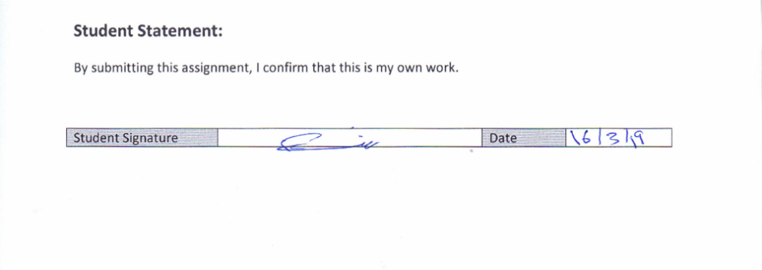
For Tutor / Assessor Use Only
Total Marks
Marks Obtained
Percentage / Grade

