
Assignment Cover Sheet

Student Name: | WINIFRED HAREWOOD
Student Number: | 13129
Course: | INTRODUCTION TO FASHION DESIGN
Assignment NO: | 1

Marking Criteria:
We expect the learners to write minimum one well expressed point in three lines against each allocated mark. This means one needs to write 15 lines with 5 well expressed points to get high grades for a 5 marks question.
For high grades use examples and illustrations where appropriate.
1. Give short answers for the following questions: (8)
(i) How did the First World War influence fashion? Which types of changes were brought about by it?
Due to the war:
- women took on jobs previously held by men. Women’s attire therefore change from restricted silhouettes to suits, split skirts, trousers and the high waisted empire-line dress.
- Hands and faces were protected with gauntlets, a face mask, and balaclava helmets all made from leather boots and long coats. Trench coats were military-style gabardine overcoats with epaulets wide lapels a belt for the waist.
The changes brought about by the war were:
- Colours become sombre and the cuts more practical.
- Emphasis was place on a natural defined waist and A-line skirt.
- Shorter, fuller skirt styles allowed greater movement, some women adapted trousers in the form of job prints or boilersuits.
- Oriental influences in the form of tunic, turbans, silk pyjamas, jackets, belts and epaulets became a part of fashion.
- Short hair styles for practicality to avoid being caught in machines.

(ii) Describe the characteristic features of the Twentieth Century’s fashion scheme.
- New synthetic fabrics - spandex, polyester, and nylon.
- Dresses and or separates had high collars, puffed out bodices and full skirts were worn over layers of rustling petticoats embroidered with tiny flowers or draped with lace.
- Bodices were pintucked or decorated with sewn on ribbons and bows
- Reduction in the use of corsets
- tea-gown – loose, flowing gown worn before dressing for dinner – crepe` de chine, chiffon or tulle.
- Hats covered with feathers or whole stuffed birds.
- Suits – tailor made- tweed- working women such as governess, typists, store assistants in the early 1900s.
- Men – black morning coats with pinstriped trousers in tweed or checkered three-piece suit; hat outdoors.
- earth tones had begun, with brown, khaki and olive drab were rising.
- Skirts hit at about the knee, heels got higher, and shoulders got wider.
- Black, white, red and grey joined the still-popular earth tones in the colour palette in the .
- Introduction of innovative designers such as Coco Chanel -collarless cardigan jacket with contrasting border and a knee length skirt
- Introduction of the mini skirt, midi skirt
- Reintroduction of vintage clothing – influence of the Beatles, emergence of thrift shops
- Sportswear emerged – spandex
- 1980s – women’s suits had wide shoulders due to shoulder pads and skirts were shorter for example Dynasty characters- Alexis Carrington Colby and Krystle Carrington.
- 1990s “grunge” and unisex look
2. Write brief note on the works of main fashion designers in the 1970s. (7)
Yves Saint Laurent
Yves Henri Donat Mathieu-Saint-Laurent (1 August 1936 – 1 June 2008) was known for making pants for women to wear for work and formal dress. Prior to the 1970s, women wore pants mostly only in casual settings. In 1966, Saint Laurent introduced the city trouser, and then in 1968, his collection included women's trouser suits, such as the safari suit. The trends began to take hold during the 1970s and remain a popular style in the 21st century.
Halston
Roy Halston Frowick (April 23, 1932 – March 26, 1990) was famous for draped jersey dresses, lean trouser suits and the use of ultra-suede fabricc. He also created turtlenecks, knitwear, sweaters, sweater sets, boxy square jackets and wide-legged jersey trousers. He was also a famous eveningwear designer.
His designs were perfect for dancing because of their draped and free-flowing construction without buttons or zippers. The jersey halter and one-shoulder style dress were his most copied. Halston designed for many celebrities and was one of the first major designers to license his name, making his clothes more accessible to everyone.
Vivienne Westwood
Vivienne Isabel Westwood (8 April 1941 – 29 December 2022) Dubbed the "Mother of Punk," Vivienne Westwood is a British fashion designer who played a big role in punk rock's influence on fashion in both America and Great Britain during the 1970s. Westwood is known for bondage pants, platform shoes and punk.
Missoni
Born on February 11, 1921, Ottavio Missoni was the founder of Missoni and represented Italy, as the hurdler in 1948 Olympics. This Italian fashion design house was born in 1953 and the brand is best known for knitwear and its bold, bright space-dyed weave patterns. The Missoni zigzag pattern knit is recognizable and made the name Missoni a fashion icon.

Diane von Furstenberg
Born Diane Simone Michele Halfin, 31 December 1946. Diane von Furstenberg made the jersey wrap dress a wardrobe essential. The kimono-inspired wrap dress was her trademark, however von Furstenberg also influenced fashion by establishing a standard for ease and comfort in women’s clothing. Von Furstenberg's robe-like design was a major '70s trend and copied by many mainstream fashion labels.

Thea Porter
Dorothea Noelle Naomi "Thea" Porter (24 December 1927 – 24 July 2000). She was a half French, half English designer. She travelled the world, and this translated into her multi-cultural ethnic experiences into clothing that inspired the bohemian look of the 1970s. Her design career began with her own extensive textile collection and a Middle Eastern import shop in London. Porter made caftans and maxi dresses, often out of antique materials like voile, velvet, chiffon and brocade.

Bill Gibb
William Elphinstone Gibb (23 January 1943 – 3 January 1988) was a Scottish fashion designer. He was a perpetuator of its trademark hippie styles. He mixed prints, textures and embellishments with ethnic, medieval and romantic influences and shapes of the past, like full-length skirts and billowing sleeves.

3. How did the Nineteenth Century influence the fashion industry? What major changes came about in fashion industry in the early Nineteenth Century and why? (7)
The major changes that took place in the Nineteenth Century was as a result of various instances such as wars, industrialization, etc. which influenced the fashion industry of that period. Historians have defined the "Nineteenth Century" as the period from 1815 to 1914. The following took place and influenced the fashion of the time:
- Napoleonic War (1802 -1815).
- United States expansion with the Louisiana purchase (1803).
- Slavery abolished in the West (1807 – 1888).
- Opium wars and fall of the Qing Dynasty (1839 – 1860).
- Widespread European Revolution (1843).
- Japan opens it borders (1854).
- Asiatic Flu wipes out one million people globally (1889 – 1890); and
- World War 1 (1914- 1918).
The 19th century was therefore a revolutionary period for world history and a time of great transition in all aspects of life. Human and civil rights, democracy and nationalism, industrialisation and free market systems, all steered in this period of change.
Women's fashions at the beginning of the century were styles that revealed more of the female figure it then shifted to wearing large dresses with huge sleeves and skirts and heavy ornamentation. It then changed to incorporate slimmer silhouettes, or profiles, with the fullness of the skirt limited to the rear bustle. There were huge variations in skirt and sleeve size, waistlines were pinched tighter and tighter due to a variety of constrictive corsets throughout the century.
The style of dress worn by men became increasingly somber and less flamboyant throughout the century: stylishly dressed men, such as George "Beau" Brummell (the arbiter of British men's fashion) who influenced male fashions by replacing fancy outfits of ornate waistcoats and ruffles with plain dark jackets, high-collared shirts and simple cravats, and vests.
Fashion was influenced by designers such as:
- Charles Frederick Worth (1825–1895) was an English fashion designer who founded the House of Worth, one of the foremost fashion houses of the 19th and early 20th centuries. He was the father of haute couture. Worth revolutionised the business of fashion with the sturdy work pant and blue jeans. Worth’s designs are notable for his use of lavish fabrics and trimmings, his incorporation of elements of historic dress, and his attention to fit.
- Paul Poiret (April 20, 1879 - April 30, 1944) was an innovative French couturier who dressed Paris' finest before World War I. He epitomized Art Deco fashion and is credited with freeing women from tight fitted corsets as well as introducing new silhouettes like the hobble skirt, harem pants, and lampshade/ high -waisted tunic; and
- Louis Vuitton (4 August 1821- 27 February 1892) was a French fashion designer, skilled craftsman and businessman. He was the founder of the Louis Vuitton brand of leather goods such as high-end leather goods, legendary steamer trunks, iconic monogram handbags, sublime watches and jewellery and cutting-edge fashion.
In addition, during the nineteenth century the change in fashion was assisted by the introduction of machines in the construction of clothing. Sewing machines, power looms, or weaving machines, steam power, electricity, new dye formulas, and other inventions increased the speed and ease in the manufacture of clothing. These inventions were used to add embellishments to women's clothing; machine-made trimmings were applied in bulk to the enormous flowing gowns.
Activity
Look through some old magazines; cut-out pictures showing the fashion trends of the last two decades. Also, find some photos from the latest fashion shoots and compare them. How does modern fashion dresses differ from those of the past? Discuss in a report. (8)
Fashion is the acceptance of styles and includes accessories or beauty products which are consistent with the trends. In comparing pictures from fashion trends of the last two decades to recent fashion shoots it is evident that the pieces are similar, but the expression is based on what is current. For example, World War 1 resulted in more women wear pants, the 70s fashion was influenced by the hippie culture- long hair, a-line dresses flared pants and wide collar shirts. These styles were recreated but influenced by the period. From the year 2000 to present fashion has been influenced by technology, social and mainstream media. It is what is referred to as Y2K fashion. This report looks at the Baguette Bag; Cargo pants; sandals; sunglasses, trucker hat; mini skirts and the sequin dress.
Baguette Bag
Baguettes are small, compact handbags, designed by Italian fashion company Fendi in 1997, by Silvia Venturini Fendi of the self-named Italian fashion house known for its fur and leather goods. The bag is thin and compact, designed to sit comfortably under the arm in the same way the French carry their daily bread and was therefore christened, the Baguette.

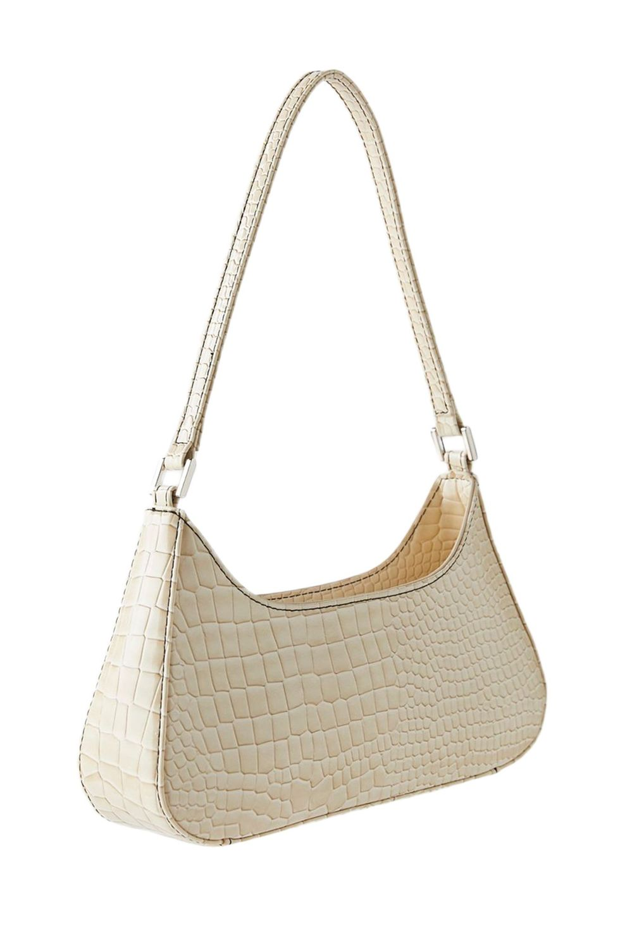
It was made popular by the sitcom “Sex and the City” in the late 1990s and early 2000s. It is often referred to as the first “it” bag. According to VOGUE the signature snug under-the-shoulder carry and flap closure made iconic by Fendi is ideal in spring of 2023 due to the Y2K trend.

Cargo pants
Cargo pants also known as battle dress was first worn by members of the British Armed Forces in 1938, and were introduced to the United States in the mid-1940s during World War II. The large pockets characteristic of cargo pants were originally designed for British forces to hold field dressings, maps, and other items such K rations and extra ammunition in the United States virgin of the design.
Cargo pants or cargo trousers are also called combat pants or combat trousers after their original purpose as military workwear. They are loosely cut pants originally designed for rough work environments and outdoor activities, distinguished by numerous large utility pockets for carrying tools, etc.

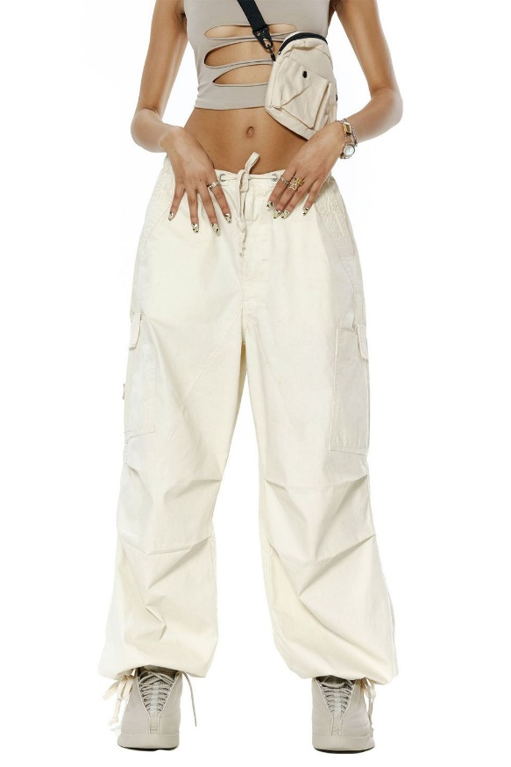
In the early 2000s Cargo pants were a popular fashion trend. They have enjoyed renewed popularity in the 2020s as part of the 'Y2K' fashion trend, where 2000s fashion trends have been brought back into fashion.
Cargo pants are the look of choice for 2023 with baggy legs, long hems, and maximum pocket space. The waists are higher than their super low-rise counterparts in 2000. According to the New York Post, 2023, “Female R&B and pop artists — like TLC, the Spice Girls and J.Lo — made the cargo cool in the aughts. Now the pants are back, with brands like Phillip Lim and Fendi featuring the style in their Resort 2023 campaigns”.
Sandals
Sandals were existence of over 10,000 years. There are an open type of shoe, consisting of a sole held to the wearer's foot by straps going over the instep and around the ankle. Sandals can also have a heel. People may choose to wear sandals for several reasons, among them comfort in warm weather, economy and as a fashion choice. Usually, people wear sandals in warmer climates or during warmer parts of the year to keep their feet cool and dry.
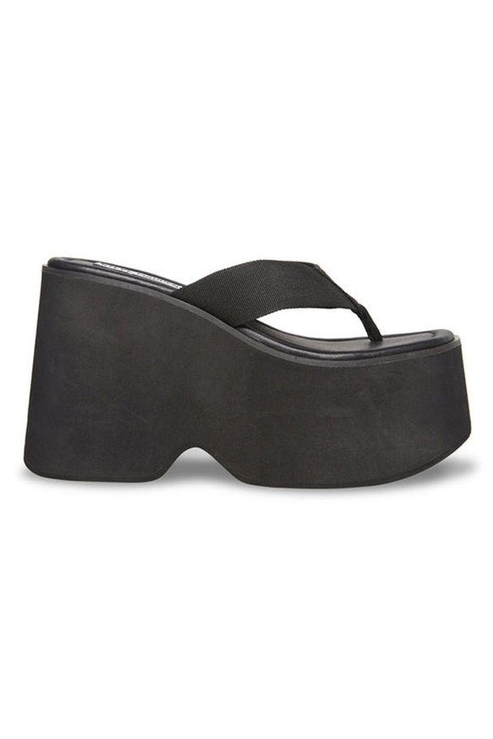
As stated in “In Style” magazine April 2023 the gladiator sandal has already been cycled back into wardrobes, promising to be one of the most popular footwear trends of 2023. On runways and red carpets for the 2023 have seen gladiators from simple lace-up styles to embellished high-heeled versions.
Trucker Hat
The trucker hat came about in the early 1970's as a promotional give-away from U.S. feed or farming supply companies to farmers, truck drivers or other rural workers, as companies began to realize the cap's potential for advertising and promotional give-aways. These hats are sometimes called "dad hats" or "gimme hats". These hats continue to be part of the accessories of farmers and sports fans.
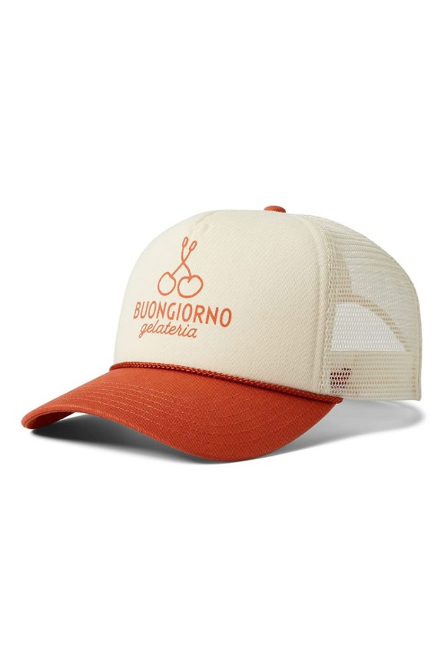
Cornley 2020 stated that trucker hats are prime outdoor wear and was expected to receive a boost the season and retailers were expected to leverage these trends to update their catalogues for Spring 2022.
Sunglasses
Shades or sun glasses are a form of protective eyewear designed primarily to prevent bright sunlight and high-energy visible light from damaging or bringing discomfort to the eyes. Since the 1930s, sunglasses have been a popular fashion accessory, especially on the beach.

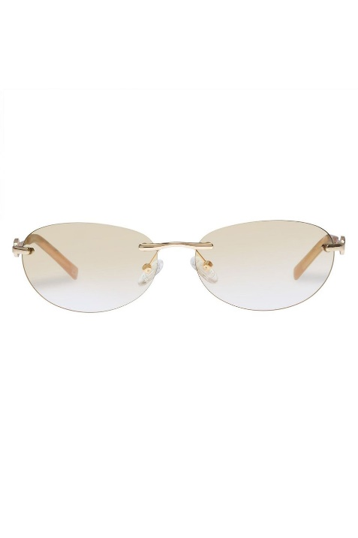

OPTXY indicated that for the Spring/Summer season of 2023, it is all about trendy sunglasses: square frames; cat eyes; and round lenses with large lens openings. The colour of the sunglasses are vibrant and varied with lots of options for color blocking and mixing things up.
Mini skirt
A mini skirt is a skirt with its hemline well above the knees, generally at mid-thigh level, normally no longer than 10 cm (4 in) below the buttocks. Short skirts have existed for a long time they became a fashion trend in the 1960s.

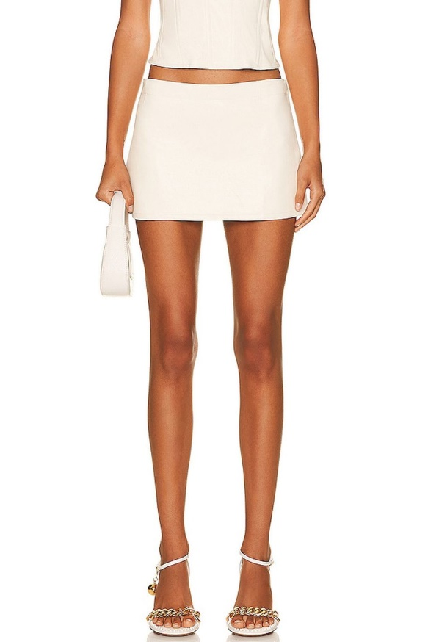
In 2023 as indicated by Brunette from Wall Street, the mini skirt with a big buckle belt creates a look that is both fun and fashionable. It is expected to be the ultimate fashion statement piece that will add a touch of fun and excitement especially if paired with sandal mules and a headband. Denim miniskirts are considered a classic.

Sequin dress
Sequin” originated from the Arabic word sikka, meaning “coin” In the late 16th century, it morphed into the French word, sequin. Formal gowns and suits were embellished with polished disks of metal throughout history, requiring hours of hand sewing by seamstresses. In 1922, archaeologists opened the tomb of Egyptian pharaoh Tutankhamen, revealing splendid garments embellished with tiny disks made of pure gold. Western fashion quickly reflected the dazzling artifacts in King Tut’s tomb as news of the discovery spread. By the 1930s, manufacturers developed a process to create lightweight sequins using gelatin coloured with lead paint. In the same decade, scientist Herbert Lieberman developed acetate sequins when working in film production for Eastman Kodak. He went on to specialize in creating sparkling, over-the-top dance costumes and band uniforms. Modern sequins are typically made of Mylar or plastics.

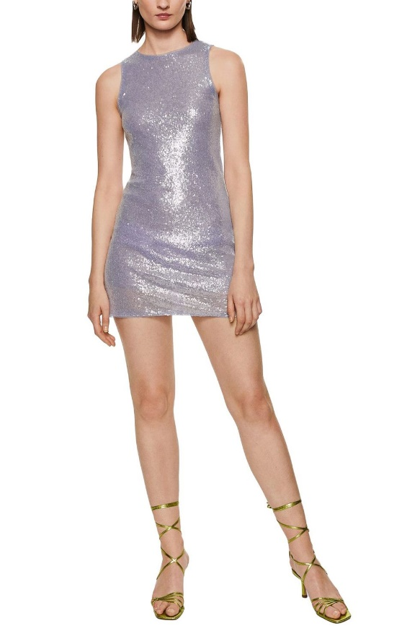

Besides the last two decades sequins were featured on the red carpet at the Oscars 2023 - 95th Academy Awards ceremony. Stars such as Kate Hudson, Fan Bingbing and Jessica Chastain all wore head to toe sequin adorned gowns.
Conclusion
It can be concluded that fashion trends of the first two decades of the twenty- first century continued into 2023, the style remains but the embellishments might change based on the trends of the time along with influence from Hollywood, music and social media.

References:
BENNETT, A. AND ACHONWA, T. 2023
British Vogue 6 Sandal Trends That Will Never Go Out Of Style Kane, A 2017.Vintage Style: 1970s Fashion Designers

brunettefromwallstreet 2023. MINI, MIDI OR LONG? WHAT SKIRTS ARE IN STYLE NOW? ARE SKIRTS EVEN IN STYLE? February 25, 2023
What Skirts Are in Style for 2023? - Brunette from Wall Street
What Skirts Are in Style for 2023? - Brunette from Wall Street

Cornley, S. 2022. 5 Best Trucker Hat Styles for Spring/Summer 2023
5 Best Trucker Hat Styles for Spring/Summer 2023 - Alibaba.com Reads (baba-blog.com)

Elovitz, D., 2023. 9 Fresh Ways to Wear Gladiator Sandals in 2023
How to Wear the Gladiator Sandal Trend in 2023 (instyle.com)

Gibson, R. 2021
19th Century – 7 Historical Events that took place in the 19th Century
19th Century - 7 Historical Events that took place in the 19th Century - HistoryColored

McCormick, M. 2017. What Is Urban Fashion? (leaf.tv) Popular Fashion Designers of the 70s

Redfern, E A Short History of Sequins - Threads (threadsmagazine.com) Lefroy, E. 2023. Cargo pants are back — and this time they’re actually stylish https://nypost.com/
1970s fashion - The decade of ready to wear - 70s fashion - Blue 17
SUNGLASSES TRENDS FOR SPRING - SUMMER 2023 (optyx.com)
Trendy Skirt Suits To Shop For Spring 2023 (forbes.com)
https://www.encyclopedia.com/fashion/encyclopedias-almanacs-transcripts-and-maps/nineteenth-century-clothing
http://www.vam.ac.uk/page/0-9/19th-century-fashion/#:~:text=The%20fashion%20of%20the%2019th,the%20back%20of%20the%20silhouette

Student Statement:

By submitting this assignment, I confirm that this is my own work.

Student Signature | Winifred Harewood | Date | 04/25/2023

For Tutor / Assessor Use Only
Total Marks
Marks Obtained
Percentage / Grade

