
Assignment Cover Sheet

Student Name: | Lynley Lacey
Student Number: | 24167
Course: | Diploma in Wedding Planning Level 4
Assignment NO: | 1

Marking Criteria:
We expect the learners to write minimum one well expressed point in three lines against each allocated mark. This means one needs to write 15 lines with 5 well expressed points to get high grades for a 5 marks question.
For high grades use examples and illustrations where appropriate.
  - What does wedding etiquette mean:
Weddings can be very complex and difficult to plan and must obey certain rules of etiquette. These are practices prescribed by social convention or by another authority as pertaining to weddings. Weddings are surrounded by traditions and protocol, Following wedding etiquette will avoid hurting anyone’s feelings or putting valued relationships in to jeopardy.
  - What is a sake- sharing ceremony and it in which culture is it performed?
Sake- sharing also known as San-San-Kudo (translated means “three, three, nine times”). It is traditional in Japanese cultures, it began in the 1600s and it is one of the oldest Japanese wedding traditions.
  - Why is a civil ceremony important in Russia?
Church weddings in Russia are not official, so couples have to marry at a civil ceremony, this ceremony is not considered very important to family and friends however the wedding reception can be very extravagant and can last up to 2 days.

Student Name: Lynley Lacey
Student Number: 24167
Assignment Number: 1
Page Number: 2
  - Outline the main skills required for a wedding planner?
To be a good wedding planner you will need to have excellent communication and organization skills, problem solving skills and the ability to adapt if a problem arises. Ability to work under pressure and meet deadlines. Excellent attention to detail, sales and excellent negotiating skills and also be able to work within a budget.
  - What is the role and scope of a wedding consultancy in the modern world?
The role of a wedding consultant is to ensure that the big day goes according to plan from start to finish and keeping to the budget discussed. They will need to strike up a good relationship with different suppliers and vendors alike, this may result in discounts and as a result can save the couple costly outlays.
2.a A traditional English reception
A tradition English wedding reception traditionally will have a fruitcake containing almonds raisins and cherries topped with marzipan as the wedding cake, sometimes to baker may hide small silver charms in side different tears of the cake with ribbons attached, these are for the bridesmaids to pull on when the newlyweds cut the cake, its meant to bring them good luck. Tying shoes to the back of the newlyweds car as they leave for their honeymoon is also meant to bring the couple good luck.
2.b German wedding traditions
Germans will plant trees when a baby girl is born, when she grows and has set a date for her wedding the trees are cut down and sold and the money from this is part of her dowry. Newspapers full of photos of the couple will be put together by friends and family and sold at the wedding and the proceeds go towards the couples honeymoon. The wedding its self lasts for 3 days, first the couple have a small civil ceremony with close family and friends. They then have a big reception the following day many people are invited to this including neighbor’s and acquaintances. ON the third day a religious ceremony will take place followed by another reception, where the best man steels the bride he
Student Name: Lynley Lacey
Student Number: 24167
Assignment Number: 1
Page Number: 3
takes her to a local pub where they drink champagne and wait for the groom to come and find them, the groom then has to pay the drinks bill. He will also have to pay another toll later on in the evening so he can take his bride on honeymoon.

Activity - Collage
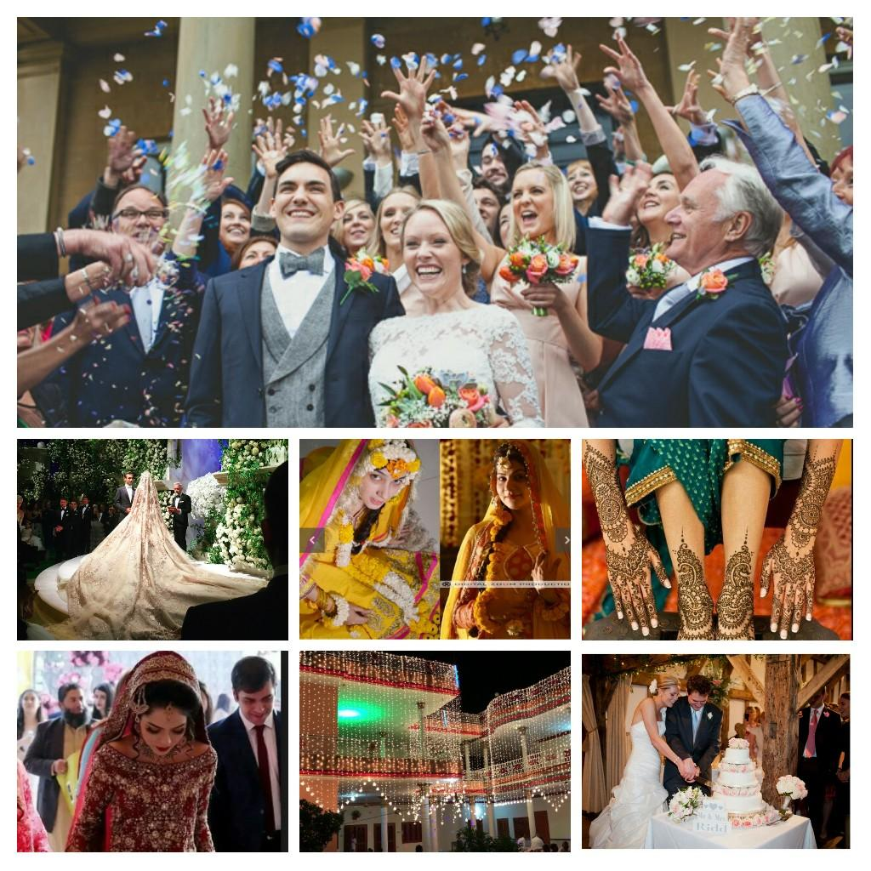

Student Name: Lynley Lacey
Student Number: 24167
Assignment Number: 1
Page Number: 4
Student Statement:

By submitting this assignment, I confirm that this is my own work.

Student Signature | Lynley Lacey | Date | 04/09/2018

For Tutor / Assessor Use Only
Total Marks
Marks Obtained
Percentage / Grade

