
Assignment Cover Sheet

Student Name: | Ahmed Ansari
Student Number: | 23422
Course: | Diploma in Environmental Management (Level 4)
Assignment NO: | 10

Marking Criteria:
We expect the learners to write minimum one well expressed point in three lines against each allocated mark. This means one needs to write 15 lines with 5 well expressed points to get high grades for a 5 marks question.
For high grades use examples and illustrations where appropriate.
Q1. Why is it important to manage and report environmental performance?
Answer Q1) Managing and reporting on environmental performance can lead to significant business benefits as well as benefits for the environment. Cost savings and productivity gains Businesses can save costs and increase efficiency through reducing and managing resource use. Typical areas where cost savings are dentified
include the use of raw materials and supplies, reductions in waste, water and energy use and transport, travel, and packaging. Good reporting improves customer
confidence. Informing customers of your efforts to improve your organisation’s environmental performance can lead to increased confidence in your products and services.
Preferred Supplier Status
Large organisations are increasingly requiring suppliers and contractors to submit environmental performance information to satisfy the expectations of their own shareholders. Reporting on environmental information can make you a more attractive supplier than your competitors.

Increased Attractiveness to the Investment Community
Investors, financial analysts and brokers are now asking questions about the sustainability of business operations. Reporting on environmental matters provides a good indication of what measures an organisation is taking to reduce risks and develop opportunities.
Employee Recruitment
Clear reporting of an organisation’s efforts to manage its environmental performance helps to attract high caliber employees as good environmental reputation and performance can be an important factor in an employee’s choice of employer.

Licence to Operate
Managing environmental impacts and minimising the organisation’s impact on the environment can reduce the exposure to fines. It can improve relations with regulators and help ensure the company maintains its licence to operate by providing assurances about compliance with environmental legislation and conformity with other relevant laws and regulations.

Q2. What are key performance indicators? Why do you use Environmental KPIs?
Answer Q2) Key Perfomance Indicators : are a quantifiable measure used to evaluate the success of an organization, employee, etc. in meeting objectives for performance.
Environmental key performance indicators. (KPIs) are quantitative measures - ie actual numbers - that put values on a business' environmental performance. Most businesses will already have facts and figures they can use to produce environmental KPIs, such as: energy bills.

Environmental Key Performance Indicators (KPIs) provide businesses with a tool for measurement. They are quantifiable metrics that reflect the environmental performance of a business in the context of achieving its wider goals and objectives. KPIs help businesses to implement strategies by linking various levels of an organisation (business units, departments and individuals) with clearly defined targets and benchmarks.

The impact of environmental matters on business performance is increasing and will continue to do so. For example, poor management of energy, natural resources or waste can affect current performance; failure to plan for a future in which environmental factors are likely to be significant may risk the long-term value and future of a business. Therefore, the Government expects that businesses will need to use environmental KPIs to adequately capture the link between environmental and financial performance.
There are additional reasons why KPIs are important:
- They focus on ‘key’ measures – i.e. those most important to an understanding of a business and they mitigate the need for lengthy reports on a wide range of measures many of which may be less relevant; and
- New regulations such as the Business Review required by the EU Accounts Modernisation Directive require significant environmental issues to be reported using KPIs.

Q3. Briefly discuss the various types of reports?
Answer Q3) Types of report
Companies can report on environmental matters in two contexts:
1. Mandatory reports – for example a Business Review and/or,
2. Voluntary reports – for example a Corporate Responsibility (CR) report.

Mandatory reports
Some 89 per cent of FTSE All Share companies currently report on environmental issues in their Annual Report and Accounts according to the Environment Agency study. Many businesses will now have to produce a Business Review that will include discussion of environmental matters where necessary for an understanding of the business.

Voluntary reports
Organisations publish environmental information in Corporate Social Responsibility (CSR), Corporate Responsibility (CR), Sustainability, or stand-alone Environmental reports. The Government does not believe that one type of report is necessarily better than another; what is important is that organisations understand and can be transparent about their actions to reduce the harmful environmental and social impacts of their activities, products and services.
These Guidelines are relevant to both mandatory and voluntary reports. In fact, the same information can be used in different reports. For example, a company might disclose its climate change performance as a part of a voluntary report, and take the view that, since this will affect the financial performance and shareholder value of the company, it should also be reported in the Annual Report or Business Review.

Q4. What are different principles of reporting and key performance indicators?
Answer Q4) General principles of reporting
Regardless of which framework a company uses, there are some common principles which, if followed, can provide assurance to a business and its stakeholders that appropriate processes and procedures have been followed. This information can be included in the narrative part of a report, to add context to quantitative KPIs.

Principle 1 – Transparency
Transparency is essential to producing a credible report. Internal processes, systems and procedures are just as important as the quantitative data, i.e. the value of the quantitative data will be greatly enhanced if accompanied by a description of how and why the data are collected. Particular issues which could be relevant to this principle are:
- The level of public disclosure
- Responsibility for environment/sustainable development exists
- Clear definition of boundaries of the company to which the report applies.

Principle 2 – accountability
A company can be accountable to a variety of different people for its behaviour. In a financial sense directors are ultimately accountable to the owners of the company. Particular issues which could be relevant to this principle are:
- The definition, level and nature of stakeholder engagement
- The existence and quality of a third party assurance statement
- Integration of environmental reporting within the Annual Report and Accounts, and Business Review
- The existence and success of a communications strategy, and
- The extent to which information is specifically identified and tailored to the needs of institutional investors.

Principle 3 – credibility
It is essential that any reporting is placed in context, to link the specific impacts and understanding of the company to the wider movement by society to embed the principles of sustainable development. Particular issues which could be relevant to this principle are:
- Understanding of the concept of sustainable development and how it applies to the business;
- A company’s procurement policy and efforts to manage the impacts of its supply chains and products; and,
- The existence and description of an externally certified (or other) environmental management system (EMS), and other data collection, measurement and management procedures.

KPI principles
In addition to these general reporting principles, there are also some common KPI-specific principles:

Principle 1 – quantitative
KPIs should be measured, and should therefore be quantitative in nature. This also means that they can be acted upon; for example, targets can be set to reduce a particular emission if it is expressed in a quantitative term. In this way the effectiveness of environmental policies and management systems can be substantiated.

Principle 2 – relevance
In addition to the quantitative information, a KPI should be accompanied by a general narrative, explaining its purpose and impacts (likely impacts are set out in the definitions of each KPI in Section 4). As part of this narrative, all relevant information and comparators should be taken into account for that KPI. Each KPI should describe the process undergone, the calculation methods and any relevant assumptions. Progress should also be discussed, including against targets, whether improvements or set-backs have occurred and how these are being tackled. Any information relating environmental performance (i.e. the environmental KPI) to financial performance should be also discussed. This can include environmental fines and expenditures.

Principle 3 – comparability
The Government is seeking to stimulate the provision of comparable, comprehensive and quantitative data, whilst avoiding the problem of over-prescriptive guidance leading to ‘boilerplate’ or ‘cut and paste’ responses. As far as possible, all companies should be able to report data in a comparable format, so users of reports can assess the performance of a single company over time and relative to its competitors. It is important that companies avoid using bespoke KPIs to hide poor environmental performance; the narrative part of a report provides the opportunity for a company to discuss any tensions which exist between providing comparable data and reporting company-specific KPIs.

Q5. Draw and explain the reporting process in detail.
Answer Q5) Figure below sets out the recommended environmental reporting processes.
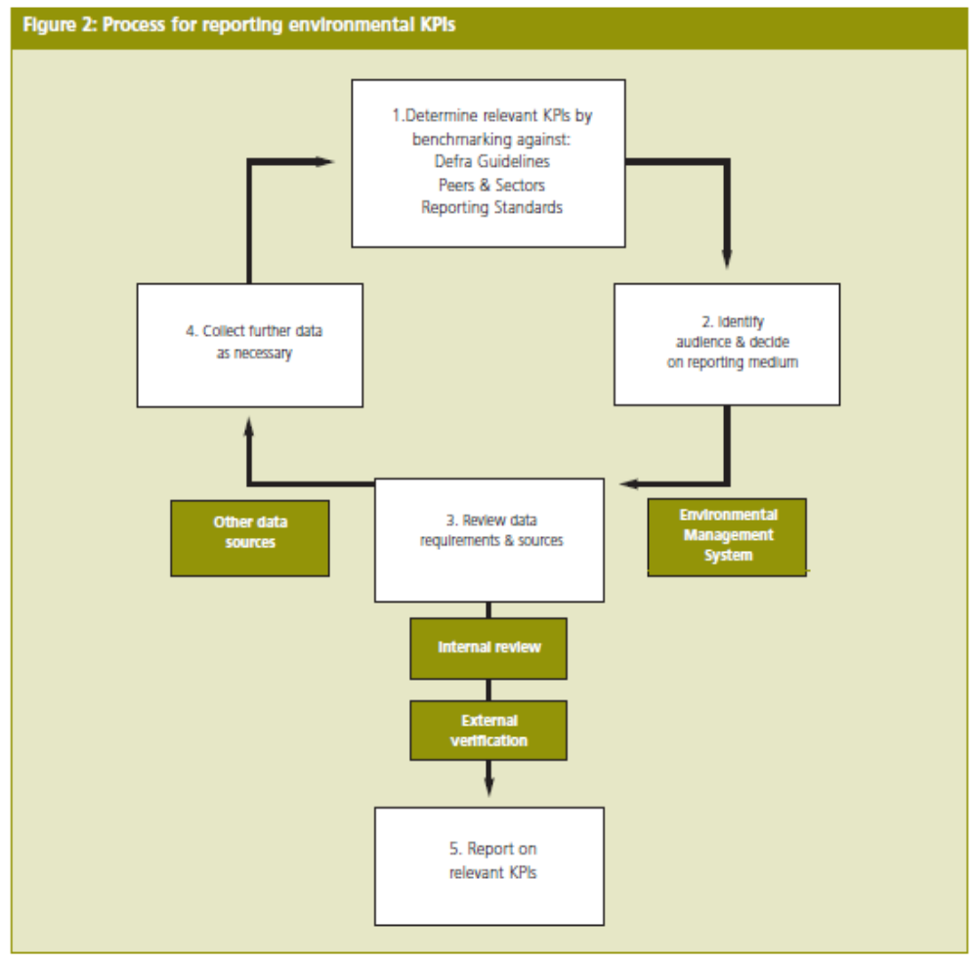

Step 1: Determine relevant KPIs
There are a number of different ways to do this and the most appropriate way will
depend on the internal resources and expertise available, and whether the organisationis experienced at reporting. There are 22 KPIs and catergorised as below
Emissions to air , Emissions to water, Emissions to land, Resource use.

Step 2: Identify audience & decide on reporting medium
It is important to ensure that when reporting environmental performance, the KPIs
selected meet the expectations of the key audiences or stakeholders. Audiences
can include shareholders, employees, government, suppliers, customers,
academics/consultancies, the local community and NGOs.

Step 3: Review data requirements & sources
The next step is to gather the data as appropriate. Companies that are already reporting
may have the appropriate systems in place; new reporters will need to consider the most appropriate way of gathering the information.

Environmental Management Systems (EMS)
Environmental Management Systems (such as ISO14001, EMAS and BS8555) are described : The Government believes that these systems are a robust and effective way of managing the data-gathering process to an appropriate standard. More information about EMS can be found at: http://www.defra.gov.uk/environment/business/scp/index.htm

Step 4: Collect further data as necessary
Once the data requirements and systems have been assessed, it may be necessary to collect more information than is currently available. This may involve implementing or expanding the data collection systems currently in place.

Step 5: Report on relevant KPIs
Once the appropriate information has been gathered, the relevant KPIs can be reported. This process can be repeated for every reporting period. Most companies that report on environmental KPIs do so annually.

=========================== THE END ========================

Student Statement:

By submitting this assignment, I confirm that this is my own work.

Student Signature | Ahmed Ansari | Date | 19/09/108

For Tutor / Assessor Use Only
Total Marks
Marks Obtained
Percentage / Grade

