
Assignment Cover Sheet

Student Name: | Millicent Efua Biney
Student Number: | 8136
Course: | Diploma in Fashion Design
Assignment NO: | 5

Marking Criteria:
We expect the learners to write minimum one well expressed point in three lines against each allocated mark. This means one needs to write 15 lines with 5 well expressed points to get high grades for a 5 marks question.
For high grades use examples and illustrations where appropriate.
Please insert your completed assignment ( in word format) here:

i. Binary colours refer to the making of colours by mixing two primary colours. Typically, two colours used in making a binary colour are black and white, resulting in the colour grey. However, any two colours can be used in creating a very good harmony of colours on the garment. There are no strict rules in mixing two or more colours in designing, but it is wise to choose two colours which will work harmoniously together.

ii. Identifying the categories of warm and cool colours are useful to inform the colour grouping where grey belongs. The warm colours stimulate positive, passionate or energetic emotions or thoughts; they consist of red, orange and yellow. The cool colours are calm, soothing, moody or depressing in nature and are made up of green, blue and purple.
Pure grey is an intermediate colour beween black and white. It is considered to be placed on the cool end of the colour spectrum. While it is recognized as a neutral colour, the grey (especially dark grey) colour’s association with moody or depressing emotions could sometimes align it more to the cool colour category. It is also generally conservative and formal, but can also be a modern colour.
Neutral colours help to project other colours or tone down overpowering colours. Therefore, in creating a very attractive colour scheme it is appropriate to mix a bright colour with grey colour tones for a good combination, i.e. when red and yellow are mixed together it will appear to be bright but a mixture of grey can tone it down. Light grey can be used in place of white in some designs and dark greys can be used in place of black.

iii. The stout person has fairly fat and heavy or thick body. In choosing a fabric or garment for this figure the colour should be considered, because not all colours are appropriate for this figure.
It is appropriate for a stout person to hide protruding areas of the body. Dark shades are suitable to hide certain areas of the body. Similarly dark colours are known to make large parts of the body appear smaller in size. Therefore, a stout person must wear dark colours on places where he or she does not want people to focus. A dark/dull colour is very good if the silhouette is good. It is best to use dark colours to reduce size; but not so dark that they will call attention to the silhouette. Light is not applicable for the stout figure because they will make the wearer look too big, e.g. white fabric.

iv. Colour illusion refers to the creation of colours such that the real colour is not what the human eye perceives. For example, using bright or light and dark/dull colour to appear bigger or dark on a figure. In creating an illusion of height and slimness it is necessary to use a single colour to create the outfit. This can be achieved through the extent of brightness/lightness or dullness/darkness of the colours. When contrasting colours are worn as tops and buttons they will produce a horizontal line where they meet. This will make the wearer appear shorter. Also, illusion of height and slimness can be created when a vertical line fabric with one colour is chosen in creating the garment, thus, the figures will be slim and height will be created.

v. Black is the strongest of the neutral colours. Black is also the traditional colour for mourning in many Western countries/cultures. It can also make it easier to convey a sense of sophistication and mystery in design.
Grey hair has different ranges; dark grey, silver, platinum and blonde-grey. The wearing of black by a grey-haired lady can be considered as a form of elegance. Though black is a suitable colour for a grey-haired lady, a touch of bright white on the black garment makes the wearer look more appealing. Warm colours - warm orange and ruby-red combined with the black hue may also be considered as part of designing for the gray-haired lady. Most experts suggest that grey-haired ladies should avoid the beige colour as that colour does not match with grey and therefore makes them look awkward. Ladies with grey hair must wear make-up that gives them a healthy glow. Defining the eyes, adding colour peach blush and red lip colour or tinted balm gives the grey-haired lady an elegant appeal

vi. A sallow complexion is skin type that can make one look sickly and older than she really is. A person with sallow skin has face with pale-yellowish, ashen colour, or no evidence of colour in the cheeks. The colour of the skin could be dark with pink undertones. In choosing colours for this type of complexion, it is important to select the colours very carefully in order to bring out the colour in the cheeks. A shade of red, rose or grey with tints of pink as well as blue are appropriate to generate elegance on the wearer. Deep, rich colours such as emerald green or blue-green are also appropriate be considered for persons with sallow complextion. Warm colours such as yellow should be avoided because the pale-yellowish skin tone would be enhanced, making the person look unpleasant.
In choosing fabrics as well as a dark colour such as navy blue, deep brown, black, charcoal should be considered.

vii. A blonde person has fair hair; the hair is characterized by low levels of the dark pigment eumelain but has a yellowish, skin colour. It is better to consider the skin type in selecting a dress for a blond person. Colours such as brown, pink, blue, grey, violet and white are great. They also look good in warmish browns. So in designing a garment for the blonde, the colour of their eyes and skin tone should all be looked at as well as the choice of colours and fabrics.
Blonde persons should usually stay away from wearing tweeds. Heavy materials such as jersey, crapes, velveteen, chiffon, are more suitable for the fairer haired women. The blonde should avoid cool colours such as pale shade of blue pink and yellow.

Activity

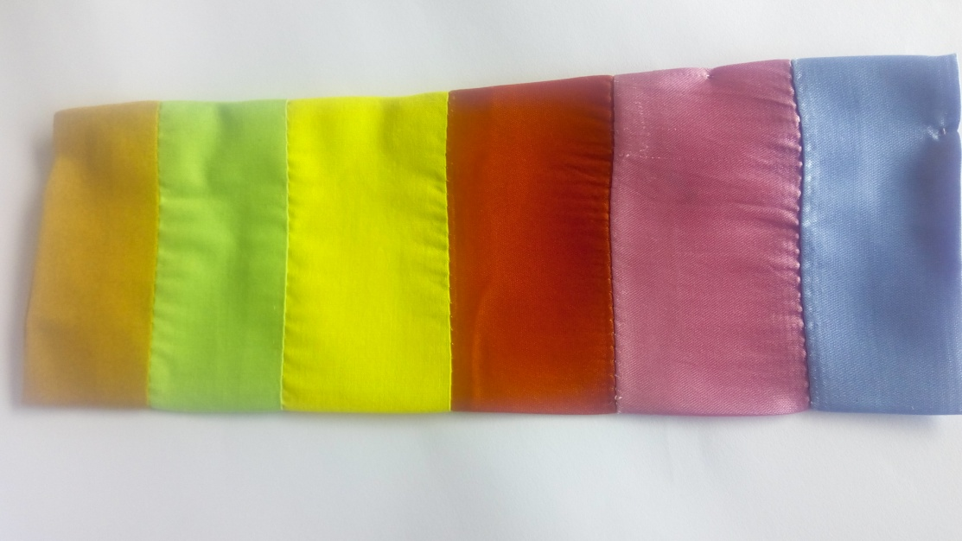
Figure 1: A colour scheme reflecting the arrangement of six fabric swatches of warm and cool colours.
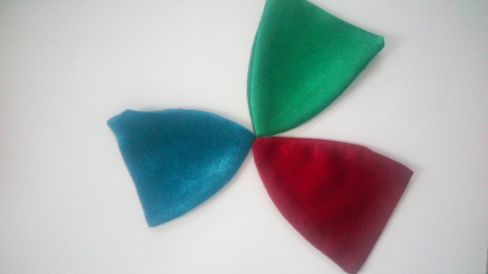
Figure 2: Contrasting colour harmony using fabric swatches
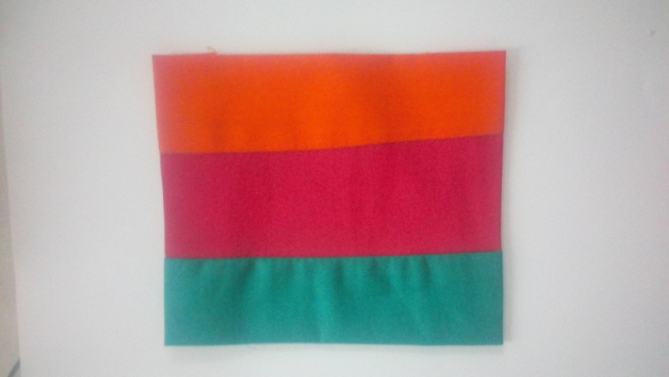
Figure 3: Fabric created with a blend of warm and cool colours
,

Student Statement:

By submitting this assignment, I confirm that this is my own work.

Student Signature | Millicent Efua Biney | Date | 3rd August, 2017

For Tutor / Assessor Use Only
Total Marks
Marks Obtained
Percentage / Grade

