
Assignment Cover Sheet

Student Name: | Viktorija Develyte
Student Number: | 36140
Course: | Advanced Diploma in Business Administration Level 5
Assignment NO: | 02

Marking Criteria:
We expect the learners to write minimum one well expressed point in three lines against each allocated mark. This means one needs to write 15 lines with 5 well expressed points to get high grades for a 5 marks question.
For high grades use examples and illustrations where appropriate.
Please insert your completed assignment (in word format) here:
Q: 1: Short questions:
I. Define the term “Management”.
Management it is when, individual works with group of people to achieve same goals, with limited time and recourses.
II. List different levels of management.
• Top;
• Middle;
• Low.
III. Define the term “equity” as a principle of management.
When everyone is fairly treated, to achieve best results.
IV. State the various functions of management.
1. Planning;
2. Organising;
3. Commanding;
4. Coordinating;
5. Controlling.
V. Match the expression given in column 1 with These given in column 2
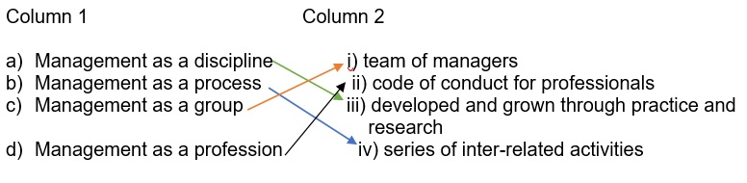
The following table contains the function, position and different levels of management.
Pick one from each column and make a meaningful combination.
(I’ve matched it with colours: Top-yellow; Middle – blue; Lower – green)
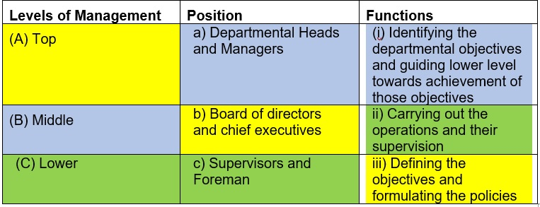
Q.2. “Planning is looking forward; whereas controlling is looking back”. Explain the
statement. (7)
Planning it is looking forward in direct words, because when you planning you are thinking about future, what you should do, how you should do, detail recourses (labour, materials, costs).
Controlling in the other hand is looking back, because every aspect of business must be looked after, this includes supervision, workflow.
Case Study (8)
The directors of Vision Tech have reorganized their business. William Davis is now Chairman, Vijhay Singh finance manager, and Irene Rogers is the floor in charge (supervisor).
Keeping in view the above situation, answer the following questions:
1. What is meant by the hierarchy of management?
Hierarchy management is when there are few managers, who overlooking organisation in different aspects, but as well can have their own teams, what can be as well management team (executives, chairman).
2. How does William Davis know about any problem on the factory floor?
Irene Rogers is factory floor supervisor, she will provide all information about issues.
3. Who determines the objectives for the business?
William Davis will determine objectives, because he is a chairman.
4. Who will ensure that the work is carried out properly and on time?
All managers are responsible for business running properly, but if related to work supervision, it will be Irene Rogers – supervisor.

Student Statement:

By submitting this assignment, I confirm that this is my own work.

Student Signature | V.Develyte | Date | 14/10/2019

For Tutor / Assessor Use Only
Total Marks
Marks Obtained
Percentage / Grade

