
Assignment Cover Sheet

Student Name: | Tan Chai Chen
Student Number: | 7435
Course: | Diploma in Business Administration
Assignment NO: | 13

Marking Criteria:
We expect the learners to write minimum one well expressed point in three lines against each allocated mark. This means one needs to write 15 lines with 5 well expressed points to get high grades for a 5 marks question.
For high grades use examples and illustrations where appropriate.
Please insert your completed assignment ( in word format) here:
Q1.
Executive Summary
U&ME Cafe is a unique local bar/coffee/tapas house that provides a friendly, effective place where singles can meet. U&ME Cafe is not your typical bar where people go to meet other singles. U&ME Cafe has a unique service called the structure conversation system that is quite effective for allowing singles to meet each other and provide them with valuable insight into the other person through reflective conversation. The structured system provide an atmosphere that lowers inhibitions and breeds confidence allowing singles to meet other singles and gain insight into their personality by way of thoughtful discourse.
Meeting people is one of the largest hurdles 25-45 year old singles face. U&ME Cafe provides this group with an effective solution to this problem.

Situation Analysis
U&ME Cafe has just begun business, and marketing is essential to its success and future profitability. The bar offers a place for people to meet in a comfortable, person-meeting environment. The basic market need is place where singles can meet new similar people. U&ME Cafe uses a sophisticated conversation system to enhance and facilitate singles meeting each other.

Market Summary
U&ME Cafe possess good information about the market and knows a great deal about the common attributes of the prized and loyal customers. U&ME Cafe will leverage this information to better understand who is served, their specific needs, and how the U&ME Cafe can better communicate with them.

Market Analysis
 |  | 2001 | 2002 | 2003 | 2004 | 2005
Potential Customers | Growth |  |  |  |  |  | CAGR
Singles | 9% | 210,987 | 229,976 | 250,674 | 273,235 | 297,826 | 9.00%
Non-singles | 7% | 134,432 | 143,842 | 153,911 | 164,685 | 176,213 | 7.00%
Other | 0% | 0 | 0 | 0 | 0 | 0 | 0.00%
Total | 8.23% | 345,419 | 373,818 | 404,585 | 437,920 | 474,039 | 8.23%

Market Needs
U&ME Cafe is a unique bar/coffee shop/tapas house that is organized to try to facilitate new friendships. The U&ME Cafe will offer a changing menu of tapas, microbrews, and assorted coffee drinks in conjunction with a structured conversation system. U&ME Cafe seeks to fulfill the following benefits that are important to their customers.
- Selection: a creative choice of food and drink and a well-constructed structured conversation system.
- Accessibility: the patron will gain access to the U&ME Cafe with minimal waits and long business hours.
- Customer service: the customer is ALWAYS right.
- Competitive pricing: all products will be competitively priced relative to the competition.
Market Trends
The market trend is headed toward a more sophisticated customer. The restaurant/bar patron today is more sophisticated in a number of different ways:
- Food quality: the preference for higher-quality ingredients is being reinforced as customers are being subjected to an increasing number of options.
- Quality conversation: patrons are recognizing intellectual conversations can be had in bar settings and would prefer this over normal bar talk.
- Access to meeting people: people are tired of being single and are looking for ways to meet like-minded individuals.

Market Growth
In 1999, the global bar/restaurant market reached $24 billion dollars. Alcohol sales are estimated to grow by 9% for the next few years. This growth can be attributed to several factors. The first factor is American's reliance on alcohol for socialization. This factor is intuitive as alcohol breaks down social inhibitions.
Another factor is the trend to eat and drink outside of the home. This occurs as Americans work longer and longer hours during the week. Eating and drinking out is a convenience that many are willing to pay for. It also provides contact with more people.
SWOT Analysis
The following SWOT analysis captures key strengths and weaknesses within the company and describes the opportunities and threats facing the U&ME Cafe .
Strengths
- Strong relationships with third party vendors.
- Excellent staff who are highly trained and customer attentive.
- The structured conversation system.
Weaknesses
- The U&ME Cafe 's limited brand equity.
- The struggle to continually have current and new conversation topics.
- A limited marketing budget to develop brand awareness.
Opportunities
- A growing market with a significant percentage of the of the target market still unaware of the U&ME Cafe .
- Increasing sales opportunities as people become familiar with the advantages of the structured conversation system.
- The ability to lower variable costs through efficiency gains.
Threats
- Competition from taverns.
- Competition from other sources of singles meeting events.
- A slump in the economy which will decrease discretionary spending.
Competition
- The competition comes from several different sources.
Bars
There are many different types of bars or taverns. Some are better than others for meeting people, however, none of them have the business mission to bring together singles.
Coffee Shops
Coffee shops are typically an easy-going social setting that does lend itself for people to meet others. Conversations occur in part because of the historical underpinning of coffee houses, in part by virtue of the fact that the background music is not blaring. Coffee shops rarely have any type of organized activities to bring singles together.
Other Events/Activities Aimed at Bringing Together Singles.
One activity/phenomenon that has started in New York City and moved to a few other larger cities (not including Portland) is an activity that has a long rectangular table that always has one seat opposing the other. People sit down with females on one side and males on the other (this seating arrangement is for heterosexual gatherings) and will have a limited number of minutes (usually 10) to chat. Typically, conversations can be about anything, however you are not to reveal the job/profession that you are involved in, beyond that, anything is fair game. The table rotates and you end up speaking with a lot of different people. You then create a list of the top five that you would like to speak with again and if the matching person also has you on their list, phone numbers are released to the two people. Another activity might be some sort of outdoor activity like hiking or rafting and it is organized as a singles event. There are also other type of singles events, too numerous to mention. Lastly, there are resources like personal sections in local papers where people can post or respond to personal advertisements.
Every person has their own method of meeting people, some more useful than others. U&ME Cafe predicts singles will abandon, or at least supplement, their current method of meeting people with the U&ME Cafe 's activities as they are thoughtfully designed to achieve the goal of introducing like-minded individuals.
Product Offering
U&ME Cafe sells the following:

Eight Microbrews on Draft and Bottled
Alcohol, specifically beer, is served for two reasons. One, alcohol reduces inhibition, making it easier for people to meet and interact with new people. Two, and more importantly, beer, particularly draft beer generates wonderful profits. Micro beers are chosen because microbrews are of higher quality than large production beers and our target segment prefers higher-quality beer.

Espresso, Cappuccino, Coffee, and other Coffee/Espresso drinks.
Coffee and coffee-related drinks are hugely popular, particularly in the Pacific Northwest. North westerners expect good coffee/espresso at most food/drink establishments and it is often associated with good conversation.

An Assortment of Tapas
Tapas are chosen because they can be relatively easy to make, the offerings can be changed frequently, and tapas are more community orientated, meaning they are designed for a table/multiple people to share. This reinforces U&ME Cafe mission of bringing new people together.
The service offerings are based on a system for singles to meet new people. This is accomplished through a structured conversation system. The U&ME Cafe is divided into two sections, one smaller section of tables that is for people meeting people that they already know. The other, larger section is the section of tables for singles to come and meet new people. This section is composed of 4-top tables (table seating for four) where a customer will come and sit down at the table among other people. The table will be marked with a topic of conversation in the center. Throughout the evening as there is turnover of the table or the conversation is exhausted, the server will introduce a new topic. The topics of conversation are far reaching, some are recent news or sports, while others are intellectual, and some are philosophical. The bulk of the topics will be of the latter varieties as people that are interested in meeting people through the conduit of conversation will typically prefer heavier stuff to provide more insight into that person.
If you ask a majority of single 25-45 year olds, most will say they have difficulty meeting new people. Regular bars are not an ideal place to meet people because beyond their visual image, it is quite difficult to learn anything material about the person to determine if there are some commonalities. The typical bar has loud music and is not geared up for serious conversation. Bars are also less than ideal to meet people because of the uncertainty or ambiguity when meeting new people at a bar. Many people feel uncomfortable in situations where they are not sure how to act. The ideal situation to meet someone is during an activity that is mutually enjoyed, whether it is at an art museum or mountain biking in the Cascade Range.
U&ME Cafe creates a setting in a bar/coffee shop that encourages thoughtful conversation, allowing patrons to gain insight into the other singles. The key to the conversation system is structure. The rules are clearly established. Singles sit down at specific tables and discuss the assigned topic of conversation. Everyone at these tables are single and looking to meet new people. The conversation is used to elicit insight into the other person, their values and perspectives as well as implicit and sometimes explicit insight to their background and past.
The structured conversation system is successful because it reduces ambiguity or uncertainty in the singles social scene allowing people to feel more comfortable in the setting and open up more to new people. Additionally, for intellectually minded people, it allows them to find people with similar interests, whether the similarity is based in the topic of conversation or more generally in conversation itself.
Keys to Success
- Attracting customers who find value in the U&ME Cafe s offering and who will frequent the Shop regularly in order to meet like-minded single people.
- Excellent customer service.
- Maintaining a cost of goods on foods at below 50%.
Critical Issues
The U&ME Cafe is still in the speculative stage as a retail operation. Its critical issues are: to continue to take a moderate fiscal approach to business operations and to build brand awareness which will drive customers to the U&ME Cafe .
Marketing Strategy
U&ME Cafe 's strategy will be based on communicating U&ME Cafe 's value to the targeted segments. This will be done through a variety of methods. The first method will be strategically placed advertisements. One place that will be used for advertisements is the Willamette Weekly, the liberal arts magazine that details all of the entertainment in Portland. This will be the main source of advertisements because the demographics of their readership are fairly similar to U&ME Cafe 's demographics.
Another source of marketing will be done with strategic relationships with companies that have similar customer demographics. One prime example is the Multnomah Athletic Club. While the club's patrons are not necessarily overwhelmingly single, the rest of the demographics match up. The MAC is a fairly exclusive downtown athletic club that by virtue of the membership costs, attracts professionals. The strategic relationship with be mutually beneficial where both organizations will develop visibility for each other.
The other form of advertising will be using "grassroots" methods where customers will be given coupons for their friends to try U&ME Cafe for the first time. The coupon will be an economic incentive for the newcomer to try U&ME Cafe . The coupon also has the added force of a referral from a friend.
Mission
U&ME Cafe 's mission is to provide a neighborhood bar/coffee shop where single people can meet. We exist to attract and maintain customers. When we adhere to this maxim, everything else will fall into place. Our services will exceed the expectations of our customers.
Marketing Objectives
- Develop brand awareness through a steady, month to month increase of new customers.
- Develop an increase in sales while achieving a status quo state or decrease in marketing expenses.
- Develop awareness of the structured conversation system measured by customers coming to the U&ME Cafe solely for meeting people.
Financial Objectives
- A double digit growth rate for each future year.
- Reduce the variable costs through efficiency gains.
- Reach profitability within the first year.
Target Markets
U&ME Cafe 's customers can be broken down into two groups, singles, and non-singles. The non-singles groups are smaller than the singles groups by virtue of the fact that if you are meeting someone whom you already know, the two of you can come up with the topic of conversation yourself, therefore, U&ME Cafe offers this group less value. The demographics for the non-singles is similar to the singles, to be listed below. The larger group then is the singles. The demographics of the singles are:
- Single: self-evident
- Professional: this characteristic is intuitive since the underlying element of U&ME Cafe is thoughtful conversation, and most professionals appreciate thought-provoking conversation.
- Income over $40,000: this to a large degree is correlated to the fact that they are professional.
- Age 25-45: the largest group of singles looking for companions.

Positioning
The U&ME Cafe will position itself as a reasonably priced tapas/bar/coffee house that has an innovative, effective system for allowing single to meet each other.
The U&ME Cafe 's positioning will leverage their competitive edge:
- A unique approach to getting singles together called the structured conversation system. This system was detailed in the Product and Services section, please refer to that section for more information.
- This system is a competitive edge because most bars/taverns do not have a niche that they are concentrating on. While every bar or coffee shop has a certain "flavor" and that is why someone will choose one bar or another, the flavor is only surface deep. The business model of the establishment is to sell alcohol and provide a social setting. Beyond these two values, there is little other genuine value that the establishments try to provide.
- U&ME Cafe is distinguished by the fact that their business model concentrates on developing value for customers beyond serving drinks. The U&ME Cafe develops an effective, albeit inherently structured, social setting that encourages meeting like-minded individuals. Providing the drinks is the source of income, an ancillary part of the business model. Generating value for the customers is the main focus, if the customers are happy then the revenue will follow (assuming of course that proper marketing and financial controls are employed). Concentrating on the client's needs beyond serving alcohol is the distinguishing characteristic that will allow U&ME Cafe to rapidly gain market share.
Strategies
The single objective is to position the U&ME Cafe as the premier place for young professional singles to meet like-minded individuals. The marketing strategy will seek to first create customer awareness regarding their services offered, develop that customer base, and work toward building customer loyalty and referrals.
The message U&ME Cafe will seek to communicate is that The U&ME Cafe is THE place to meet intelligent singles. This message will be communicated through a variety of methods. The first method will be advertisements. The bulk of the advertisements will be in the Willamette Weekly, a weekly entertainment guide in Portland that has impressive readership numbers for the desired target population.
Another method will be through establishing strategic relationships with companies that have similar demographics such as the Multnomah Athletic Club. Establishing a mutually beneficial relationship will allow both organizations to develop visibility for each other.
The other form of advertising will be using "grassroots" methods where customers will be given coupons for their friends to try U&ME Cafe for the first time. The coupon will be an economic incentive for the newcomer to try U&ME Cafe . The coupon also has the added force of a referral from a friend.
Marketing Mix
- U&ME Cafe 's marketing mix is comprised of these following approaches to pricing, distribution, advertising and promotion, and customer service.
- Pricing: the pricing scheme is based on standard industry practices.
- Distribution: all services and products will be distributed from U&ME Cafe 's retail space.
- Advertising and promotion: the most successful advertising will be with Willamette Weekly. Additionally, strategic relationships will be developed with companies such as Multnomah Athletic Club as well as use of a grassroots promotion system.
- Customer service: obsessive customer attention is the mantra. The U&ME Cafe 's philosophy is to do whatever needs to be done to impress the customer. While this could reduce short-term profits, it will strengthen long-term profitability.
Marketing Research
During the initial phases of the marketing plan development, several focus groups were held to gain insight into a variety of likely customers. These focus groups provided useful insight into the decision making process of these consumers.
An additional source of dynamic market research is a feedback system based on a suggestion card system. The suggestion card has several statements that patrons are asked to rate in terms of a given scale. There are also several open ended questions that allow the customer to freely offer constructive criticism or praise. The U&ME Cafe will work hard to implement reasonable suggestions in order to improve their service offerings as well as show their commitment to the customer that their suggestions are valued.
The last source of market research will be competitive analysis. This will be done by regularly visiting competitors and analyzing their service offerings.
Financials
This section will offer a financial overview of the U&ME Cafe as it relates to the marketing activities. The section will address break-even analysis, sales forecasts, expenses forecasts, and how those link to the marketing strategy.

Break-even Analysis
The Break-even Analysis indicates that $30,237 will be needed in monthly revenue to reach the break-even point.
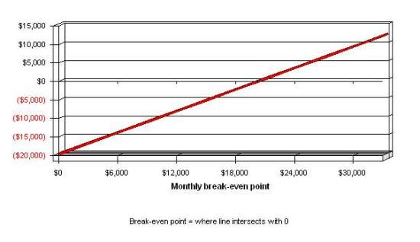
Break-even Analysis

Break-even Analysis
Monthly Revenue Break-even | $20,299
Assumptions:
Average Percent Variable Cost | 32%
Estimated Monthly Fixed Cost | $19,654

The first two months will be used to set up the physical location, hire personnel, establish vendor relationships and obtain an alcohol license. The third month will be the grand opening. Business during the second month will be understandably slow as a steady customer base takes time to build. By month four it is forecasted that sales will steadily grow.

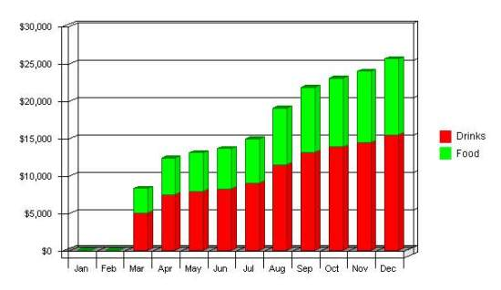

Sales Forecast
 | 2001 | 2002 | 2003
Sales
Drinks | $105,921 | $271,254 | $296,874
Food | $69,908 | $179,028 | $195,937
Total Sales | $175,829 | $450,282 | $492,811
Direct Cost of Sales | 2001 | 2002 | 2003
Drinks | $26,480 | $67,814 | $74,219
Food | $29,361 | $75,192 | $82,293
Subtotal Direct Cost of Sales | $55,842 | $143,005 | $156,512

Expense Forecast
Marketing expenses are budgeted to remain fairly steady throughout the year. There will be an initial ramp up of spending to generate visibility. After this ramp up advertising will be fairly consistent month to month.
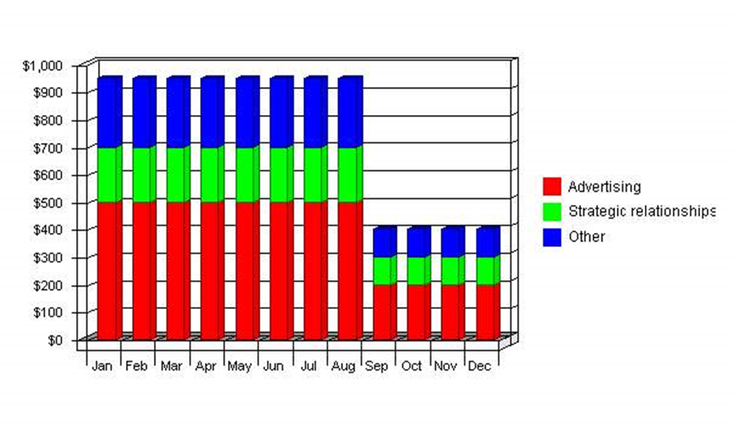
Marketing Expense Budget
 | 2001 | 2002 | 2003
Advertising | $4,800 | $2,400 | $2,400
Strategic relationships | $2,000 | $1,200 | $1,200
Other | $2,400 | $1,200 | $1,200
 | ------------ | ------------ | ------------
Total Sales and Marketing Expenses | $9,200 | $4,800 | $4,800
Percent of Sales | 5.23% | 1.07% | 0.97%

Controls
The purpose of The U&ME Cafe 's marketing plan is to serve as a guide for the organization.
Implementation
The following milestones identify key marketing programs. It is important to accomplish each one on time and on budget.
Milestones
Advertising | Start Date | End Date | Budget | Manager | Department
Marketing plan completion | 1/1/2001 | 2/1/2001 | $0 | Karen | Department
Advertising | 1/1/2001 | 1/1/2004 | $9,600 | Karen | Department
Strategic relationships | 1/1/2001 | 1/1/2004 | $4,400 | Karen | Department
Grassroots promotion | 1/1/2001 | 1/1/2004 | $4,800 | Karen | Department
Name me | 1/1/2003 | 1/15/2003 | $0 | ABC | Department
Name me | 1/1/2003 | 1/15/2003 | $0 | ABC | Department
Name me | 1/1/2003 | 1/15/2003 | $0 | ABC | Department
Name me | 1/1/2003 | 1/15/2003 | $0 | ABC | Department
Name me | 1/1/2003 | 1/15/2003 | $0 | ABC | Department
Other | 1/1/2003 | 1/15/2003 | $0 | ABC | Department
Total Advertising Budget |  |  | $18,800
PR | Start Date | End Date | Budget | Manager | Department
Name me | 1/1/2006 | 1/15/2006 | $0 | ABC | Department
Name me | 1/1/2006 | 1/15/2006 | $0 | ABC | Department
Name me | 1/1/2006 | 1/15/2006 | $0 | ABC | Department
Other | 1/1/2006 | 1/15/2006 | $0 | ABC | Department
Total PR Budget |  |  | $0
Direct Marketing | Start Date | End Date | Budget | Manager | Department
Name me | 1/1/2006 | 1/15/2006 | $0 | ABC | Department
Name me | 1/1/2006 | 1/15/2006 | $0 | ABC | Department
Name me | 1/1/2006 | 1/15/2006 | $0 | ABC | Department
Other | 1/1/2006 | 1/15/2006 | $0 | ABC | Department
Total Direct Marketing Budget |  |  | $0
Web Development | Start Date | End Date | Budget | Manager | Department
Name me | 1/1/2006 | 1/15/2006 | $0 | ABC | Department
Name me | 1/1/2006 | 1/15/2006 | $0 | ABC | Department
Name me | 1/1/2006 | 1/15/2006 | $0 | ABC | Department
Other | 1/1/2006 | 1/15/2006 | $0 | ABC | Department
Total Web Development Budget |  |  | $0
Other | Start Date | End Date | Budget | Manager | Department
Name me | 1/1/2006 | 1/15/2006 | $0 | ABC | Department
Name me | 1/1/2006 | 1/15/2006 | $0 | ABC | Department
Name me | 1/1/2006 | 1/15/2006 | $0 | ABC | Department
Other | 1/1/2006 | 1/15/2006 | $0 | ABC | Department
Total Other Budget |  |  | $0
Totals |  |  | $18,800

Contingency Planning
Difficulties and risks:
- Problems generating visibility and awareness of the U&ME Cafe .
- An entry into Portland of the "conversation roundtables" or other single meeting events.
- Lower than forecasted consumption of alcohol.
Worst case risks may include:
- Determining that the business cannot support itself on an ongoing basis.
- Having to liquidate equipment to cover liabilities.

Q2. 1)
- Basic business concept. This is where they discuss the industry, business structure, particular product or service, and how they plan to make business a success.
- Strategy and the specific actions they plan to take to implement it. What goals do have for business? When and how will they reach your goals?
- Products and services and their competitive advantages. Here's chance to dazzle the readers with good, solid information about they products or services and why customers will want to purchase they products and services and not those of competitors.
- The markets pursue. Now have to lay out marketing plan. Who will they customers be? What is they demographic audience? How will attract and retain enough customers to make a profit? What methods will they use to capture audience? What sets business apart from the competition?
- The background of management team and key employees. Having information about key personnel is an important but often misrepresented portion of a business plan. It’s not a long and detailed biography of each person involved but an accurate account of what they've done and what they bring to the table for this specific business opportunity.
- Financing needs. These will be based on your projected financial statements. These statements provide a model of how they ideas about the company, its markets and its strategies will play out.
2)
a) To Test the Feasibility of Business Idea.
Writing a business plan is the best way to test whether or not an idea for starting a business is feasible, other than going out and doing it. In this sense, the business plan is safety net; writing a business plan can save a great deal of time and money if working through the business plan reveals that business idea is untenable.
Often, an idea for starting a business is discarded at the marketing analysis or competitive analysis stage, freeing to move on to a new (and better) idea.
b) To Give Your New Business the Best Possible Chance of Success
Writing a business plan will ensure that pay attention to both the broad operational and financial objectives of new business and the details, such as budgeting and market planning.
Taking the time to work through the process of writing a business plan will make for a smoother startup period and fewer unforeseen problems as business becomes established.
c) To Secure Funding, Such As Bank Loans
Going to need both operating and startup capital to start a new business and have no hope of getting any money from established financial institutions such as banks without a well developed business plan.
And established businesses often need money, too, to do things such as buy new equipment or property, or because of market downturns. Having a business plan gives you a much better chance of getting the money need to keep operating or to expand.
d) To Make Business Planning Manageable and Effective
A business plan is essential if you're thinking of starting a business, but it's also an important tool for established businesses. Viable businesses are dynamic; they change and grow. The company's original business plan needs to be revised as new goals are set.
Reviewing the business plan can also help see what goals have been accomplished, what changes need to be made, or what new directions company's growth should take. Quick-Start Business Planning for Small Businesses will get started.
e) To Attract Investors
Whether want to shop business to venture capitalists, or attract angel investors, need to have a solid business plan. A presentation may pique their interest, but they'll need a well-written document they can take away and study before they'll be prepared to make any investment commitment.
Be prepared for business plan to be scrutinized; both venture capitalists and angel investors will want to conduct extensive background checks and competitive analysis to be certain that what's written in your business plan is indeed the case.

Student Statement:

By submitting this assignment, I confirm that this is my own work.

Student Signature | Tan Chai Chen | Date | 4/2/2018

For Tutor / Assessor Use Only
Total Marks
Marks Obtained
Percentage / Grade

