
Assignment Cover Sheet

Student Name: | Lydia johnson
Student Number: | 4996
Course: | Level 4 in Travel and tourism
Assignment NO: | 2

Marking Criteria:
We expect the learners to write minimum one well expressed point in three lines against each allocated mark. This means one needs to write 15 lines with 5 well expressed points to get high grades for a 5 marks question.
For high grades use examples and illustrations where appropriate.
Please insert your completed assignment ( in word format) here:
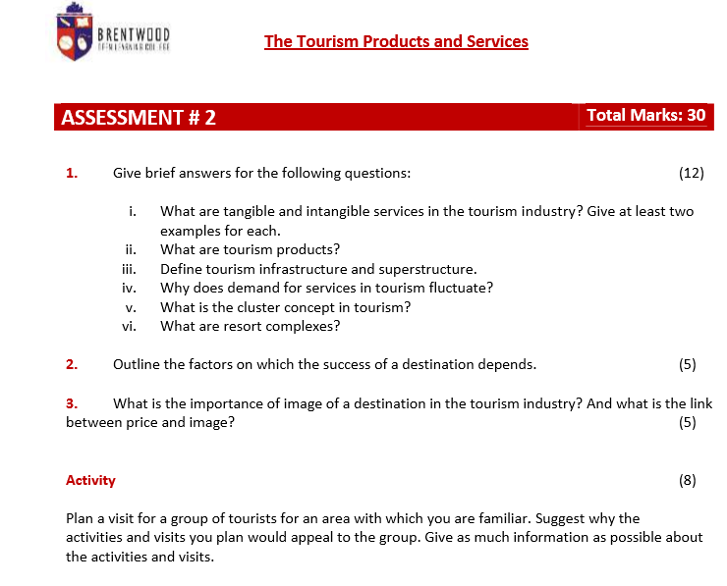

  - What are tangible and intangible services in the tourism industry? Give at least two examples for each.
Tangible services are items that can be measured and that are in place to provide the infrastructure for the tourism industry e.g. airports and electricity.
Intangible services cannot be measured they create the environment of the location e.g. the friendliness of the welcome and the events that occur at the location to create the atmosphere.
  - What are tourism products?
Tourism products are made up of intangible and intangible products. Tourism products are natural assists e.g. mountains or historical characteristics e.g. Notre Dame. They could also be the friendliness of the welcome and the environment of the location.
  - Define tourism infrastructure and superstructure
Tourism Infrastructure provides the basis for the superstructure to occur. The infrastructure are the external facilities that are required to exist to enable the public to get the tourist to the location. These include airports, water supply and drainage.
Tourist superstructure are the facilities built for the tourist to enjoy once they have arrived at the location e.g. accommodation, restaurants, and other tourist facilities.
  - Why does demand for services in tourism fluctuate?
The demand for services in tourism fluctuates can be for a wide range of reasons. They can be environmental, for example the building of the services could effect a rare breed of animal and the animal group protest to stop the building. Another reason could be how the country is marketed, if the demand from the tourist is not there and they don’t want to visit the country (this could be for many reasons e.g. a terrorist attack). Also, it could be the welcome that is received by the visiting tourist e.g. a specific travel company (i.e. Holiday Inn) does not offer friendly service and a welcoming atmosphere this could result in a decline in their hotels being built until this is resolved.
  - What is the cluster concept in tourism?
Cluster concept in tourism is the combination of a variety of products to ensure the tourist has everything that they require. The core product includes the accommodation, restaurants, and recreational amenities. This is combined with additional facilities e.g. shopping, entertainment. It is the combination of these components is the definition of the cluster concept.
  - What are resort complexes?
An example of a resort complex is centre parks, it is a leisure facilities that concentrates the visitor in one location. Resort complexes are well spaced, appropriately organised in appealing landscaped surroundings. It can also be set up and managed by the local government, they own the land and a corporation will set up the infrastructure.
- Outline the factors on which the success of a destination depends
The success of a destination depends on several different factors.
There need to be good transportation links to ensure the tourist can access the destination.
The destination needs to be marketed well to attract the tourist there. Once there the needs to be adequate and easily accessible information to ensure the tourist has adequate knowledge of the local provisions.
The destination needs to be aware of the environmental impact it has e.g. does the project contribute to the enhancing the environment quality?
The economic impact is a factor of the success of the destination. It is important to consider how it contributes to the local and regional community e.g. does it create jobs?
Social impact, has the destination been discussed with the local community and do the locals support the project.
The ownership and management of the destination can determine its success. What kind of ownership is it? It needs to consider whether it is a foreign, local or a mix of both to ensure the local heritage and labour are factored into their strategic plan.
- What is the importance of image of a destination in the tourism industry? And what is the link between price and image?
The image of the destination in the tourism industry is very important. People can create an idea of the destination based on a preconceived image of the country; sometimes it is the media portrayal of the country that could stop tourists from visiting the location. On the other side a positive image will make people want to visit.
The image is created over time and it based on many factors e.g. history and influence of the culture, political opinions, and international relations. Recently due to the terror attacks in some European countries the tourism industry has declined, as people are concerned for their safety.
Different countries may have a different image of a tourist location than others. For example, due to the wide cultural and traditional differences France is perceived differently to a Japanese tourist than to a European tourist. The image that is shown on the internet or media (the tourist can view before they decide on the location) can promote the country to the unfamiliar tourist.
Here are other factors that can affect the image of the location:
- It needs to be strong, which is built up overtime, and upheld consistently
- People write a review about the location, this is becoming more popular via the internet, and this can play a major impact on future tourists.
The link between price and image is very strong.
If a famous person has visited or recommended a location, therefore portraying a high-quality image, the price would be high. This can be linked to the location having an exclusivity image. On the other side if a political event has occurred e.g. 911 in America, then the image of how safe America is would be low and therefore the price of travelling and staying to America would be cheaper to encourage tourists to visit.
ACTIVITY
Plan a visit for a group of tourists for an area which you are familiar. Suggest why the activities and visits you plan would appeal to the group. Give as much information as possible about the activities and visits.

I am familiar with Essex in the UK, this offers a wide range of possibilities to the tourist. I would plan for them to stay in a hotel in Harwich; which is a port town. This could of tourists could visit by rail, car, or ferry – via Harwich International Port.
The activities and visits I would plan are:
- A trip to Grayson Perry house in Wrabness. This is a short drive from Harwich. It is part of living architecture organisation. Grayson Perry and FAT architecture have designed it. It is both an artwork and it explores the special character and unique qualities of Essex. It is also possible for the tourists to stay here for a night or two. The building overlooks the water.
- Suffolk food hall – It is the best local food venue in the UK and Ireland as judged in the countryside alliance. The offer quality and local food to buy and to eat. In addition, there is a cookery school. For the children, there is jumping play area. It is located underneath the Orwell bridge which is a key feature in Ipswich.
- Dedham vale vineyard _ Seasonal trails through a countryside vineyard, plus formal and casual tastings, and a wine shop. The tourists can experience locally grown wine.
- Harwich Redoubt fort – it was built between 1808 and 1810 to protect the port of Harwich against the threat of Napoleonic invasion. French prisoners of war helped make the construction. It is open to the public. During WW2, it served as a dentition centre for the British troops awaiting trial. It is a museum with several guns on display, battle re -enactments are held during the summer.
- Thai up at the quay – has been awarded the best Thai restaurant in Essex.
- Essex way – This rural walk is free. It is 81 miles long and runs along the countryside, footpaths, and roads in Essex. It starts in Epping and ends in Harwich. Walking any part of the Essex way is very rewarding as you will experience different sights and sounds away from the main road.

Student Statement:

By submitting this assignment, I confirm that this is my own work.

Student Signature |  | Date

For Tutor / Assessor Use Only
Total Marks
Marks Obtained
Percentage / Grade

