Mark Nagy
IntroductionTo Supply Chain And Logistics Management unit 1

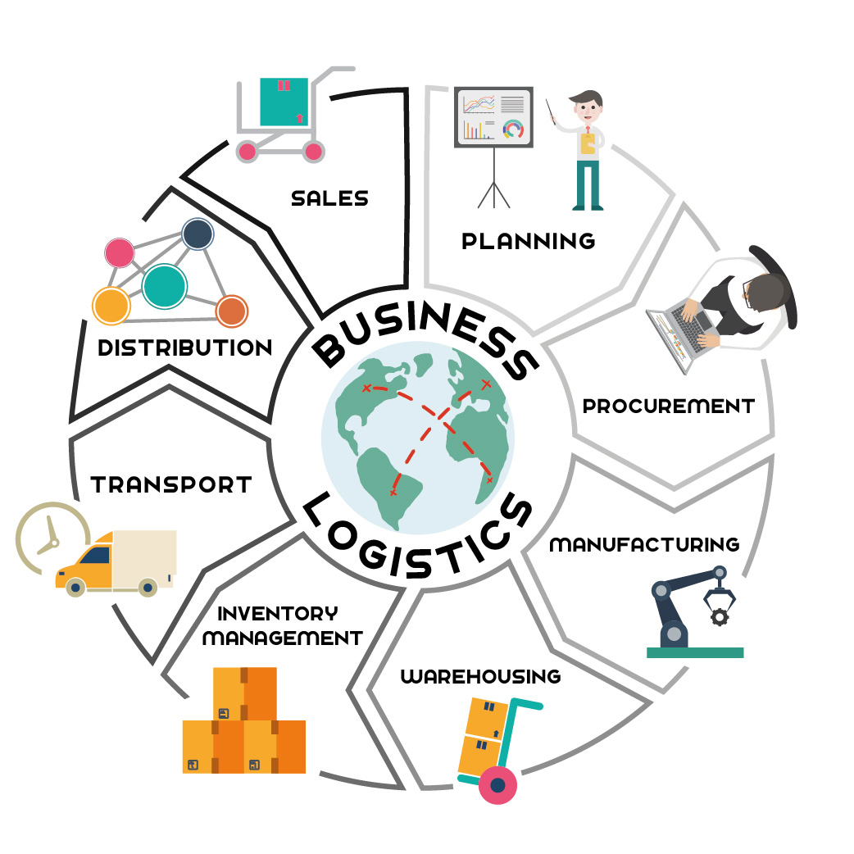

1.)
i.When we are sell the products from the primary producer to the final customers. For example when the farmer is sell the fruits or meat or vegetables direct to the customers, or when the self-employed fisherman, sell the fishes and the crabs from the ship direct to the customers in the harbor.
ii. Production, inventory, location, transportation, information
new: row materials company

transportation company

manufacturing company

independent distributor

independent retailer

Fragmented, Fast-Moving

iii. old: row materials

transportation

manufacturing

distribution

retail showroom

slow – moving
mass market
The new system is more flexible because the goal is the production accelerating and decoupling, and in this case the quantity is higher too, but the quality is similar or same.
iv.
Stock counting in the stores, from the row materials to the products.
v.
The information is contact between the supply chain operations and activities. With the information we can create the business plan for the future, and we can count how strong we are against the competition, in the production and on the stock exchange too.

vi.
- cycle inventory
- safety inventory
- seasonal inventory

2.)
Have a lot of things what is influence the good location from the rent or purchase price, what’s must to be the cheapest, but the best for the price, to the type of the company. if the company is the small retailer, must be in front of the customers, if a large wholesaler or factory that’s better in a middle of a big industrial site, and for the farms are better near the plough land. What is the most important thing is the good place for us and for the target market. Must to be good quality of roads and streets, about the product or material transfers, and about the all of deliveries.
3.)
i.
- prducers: for example the farms or the mines, that’s companies who’s supply the wholesalers and the retailers with row materials.
-distributors: Between the wholesalers and the retailers a investor company.
-retailers: That company what is sell the finally products to the customers.

ii.
- Describtion: From the commercial diary farm going the low milk in the bulk collection. From the bulk collection goes the milk to the diary processor company. From here the milk goes the two lines up to the type of the product.
first: The cream whey is go to the diary product factories, and from the factories to the retailers or direct to the customers.
second: From the diary processor goes the butter , the cheese, the yoghurt, the juices, and the other diary product to the secondary diary processors, and after to the retailers, or directly to the customers.
- The PE diaries is a retailer, what is a diary product home delivery company. Simon Hull is take the diary product directly to the customer’s home.
- The main problems in the company’s are:
- The concurents, because a lot of people are going to the supermarkets.
- The product life are too short, and what’s not delivered, that’s thrown away, so he need to count the quantity what, he can sell to the customers, what is more less time to time, about the concurents.
- The PE diaries was going very nice in the first 10 years, but from 1990 to 2007 time to time declined.

