
Assignment Cover Sheet

Student Name: | Irini Girgis
Student Number: | 5338
Course: | Diploma in Child Psychology
Assignment NO: | 1

Marking Criteria:
We expect the learners to write minimum one well expressed point in three lines against each allocated mark. This means one needs to write 15 lines with 5 well expressed points to get high grades for a 5 marks question.
For high grades use examples and illustrations where appropriate.
1.i. Do all children develop various skills and abilities at the same time? If not, why?
Children development stages, in general, takes place in an orderly manner; however, each child develops various skills and abilities, in each stage, in his/her own pace. In any developmental area, there are some known ranges in which each child develops within them, based on his/her abilities and experiences. Parents should not focus on how fast their child develops a skill, but rather if that skill is developed within the expected rate or not.
Below is a diagram that shows movement skill milestones, as an example.
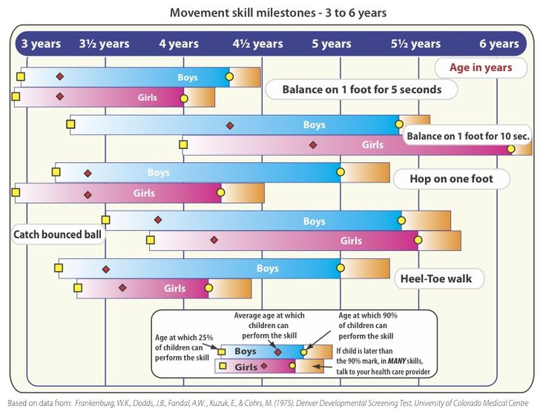

1.ii. Explain the difference between growth and development.
When the term ‘Growth’ is used, it describes the physical appearance of a human being. This growth, increase in body parts’ size, is more noticeable in children than adults. It can be measured using standard units.
When we use the term ‘Development’, we usually refer to wide range of changes. It refers to not only the physical changes but the behaviour ones as well. Development refers to ongoing behavioural changes in both children and adults. As stated in the course outline, these changes are progressive, orderly and long-lasting. Humans do not just grow, they develop.
1.iii. What are the various stages of development in humans?
The human’s life is divided into four stages of development.
Infancy: Birth to two years old.
Child is fully dependent. The period with the most rapid growth and development.
Childhood: Early childhood from two to six years old.
Uses the basic skills learned before and refines them into more complex ones as well learns new ones.
Middle childhood from six to twelve years old.
Matured a lot. Fast development of the cognitive abilities.
Adolescence: 12 to 18 years old.
Rapid noticeable physical changes that requires emotional adjustments. Acquires cognitive development.
Adulthood: from 18 years of age
Growth is fully mature. Socially treated as adults relies on their backgrounds.

1.iv. What are the different areas of development throughout an individual’s life?
a- Physical development: the different body parts changes that an individul goes through
b- Motor development: control that a child has over his/her large and small muscles which affects his/her body movement.
c- Social development: the changes in how a child behaves and interacts with any group of individuals and in any situation he’s been placed in.
d- Emotional development: the changes that a child experience in dealing with and expressing his/her emotions.
e- Language development: the progress in the child's ability to both understand and use language.
f- Cognitive development: the development of the child’s learning abilities as well as problem solving abilities.

v. What is the relationship between different areas of development in a child?
Each area of the human development has specific characteristics; however, they all have an effect on each other.
The more a child develops physically, the more control he will have over his muscles and other different body parts (motor development) and this will naturally affect the development of his thinking skills to solve any problem faced (cognitive development).
A human’s development of confidence may be affected by the physical development. Physical development through puberty (physical development) affects a person’s self-image and interaction with peers (social-emotional development).
The ability to think and reason (cognitive development) affects a person’s ability to understand feelings and emotions (social-emotional development).
Social development is greatly linked with language development as the child uses their communication skills to socialize with others.
vi. Define the term ‘Cognitive Development’.
Cognitive development is the development of the child’s thinking process as well as problem solving abilities. This includes logic and reasoning; remembering and decision-making.
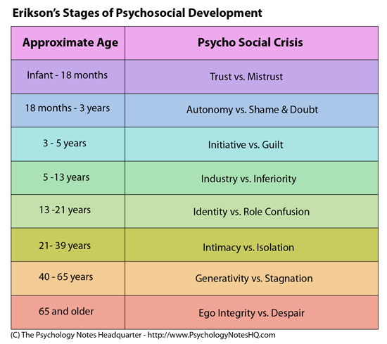
vii. What are the five stages of development in children according to Erikson’s theory of Psychological Development?

2. Social development refers to the development of those abilities that enable the individual to behave in accordance with the expectations of society. Discuss this.
A Child’s social development is not only affected directly by the adults who care for the child, but also indirectly through the child’s interaction with the peers, family members and all individuals within the community. These interactions help develop the values and skills needed in dealing with others in positive ways.
Children who develop balanced social skills at a young age, help build a real image of themselves which in turn allow them to have successful relationships throughout their adolescent and adulthood.
As the years pass by, children start realizing which behaviours are acceptable within their society and which are not.
Influences on child’s social development

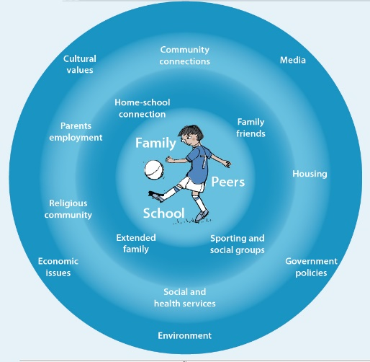

As seen in the illustration, different aspects in the child’s culture and society influence his/her social development.

Kids Matter - http://www.kidsmatter.edu.au

Activity 1.
Think of two children that you know. List three ways that they tend to be different from one another in the way they respond to situations.
I will give an example of my own two children.
Social development: one of my children is shy, sensitive and introvert; does not interact with any non-close people; takes time to get used to new people or friends; gets embarrassed easily; plays with only close friends. The other one is outgoing, social and extrovert; does not mind interacting with new people or being in new situations; has many friends and doesn’t mind playing with any of them, even the not-so-close ones.
Motor development: one is athletic and have good gross and fine motor skills. The other one struggles with having control over the muscles and therefore does not prefer to join in any physical activities that most children involve in.
Emotional development: one can deal with different emotions as well as clearly express them. The other one does not have the ability to deal with different emotions as well as tends to not express or share them.

Case Study
Dave’s mum is very concerned about her son’s speech. Dave is four-years old and although he is very active in nursery, he uses offensive language in almost every sentence. Dave’s mom discussed the situation with his teacher. Her discussion with the teacher showed the reason every sentence she spoke contained the same language she was complaining about Dave’s using. Dave’s teacher tried to explain that children learn to speak by example.
i. Where does the problem exit?
Social, culture and socioeconomic backgrounds affect any child’s development. As mentioned in the study guide, a child’s family’s social class affects both his social and cultural contexts. Dave’s parents’ background play an important role in the use of offensive language. It is clear that the use of such language has been accepted within their social environment.
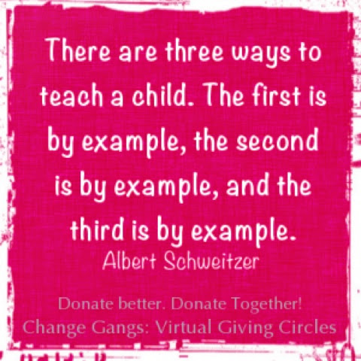
As Jerry Banfield mentioned “If I want to show her patience, I must have patience. If I want to show her love, I must have love. If I want to teach her how to be a good person, I must lead by example in everything I do. I cannot use ‘do as I say, not as I do’ or ‘because I said so’ in any instance. I cannot give my daughter something I do not have myself.” The use of offensive language by Dave’s mother has had a great influence on Dave’s language.

ii. Is there any developmental issue involved?
Dave’s social development is surely affected by his language. Most probably he gets into fights with his peers because of his offensive language. Also, a feeling of unacceptance within his peers will surely affect his emotional development.

iii. In your opinion, how can Dave’s teacher help him improve his behavior?
Dave’s teacher can use a reward/consequence system. Every time Dave uses an offensive language, a sticker or a point is taken away and vice versa, every time he uses an acceptable language, he gains a sticker or a point. This chart should be visible to him all the time and he needs to be frequently reminded to follow the chart until it becomes a habit. The teacher can also convey his progress to his mother as well as encourage her to do the same at home.

Student Statement:

By submitting this assignment, I confirm that this is my own work.

Student Signature | Irini Girgis | Date | 27 Jan 2017

For Tutor / Assessor Use Only
Total Marks
Marks Obtained
Percentage / Grade

