
Assignment Cover Sheet

Student Name: | Jason Thompson
Student Number: | 29096
Course: | Diploma in Logistics Management (Level 4)
Assignment NO: | 6 – Warehousing and Materials Handling

Marking Criteria:
We expect the learners to write minimum one well expressed point in three lines against each allocated mark. This means one needs to write 15 lines with 5 well expressed points to get high grades for a 5 marks question.
For high grades use examples and illustrations where appropriate.
- Give short answers:

    - What are the aims and functions of warehouses?
Aims and functions of a warehouse are storage area, breaking down of bulk products, movement control and finishing.

    - What is the difference between public and private warehouses?
Private warehouse is either owned or leased by the company. Public warehouses a self-run business charging rates for various actives.

    - Explain the advantages of public warehouses.
The advantages of a public warehouse are ease of access to various skills, not supplied internally, cost reduction, immediate access to a working area and flexibility.

    - What are manual warehouses?
Manual warehouses are more or less a picking container for staff to pick various parts from bays and racking.

    - What are automated warehouses?
Automated warehouses are usually working areas involving accessible only by aisle trucks to pick with.

    - What are the main materials used for packaging?
The main materials used for packing are, plastic, glass, wood, cardboard, metal.

2) Outline the activities that take place in a warehouse.
The main activities within a warehouse are, receiving of raw goods, unloading of delivery vehicles of various items raw and otherwise, loading of vehicles of either finished goods or goods moving elsewhere for finishing, matching of orders and fulfilments of orders, picking and sorting of items putting goods into racking.
Also, re-packing of items possibly into smaller containers, quality control on products, this would include both goods coming to ensure they meet standards, but also quality control checks on products leaving the site, to fulfil customers’ orders.
Packing and labelling of finished items for despatch. Another activity could also include re-working of items that have failed quality control checking for various reasons.

3) Describe, in detail, the general layout of a warehouse. Using examples and illustrations.
The general layout of a warehouse would typically consist of a yard for which both vehicles and packing materials can be stored, these would usually be pallets and plastic containers.
You would also have loading and unloading bays or even cross dock bays for goods which are received in quality control checked then moved straight back for possible further production work.
You would also have aisles within the warehouse for storage of items at various stages of completion, this would typically be where you would have an automated warehouse including the use of fork lift trucks and narrow aisle trucks and pump trucks for movement of pallets on ground level.
A packing are would also be an area where picked items are packaged and labelled for customers delivery, then stacked onto pallets usually shrink wrapped, then loaded onto a vehicle packed on one of the loading bays.
This area would also include the re-work are if that is part of the business set, as re-work normally helps reduce waste and reduce costs.
See diagram below of a general layout of a warehouse:

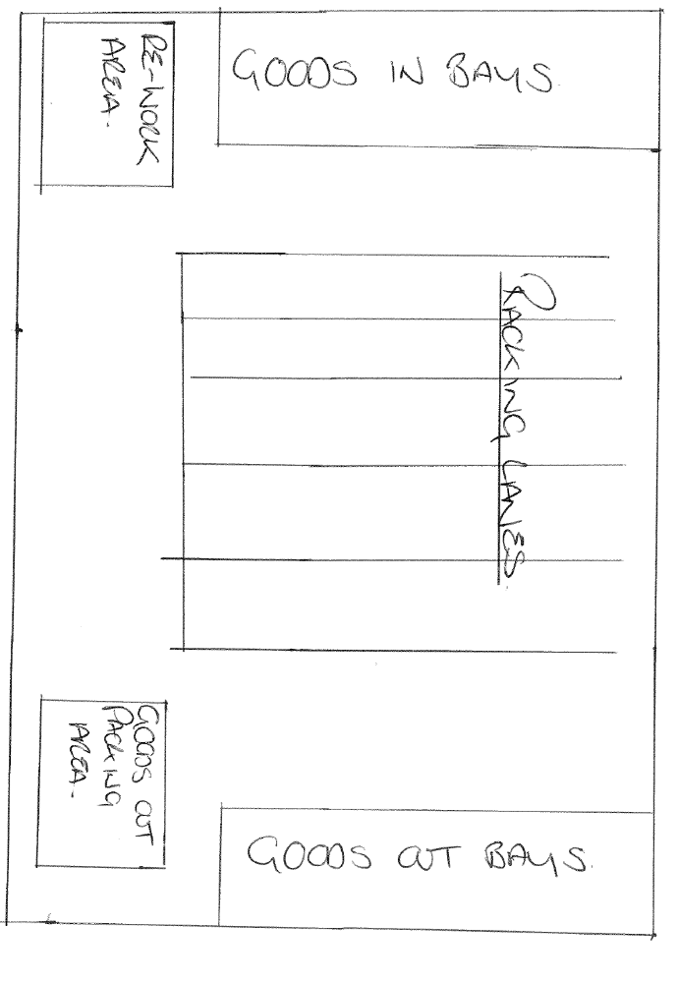

Student Statement:

By submitting this assignment, I confirm that this is my own work.

Student Signature | Jason Thompson | Date | 16/06/2019

For Tutor / Assessor Use Only
Total Marks
Marks Obtained
Percentage / Grade

