Assessment 6 – Planning for the Big Day

Question 1

i. When selecting a wedding venue, a variety of questions should be asked. Particularly how many guests can the venue hold, availability, price & deposits, is there enough space, will the couple have exclusive use of the place, is it accessible for all guests? Do the venue provide all food, drinks & lighting/equipment. Once the venue is selected, the finer details can be determined.

ii. If a ceremony is being held outdoors, the wedding planner should consider the following:

- Bugs – In the height of summer this could potentially cause mayhem, they will disrupt the couple & guests, especially where food is concerned. Spray/alternative measures should be found to prevent this from happening.

- Bathrooms – There will need to be a sufficient amount of toilets available, depending on the guest ratio, ideally a separate standing bathroom away from the main area/catering.

- Tents/Marquees – As the weather can be so unpredictable all over the world, it would definitely be a wise idea to have a tent/marquee to fall back on. There are a range available & the couple will need to be specific about their requirements & headcount, to ensure there is a sufficient amount of space.

- Linen/table cloths – If the reception is not held in an official venue, linen, table cloths, cutlery/glasses etc will all need to be sourced separately, if not provided by the catering company.

- Generator/electrical power – Extremely important, so the area can be lit well, music can be played, food cooked & everything else runs accordingly.

- Lighting – Lighting is an important factor in a wedding, especially the centrepiece lighting, dance floor/wall lighting & the tent lighting. it can really shape an event, so it needs to be given a lot of thought!

- An engineer on the premises in case of disruption – If the electrics go down, it would cause a big issue, so it would be worth every penny having someone on standby who knows what to do in an emergency.

- Floor plan/layout – Drawing up a plan of the venue will be hugely beneficial when the suppliers are setting up, so they are clear on the clients wishes & expectations.

iii. The history of wearing a white wedding gown stems from the 1400’s due to Anne of Brittany. White symbolises purity/virginity, prior to white being tradition it was blue. Queen Victoria then brought white back during her reign in the 1800’s.

White was viewed as having a high status amongst society, as white fabric was expensive. As it couldn’t be cleaned professionally in that era, it became a rare/occasion colour clothing choice.

iv. The 3 primary food service styles are:

- Plated – Suited to historical venues with various rooms. There are usually waited staff, enabling a quicker/seamless service.
- Buffett – Best choice for informal weddings or large groups, as a variety of different food can be served to suit preferences.

- French – Served from 1 large platter/dish, each guest receives special attention.

V. The difference between buffet & French style service is that buffet style is much less formal & more relaxed, guests help themselves to the range of food on offer. Less waiting staff are required, making it better suited to larger groups.

French style is served as ‘sharing plates’ – better for venues with the kitchen on a different floor to the dining area. the entire meal for everyone at one table is brought out & served from one large platter/dish. The servers wear white gloves & serve each guest personally.

VI. Two different photography styles are photojournalistic & traditional.

Photojournalistic is usually natural, candid, all angles, spontaneous, little communication, hands-off & presented in a flush mount album. Examples below:
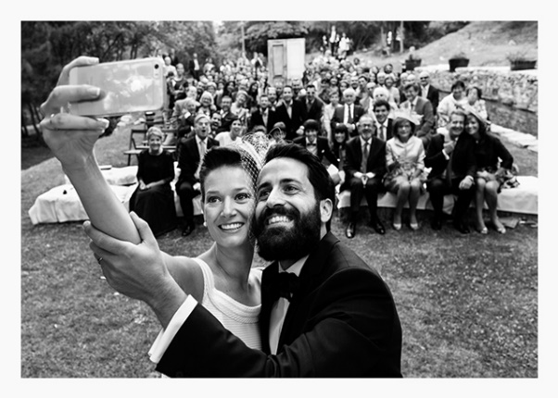
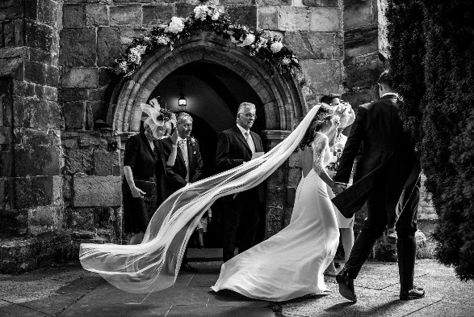

Traditional photos are posed, directed/staged, front & centre, a lot of communication, hand’s on & presented in a mount album. Examples below:

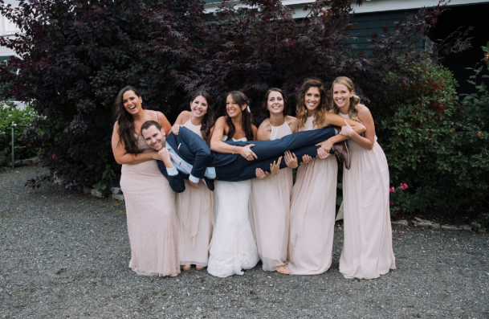
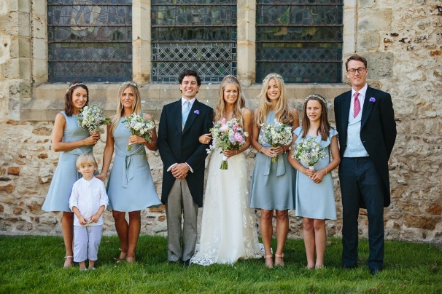

VII. The tradition of the bridal bouquet stems from Ancient Rome, brides carried or wore flower garlands, believing that flowers signify new beginnings, fidelity and hope of fertility. A traditional bouquet usually consists of masses of one type of flower.

VIII. The different music types at weddings are:

Dramatic – Choir, bagpipes, string quartets.
Formal – Harpists, classical singer, pianists & organists (etc).
Fun – Live bands, DJ’s, jazz, pop, singers, saxophone.
Romantic – Harpists, guitarists, pianists, Flautist, string quartets, violinist & singers.

IX. The different parts of a wedding invitation are an outer & inner envelope, a reception card & a response card. Detailed invites will contain information about directions & accommodation options.

Example below – where the reception invite is to follow.
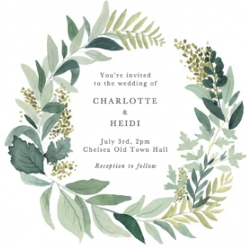

Date & time – the most important details

X. The vehicle company manager should ask the following upon booking the vehicle:
- If the company have any photos/videos from previous wedding transfers
- Are the vehicles & staff the same as those on the actual day?
- How many people do they seat?
- How many staff will be there with each vehicle?
- Will there be umbrellas/people to help the bride get out?
- How many weddings will they be taking on that day?
- Do you get any food/drinks?
- Are they licenced?
- What packages do they provide?
- Confirm prices/deposits & whether there are cancellation costs
- Are the vehicles heated/air conditioned?
- What happens if there is a breakdown?
2. Creative modes of transport for the wedding ceremony:
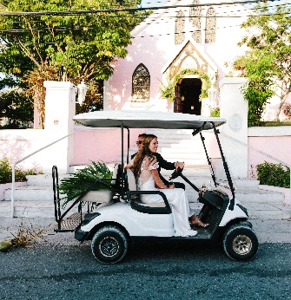
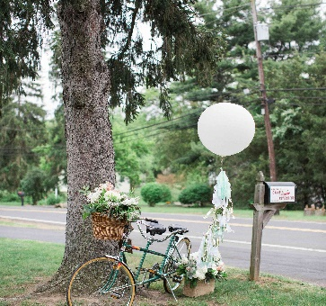
- Antique fire engine
- All-terrain vehicles
- Bicycle for 2
- Canoe
- Camel
- Chinese rickshaw
- Cross-country ski
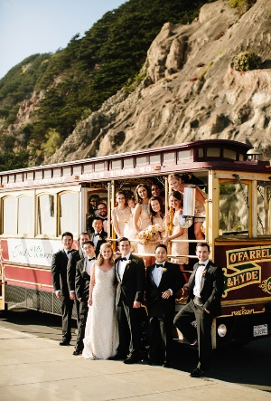
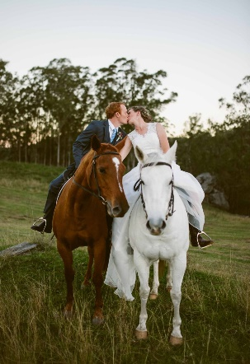
- Dog Sled
- Duck Boat
- Golf cart
- Horseback
- Ice cream truck
- Mini cooper
- Monster truck
- Moped
- Motorcycle with sidecar
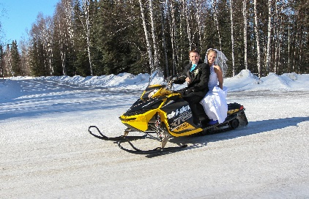
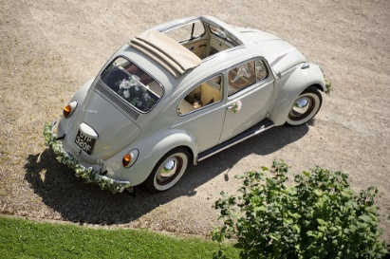
- Sailboat
- Sleigh
- Snowboard
- Snowmobile
- Subway
- Vintage VW beetle

