
Assignment Cover Sheet

Student Name: | Joanne Kerr
Student Number: | 8937
Course: | Diploma in Interior Design Level 4
Assignment NO: | 5

Marking Criteria:
We expect the learners to write minimum one well expressed point in three lines against each allocated mark. This means one needs to write 15 lines with 5 well expressed points to get high grades for a 5 marks question.
For high grades use examples and illustrations where appropriate.
Q.1 Short Questions:

i. It is crucial to establish the function of a room before decorating it. How the room is used, when, and by whom, will significantly influence the type of furniture and decoration that is suitable for the room.
The types of questions I would ask a client would include:
- What activities happen in the room? Is it single use or multi-use? (the answer to this will influence attributes such as furniture, storage, segregation of space and the type of lighting required)
- Who in the family will use the room? (This is similar to above, but considerations for children will be different to adults. For example, the placement and protection of power sockets, the formality and style of decoration will differ.)
- When will the room be used? (This is an important consideration for lighting – both natural and artificial which will need to support the activities undertaken in the room. Things like hobbies/crafts for example will need special lighting. Other things like privacy will be a consideration for window furnishings in bedrooms).
Once established you can move on to other design features like style, colour etc. knowing that what is being created will be fit for purpose.

ii. Mirrors can be used to create a focal point in rooms where there is no existing focal feature (fireplaces, quite naturally play this role). Mirrors are so versatile. They come in all shapes, sizes and styles. They bounce light and also create a greater depth of field in a room. Therefore, the opportunities for using mirrors I think is fairly boundless. I have found a few examples that I personally really like to demonstrate this variety:
Firstly, this oversized gold mirror is incredible. I think it does a great job of giving an old world glamour feel to this dining room and provides a great focal point – based on its enormous scale. Without it I think this room would look fairly bland.

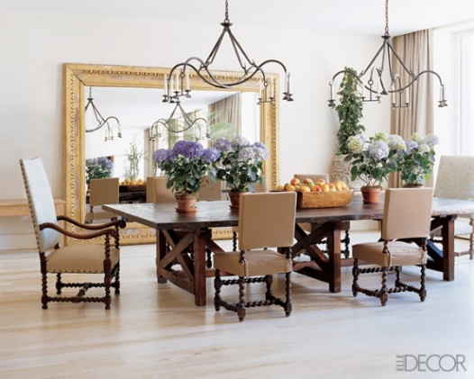
Source: Frog Hill Designs website.

Secondly, you don’t need to stick to just one mirror to create a focal point. Clustering of different mirrors can create an amazing focal wall.
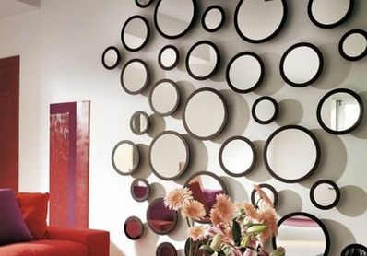
Source: Pinterest

And not only can mirrors be used as a focal feature themselves, due to their reflective nature they can also create depth of field and a focal point of another feature within the room. I love how this mirror draws attention to the dramatic candelabra over the table.
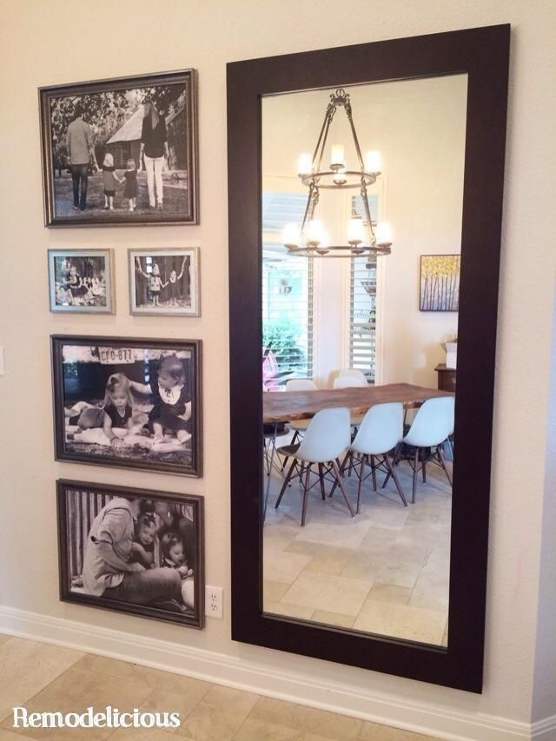
Source: Pinterest

iii. Children are creative, exuberant and full of energy. They are also messy, prone to illness and tend to eat things they shouldn’t. Cushions provide an easy way to decorate and update the look of a child’s room as they grow and become interested in different things. Key considerations would include:
- The size and shape of the cushion. Will they be used for sitting on, resting a head or as a nap space?
- Safety. Is the cushion made from fire retardant and non-toxic material?
- Does it incorporate things that they child loves e.g. Animals or dinosaurs?
- Can the covers be removed for easy cleaning / replacing?
I particularly love this quiet reading corner arrangement of cushions (source: Pinterest). You can see how this could evolve as the child’s needs and interests change over time.

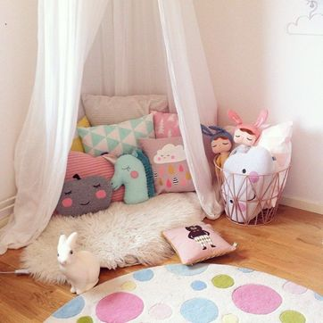

iv. It is massively important to draw a floor plan before buying furniture to ensure that the furniture within the room is functional, with enough clearance space, and looks right for the size of the room. As we have previously explored, you can use furniture to correct perceptual challenges with a room – making is look bigger or smaller for example. Our eyes are often not a good judge of size and sofas/cabinets/bookshelves etc. are normally displayed in showrooms vastly different to the size of the room we need to furnish ourselves. By making a scale drawing of your room size and shape you can get very clear about how the room will start to look in reality. There are now a number of online tools that help visualize this further (I have used Room Sketcher below) but I have also found that by cutting out shapes the size of sofas, drawers etc. and placing them on a scale drawing is a really easy way move stuff and place items accordingly before committing to an expensive purchase.

v. I recently watched a TV show where compromise was described as, ‘half way happy’, which made me smile a lot. But that is the reality of living with others. We all have our own tastes and ideas. I think it comes down to establishing some common needs and working from there – starting with function. Are both individuals going to use the room in the same way (does one person need a home office space for example?).
Once function is established I think looking for common ground is important. Are there common colours, styles or textures that you both like? I also think that budget is something that often is the real source of debate often wrapped up in style conversations.
A personal example: When my boyfriend and I moved in together we moved into a rental apartment with a very large, furnished lounge which had an ‘80’s office block vibe’ about it – lots of beige and at the centre of the room were two mismatched sofas, kind of drifting in space. I could see that with the addition of a statement rug and floor lamp we could create a much improved relaxing zone and draw the eyes away from the wider beige palette. After 2 months of debate over said rug and lamp (I like it / I don’t like it - repeat) I finally asked what was really important. It turns out my boyfriend loves finding a bargain. He gets joy from it. I had cracked the code! I would send a selection of the types of rugs and lamps I thought would work and bingo – within a week my boyfriend had found just what we needed on EBay for half the price. We were both happy.

vi. Given the proximity of a bedroom and en-suite bathroom, I believe there should be continuity in the design of the two rooms. Whilst they functionally do very different things and may require very different treatments (e.g. you could have a carpeted bedroom and a fully tiled en-suite), you can create flow through the use of colour and style. For example, a grey-toned bedroom can be reflected in the tiles and work surfaces in the en-suite. I think there also needs to be a style flow. A modern sleek bedroom needs and equally sleek bathroom. Even things like towels or colourful bottles in an en-suite can reflect some of the bedroom colours to create greater flow if full renovation is not practical.

Activity

I currently live in furnished, rented accommodation, so am very restricted in what I can do. I have however planned what I would love to do given a free reign!
My bedroom is approximately 400 cm wide x 400 cm long. It has high ceilings that are 2.65m tall and one wall is dominated by 3 windows that are 100 cm off the ground, and are 100 cm wide x 100 cm tall.
I have attempted a scale drawing using a 1.25 scale. I am no mathematician so bought a scale ruler which was incredibly useful to draw in scale ‘real time’ rather than constantly calculating.

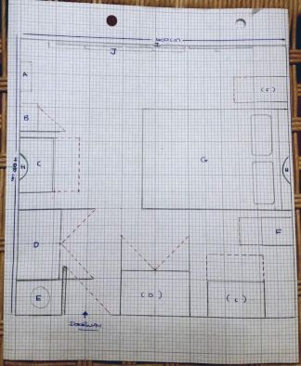

The bedroom contains:
A.: A freestanding mirror
B: A strange built in cupboard attached to the wall
C: Malm Ikea drawers (x2)
D: Freestanding Ikea wardrobe (x2)
E: A round washing basket behind the door
F: Bedside tables (x2)
G: A King size bed and headboard
H: Wall mounted bowl lights (x2)
I: Windows (x3)
J: Radiator underneath the windows

Whilst in theory, we have considerable storage in the bedroom, it is bulky and makes the room look crowded and messy. There is wasted space above the wardrobes that could be much better utilized. We also don’t have any hooks or space to hang clothes overnight. The wardrobes have outward opening doors which creates further space challenges (the red dotted lines on the drawing show clashes). And lastly, on both the left and right walls there are large and dated bowl style lights with commercial style bulbs. These create quite a cold light so we don’t use them. These lights also restrict where we can place the freestanding wardrobes. Lastly, it has dated carpet, which whilst warm, I think makes the room appear smaller.
I think the whole space could be drastically overhauled by doing the following:
- Removal of the wall lights – replaced with a single feature pendant light and a couple of modern bedside reading lamps.
- Removal of the strange attached cupboard that adds no value.
- Removal of the freestanding wardrobes and drawers.
- Replace dated carpet with a modern wooden floor and large feature rug.
- Create one built in wardrobe – 3 metres wide with both hanging rails and drawers inside. This wardrobe should have sliding doors, rather than outward opening.
- Change the bed for a super-king, ottoman style bed that has storage underneath.
- Include a low level unit and some hooks for hanging items.

I have used Room Sketcher (online free tool) to visualize my recreated bedroom with smarter storage.

This is the top down view of my re-designed bedroom:
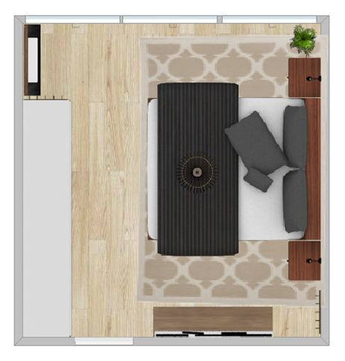

This is the view looking in to the room from the doorway:

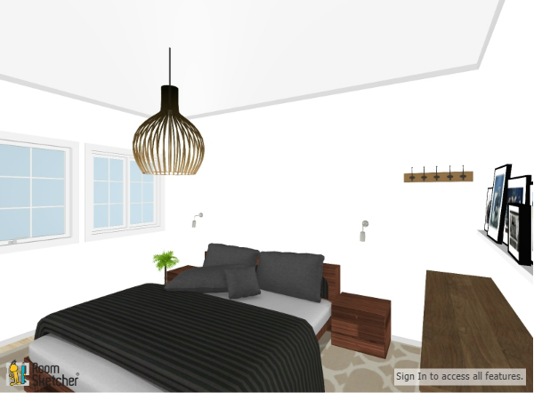

This is the opposite view back towards the door, showing the built in wardrobes:

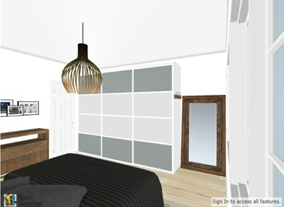

And lastly the view from the windows back towards the door:

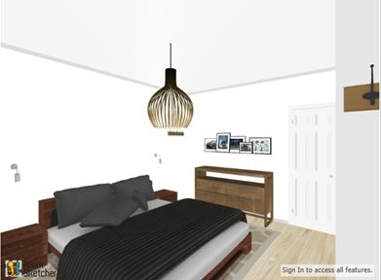

Student Statement:

By submitting this assignment, I confirm that this is my own work.

Student Signature | Joanne Kerr | Date | 8 January 2018

For Tutor / Assessor Use Only
Total Marks
Marks Obtained
Percentage / Grade

