Assignment Cover Sheet

Student Name: | Joanna patey
Student Number: | 9823
Course: | Certificate in event management level 1
Assignment NO: | 3

Marking Criteria:
We expect the learners to write minimum one well expressed point in three lines against each allocated mark. This means one needs to write 15 lines with 5 well expressed points to get high grades for a 5 marks question.
For high grades use examples and illustrations where appropriate.
Please insert your completed assignment ( in word format) here:

Question one -What is the importance of a feasibility study when making a budget?

The feasibility study is important because it will give an overall picture of the financial outcome of the event and whether it will be viable or not, it is important that the organizers and the clients
are both realistic when estimating possible revenues and outcomes, these should be as comprehensive/accurate as possible, these should also should include outgoings and incomes. It is a good idea
to start from scratch so that no areas are missed or overlooked

this should include
- Feasibility/ initial budget
- Forcast
- Re- forcast updated
- Updated budget
- Cash flow forcast

This should be updated on a regular basis so that any costs that have arisen along the way can be accounted for, a contingency budget should also be included for unexpected costs
this should be around 5% to 10%

These are a few typical scenarios that could mean disaster if a feasibility study is not followed

- The event goes ahead despite loss of possible income i.e sponsorship pulls out at the last minute or less than half of the tickets have been sold
- Unexpected costs have arisen such as venue costs have escalated, extra equipment needs to be bought or errors have been made in calculating the costs
- Or the feasibility study has been ignored completely which could mean costs couldhjx spiral out of control

There are some factors to consider when working out costs/income which include

- The length of the event i.e will it be held on just one day or will it be over a few days?
- The estimated number of visitors, speakers, officials, delegates and v i p s
- The amount of accommodation and transport required
- Payments to speakers and the entertainment
- Catering costs
- Promotion and marketing costs
- Licence’s
- Insurance
- Venue costs
- Decoration costs
- Printing costs
- Lighting costs
- Wages for staff
- Petrol costs
- Any additional equipment needed

There are a number of places the income could come from such as

- Government grants
- Sponsorships
- Sales of merchandise
- Ticket sales
- Raffles
- Participant fees

Question 2 – Describe the main factors that should be considered when selecting a venue

The first thing to consider is location

1 – is it local to where most attendees live or will they have to travel? It’s a good idea to check out where the local train stations are located and also bus links, if the attendees are coming from
abroad it’ll be helpful for the airport to be near local hotels, providing g p s locations would be useful for the attendees/ delegates to find the event easily

2 – It is within budget you don’t want it to be above budget but equally not too cheap either because it could be very cheap for a reason

3 – Parking – Does the venue have a carpark? if so it must be big enough for all the attendees to park is there disabled parking available?
You may be able to reserve a section of the carpark for your attendees and possibly include the cost of parking in the ticket prices its worth asking if this is possible, if there isn’t a carpark
available you will need to find one nearby that your guests will be able to use but this must be within walking distance, in this case you may need to ask the owner of the carpark if you can use it

4-How big is the venue? and will it be able to hold the amount of attendees/delegates expected? Find out what the maximum capacity of the venue is, this is important because
of fire regulations which must not be breached

5-Is the venue suitable for the type of event planned? for example if a concert is planned outdoors may be more suitable as you would have more space for a large amount of people and
does it fit with the goals of the client? also it would be useful to take note of the décor of the venue and that it matches the type of event planned, for example for a wedding that has a gothic theme
a castle might be an idea

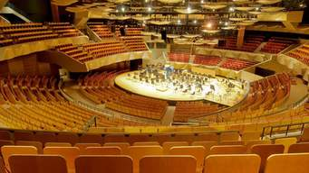this venue has a large amount of seating for a music concert for example

6-Does it have a kitchen available to cater for the delegates/attendees and what sort of kitchen equipment is supplied also if tables and linen are supplied this will save a great deal of
Money, and also will the venue provide the food if so it maybe a good idea to try the food yourself first to test the quality as you don’t want disappointed guests
7-Where are the electric points located this is important if microphones and sound equipment are being used
8-Is there a bar area? and does the venue hold the correct licences
9-The flow of traffic is important, it’s a good idea to keep the possibility of bottlenecks occurring to a minimum by maybe having several entrances/exits available
10-Does the venue cater for those with special needs I e widened doors, disabled toilets and ramps would be helpful
11- Does the venue hold a music licence? Find out what time the music needs to be stopped, and also is it too near to residents that may become irritated by any noise
12- Does the venue supply security, if not this may need to be supplied
13- Who else is using the venue at the same time and will they/yours interrupt each other?
14- Does it have a good reputation? It may be a good idea to ask around and find out from local people
15 – Check out local entertainment/hotels within walking distance of the venue this could be helpful if the event is being held over a few days
- will the venue allow for all the trade stands needed for your event to be erected and is there enough room for them to fit through the door both in and out
- Is there a separate room for event staff to change and rest, and also storage for any valuables they may have
- Does the venue have changing rooms/ showers for the attendees?
- Is the venue available for the dates planned and are they/you flexible?
- It may be helpful to have several venues in mind so that you can compare each, also in case of a problem with any of the venues
- Is there a stage available at the venue or will this need to be supplied? (in the case of an outdoor event this will be very unlikely)
- Is there an area available for smokers?
- Is there adequate disabled access inc widened doors, lifts and ramps and disabled toilets/showers?
- Does the venue have adequate fire- fighting equipment such as fire blankets and extinguishers, and where is the emergency meeting place?

Question three- outline the main safety considerations for catering operations

The main safety considerations are as follows-

When catering for an event where the public will be served food there are a number of considerations such as

1 The number of people to be catered for including children
2 The time of day the food is being served such as late in the afternoon or evening as you don’t want food sitting round all day
3 Where the food will be stored prior to preparation
4 Where the food is stored after it is prepared but before its served and is there enough space for everything
5 How the food will be transported to the venue and how far it is coming from
6 Who is preparing the food at the venue

The most effective way to make sure the food is safe to eat is to plan ahead the use of a monitoring sheet for example will help to achieve this

The venue

The venue where food is to be served is very important it must have

Facilities – What facilities does the venue supply?
- It must have a kitchen that is suitable to cater for a large amount of people
- The kitchen must be big enough to prepare food
- A freezer
- 2 fridges one to store any uncooked food and one for storage of food after preparation (if there is no storage available you will need to consider somewhere else suitable such as an insulated van)
- It will need a separate sink for hand washing and one for dirty crockery
- A dishwasher
- Suitable work surfaces that are easy to clean (stainless steel is best)
- A kitchen that is clean and tidy in a good state of repair eg not dusty or dirty
- No visible signs of any pests
- A floor that is easy to keep clean (find out if there is cleaning equipment available)
- Are there a suitable number of working temperature probes or will you need to supply your own?
- Are there facilities to re-heat food such as a microwave
- Suitable fire-fighting equipment such as fire blankets and extinguishers
- Is there an area to store dirty over clothing and linin?

>If there is no kitchen at the venue plan where the food will be prepared in advance, where cold storage is provided the fridges must be below 8c and freezers must be below -18c at the very least
> You need to consider how far the kitchen is from the food service area/s are there any hazards along the way and how will you transport the food from the kitchen (are there wheeled trollies available)?

> You will need to make a note of any equipment that you need to supply yourself and add these to the budget

Waste

It is important to plan how to dispose of any waste at the end of the day and how it will be collected, if bins are not provided you must provide them, it is a good idea when viewing the venue that
this is taken into account, some venues may insist that any waste is disposed of by the key holder and taken away and disposed of correctly you will need to consider how it will be transported and to where
such as a waste disposal site

Staff

Any staff that are helping with the catering/food service must be either supervised or suitably trained with adequate food hygiene certificates that are up to date, everyone must follow rules such as washing
hands,), long hair tied back, use of hairnets/ hats, clean clothing, minimal jewelry(rings and dangly ear rings removed)

Cooking

Cooked meats such as chicken pork rice etc(the last two items must not be re-heated) must have a core temperature of at least 75c for 30 seconds this can be checked with a clean disinfected food probe, this temperature applies to all
Cooked food and adequately recorded, if the food needs to be cooled before being stored in the fridge the food needs to be cooled quickly before being stored or it could cause the fridge temperature to rise these cooling times will also need to be recorded

Hot food service at the venue

If the food is delivered hot to the venue it must be at least 63 c or above until it is served, if it is cooked at the venue it must be served within 2hrs to ensure it is safe to eat also record the times the food was
cooked and served- retest the temperatures of the food just before it is served to make sure it has stayed at the correct temperature

Cold food

This must be served within 4hrs after being removed from the fridge if this time has passed the food must be returned to cold storage this will help ensure the food stays at an adequate
temperature and safe to eat again, all times must be recorded also it is important that the temperatures on the fridges are monitored at regular intervals and recorded

Food Disposal at the end of service

All leftover food must be discarded in the correct manner at the end of service

Heath and safety

> Not working when ill (at least 48 hours must have passed with no symptoms
> A well stocked first aid box with a supply of blue plasters
> Must wear suitable shoes ie no open toed shoes(steel toecaps are best)
> Clean aprons/gloves must be supplied
> Good standard of hygiene
> Fully stocked first aid box must be supplied which includes blue plasters

Question four- If the event is at a distance from the train station, would some extra arrangements be required to facilitate the public and what would those
arrangements be?

The transport management plan

It is possible that arrangements will need to be made particularly in the case of non- drivers such as:

>For large groups of people hiring a coach from the train station may be a cost effective option where everyone can meet at the same pick-up point and be dropped off again at the same meeting point
> If a smaller group is traveling maybe private hire cars/minibus maybe a better option where the passengers can share the cost, this can be booked in advance

> Having a local coach park close to the venue would be a bonus

Hiring some extra volunteers to pick travelers up from the train station could be helpful these people could share the cost of petrol

>If the event is over a few days/finishing late it may be helpful for travelers to stay in a hotel nearby preferably within walking distance of the venue so this will need to be booked in advance
they will need to make their own arrangements for onwards travel to the train station home giving details of local taxis and bus times would be helpful in this situation

>Rental cars could be an option for those people that would like to drive to the venue from the train station giving people this option could be hugely helpful to those people that have children
for example you could give some options of local car rental companies on your event posters/website and event invites

> For the disabled and those in wheelchairs you would need to make arrangements for private hire cars/minibuses to have wheelchair access/ease of access

> If there is a bus stop close to the train station this could be useful if there is a shuttle bus travels to/from the venue getting the local bus times and costs and putting these on your website is a good idea

How the pa system and video screens can be best used to manage the crowds

There are many ways both video screens and pa systems can me used to manage the crowds

Pa systems

The system should be clear and audible, it can be used inform advise and direct people it is important that the person using the system should have a clear and calm voice and should
speak loud enough so that people can hear and understand properly and that they have a good view over the venue so that they can see if a problem arises and act accordingly

Before the event starts test run the system to ensure it is working as it should be and continue to monitor the system thoughout the event to ensure it is still working properly, if the system fails it is a good
Idea to have a back- up system of communication such as radios or mobile phones and also a back-up power supply in the case of power failure

> It can be used to alert the public of any changes/cancelations and what measures have been put in place
> Event staff can use it for coded messages in the case of an emergency situation or problem so they are able to take up emergency positions the crowd can then be informed by a chime/bell
for instance as this will get every ones attention
> It can be used for instructions such as a way to push people further back from the front of the stage

> It can be used to alert parents in the case of a lost child being found and to tell them where to go to collect them or alternately to ask people to be on the lookout for a lost child
> It can be used to re-unite lost property to its owner
> Pa systems can be mounted on vehicles and can be placed at entrances and exits of venues to communicate with the public who are leaving/arriving these can also be used to communicate
With large crowds in the case of an evacuation as they are mobile

Location of the speakers/pa systems

Where these are located at the event is particularly important as you need the audience to be able to hear messages clearly and uninterrupted the best place to have them is situated above the
audience so that the sound can be reached towards the back but less towards the front also place any microphones away from the speakers to prevent feedback the use of a good quality pa system
which is suitable for the size of the event is of the up most importance
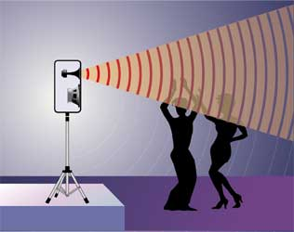 for a better coverage this speaker could be placed around 6-8ft above the audience

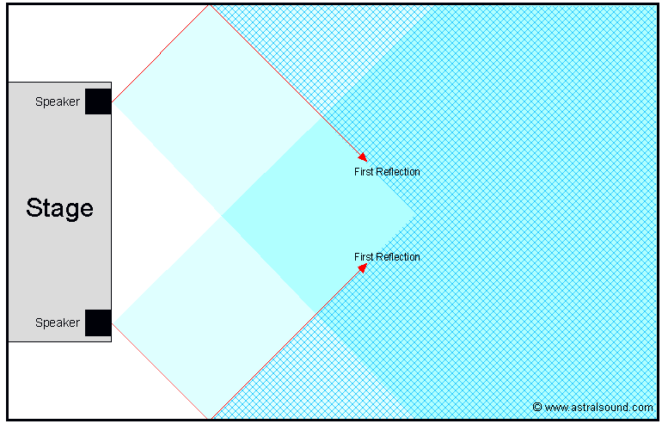the blue shaded area shows the area covered by the speakers (photo credit astralsound.com)

Video screens

> These can be used at selected points at a venue providing a view of the stage/event for the audience to see this helps the crowd surging forwards in an effort to be able to see better

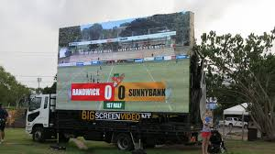
v

>They can help enforce the rules before entering a venue they should be clear and easy to understand/read
> people can be informed of an emergency situation such as an evacuation
> video screen display informing people of what they need to provide such as tickets/passes before entering a venue this will help reduce congestion at the entrances
> they can be used to inform the public of alternative entrances/exits this will help prevent bottlenecks occurring

> The screens should be a suitable size so that people can see them from a distance this will help prevent too many people getting too close to the screens
> they could be used to guide people to exit points to avoid bottlenecks in one area
> they could be used to update information such as when the event is likely to be reopened following an evacuation or used in conjunction with a pa system to relay the same message

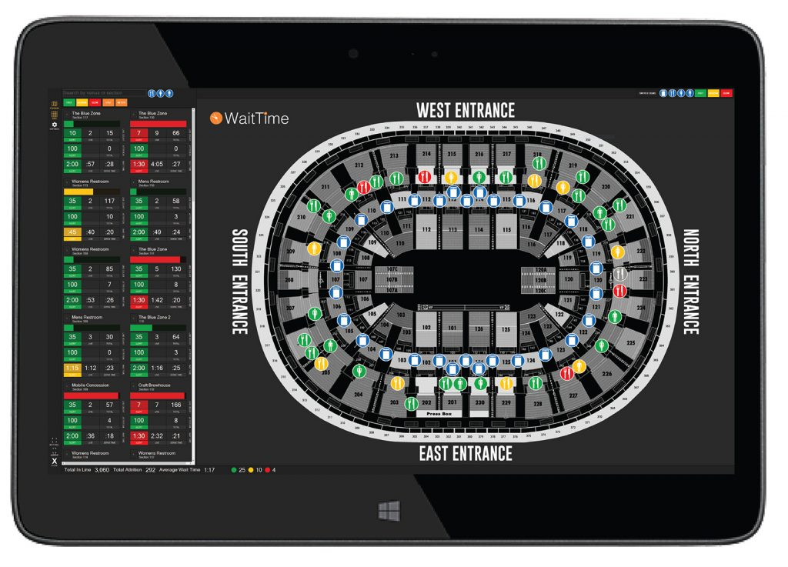image credit mcg trials technology
A video screen could display something like this which would show the average waiting times and which entrances/exits are open, this could be a huge help to people to find where they
need to go without trying to find someone to ask

Activity- experiment with a brain storming process, by gathering together a group of friends from your local community, explain to them that you would like to create a concept
for a festival that would attract a wide cross section of the local community and provide a report on the above activity

- How was your experience – really good, got plenty of feedback from quite a few people with some interesting ideas, I asked around a dozen people including those with children
to get a well rounded idea of what people want to see at a festival

- Which ideas were discussed –

- What type of music people like
- What theme should the festival have
- Where the festival should be held eg the local park or the big field on the other side of town
- What time of year
- What food stalls should be included?
- What type of other entertainment would appeal? such as a fair ground attraction or maybe bouncy castles
- Should there be craft stalls? showcasing item’s made in the local area
- What type of hot food people like – The choices would be burgers and chips, jacket potatoes or hog roast
- Would people like a charity raffle
- What would people pay for ticket prices?

> The majority of people suggested a music festival showcasing local bands playing music the whole family can enjoy while a few people said they would enjoy a folk festival
> Everyone agreed that the local park is best as its nearer town and has plenty of parking
. >held in summer was a universal choice so people can sit on the grass
> nearly everyone said they would buy from food stalls such as cakes (this was most popular with children)
> The choice of either bouncy castles or a small fairground was given, the majority preferred a small fairground as the whole family can join in >
> The majority of people would be interested in local craft stalls
> Given the choice of hot food burgers and chips was universal, hog roast was a close second but jacket potatoes less popular as people felt they could be awkward to eat
> The idea of a charity raffle was also a universal favorite
> The universal choice for tickets would be free entry but would be willing to pay for parking

- Which theme/idea was finally selected and why?

The most popular idea was a music festival was showcasing local talent that plays a wide variety of music that would appeal to most tastes but also so families with children can enjoy

References

www.leoisaac.com>evt>topo72.ht
www.majorevents.govt.nz/resunce-bank-budgeting-financeal-insurance/budget-development
www.event-juice/how-to-event-budget-like-a-pro
https//whova.com/blog/things- consider-when-choosing-event-venue
https//planningpod.com/2014/06/19/13-factors-choosing-event-venue
https://www.cardiff.gov.uk>documents

>

.

Student Statement:

By submitting this assignment, I confirm that this is my own work.

Student Signature | Joanna patey | Date | 4/12/2017

For Tutor / Assessor Use Only
Total Marks
Marks Obtained
Percentage / Grade

