Assessment - 2
NAME: - Sujon Hawlader
ID-21188
Assessment – Basics of Administrative Management

Answer to the “Q” No-1

Different levels of management:-
Most organizations have three management levels:
- Low-level managers;
- Middle-level managers; and
- Top-level managers.
These managers are classified in a hierarchy of authority, and perform different tasks. In many organizations, the number of managers in every level resembles a pyramid.
Below, you’ll find the specifications of each level’s different responsibilities and their likely job titles.

Top-level managers
The board of directors, president, vice-president, and CEO are all examples of top-level managers.
These managers are responsible for controlling and overseeing the entire organization. They develop goals, strategic plans, company policies, and make decisions on the direction of the business.
In addition, top-level managers play a significant role in the mobilization of outside resources.
Top-level managers are accountable to the shareholders and general public.

Middle-level managers
General Managers, branch managers, and department managers are all examples of middle-level managers. They are accountable to the top management for their department’s function.
Middle-level managers devote more time to organizational and directional functions than top-level managers. Their roles can be emphasized as:
- Executing organizational plans in conformance with the company’s policies and the objectives of the top management;
- Defining and discussing information and policies from top management to lower management; and most importantly
- Inspiring and providing guidance to low-level managers towards better performance.
Some of their functions are as follows:
- Designing and implementing effective group and intergroup work and information systems;
- Defining and monitoring group-level performance indicators;
- Diagnosing and resolving problems within and among work groups;
- Designing and implementing reward systems supporting cooperative behavior.

Low-level managers
Supervisors, section leads, and foremen are examples of low-level management titles. These managers focus on controlling and directing.
Low-level managers usually have the responsibility of:
- Assigning employees tasks;
- Guiding and supervising employees on day-to-day activities;
- Ensuring the quality and quantity of production;
- Making recommendations and suggestions; and
- Upchanneling employee problems.
Also referred to as first-level managers, low-level managers are role models for employees. These managers provide:
- Basic supervision;
- Motivation;
- Career planning;
- Performance feedback; and
- Staff supervision.

Answer to the “Q” No-2
Various functions of Management Every day, managers are tasked with leading and inspiring the people who work under them. This includes planning for team success, and fulfilling what it takes run a business. Five key functions are regarded as the ways that management should lead and interact with team members. From planning to review, the more specific management is the more effective the business is in achieving goals.
The functions of management divided into the following five categories, as given in the diagram below.
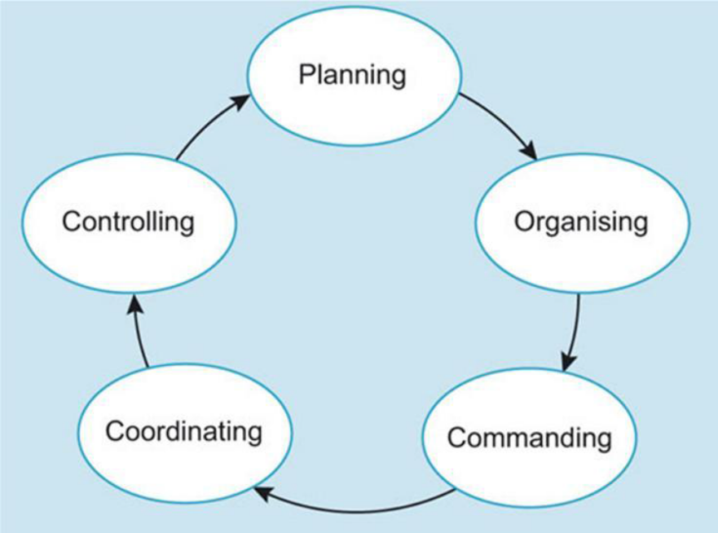

Planning
Planning actions as a function evaluates the goals of the company and then sets a course for success. This function evaluates the existing activities and goals. Managers then schedule activities that will lead to achieving those goals. Leaders must become problem solvers able to see the big picture while also identifying specific things that affect overall success. For example, if the goal is to improve the time it takes for customers to get their order fulfilled, then an operational strategy is executed to improve product fulfillment.

Organizing
The organizing function brings resources together to achieve the goals established in the planning function. Resources include materials, personnel and financial backing. Leaders need to identify what activities are necessary, assign those activities to specific personnel, effectively delegating tasks. Leaders need to coordinate tasks to keep resources moving efficiently toward goals. It is important to prioritize which resources are essential at any given time. For example, if more inventory is needed but the company doesn't have the financial resources to obtain the inventory, then the priority is to tackle the financial need.
Commanding

Commanding is when the manager communicates his expectations with every subordinate and their involvement in the work. A manager must delegate the work amongst his subordinate and then instruct and inspire them to work to their best of abilities. It is important for the manager to treat her subordinates with respect and not overburden them with work..

Coordinating
Coordinating activities is a key function. Letting staff know what needs to be done, and also by when is a responsibility of managers. However, bosses tell people what to do, while leaders motivate people to contribute in meaningful ways. The directing function requires leaders to do more than simply give orders, even though tasks must be completed for business success. This function begins with supervising subordinates while simultaneously motivating teams through guided leadership communicated in clear ways.

Controlling Systems
Controlling systems refers to all the processes that leaders create to monitor success. Sports coaches have a saying, "Winners keep score," meaning that winners know where they are and know what is necessary to achieve a goal. This business function requires leaders to establish performance standards, measure actual performance and compare the metrics to determine anomalies. For example, a sales leader is focused on more than only the final sales numbers; he considers the leading activities such as the number of minimum pitches and outbound calls. Leaders review the data and make adjustments in processes, policies, training or personnel to address failures based on that data. Winning leaders don't look at poor performance as failures but as opportunities to solve a problem that gets the desired results.

Case Study
  - Management refers to the process of using men, money, machines, material and processes through proper direction, coordination and integration of several activities so as to produce desired results and attain predetermined goals. In other words, management consists of a series of activities classified into various functions like planning, organizing, staffing, directing and controlling.
  - Irene Rogers is the floor in charge (supervisor) of William Davis business and as Lower-Level employee he knows everything what is happening like inside any factory or firm. So, Mr. William Davis can know about any news or problems from lower level employees.
  - Middle level management will take determine or objective for the business and properly fixed a match up determine with circumstance and give the other function management to fulfill goals.
  - Middle level management will take this responsibility as planning engineer/manager every moment he will plan and following about progress. He will handle to follow up work activities as per programme and how much achieved and he will give proper report about business or project to top level management.

