
Assignment Cover Sheet

Student Name: | ALAN KENWORTHY
Student Number: | 22331
Course: | Certificate in Logistics and Supply Chain Management Level 3
Assignment NO: | 3

Marking Criteria:
We expect the learners to write minimum one well expressed point in three lines against each allocated mark. This means one needs to write 15 lines with 5 well expressed points to get high grades for a 5 marks question.
For high grades use examples and illustrations where appropriate.

Student Statement:

By submitting this assignment, I confirm that this is my own work.

Student Signature | ALAN KENWORTHY | Date | 14.7.2018

For Tutor / Assessor Use Only
Total Marks
Marks Obtained
Percentage / Grade

Q1: What is purchasing?

If we focused on the logistics of any given organisation that is hoping to have a relationship in business with customers & suppliers OR position themselves within a specific Supply Chain, they will require a department that handles ‘the flow’ of materials upstream and downstream (in and out) to support their operation. This department would be Procurement and within procurement would be Purchasing - Purchasing is a ‘function within the procurement process’ and is a vital part of the movement of materials/product. Fig 1 (Source - April 4, 2017 by Shivani Paturkar)
This is a good quote and comes from Unit 3 in Supply Chain Management and relates to purchasing as ‘...a trigger that begins a movement to say we have agreed terms, so deliver us materials and we will pay you’
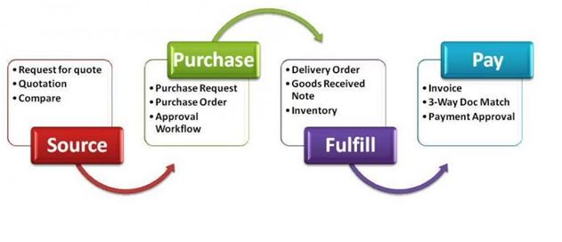
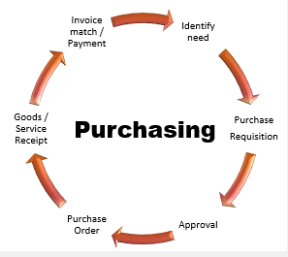
Closely related and integrated with procurement, purchasing is the ‘nitty gritty’ of procurement and the part that deals with the sale exchange. Other aspects of the movement of material (and services as required) may well be in negotiation and being arranged by other departments who can then share information that will activate the purchasing department and initiate Purchase Orders and Purchase Order Numbers as required.
Fig 2 : (Source – Procurement Process – Anna Aldana)

Purchase Orders will normally confirm details and be accompanied by terms & conditions, which on receipt will confirm the deal. Fig 1 shows what is involved in purchasing.
For me Fig 2 shows where purchasing fits into a procurement process as a function.
It is only when initial groundwork and sourcing of much information has been done within a procurement cycle, would a purchasing requirement be initiated. Maybe as a supplier if you are communicating with a potential customers purchasing department you should be pleased and possibly further down the negotiation process than you think!

Q2: What is the importance or procurement in a supply chain?
Effective supply chain management will have a series of strong departments that communicate effectively internally and who are also able to represent the organisation in negotiations and discussions with external contacts such as suppliers and customers as required. Examples of supply chain departments can include Logistics, Inventory Control, Marketing and Procurement.
Procurement is the art of ‘doing’ it’s the department that will go and make it happen when an organisation or body requires X to make or do Y.
Source: Jantoo cartoons

Let’s try an example:
I need a haircut and I have decided with my family that I should get one. It’s a simple process and doesn’t require a lot of thought necessarily and I can quite easily work out where to go, when and how much it will cost me – so if I had to report to my family I could easily let them know – its 1 person with a simple haircut.
So now, because of my successful haircut, I have been asked by my whole town who wish to have a particular style of haircut and all the same, to help them! My thinking will now take on a more in-depth approach because I will now need to know how all of this is going to work? How many questions do I need answers too?
How many haircuts do we need? When do we need them? Where will this take place? Who can provide the style? Have they done this before? Can they do everybody? When can they do it? How long will it take? What will the cost be for each haircut? Is there a discount for quantity? How often can we repeat the process? What are the payment terms and do they match our requirements?
Sourcing the finer details of ‘what is required and when, for how much’ is a tricky process and can be lengthy dependent on what is required but it is vital to a supply chain that ALL of this information is sourced, documented, negotiated, agreed, finalised and our due diligence produces the information we need. An organisation wishing to operate well and maintain and degree of sustainability will need a professional approach to procurement to maintain quality, delivery and cost as shown in Fig 1
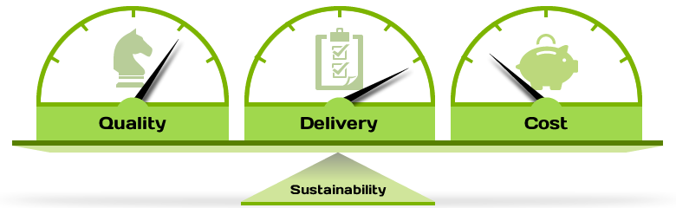
Fig 1 (Source – Delta Bid Procurement)
Although the different departments involved in an organisation and its supply chain are very important, the Procurement department is arguably the most important.

Q3: Describe the procurement cycle in details
If information is knowledge and knowledge is power, it goes without saying that every piece of information that can be attained from every area within a ‘business process’ and all that effect that business, should be found. From the general workings of the initial ideas to the finer details in production and the end user experience, ALL of the information is vital.
If we look at the procurement cycle that we have already identified as being vital to an organisation and supply chain, and examine how it works, we can find that a procurement process can be quite diverse from organisation to organisation.
There are however some basic steps that are followed by most. See Fig 1 for an insight
Fig 1 – (Source – GCU Process) 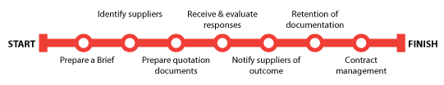
Information is prepared, delivered and shared at every step, either by the organisation or by the potential supplier in response. Questions are asked at every step to initiate responses that will provide information that can then be matched to requirements or discarded, until finally a contract or agreement is reached.
An effective procurement process that is set out correctly and engaged, may well take on the shape in your mind of a pyramid that has several ‘levels’ and at each stage some are unable to meet the level requirements so will fall by the wayside, others will continue until the top is reached.
As a procurement cycle starts off, an organisation will clearly identify what is required and prepares specifications in preparation for procurement and purchasing. Information is then shared between procurement and organisation to check understanding, requirements and boundaries or limitations such as financial restraints.
If all agreed, a request to ‘find’ what is required will be sent out by procurement and an expectancy for suppliers to quote. (This is where the procurement cycle can differ in terms of time length form one product to the next depending on specifics and size) As suppliers receive the information, they are then engaged to share information and provide details of themselves, their services and their intentions.
As the procurement department receives more information from suppliers it can assess their suitability against an evaluation template and discuss plans with internal departments. Suppliers can then be made aware of the next stages or if not required.
This process will continue until both procurement department for the organisation and supplier have negotiated suitable terms and met requirements for both parties that they feel is a good fit. Please refer again to Fig 1 for a simpler outline.
NB: A word of warning for procurement though. As technology and time has had a significant effect on how a supply chain can be structured, it has also had an effect on the dynamics now present between suppliers and customers. Years ago if an organisation needed a supplier there may well have been only a handful to choose from (depending on their particular requirements of course) which would give power to the organisation. The warning now however could be that if there are more suppliers available and the power dynamic has shifted, negotiation will be tougher.

End.

