
Assignment Cover Sheet

Student Name: | Rekha Pramodu
Student Number: | 3312
Course: | Diploma in Logistics and Supply Chain Management
Assignment NO: | 13

Marking Criteria:
We expect the learners to write minimum one well expressed point in three lines against each allocated mark. This means one needs to write 15 lines with 5 well expressed points to get high grades for a 5 marks question.
For high grades use examples and illustrations where appropriate.
Please insert your completed assignment (in word format) here:

Assignment 13
Ans1. i. The framework to supply chain performance management is to respond effectively to performance expectations of the markets which means people require. This in turn leads to higher profitability for the provider of services who takes these opportunities offered by the markets. Certain key performance metrics or indicators would have to be identified, measured and monitored to determine the extent of fulfilling the performance obligations to the customers. Each of the four categories of measurements such as customer service, internal efficiency, demand flexibility and product development should be measured and improved upon to earn high profits.

ii. Internal efficiency pertains to the operational efficiency and ability of the companies to streamline the operations to achieve overall profitability which is mainly determined by the market nature. Well-developed markets provide lower margins of profits due to lower levels of risks and uncertainty while developing markets on the other hand usually come with higher risks and uncertainty and so larger profit margins are to be expected to make up for the time and resources required to run supply chain operations in this kind of market. Taking care of the process involved within the company also adds up to internal efficiency. Internal efficiency metrices check how efficiently the company utilizes the assets of the companies to generate profits. The tools commonly used are inventory value, return on sales etc.

iii. Customer service metrics are measurements which highlight how customers have been effectively served by companies and how supply chains are able to meet the needs of markets. Two main customer service metrics are used: the build to stock (BTS) and the build to order (BTO) metrics. The basic premise for service metrics is to measure how well the company is serving (or not serving) their customers. Generally it is difficult to quantify the cost of stock outs or late deliveries, so it is normal to set targets on customer service metrics.

iv. 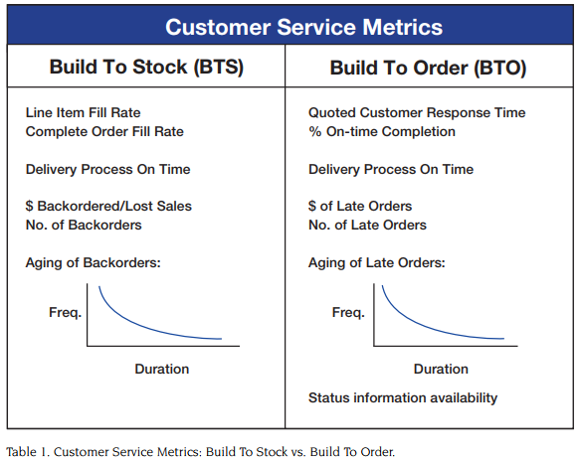
Source: Hausman(2002)

v. Data warehouse is a business intelligence system where important operational information sourced from primary sources is kept to be accessed by authorized personnel when the need arises. Data warehouse needs to have automatic data capturing features to enable it to retrieve data on daily operations across different departments of a company. Manual data entry is not permitted for capturing data for data warehouse systems. Using database software with automated connections to nodes of other computers in a network is the best means of sourcing data to be stored on the data warehouse platform. In addition to using the best available databases to source data from primary sources, software for producing predefined reports and displaying data in graphical format helps people to effectively monitor operations. Another feature for the software to have is the ability to enable authorised personnel to make ad-hoc request for data and for them to perform further investigation into issues when needed. Apple uses the data warehouse to get a better understanding of its customers across product groups. Now every piece of identifiable information — and those iTunes interactions generate a lot of data — goes into the system so the company knows who’s who and what they’re up to.

Ans 2. The four main operations that measure supply chain performance are:
- Plan operation
- Source operation
- Make operation
- Deliver operation
- SUPPLY CHAIN MANAGEMENT
The companies need to collect data from all the four operations and monitor the results.
Plan operations are concerned with measuring the number of stock keeping units (SKUs) carried, the number and percentage of order changes, the inventory carrying costs and production volume.

Source operations require measuring percentage raw material by geography, the number of suppliers and the percentage of cost of purchasing by distance, payment period, supplier delivery performance and the percentage of items procured based on lead time.

Make operations involve consideration for the number of SKUs, ‘manufacturing steps by geographical location’, upside production flexibility and how capital is deployed, assessing performance by determining the build-to-order percentage, percentage of manufacturing order changes due to intern issues, percentage of value added and the number of work in progress.

Delivery operations are measured by considering the ‘number of line items and shipments by channel’ the number of orders by channel and the percentage of line items returned. There are configuration measures such as the number of channels and the geography of delivery locations to consider when dealing with delivery operations. Important practice measures include determining the lead times, the order entry methods and the percentage of invoice containing errors.

References
Hausman, W.H. (2002). Supply Chain performance Metrics. Available at http://citeseerx.ist.psu.edu/viewdoc/download?doi=10.1.1.197.6665&rep=rep1&type=pdf

Student Statement:

By submitting this assignment, I confirm that this is my own work.

Student Signature | Rekha Pillai | Date | 19/07/2017

For Tutor / Assessor Use Only
Total Marks
Marks Obtained
Percentage / Grade

