
Assignment Cover Sheet

Student Name: | Nadim E Shaikh
Student Number: | 3172
Course: | Diploma in Logistic & Supply Chain Management
Assignment NO: | 10

Marking Criteria:
We expect the learners to write minimum one well expressed point in three lines against each allocated mark. This means one needs to write 15 lines with 5 well expressed points to get high grades for a 5 marks question.
For high grades use examples and illustrations where appropriate.
Name – Nadim E Shaikh
Student Id – 3172

Answer. 1 (i). Warehouse used for finished products, , packaging, labelling, making products ‘store ready’ for retailers, doing other aspects of delay, and servicing seller managed inventories, etc. warehouse are to sustain the broader logistics function by giving a mixture of high shopper service and low costs.

ii) Private warehouses are owned or leased by a business as part of its own supply chains. The business runs its own warehouses to sustain its major operations.
A public warehouse is run as a self-governing business, which makes money by charging users a fee.

iii) Following are the advantages of public warehouse.
- Flexibility to deal with changing demand, possibly due to seasonality
- Ability to supply skills and knowledge that the business does not have internally
- Access to the newest equipment and practices
- Avoiding big capital investment, giving higher return on investment
- Easy access to a wider geographical regions
- Allowing immediate tests of working in new areas
- Use of economies of scale to lessen warehousing costs
- Consolidating loads with other organizations to decrease transport costs
- Certain high quality and well-organized service
- Flexibility to deal with varying conditions, removing risks from dated practices and technology.
iv) Items are stored on shelves or in bins. People go around and choose items from the shelves, and put them into container or pallets. Manual warehouses only work if the items are small and light enough to lift. Shelves must be low enough for them to achieve and close together to decrease the distance walked.

v) Automated warehouses include the following components:
- Storage regions that can be accessed by mechanical equipment; these often make use of narrow aisles up to, say, 40 M. tall to get an elevated density of materials and reduce the distances moved.
- Equipment to shift materials around the warehouse; these are typically automated guided vehicles (AGVs)
- Equipment to mechanically choose materials and place them into storage, including high speed stacker cranes that can arrive at any point in the thin aisles very fast.
- Equipment to move materials between the diverse types of equipment; these mechanical loaders and unloaders may include industrial robots.
- A warehouse administration system to record material locations, and manage all movements.

vi) There are 5 key materials used for packaging
- Glass is simple to clean, reuse and reprocess, but is easily broken, comparatively expensive and hard to make
- Plastic is light, strong and simple to clean, but can be costly and hard to create or reuse
- Cardboard is light, inexpensive, and can be recycled, but has slight strength and poor toughness
- Wood is strong, tough, easy to use and can be reused, but it is weighty, bulky and tricky to clean.
- Metal is strong and tough, but it is weighty and can be costly.

2) Below mentioned are some activities that take place in ware house on daily basis.
- Receiving goods from upstream sellers
- Identifying the goods, matching them to orders and finding their planned use
- Unloading materials from delivery vehicles
- Doing any essential checks on quantity, quality, and state
- labelling materials (usually with bar codes) so they can be recognized
- Sporting goods as essential;
- Moving goods to mass storage area
- Holding them in stock until required
- When required, moving materials from mass storage to a smaller picking store
- Picking materials from this store to meet orders
- Moving the materials to a marshalling area
- Assembling materials into orders
- Packing and packaging as necessary
- loading delivery vehicles and dispatching the order
- Controlling all communications and connected systems, such as, inventory control and finance.

3) One of the most significant decisions when operating a warehouse is its design. This describes the physical plan of storage racks, loading and unloading areas, offices, rooms, equipment, and all other facilities.
Layout decisions are imperative for three essential reasons:
(1) They need substantial investments of both money and effort
(2) They involve long-standing commitments
(3) They have important impact on the cost and competence of immediate operations.
This suggests that the necessary elements in a warehouse are an arrival bay or dock, where goods coming from suppliers are delivered, checked, and sorted -

- A storage area, where the goods are kept as stock;
- A departure bay, or dock, where customers’ orders are assembled and sent out;
- A material handling scheme, for moving goods around; and
- An information system, which records the site of all goods, arrivals from suppliers, departures to consumers, and other applicable information.

Examples of Warehouse Layout
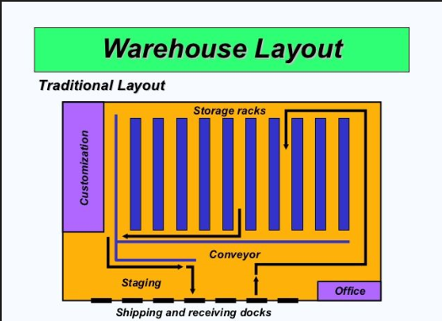

Illustration of Warehouse Layout
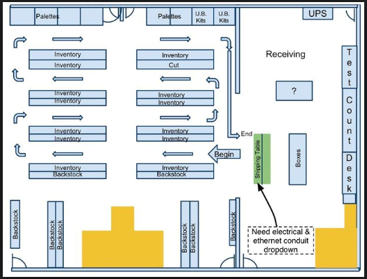

Student Statement:

By submitting this assignment, I confirm that this is my own work.

Student Signature | Nadim E Shaikh | Date | 03/05/2017

For Tutor / Assessor Use Only
Total Marks
Marks Obtained
Percentage / Grade

