Outline the main benefits of a supply chain
1. Producers place operations in the finest locations, regardless of the locations of their consumers.
2.By focused operations in big facilities, producers can obtain economies of scale.
3. Producers do not maintain huge stocks of finished goods, as these are detained further down the supply chain closed to customers.
5. Wholesalers maintain stocks from a lot of suppliers, giving retailers an alternative of goods.
6. Wholesalers are close to retailers and have little lead times.
7. Retailers take lesser stock as wholesalers offer reliable deliveries.
8. Retailers can have minute operations, giving a reactive service close to customers.
9. Transport is simpler, larger and fewer deliveries reducing costs. Organisations can expand expertise in particular kinds of operation

Companies in any supply chain can make their decisions individually and collectively in five areas. What are these areas?
1. Production —what products does the market demand? How much of which products should be manufactured and by when? This activity comprises of the formation of master production schedules that consider plant capacities, quality control, workload balancing, and equipment preservation.
2. Inventory —what inventory should be placed in stock at every phase in a supply chain? How much stock should be held as raw materials, semi finished, or finished goods? The main reason of inventory is to act as a cushion against ambiguity in the supply chain. However, holding inventory can be costly, so what are the best inventory levels and reorder points?
3. Location —where should production facilities and inventory storage space be located? Where are the most inexpensive locations for production and for storage of stock? Should present facilities be used or new ones established? Once these decisions are made, they decide the potential paths which are accessible for products to flow through for delivery to the final customer
4. Transportation —how should stock be flown from one supply chain site to another? Air freight and truck delivery are usually fast and consistent but they are costly. Shipping by sea or rail is much less costly but generally involves longer transit times and more doubt. This doubt must be remunerated for by stocking higher levels of inventory. When is it better to utilize which form of transportation?
5. Information —how much data should be gathered and how much information is to be shared? Timely and accurate information holds the guarantee of better coordination and better decision making. With fine information, people can make effective decisions concerning what to make and how much, about where to place inventory and how best to Tran
How is a modern supply chain different from that of the past?
In spite of vertical integration, businesses now perform “virtual integration.”
Companies locate other companies whom they can work with to carry out the activities called for in their supply chains. How a business defines its centre competencies and how it positions itself in the supply a chain it serves is one of the most significant decisions the business makes.

Traditional Supply Chain –
Improper planning leading non-harmonization between channel partners
Focused on individual performance without considering the intermediaries
Lack of long-term growth plan and focus
Supported by old legacy with very low integrations among various parts
Lack of Vision and Mission statements

Main features of New Supply Chain models –
Strong network across the whole supply chain leads to cost savings and higher profitability
Long-term growth plan and strategies are alignet with the company vision and mission
Strong connection between the suppliers and procurement managers
Constantly monitored the existing practice and regular intervals to improve performance and efficiency
Reduction of inventory waste through effective supply chain management process
All the individual systems are integrated with each other properly

Information ’is one of the five drivers of supply chain. Discuss the purpose of information in a supply chain
Information is utilized for two purposes in organization’s supply chain:
1. Coordinating Daily Activities
2. Forecasting and Planning
Information is a key supply chain driver because it serves as the glue that allows the other supply chain drivers to work together with the goal of creating an integrated, coordinated supply chain. Availability and analysis of information to drive decision-making is a key to the success of a supply chain

What is Inventory Management?
Inventory management is the supervision of non-capitalized assets (inventory) and stock items. A component of supply chain management, inventory management supervises the flow of goods from manufacturers to warehouses and from these facilities to point of sale.

Name various types of inventory
There are three essential decisions to make concerning the creation and holding of stock:
Cycle Inventory -

this is the quantity of the inventory, which is required to satisfy demand for the product in the time between purchases of the product.

Safety Inventory -

this is theinventory that is held as a cushion against ambiguity.

Seasonal Inventory -

this is inventory, which is stocked up in expectation of expected increases in demand, which occurs at certain times of the year.

Write short notes on the following participants of supply chain:
- Producers
These organizations make a product. This includes businesses that are producers of raw materials and corporations that are makers of finished goods.

- Distributers
Distributors are businesses that take inventory in mass from producers and supply a bundle of associated product lines to consumers. Distributors are termed as wholesalers. For the consumer, distributors complete the “Time and Place” function—they supply products when and where the consumer wants them.

- Retailers
Retailers stock inventory and sell in lesser quantities to the common public

Location decision shave strong impacts on the cost and performance characteristics of a supply chain –

When making location based decisions, managers are required to consider various factors that relate to a given site including the cost of facilities, labour cost, skills available in the workforce, transportation conditions, taxes and tariffs, and the nearness to suppliers and consumers.
Location decisions have powerful impacts on the performance and cost of characteristics of a supply chain

Supply chain for milk –
Dairy products have a short life and anything not delivered quickly is thrown away.
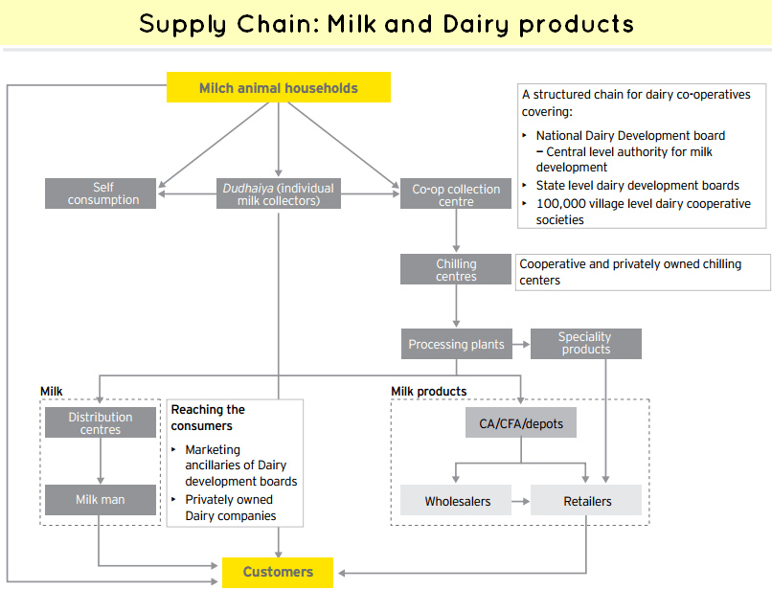

Where does PE Dairies fit into this? What specific activities form the logistics in PE Dairies?
Simon has to carry spare stock. He cannot carry too much, as dairy products have a short life and anything not delivered quickly is thrown away. Simon aims at keeping this waste down to two percent of sales. There are also problems maintaining a service during holidays or when PE has difficulties with their deliveries.

What are the main problems that PE Dairies has with logistics?

The main aim in the logistics of dairy products is to enable a high standard of qualified, fresh products with a limited shelf-life. The best time for delivery of perishable products is at most 11days as the key challenge is maximizing the remaining shelf-life . Thus, an effective logistics strategy for dairy products must face critical issues that consider the shortest time, the freshest products, the least cost for transportation and the most utilized customers whom demands are met. Daily transporting of dairy products is one way to keep food fresh. Unless the time that is spent between collections and selling is short enough, quality problems may occur. The possibility for fat and proteins in the milk’s breaking down after 48-72 hours will lead to bacteria reproduction below certain temperatures . In conclusion, the dairy producers and retailers obviously are in the need of logistics firms that will care about the special needs and problems in their working environment, mind the customers’ needs and act accordingly. At that point, the transportations system will be customized and rearranged according to the particular dairy firm’s requiremints.

