
Assignment Cover Sheet

Student Name: | Shauna Hoey
Student Number: | 31707
Course: | Advanced Skills for Practical Trainer Level 3
Assignment NO: | 1

Marking Criteria:
We expect the learners to write minimum one well expressed point in three lines against each allocated mark. This means one needs to write 15 lines with 5 well expressed points to get high grades for a 5 marks question.
For high grades use examples and illustrations where appropriate.
Question 1:
- What is the difference between classroom learning and self-directed learning?

Classroom-based learning is the traditional way of learning where the curriculum is designed and delivered by teachers. The role of the teacher or trainer is to impart information on the students who attend the classroom with the aim of learning about a topic. This means that the teacher must cater for different student needs, capabilities, interests and learning styles (VanTassel & Stambaugh 2005).

Self-directed learning, on the other hand, is often the preferred method of adult learning and continued professional development (CPD). Self-directed learning allows the learner to take control of what, how and when they learn, which is often preferred by adult learners. In self-directed learning environments, the role of teacher is replaced by a facilitator. The level of self-direction achievable by students often varies depending on age, level of education and learning styles. This will influence the extent of the facilitators input in the learning process (Devi et al 2016).

- What is Experiential Learning Cycle?

The study of individual learning styles and teaching methods lead to the development of the ‘applied theory of experiential learning’ by Kolb (1974). This theory suggests that learners naturally lean towards a distinct learning style; feeling, watching, thinking or doing. This preference is influenced not only by the cognitive predisposition of the individual, but also environmental factors and educational experiences. Figure 1 illustrates the four stages of the ‘Experiential Learning Cycle’ proposed by Kolb. While individuals may prefer one or more of the stages, it is necessary to complete the entire cycle to ensure lasting learning occurs. The two axes are known as the processing continuum, which represents how we approach a task; and the perception continuum, which represents how we feel about it (McLeod 2013). This model can be used by teachers and facilitators to optimise individual learning success by allowing students to learn through their preferred style, as well as identifying their weaker learning styles and building these up by incorporating the Experiential Learning Cycle in the process.

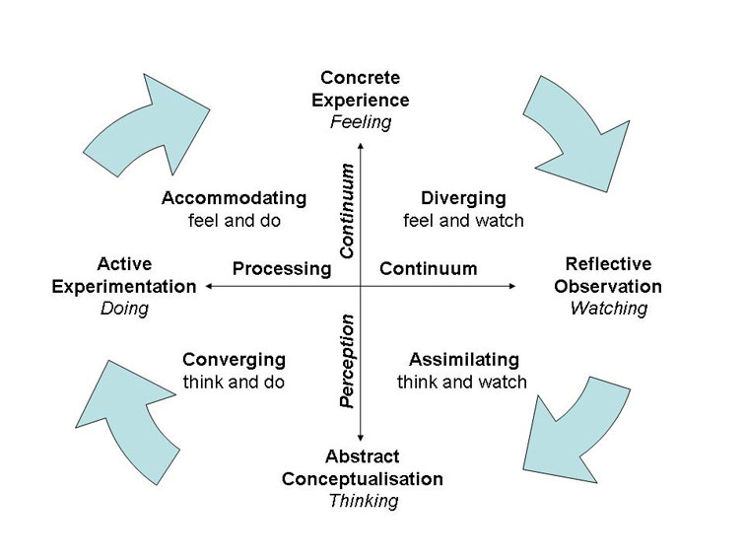
Figure 1. The Experiential Learning Cycle described by Kolb (1974).

- Explain the trainer’s role in training.

Although the two terms are used interchangeably, teaching and training have some important distinctions. Teaching involves imparting knowledge and information at a theoretical level. Training, on the other hand, involves a more practical approach and often includes hands-on practice. The role of a trainer differs from that of a teacher in that both theoretical knowledge and practical experience is required to effectively complete the job (Reese & Walker 2016). An effective trainer will need to identify individual needs, interests, motivation, capabilities, and developmental characteristics, and apply that information to the design and delivery of the training.

Question 2. Discuss various learning styles in detail.

Research on learning styles has largely been conducted using the Learning Style Inventory (LSI) and has produced four distinct approaches to learning; diverging, assimilating, converging, and accommodating (Kolb & Kolb 2004).
Those with a diverging learning style, often called ‘authentic idealists’ are good at viewing concrete experiences from a variety of viewpoints. These individuals enjoy brainstorming, gathering information, working in groups and often have broad interests. In order to increase their learning power, authentic idealists need to put more energy into forming meaningful conclusions, looking for patterns and finding practical applications for what they are learning.
Individuals with an assimilating learning style, often called ‘inquiring rationals’, are often less people-orientated and prefer dealing with ideas and concepts. People with this learning style can comprehend large amounts of information and organise it in a concise and methodical way. To develop their learning power, inquiring rationals need to take the information they have collected and put more emphasis on action, looking for ways they can immediately apply their new knowledge.
An individual with a converging learning style, often called a ‘resourceful artisan’, is best at generalising and applying their knowledge. This means that they can find practical solutions and applications for theories, concepts and ideas. These individuals prefer to deal with technical tasks than with social issues. It is important for resourceful artisans to discuss ideas with others, especially authentic idealists’ and try to improve their learning power by viewing topics from other points of view.
People with an accommodating style of learning, often known as ‘organised guardians’, tend to learn best from ‘hands-on’ experiences. They like to complete tasks and apply themselves to problems, often relying on other people for information instead of using their own technical reasoning. Organised guardians are action-orientated individuals who rely heavily on intuition and ‘gut feeling’ instead of searching for facts. It is important for organised guardians to try and remove themselves from the situation, taking a less personal approach to the issue they are dealing with or topic they are learning. Instead they should look for the hidden logic and patterns in situations, discussing a topic with someone who has an inquiring rational learning style to gain a more long-term understanding.
The experiential learning cycle can provide valuable insights for teachers, trainers and students alike. Through understanding the strengths and weaknesses of different learning styles, curricula can be designed in a way that engages a heterogenous student group and allows for collaboration and discussion between members of each group.

Question 3. Discuss the competencies that are required to teach adult learners.

In order to effectively teach adult learners, teachers must possess several core competencies and strive to develop those that they lack. An example of this is the ability to understand adult learners in terms of their needs, interests, motivation, capabilities and developmental characteristics and apply that knowledge to the teaching or training. Understanding the major differences between children and adult learners is also vital for effective teaching. Unlike children, who rely almost entirely on their teacher for guidance, adults may decide for themselves what is important to be learned and often already have a fixed viewpoint, developed from life experience. Adult learners often benefit from group discussions, drawing on past experiences or working on a task or problem to better understand a topic. To effectively teach adult learners, a teacher must also understand the value of the experiential learning cycle and its role in maximising the individual or groups learning power. Since the lines of learner and teacher may be blurred slightly in adult learning environments, it is important to establish a mutually respectful and facilitative relationship with students and build an atmosphere of openness, trust and interactivity. This will encourage students to engage in their own learning, participating and sharing viewpoints and ideas. Teachers should be comfortable using a broad range of materials, methods, and techniques and inventing techniques to fit new situations. Small group processes should be understood and used effectively in suitable learning situations. Developing effective training plans often requires collaboration between various groups within an organisation so trainers need to be comfortable dealing with these various audiences. The ability to design and operate training programs as well as promotion, publicity, and public relations strategies, within the framework of a limited budget is important in many organisations. Finally, in order to improve their skills as a teacher, one must accept feedback from learners and apply that feedback to create more meaningful learning opportunities for them. The ability and willingness to experiment with program innovations and to assess their results will ensure that a teachers skills and effectiveness will continually improve.

References:
- VanTassel-Baska, J., & Stambaugh, T. (2005). Challenges and possibilities for serving gifted learners in the regular classroom. Theory into Practice, 44(3), 211-217.
- Devi S, Bhat K S, Ramya S R, Ravichandran K, Kanungo R. 2005. Self-directed learning to enhance active learning among the 2nd-year undergraduate medical students in Microbiology: An experimental study. J Curr Res Sci Med; 2:80-3.
- Kolb, D. A., & Fry, R. E. (1974). Toward an applied theory of experiential learning. MIT Alfred P. Sloan School of Management.
- McLeod, S. A. (2013). Kolb - Learning Styles. Retrieved from www.simplypsychology.org/learning-kolb.html
- Reece, I. and Walker, S., 2016. Teaching, training and learning: A practical guide. Business Education Publishers Ltd.
- Kolb, A.Y. and Kolb, D.A., 2005. Learning styles and learning spaces: Enhancing experiential learning in higher education. Academy of management learning & education, 4(2), pp.193-212.

Student Statement:

By submitting this assignment, I confirm that this is my own work.

Student Signature | Shauna Hoey | Date | 20/03/2019

For Tutor / Assessor Use Only
Total Marks
Marks Obtained
Percentage / Grade

