
Assignment Cover Sheet

Student Name: | Charlene Lynda Kennedy
Student Number:
Course: | Accounting and Finance Level 5
Assignment NO: | 4

Marking Criteria:
We expect the learners to write minimum one well expressed point in three lines against each allocated mark. This means one needs to write 15 lines with 5 well expressed points to get high grades for a 5 marks question.
For high grades use examples and illustrations where appropriate.
Please insert your completed assignment ( in word format) here:
Assessment 3

1.i. Subsidiary books are where specific transactions of similar nature are recorded
ii. A journal is a record of financial transactions in order by date. This can also be known as a book of original entry.
iii. A petty cash book is a book to record small expenses for example, postage, stationary, tea, coffee and milk.
iv. Different kinds of subsidiary books are
Cash Books – records receipts and payments for cash transactions
Sales Day Book – Records and maintains credit sales
Sales Return Day Books – records return of goods which are sold to customers on credit
Purchases Day Book – for keeping records of credit purchases
Purchases Returns Day Book – for recording the return of goods purchased from suppliers on credit.
Bills Receivable books – records bills received and the details
Bills Payable Book – Records bills to be paid and there details

2. A ledger is a written or computerised record of all the transactions a business has completed. These transactions are recorded in the ledger in different accounts. This list of accounts is usually called the chart of accounts.

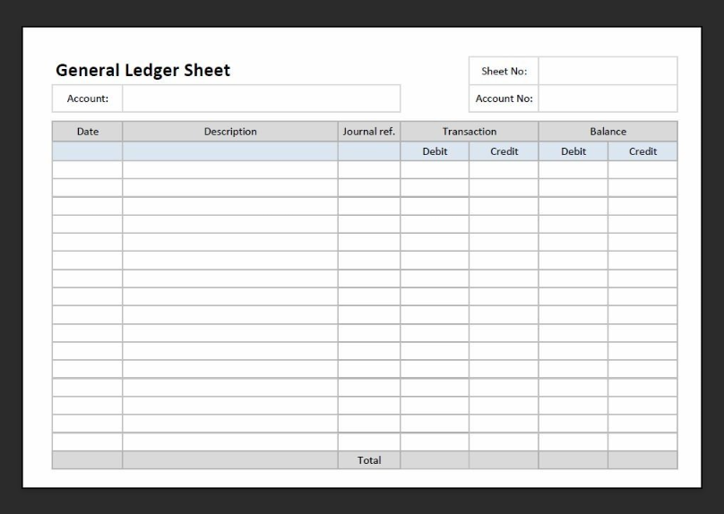
For example as above the date is required, a small description, the transaction amount of either a credit or a debit and then the balance minus the debit or plus the credit.

3. The advantages of subsidiary books are

Division of Work – meaning the recording of entries can be divided between clerks

Facilitate posting – transactions of similar nature can be recorded together in one place.

Time saving –

Minimum Fraud and Errors – Maintaining journals and recording transactions lowers the possibility of fraud or errors.

Better Information – Only records information that is useful and related to the entries.

Management Decisions Facilitated – these records provide the information for to make the right decision for the business.

Specialisation and Efficiency – Clerks who are recording the information repeatedly over a period of time become experts in what they are doing and become more efficient.

Student Statement:

By submitting this assignment, I confirm that this is my own work.

Student Signature | Charlene Lynda Kennedy | Date | 20/01/2020

For Tutor / Assessor Use Only
Total Marks
Marks Obtained
Percentage / Grade

