
Assignment Cover Sheet

Student Name: | Andrew Fisher
Student Number: | 28049
Course: | Advanced Diploma in Construction Management Level 5
Assignment NO: | 6

Marking Criteria:
We expect the learners to write minimum one well expressed point in three lines against each allocated mark. This means one needs to write 15 lines with 5 well expressed points to get high grades for a 5 marks question.
For high grades use examples and illustrations where appropriate.
- Plant is an integral part of the early stages of a construction project and its cost can vary dependant on size, specialism and length of need. When we plan for this equipment we need to look at differing ways to employ it. Are we going to Buy it(capital purchase) Usually a one of payment followed by a maintenance contract, Or do we rent/Hire it which can be costly too but all maintenance cost would be covered. We need to ensure we have the correct plant required at the time we need it and it is cost effective.
- In my opinion the primary requirement for scheduling Plant in any project is usage of the equipment, then costs (purchase or Hire). Once we work out how long we need the equipment, the time limits for each phase, cost of the equipment and type. We can then schedule its place in the project. 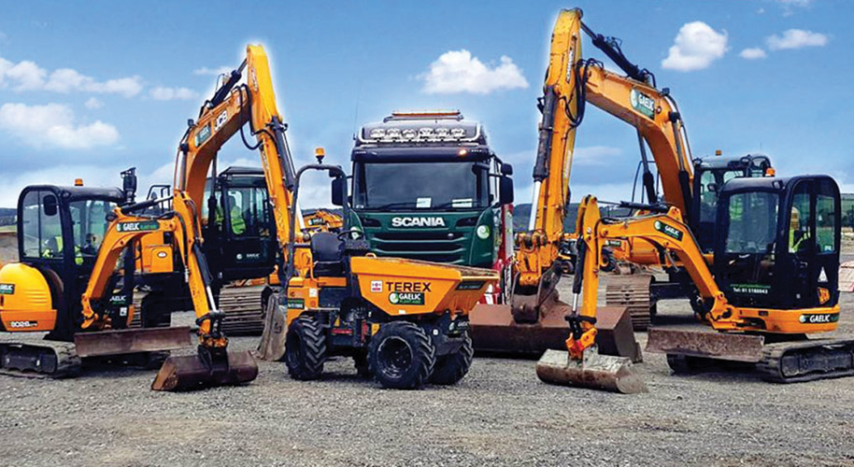

- The contractor can fully purchase the equipment using a one off payment or credit payments spread out over a matter of months or years. The contractor could also rent the equipment with a view to purchasing at a later date with the rental costs coming of the purchase price. Or the other option could be to lease or rent the equipment for the time that it is required.
- Plant needs to have free movement to the areas it is required and for the term it is required. Storage should not be too far away from where it is to be used but secure enough to stop theft. Waste products need to be removed such as spoil and top soil, so trucks need an access road in and out of the site. Once the build is complete the plant has to have an exit to be removed from site safely. 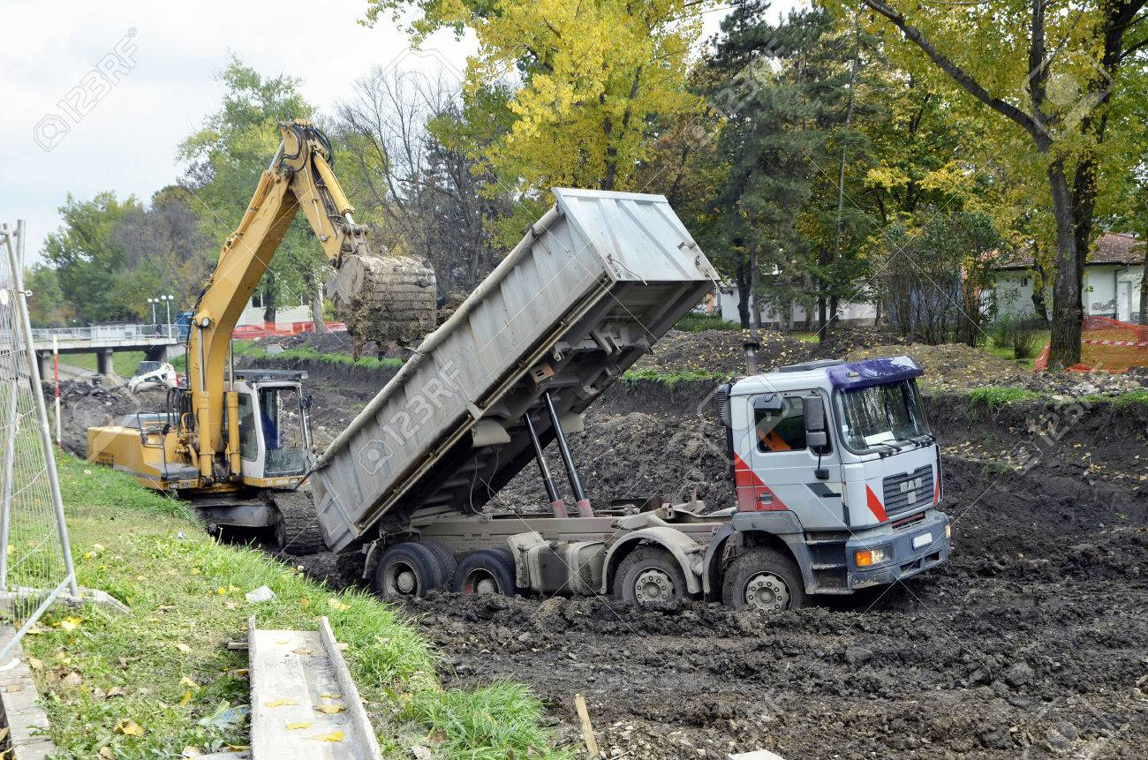

- When A contractor purchases a piece of plant there will be a large financial cost involved and the maintenance of the equipment is then left to the contractor this is ok if the contractor is large with its own maintenance department experienced enough to take on the plant. If the plant is only to be used for a short period of time then the project may not be profitable enough to keep the plant.

2 Costs is a major factor in the purchase of plant, no one wants to lose money on a project.
- Will the plant be used regular?
- What are the running costs?
- How often will servicing be required?
- What will be the costs of either employing an operator of training a member of staff to operate it?
- How will we get the Plant from site to site?
- Can it go on the roads or will it need to be transported?
- Where will it be stored when not in use?
This list is not exhaustive but different projects, locations and company sizes will add to the list of questions.

3 We need to look at the overall cost of the equipment against the amount of time it is to be used. We also need to look at the finances available for the projects. Is this equipment going to be used a lot on this project and then on other projects over the coming years or is it going to be used for a matter of weeks and then left idle. How often will it require servicing or maintenance, can we purchase a maintenance plan with the equipment or if we rent will all repairs and maintenance be included in the rental price. The needs of the projects in this respect are put to the QS department to solve and come up with an adequate solution. 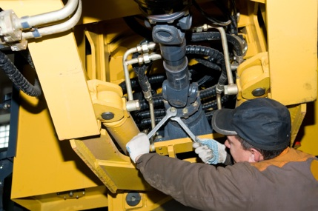

3

Student Statement:

By submitting this assignment, I confirm that this is my own work.

Student Signature | A M Fisher | Date | 11/06/2019

For Tutor / Assessor Use Only
Total Marks
Marks Obtained
Percentage / Grade

