
Assignment Cover Sheet

Student Name: | Victor T. Omotoso
Student Number: | 22193
Course: | Forensic Accounting
Assignment NO: | Units 3 - Psychology of The Fraudster

Marking Criteria:
We expect the learners to write minimum one well expressed point in three lines against each allocated mark. This means one needs to write 15 lines with 5 well expressed points to get high grades for a 5 marks question.
For high grades use examples and illustrations where appropriate.
Please insert your completed assignment ( in word format) here:
- Give short answers for the following questions:

- You are in investigative officer; how would you differentiate between high and low-level thieves?

Persistent career thieves are divided into high level and low-level group of scale of their crimes. There are different between professional and amateurs’ thieves. At professional level of an organizational life, it is easy to steal because the internal control is week or controls can be overridden or bypass. The sums professional thieves steal tends to be greater than low-level personnel steal. Professional thieves have detail knowledge of financial accounting system and their weaknesses and place in position of trust.

- Give the profile of a typical criminal who commits more expensive fraud.

The typical criminal gang is an organized group who intend to steal money, goods or services from one or more merchants. The criminal gang has multiple people involved in their scheme and will put as much effort into hiding their activity as they do in committing the fraud. They commit large sums of money e.g high income earners; people with higher level education; people working in collusion with other perpetrators and have never been subject to criminal charge

- Define the term ‘calculating criminals’:

Calculating criminals are hunters. They tend to be replication offenders, they have higher-than-average intelligence, and they are relatively well educated. They usually begin their careers in crime later in life than other criminals. These predators are generally inclined to risk taking no surprise there and they lack feelings of anxiety and empathy. External locus of control that is they lacked inner direction, self-confidence, and self-esteem and were motivated by their desire to fit in and be accepted.

- What are the different between Situation dependent criminals and power brokers?
Situation dependent Criminals are anxious to protect themselves, their families or their companies from a devastation. The majority of corporate crime is committed not by the people who want to harm others intentionally but those who are driven by their situation’. They are good psychological health, account for vast majority of white collar crimes and less criminal record.
Power brokers: Appeared out of disastrous business failures and humiliations, these are powerful corporate criminals who hold high positions in the establishment. A power broker is typically an industry insider and is familiar with other individuals and groups able to exert influence or make decisions. Power brokers may be elected officials, business leaders or individuals who are "connected." A person who controls a number of politicians or a large number of vote use to influence political affairs. Like many of us, you have read about their excesses and asked yourself how respected business leaders could have been so fooled as to believe that they could grab the financial and human resources of their companies to line their own pockets and deceive a wide range of investors, including their own employees.
Situation dependent criminals can be categories as pressure opportunity and rationalization while power broker can be opportunity and capability.

- What are the three situations that are usually present in fraud case, according to the fraud triangle?

The Fraud triangle is a framework designed to explain the reasoning behind a worker’s decision to commit workplace fraud. The three stages, categorised by the effect on the individual, can be summarised as pressure, opportunity and rationalisation
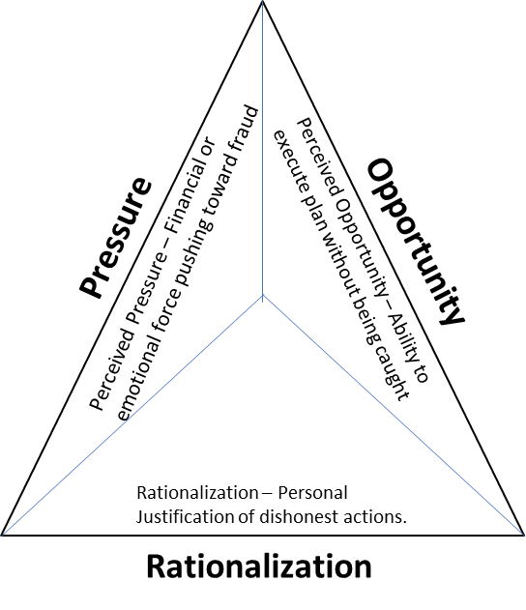
The Fraud triangle describes three factors that are usually present in every situation of fraud case:
- Perceived pressure: the need to commit fraud (emotional forces pushing towards fraud – need pf money)
- Perceived Opportunity: Ability to execute plan without being caught- when the internal controls is weak or non-existent
- Rationalization: Personal justification of dishonest actions or mind set of the fraudster that justifies them to commit fraud.

- Briefly describe the Gwynn Nettlers perception about employees lying, cheating and stealing.

The most likely people to cheat are the people with experiences in on or two failures of their lives
- The level of motivation for an individual to commit fraud, lie or cheat depends on his/her needs
- The motivation to deceive increases with the struggle and determination to survive.
- Middle/upper-class people are less likely to cheat than lower-class people, and intelligent people are more honest than ignorant people.
- A variety of personal and organisational situations lead to people lying and deceiving.
- People will steal and cheat more the easier it is to do so.
- People who have a low opinion of themselves and are disliked by others have a higher tendency to deceive.
- Greater stress and pressure to achieve objectives leads to more deceit and cheating.
- Impulsive, easily distractible, impatient and selfish people are more likely to be untrustworthy
- People who are afraid of being caught and suffering punishment, e.g. those who have a higher perception of detection, are less likely to be tempted to cheat or deceive.
vii What are the typical motivations for a white-collar criminal, which persuades him to commit fraud?
White Collar Crimes are the crimes committed by a person of high social status and respectability during the course of his occupation.
It is a crime that is committed by salaried professional workers or persons in business and that usually involves a form of financial theft or fraud.

Causes of White-Collar Crime
The general perception is that the white-collar crimes are committed because of greed or economic instability. But these crimes are also committed because of situational pressure or the inherent characteristic of getting more than others. However, there are various reasons for white collar crimes.
• Not really a crime: Some offenders convince themselves that the actions performed by them are not crimes as the acts involved does not resemble street crimes.
- Not realizable: Some people justify themselves in committing crimes as they feel that the government regulations do not understand the practical problems of competing in the free enterprise system.
- Lack of awareness: One of the main reason of white collar crime is the lack of awareness of people. The nature of the crime is different from the traditional crimes and people rarely understand it though they are the worst victims of crime.
• Greed: Greed is another motivation of the commission of crime. Some people think that others are also violating the laws and so it is not bad if they will do the same.
• Necessity: Necessity is another factor of committing crimes. People commit white collar crimes in order to satisfy their ego or support their family.

2. “The profile of a white-collar or blue-collar criminal is different from other typical street criminal” Discuss this.

The profile of a white-collar criminal. White-collar crime is not a new phenomenon, but it has escalated dramatically during the past decade. One cannot study white-collar crime without looking at the profile of the offender.

Blue collar crimes vs. White collar crimes
- Our society has always admired those with intelligence just like they do for people with musical talents or athletic abilities
- This is why historically human nature has held financial fraud as a substantially smaller wrongdoing than other types of crime.
Typical White-collar Criminal
- Position of trust
- An appearance of a stable family situation
- Older (30+)
- 55% Male
- Detailed knowledge of accounting systems and their weaknesses
- Prior accounting experience

According to various studies conducted by the Association of Fraud Examiners (ACFE), over 90% of white-collar criminals don’t have previous criminal records). The higher the economic value of the crime, the less likely it is the perpetrator had a previous criminal record. There are three forms of white collar crime: Income Tax evasion; Stock fraud and Bribery.
Street crime is a loose term for any criminal fault in a public dwelling like Robbery, often called 'mugging', and thefts from victims in the street where their property is snatched, and the victim is not battered is also considered street crime. The most common forms of predatory crime: rape, robbery, assault, burglary, larceny, and auto theft occur most frequently on urban streets.

3. “Fraud is most common in organisations that have no controls, no trust, no ethical values, no profits, and no prospects”. Discuss this

Fraud prevention expert says, situation increases the risk of fraud. Evidence show that the most common factors in all fraud committed is the lack of review, poor segregation of duties and lack of policies and procedure with no effectives control, a situation common targeted to small business and charities organisation. They are more likely to have one Accountant/Administrator, no isolation of duties, and no compensating control, and those factors are the most common fraud. These factors are not unique e.g. size of the business is not the only factor, as fraud can also occur within a big business and one with strong corporate philosophy. There are a number of ways to decrease the chance of fraud like – monitoring employees behaviours, fraud risk assessments and anti-fraud policy. Many small organisations don’t have the resources to allow the rigorous segregation of duties that deter fraud, however, common-sense, low-cost controls that most organisation.

Case Study:
- If the trader has actually committed the crime, what kind of crime it is?

The Trader crime committed by the trader might be ignorant to the trader, but has to recognise the following: a. The impression given from the trader website that he had the fitting luxury of fitting kitchens. Firstly, he need to posses some rights before using pre-pare write-up from owner. B. There must be interconnectivity. C. the obtaining of an economic benefit.
b. Copyright infringement – (This is civil offence not a crime) In copyright law of the UK. This is an instance whereby the trader exercise one of the rights of the copyright holder without authorisation. Courts have distinguished between copyright infringement and theft. The Copyright, Designs and Patents Act 1988, Section 17 is up to date with all changes known to be in force on or before 25 July 2018. Copying in relation to any description of work includes the making of copies which are transient or are incidental to some other use of the work.

However, the trader did not commit a tax crime.

- How can forensic expert investigate the case properly when trader could have sold the goods without generating any invoices or no cash?

The forensic expert should examine the circumstantial evidence e.g. usage of electricity in the future workshop, purchase of materials and payment of wages to workers etc. it is also good to obtain court order to get access to the bank statement as the cash should be stirred somewhere.

Student Statement:

By submitting this assignment, I confirm that this is my own work.

Student Signature | OmotosoVT. | Date | 31/07/2018

For Tutor / Assessor Use Only
Total Marks
Marks Obtained
Percentage / Grade

