
Assignment Cover Sheet

Student Name: | Irini Girgis
Student Number: | 5338
Course: | Diploma in Child Psychology
Assignment NO: | 6

Marking Criteria:
We expect the learners to write minimum one well expressed point in three lines against each allocated mark. This means one needs to write 15 lines with 5 well expressed points to get high grades for a 5 marks question.
For high grades use examples and illustrations where appropriate.
1.i. What is socialisation?
Socialisation is the process of learning different social skills as well as understanding one’s society and culture through the interaction with a variety of individuals in the society.
This socialisation process can be either primary, in which a child interacts with individuals within his/her family. Or secondary, in which a child interacts with individuals in the society around him/her outside the family, like the nursery, playgroups, kindergarten, etc.
No matter what socialization process a child passes by, it will affect the child’s attachment and bonding with the parents, siblings and the close individuals within his/her community; his/her identity and self-confidence.

1.ii. What does the term ‘separation anxiety’ mean?
Separation anxiety is a common and normal behavior in a child’s early development stages. It is defined as the excessive fear, distress or anxiety that can happen to an individual when separated from home or from an attachment figure.
It usually ends at around age 3 when children start understanding the concept of ‘object permanence’ (the object is still there despite not being visible), which in turn will help them understand that even if his/her parent may be out of sight at the moment, he/she will return later.
Children with separation anxiety disorder may cling to their parents excessively and refuse to do any activity away from their parent’s sight. Headaches, nausea and vomiting can be some physical symptoms that may occur when separation takes place. Feeling withdrawn, sad, or have difficulty concentrating on work or play can be some emotional symptoms.
1.iii. Who are ‘shy babies’?
Having a "shy gene", may or may not be a confirmed fact. However, what is confirmed to affect a child’s shyness attitude is the parental personality traits. Having a shy, introverted parent who are uncomfortable in social situations will have an effect on the child’s social development. These parents will limit the social experiences and interaction with different people which in turn will impact the child’s socialization skills and comfort level in different circumstances and people around. These children tend to be a bit reserved themselves.

1.iv. What is meant by attachment and bonding?
From the moment a child is born, he/she starts developing different feelings which are affected by the level of attachment and bonding with the caregiver. Physical actions performed by the caregiver such as skin contact, feeding, bathing, playing, talking and singing all impact the bond that the child develop with their caregiver. This bond and attachment is essential in the child’s social and emotional development as it helps them feel more secure and adapt easier to different circumstances. Having a stable environment is a key element to develop this bond.

1.v. What is the difference between primary and secondary socialisation?
Primary socialization occurs in the early childhood years. It is the process where the immediate family is the main source in which a child learns the attitudes, values and appropriate actions towards individuals within the family. Any interaction and observation that a child experiences with the immediate individuals around him is considered primary socialization and influences his/her social development.
Secondary socialization occurs later in the years. It is the process where smaller groups within the larger society is the child’s main source of learning acceptable behavior. In secondary socialization, the involvement of the family is less as other social agents or agencies take up the prominent role.

1.vi. How do babies interact differently from toddlers?
Babies up to 12 months:
Crying is often used by babies in their early life to show signs of discomfort. Smiling when seeing familiar faces, giggling and making other simple sounds are also ways of expressing their emotions. Babies at this age are very interested in all around. They start becoming more interested in social interaction with familiar members; however, start developing separation and stranger anxiety using crying as a tool to show such feelings.
Toddlers from 12 to 2 years old:
At this age, toddlers become emotionally volatile. Frustration, anger and tantrums are often used as part of showing what they want. They get annoyed by changes in routines. This is the age where they starts distinguishing between self and others and engage in play along side others. They develop from separation anxiety to object permanence; however, still show some signs of stranger shyness.

1.vii. How would you differentiate between authoritave and authoritarian parents?
Both authoritative and authoritarian parenting styles have strict rules and high expectations. The differences lie in how parents communicate with their children and how the children are punished.
Authoritative parents use open communication and mutual understanding with their children, on the other hand, authoritarian parents, do not express much nurture or warmth. Authoritative parents teach and guide their children to work independently, on the other hand, authoritarian parents exert their will and show own power over their children.
Interestingly, authoritative parents tend to be MORE strict and MORE consistent than authoritarian parents. They set fewer rules, but are better at enforcing them.

1.viii. What is ‘social phobia’?
Social phobia is the fear of interaction in social events or with other people that brings on self-consciousness, feelings of appearing foolish, negatively judged and ridiculed. This disorder leads to avoidance of any social gatherings or any interaction with unfamiliar adults as well as escaping situations in which they have to publicly speak. Social phobia is far beyond simple shyness.

1.ix. What are the different stages of social and emtional developments in children?
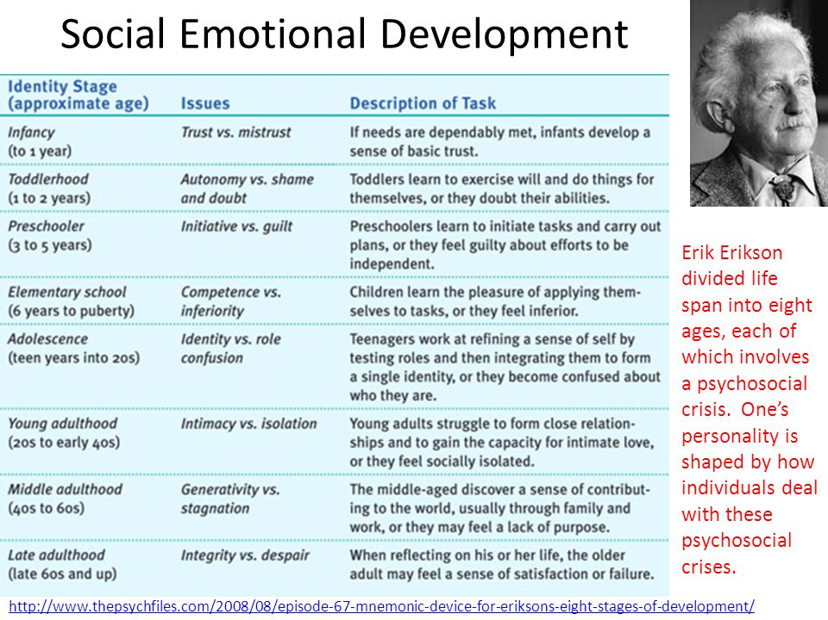

2. Many adults, who harm others or carry out serious crimes, have had negative experiences as children, Discuss this.
When a child passes through severe negative events during childhood, there’s a big possibility that these events might affect the child’s self concept which will in turn affect his/her whole life and actions as adults.
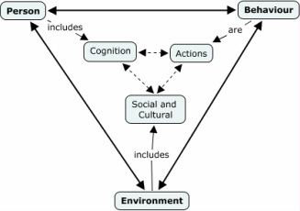
“Most human behavior is learned observationally through modeling: from observing others, one forms an idea of how new behaviors are performed, and on later occasions this coded information serves as a guide for action.” (Bandura).

According to Bandura’s theory, ‘Modeling’ or ‘social learning’ is a key aspect of the social and emotional development of children. He states that people learn from one another via observation, imitation, and modeling. When applying this theory to aggression, it makes it a direct consequence of social learning during childhood which develops over time and might take different forms of crimes in adulthood.

Bandura believes that aggressive models appear in the:
1. Family: Abusive parents were usually abused as children. Abused children are four times as likely to abuse their children than non-abused children.
2. Subculture: Cultural Stereotypes can enforce expectations of "Macho" behavior in men. Teen-age gangs provides younger members with aggressive models.
3. Mass Media: Viewing television violence
On another note, aggressive behavior can also be a result of Biological and Psychological influences.

3. Discuss, in detail, external factors affecting the social development of children.
The social development of children will surely be impacted by factors that are out of the control of parents, either positively or negatively.

Economic Factors
The more social activities that children get involved into, the better social skills they develop.
‘Studies show that children who live in impoverished areas have a harder time socialising than their more affluent peers.’ This is due to the fact that they lack the opportunities in which they practice acceptable behavior within different situations. In order to master a skill, one should practice it often. The more varities of activities the children get exposed to, the more social skills that they develop. Children in low economic status lack this varity of activities.
School
School is the main secondary socialisation setting in developing the children’s social skills. In schools, the child is not the main focus and center of attention as being at home. This change causes a struggle to the children as they develop their social skills from being self-focused to accepting others through learning to interact, cooperate and compromise.
Fitting In
Moving into and interacting with the outside world, especially school, is always a challenging step in the children’s lives. It is a critical move especially in the development of their social skills. The main challenge that the children face is fitting in and being accepted by others despite of any differences they might have. The same attitudes, behavior and acts that are fully accepted at home and within the family, might not be accepted by their peers which may lead to frustration and insecurity.
It is the parents’ role to assist their children in developing some social skills and tools that they can use to cope with the negative responses and attitudes displayed by other children. It is also important for the parents to help build their child’s self-esteem and self confidence in order to overcome any challenges.
Stress
Stress in children can either come from external sources, such as family, friends, or school, or from within, often related to what we should be doing versus what we're actually able to do.
Separation from parents, interacting with strangers or new social groups, family difficulties (even if not directly discussed with the children), being too busy to have time to freely and creatively play or relax after school can cause stress. On the other hand, academic and social pressures (especially from trying to fit in) create stress.
Exposure to frightening world news, or disturbing images on TV or hear talks about natural disasters, war and terrorism may worry the children, same as violent movies or video games.
Proper rest and good nutrition can boost coping skills, as can good parenting. Parents need to reassure their children that they are always there for them and help them feel secure.
‘Providing kids with a solid, secure base is vital for healthy emotional development and without this foundation, social development is negatively impacted’.

4. ‘Emotional development is a complex task that begins in infancy and continues into adulthood’. Discuss
Emotional development is a complex task that begins in infancy and continues into adulthood. Joy, anger, sadness and fear are the ﬁrst emotions that can be recognised in babies. As children grow older, they start developing some more complex emotions like shyness, surprise, elation, embarrassment, shame, guilt, pride and empathy.
Emotional development starts by learning to identify different emotions, then understanding the reason behind them and then practicing how to manage them appropriately.

Children’s emotional development
Skills needed | Children with beginning skills | Children with developing skills | Children with more developed skills
Emotional self-awareness | - tend to have one emotion at a time  - act out how they feel  - flip between one emotion to another quickly | - start to understand that they can have more than one emotion in reaction to the same event as long as they are similar (eg happy and excited) | - understand that they can have opposite feelings to the same situation (eg feel both happy and sad that the school year is ending)
Recognising other people’s emotions | - rely on physical clues to identify emotions (eg tears = sadness) | - take into account clues from the situation to help explain the emotion (eg understand that a child might be sad because his/her toy has been broken.) | - have a more complex understanding of the interaction between emotions, situations and people (eg the child is sad because the thing that was broken was a gift from a loved grandparent who died recently)
Emotion regulation – ie the ability to manage emotions effectively | - able to use simple ways to manage emotions with support from adults (eg choose a different activity to distract them from feeling frustrated) | - are increasingly able to choose appropriate behavioural responses (eg asks and waits for assistance with difficult task) | - are increasingly able to manage emotions by rethinking own goals and motives (eg decide that there is no point being angry about something he or she can’t change)

How children express emotions relies on different things:
- Values and beliefs of appropriate and inappropriate ways of expressing emotions that children learn from parents.
- How effectively children’s emotional needs are usually met
- Children’s temperaments
- Emotional behaviours that children have learned through observation or experience
- The extent to which families and children are under various kinds of stress

In order for parents to support such complex task, they need to identify and understand their children’s feelings as well as know how to react and manage them. Sometimes parents have to pay attention to their children’s body language and different behaviors in order to identify emotions that are not obvious and cannot be identified through listening to their children.
Parents should also help their children identify, understand, accept and manage the different emotions that they experience.

Student Statement:

By submitting this assignment, I confirm that this is my own work.

Student Signature | Irini Girgis | Date | 12 September 2017

For Tutor / Assessor Use Only
Total Marks
Marks Obtained
Percentage / Grade

