
Assignment Cover Sheet

Student Name: | Josephine Lilian Price
Student Number: | 29897
Course: | Diploma in Wedding Planning
Assignment NO: | 7

Marking Criteria:
We expect the learners to write minimum one well expressed point in three lines against each allocated mark. This means one needs to write 15 lines with 5 well expressed points to get high grades for a 5 marks question.
For high grades use examples and illustrations where appropriate.
Please insert your completed assignment ( in word format) here:
Josephine Lilian Price
29897
Assessment 7
Page 1

1.i As Amy Finley discusses in her article on the History of Wedding Dresses (online), Wedding attire used to reflect the social standing and wealth of the family, with the wealthiest wearing more opulent gowns that were made with golden weaved thread, sewn with real jewels and fur. Whilst every Bride made the effort to look good on her wedding day, practicalities of being able to wear the dress afterwards also came into play. With limited laundry facilities and techniques, and those that existed being a luxury of only the wealthiest, white was considered a very difficult colour to wear, as it would ruin easily. Bright colours were worn instead, with the preference being on blue as this represents purity. The white Wedding Dress, although not the first dress of this colour to be worn, is attributed to Queen Victoria for her wedding to Prince Albert, Duke of Saxe-Coburg and Gotha on February 10th 1840. Queen Victoria was eager to give the lace makers of England an economic boost, and therefore chose to wear a dress and veil consisting of Honiton Lace. She
Josephine Lilian Price
29897
Assessment 7
Page 2

felt that the best way to showcase the lace was to wear white. She teamed this with a floral headdress, as she was already Queen and wished to feel that Albert was marrying a woman and not a queen. Having surprised the guests with the simplicity of this, rather than being fully jewelled, the high society of England and Europe soon copied the idea, and the white wedding dress became the trend, eventually passing on to all Brides as laundry techniques improved and fabrics and their uses developed.

1.ii When choosing a Wedding Dress there are several important factors for the Bride to consider. One of the most important factors is budget as Wedding Dresses can vary from a few hundred pounds to several thousand pounds.
The cost will very much depend on whether the Bride wishes to buy a designer dress or an “off the peg” dress from a Wedding dress shop. This gives different considerations. If a designer dress is desired, then this needs to be ordered well in advance, and there can be an increased cost for a petite or plus sized Bride, with Brides usually needing a larger size of Wedding dress than the dress size they would normally have. A “rush” order charge can also be placed on dresses which are not ordered early enough. This dress will come made to measure but will require the bride to maintain her weight and shape until the big day. An “off the peg” dress can be sourced nearer to the date but may need alterations to fit the bride perfectly. This is an additional cost which needs to be borne in mind. Whichever way is chosen, it can be a good idea for a Bride to try on several dresses to see what style and what fabric suits her the best. Fashion trends are not for everyone, and a bride might not look as good in the latest trend as she does in a more classic style. Second hand dresses are also becoming a popular option – but care must be taken that they can be altered to fit the new bride properly, which comes at a price.
The theme / style of the Wedding needs to be considered – an ultra-modern dress

Josephine Lilian Price
29897
Assessment 7
Page 3

may clash with a traditional style. The time of year will have an impact on the chosen design as a winter wedding will require an additional layering of a wrap or shrug that
may not be required for a summer wedding. In addition, cultural and family values may need to be considered. But when everything else is said and done, the ultimate choice should be one which the Bride feels is ‘the one’ and makes her feel like a zillion dollars!

1.iii Traditional weddings tend to lend themselves more towards formal, full gowns with embellishments and detailing usually done in pearls, lace or sequins. The most popular two are ball gowns and “Cinderella” ball gowns. These dresses are usually strapless, with a tight-fitting bodice, which is framed in a sweetheart neckline. The bodice usually goes into a tight waist from which the skirt then swells out, usually requiring full hooped underskirts and several layers of fabric, often with a train. An alternative to this is an A line dress, which is similar in style on the bodice but does not have quite such a full skirt. This is more practical if your venue has limited space for the aisle, particularly in Churches where fixed pews may mean that no alterations to layout can be considered.

1.iv In the past Wedding dresses were often the Brides ‘best’ dress, which was reserved for church outings and special occasions. If a new dress was purchased, it would then double up as a suitable dress for other occasions. These dresses could be any colour, but typically would feature blue as a symbol of purity. Following on from Queen Victoria’s Wedding, the white Wedding dress began to make more of an appearance. White remained a choice of the landed gentry and high society due to the cost of the material in the first place and secondly the dry-cleaning bill. This saw a change in the colour white as representing wealth, and an emergence of white symbolising “light, goodness, innocence, purity and virginity.”(Colour meaning

Josephine Lilian Price
29897
Assessment 7
Page 4

- online). Following on from the Great Depression and the Second World War another change was seen whereby “With rations gone, it became a novel idea to buy a dress just to celebrate for a day,” (CNN style - online) with Hollywood and celebrities bringing this to the stage and screen. As technology developed, white material became more common place and easier to keep clean. Bridal gowns became more and more the white dressing dress. Modern Wedding dresses are now seeing a splash of colour added to them, whether this as a sash or built into the actual design of the dress itself. Fabrics have altered greatly over the years, with a much wider variety being available to a much greater consumer base. Today’s fabrics are light and can be made into a variety of styles. Elements can easily be added; fabrics can be overlaid with other fabrics and threads can be woven together to make new fabrics. These are all techniques which would not have existed in the past when the most commonly used fabrics would have been silk for the wealthiest and cotton and wool for everyone else.

2. As a major purchase, the Wedding gown should ideally fit in with the theme and style of the Wedding itself. This creates for a visually pleasing effect and visually adds continuity to all aspects of the day. However, this does not mean that a Bride getting married in a barn with a hog roast has to wear dungarees – every Bride is entitled to their special dress!
A traditional Wedding would call for a traditional dress, with the ball gown being the most popular choice. However, as a traditional Wedding lends more towards a Church Wedding, it may not be able to accommodate a full ball gown, with there being no option to move the seating. In these cases, an A-line dress will keep the traditional look but with a smaller skirt. Teamed with a veil and headdress these dresses form the look of the traditional bride. Similarly, a Romantic theme will tend to lean towards a Cinderella style of dress.

Josephine Lilian Price
29897
Assessment 7
Page 5

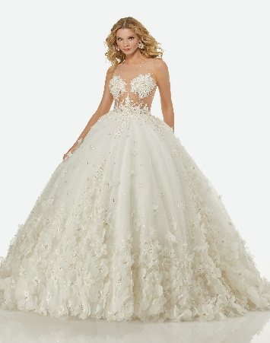
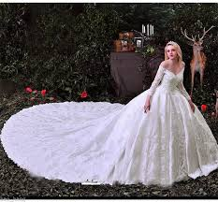
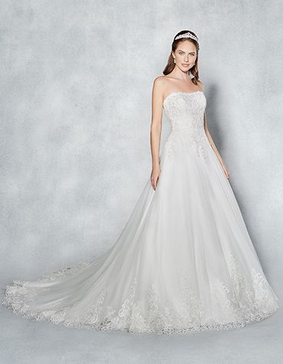
Ball gown Wedding dress A Line Wedding dress Cinderella dress
dhgate.com wed2be.co.uk vickvanlian.com
A sophisticated and elegant themed Wedding will require a simpler dress with elegant accessories. Mermaid, sheath and fishtail dresses are common in this category. These dresses are cut on the bias meaning that the material has been cut diagonally rather than straight and this allows the material to fall and drape more easily, giving a figure-hugging dress. These can then be teamed with jewelled accessories.
Sheath dress Fishtail dress Mermaid dress
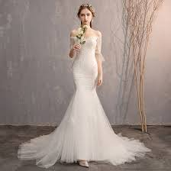
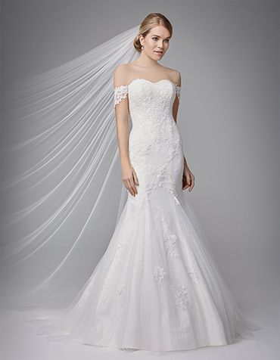
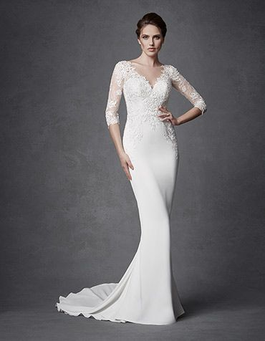

wed2be.co.uk wed2be.co.uk veaul.com
Josephine Lilian Price
29897
Assessment 7
Page 6

In addition to these 6 styles, there is the tea length dress, which finishes just below the knee, ideal for 1950 themed Weddings, fit and flare dresses which will show off curves and then go to a fuller skirt, and empire dresses, most loosely fitting, all of which can add to the modern wedding with sophistication and elegance.
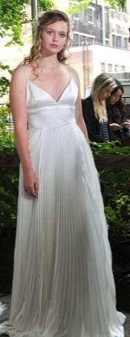
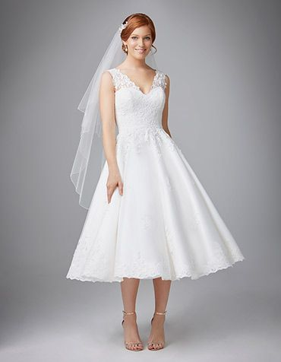
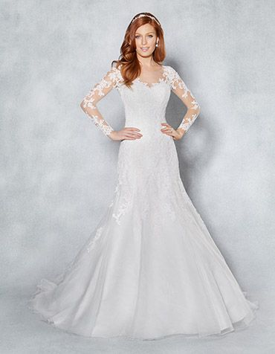
Tea Length Dress Fit and Flare Dress Empire Dress

wed2be.co.uk wed2be.co.uk Kurt Wilberding

However, whilst a dress that would be suitable for the beach would not look right in Church and a ball gown with a full train would not look right on the beach, the above suggestions are not set in concrete. A modern style dress can fit just as well for a romantic Wedding, as a Traditional dress can at a modern Wedding. It is just as much about the Bride and the body shape of the Bride as it is the venue. As Sue Fox (2010) states “you may want to try on a dress in each style to find out which one fits your body type the best.” A plus size bride who is getting married in a modern hotel may not feel comfortable in figure hugging dress and may prefer for her curves to be hidden under an A line dress. A petite Bride getting married in a Church may feel overwhelmed in a ball gown. Locations of different venues must be considered as well. A traditional Church Wedding may move on to a modern hotel for the reception, the Bride will need to fit into both locations in one dress.

Josephine Lilian Price
29897
Assessment 7
Page 7

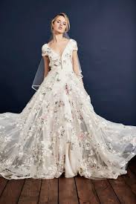
It is about finding the correct balance that works both practically for the Bride and visually for the venue. A splash of colour either in accessories or on the dress itself such as a bow around the waist or a sash can easily pull the dress in line with the colour scheme.
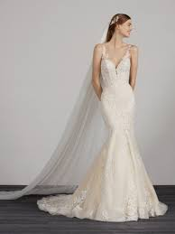
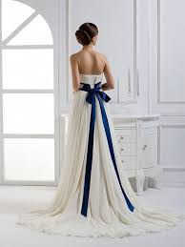

Savin London rockmywedding.co.uk pinterest.de
This allows extra flexibility to ensure visual continuity, and a greater flexibility for the Bride to find a dress that she truly feels is ‘The One’.

Josephine Lilian Price
29897
Assessment 7
Page 8
Activity:
TURKEY
Whist most Brides around the world are free to wear a white dress, or a dress of their choice some countries have their own traditions Brides may follow.
WEDDING DRESSES AROUND THE WORLD
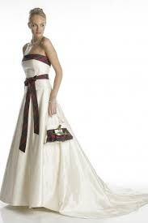
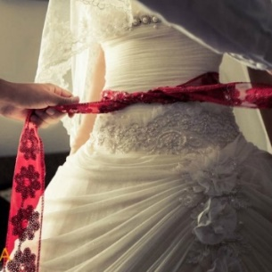
SCOTLAND

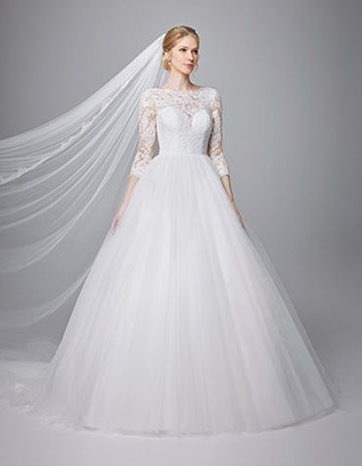
A maidenhood belt – a band of red ribbon is tied around the Bride’s waist to symbolise her virginity. An option for modern Brides, it caused quite a talking point in older times if the belt was missing.

INDIA
For a traditional Scottish Wedding where the Groom wears a kilt, the bride may want to highlight her dress with tartan to match.
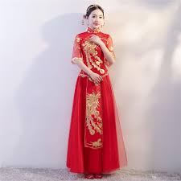
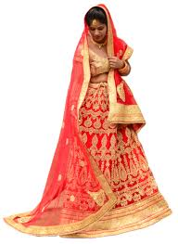

YORUBA (AFRICA)
A Bride typically wears a Gele – an elaborately tied headscarf, with a Buba – a blouse and an Iro – a huge piece of material tied around the Brides waist – usually to ankle length.

HUNGARY
A Chinese Bride would wear a Qipao. This would typically be one of three dresses worn on the day. Red is considered a lucky colour.
CHINA
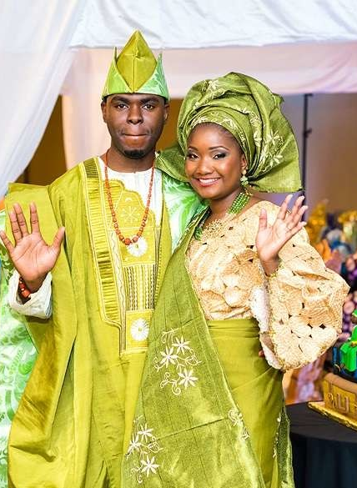
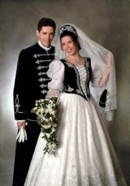

An Indian Bride would wear a Lehenga or Wedding Sari, typically in Red.

If a bridal couple in Hungary want to pay tribute to their origins, they may choose to wear a Diszmagyar or Gala-Suit.
Josephine Lilian Price
29897
Assessment 7
Page 9

Bibliography :

Color meaning Available at
http://www.color-wheel-pro.com/color-meaning.html [Accessed 3rd May 2019]

Fox, S 2010 Wedding Etiquette For Dummies, Wiley Publishing Inc

History of Wedding Dresses Available at
https://weddings.lovetoknow.com/wiki/History_of_the_Wedding_Dress [Accessed 3rd May 2019]

Why so many brides wear white on their Wedding Day Available at
https://edition.cnn.com/style/article/history-white-wedding-dress-royal-wedding/index.html [Accessed 4th May 2019]

Student Statement:

By submitting this assignment, I confirm that this is my own work.

Student Signature | Josephine Lilian Price | Date | 06.05.2019

For Tutor / Assessor Use Only
Total Marks
Marks Obtained
Percentage / Grade

