
Assignment Cover Sheet

Student Name: | Jernita Esprit
Student Number: | 24204
Course: | Diploma in Travel and Tourism Level 5
Assignment NO: | 05

i. The main objective of a promotional activity is to highlight product positioning and existence. Promotional activity also serves to persuade customers that the product advertised supersedes that of its rival. Should a customer purchase a product, the aim of developing and sustaining the brand is achieved and customers are reassured of their choice.

ii. The acronym GRA is referred to as the General Tourism Authority and it is responsible for highlighting the basic image of a country’s tourism sector. The GTA aides in assisting the tourism product to achieve its goal by highlighting the benefits and features of a product, hence setting itself apart from the competition. The General Tourism Authority works in partnership with the private sector to ensure that the destination images presented supports the proposed marketing strategy in order to fulfil the aim. These two bodies capitalises on their Union by devising a committee which will increase the probability of the private sector supporting the promotional activities displayed. Although the GTA’s role within the tourism marketing sector is omnipotent, such power is non-existent with the absence of the private sector. Hence, the success of the tourism sector is based upon the involvement of organisers such as Tour Operators and Travel Agents due to their dominance in selling and promoting destination images towards great effect.

iii. Considered a sub-section of marketing, advertising is the gateway to creating awareness of a product to the target audience. It uses data and research collated from marketing strategies in order to convey the brand across and it places emphasis on persuading the customers as well as reminding them of what the message represents.
Mediums such as newspapers, Television and the internet consist of advertisements which assist in drawing attention to a product.
Marketing in contrast, is a defined strategy which prepares the product by bringing the product or service to the forefront of the customer’s mind. The concept of marketing intentionally creates a mutually advantageous exchange between the customer and a business. Whilst marketing and advertising aides a company in achieving a mutual goal, they should not be used interchangeably as this could result in the misrepresentation of the specified brand.

iv. Promotional materials are effective tools used when trying to attract potential customers, luring them to purchase a product or service. Brochures are a common promotional material used as it aims to create a visual image of the destination. The photographs, information provided as well as contact details, helps produce an outstanding brochure. Tour operators and Travel Agents also rely heavily on posters as it depicts first-rate quality images of a destination which will most likely create an everlasting impact. Overall, the choice of promotional materials used is crucial in attracting potential customers by creating a great first impression.
Prior to disclosing materials to the public, operators and agents must be aware of its purpose and target audience. These two factors will provide a foundation for operators as it is the gateway in providing a sense of clarity for the campaign or advertisement. The contents to be included will also aide in the results which ought to be achieved from the promotion. A vital element in the promotion of materials is the manner in which it will get to its target audience. The distribution process, be it via mail or social media, will determine how costly the advertisement is. As far as brochures and posters are concerned, operators must determine how many copies will be printed and the manner in which they will be utilised.

v. Sometimes considered as the collection of media used to promote the sales of a product of service, collateral material carries the brand and is used after the launching of a media campaign for a new product. This varies in comparison to general advertising as it caters for established target audiences.
Collateral materials comprises of pens, postcards, credit card wallets, lighters and writing cases.

vi. Seen as a directory for agents, the travel agents manual is a specific produced material inclusive of detailed destination information. It is mandatory that all manuals consists of hotels, travel agencies, tourist attractions, inbound tour operators, restaurants, recreational and sporting facilities. This manual holds vital information travel agents require when creating destination bookings which are costly but are effective in generating economic growth. Therefore, the strategic decision to target independent tour operators and retailers through the manual proves to have a tremendous impact on the tourism industry in general.

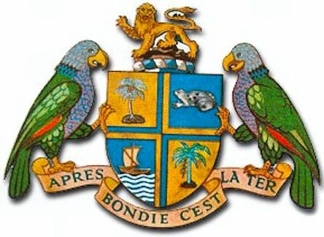
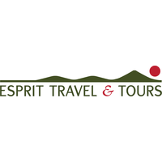
“Providing you with a prestige experience which allows your spirit to be free.”

54 Hillsborough street
PO box 752
Roseau
Dominica
Tel : (767)4482452

TABLE OF CONTENTS

Glossary................................................................................5

Introduction...........................................................................6

Kempinski Rooms & Suites...................................................6-7

Tour Packages.......................................................................8

Attraction photos.....................................................................9

Travel Advisory.......................................................................9

Discounts & offers..................................................................10

Conclusion..............................................................................10

Recommendations..................................................................11

Appendices.............................................................................11

Glossary

ETT: Esprit Travel and Tours; Tour Operator specialising in inbound Tours for eco-lovers.

KCRS: Established in November 2019, the Kempinski Cabrits Resort and Spa is a 5 star resort which provides luxurious facilities.

Cabrits National Park: One of the most historic sites in Dominica, this park surrounds the resort and offers breathtaking views.

Luxurious Jumbo Nature Tour: Targeted at travellers wishing to allow the Tour Operator to facilitate all arrangements, avoiding the experience of stress as far as organising a holiday. This tour offers an extensive range of attractions which leaves very little room for boredom.

Nature Independent Tour: This tour is aimed at travellers who would like to have an involvement in the arrangement of their holiday. Travellers are also allowed to submit their places of interest and a personalised information booklet will be created to suit their needs.

Sisserrou Parrot: Dominica’s national bird which can only be found in this island. This type of bird species is notorious for being colourful and very loyal to their mates.

Scottshead Mountain Experience: This is situated at the very bottom of Dominica and this captivating view will allow you to catch a glimpse of where the Caribbean Sea meets the Atlantic Ocean.

Calling all Luxurious travellers with a thrill for nature!!!

With the summer season vastly approaching, this report aims to highlight the various tour packages on offer from Esprit Travel & Tours to tourists wishing to visit the Caribbean island of Dominica. Through the use of various promotional materials, ETT strives to entice readers based on information displayed by this unspoilt gem of the Caribbean. The manner in which the campaign will be conducted will also be instrumental in the company achieving its marketing and economic goals.

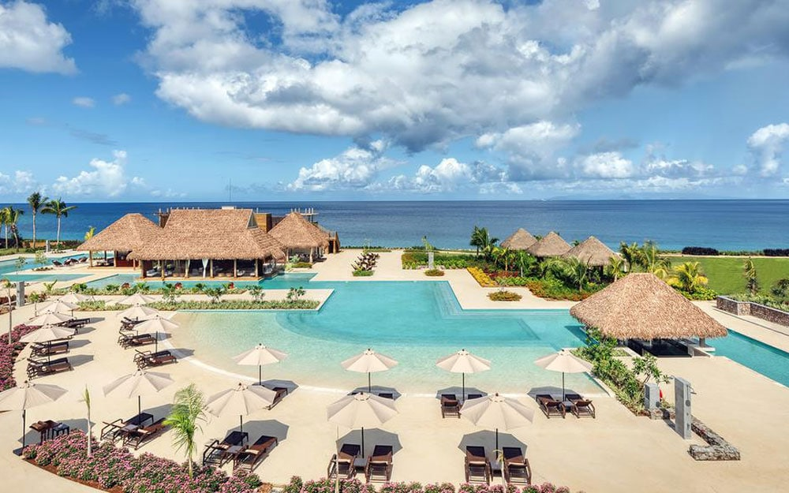
Internationally known as The Nature Isle of the Caribbean, Dominica is renowned for its natural scenic beauty and 365 rivers. In November 2019, the island welcomed the inception of the 5 star hotel; Kempinski Cabrits Spa Resort to its shores. As a result, ETT has partnered with The Kempinski Resort to provide tour packages targeted at luxurious travellers who possess a genuine love and thrill for nature. The following are the range of suites available at the resort:

- Presidential suite
- Superior Mountain view room
- Deluxe Ocean view

Presidential Villa


The finest stay awaits you in a luxurious ambiance like a President indeed. Unrivalled by its amenities, this villa covers 426 square miles and features two bedrooms, bathrooms and a separate butler’s pantry along with a private sauna and spa room.

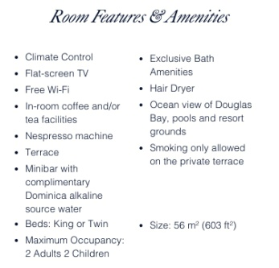
Superior Mountain View

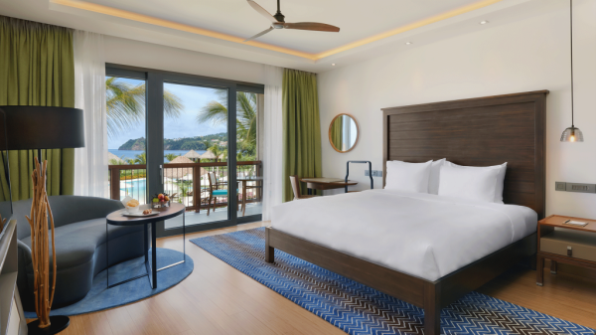
Situated on the ground floor, the Superior Mountain view rooms with pool are surrounded by views from the Cabrits National Park. Decorated in an elegant, contemporary style, these rooms contain their own outdoor along with a furnished private terrace and luxurious amenities.

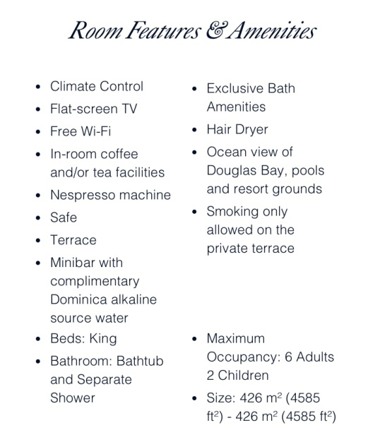

Deluxe Ocean view

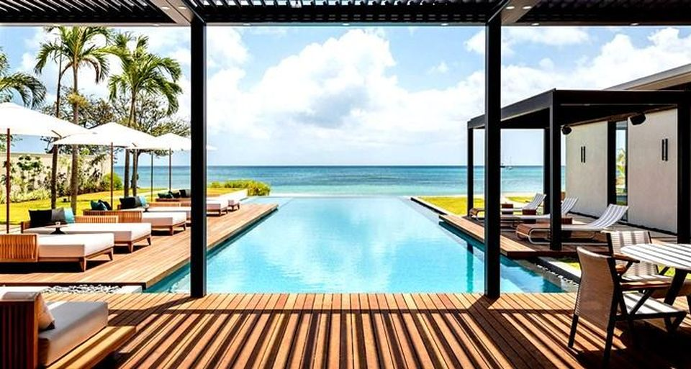
Wake up to the sweeping views of the Caribbean Sea from your room’s private terrace. This room is spacious and is designed for the ultimate comfort with a desk area and separate bathtub and shower.
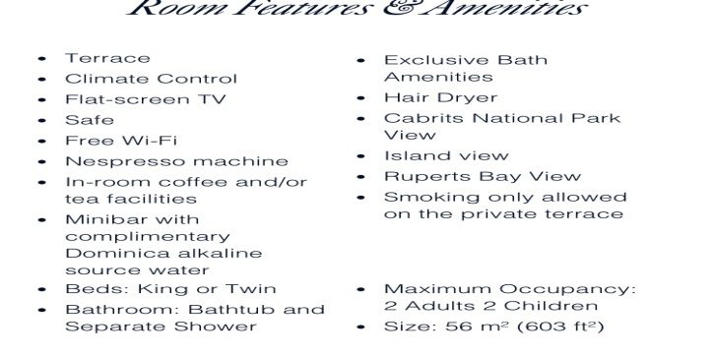
Tour Packages:

Luxurious nature jumbo tour (from just £1500pp!)
- Free airport transfer
- Champagne upon arrival
- Island tour
- Diving/Snorkelling
- Meet the Sisserrou Parrots
- Hiking
- Boiling Lake visit
- Freshwater Lake
- Sulphur Springs visit
- Emerald Pool Visit
- Scottshead Mountain Experience
- Personal Tour Guide

Nature Independent Tour (from just £1200pp!)
- Free airport transfer
- Champagne upon arrival
- Hiking
- Personalised tour booklet
- Car Hire
- Scottshead Mountain Experience

All tours are inclusive of flights but exclusive of accommodation. Accommodation details should be priced separately and discussed with customers prior to booking being confirmed. In the 2019 End of Year Report for Esprit Tours and Travel, it was reflected that there was an increase in sales by 5%. Due to the partnership of the luxurious KCRS, ETT strives to accomplish the objective goal of increasing sales by 10% in 2020. This feat can be achieved by aiming to conduct on average, 10 bookings per week with a transactional value per booking of £1200.
Champagne Reef
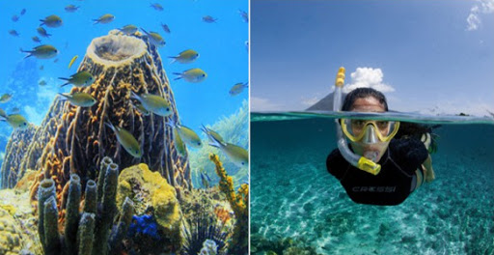

The Freshwater Lake Emerald Pool
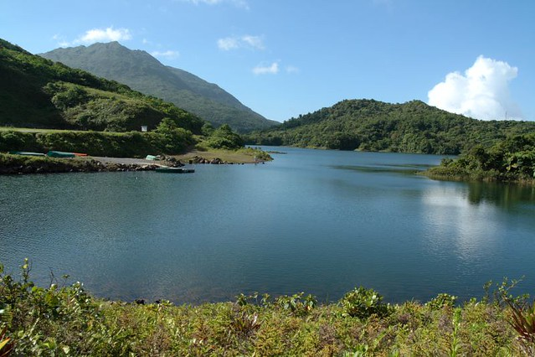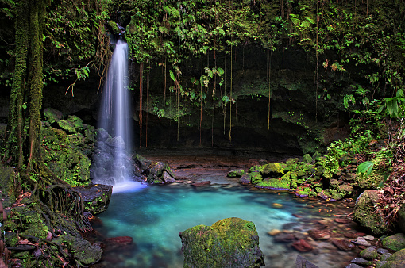

Scottshead The Boiling Lake
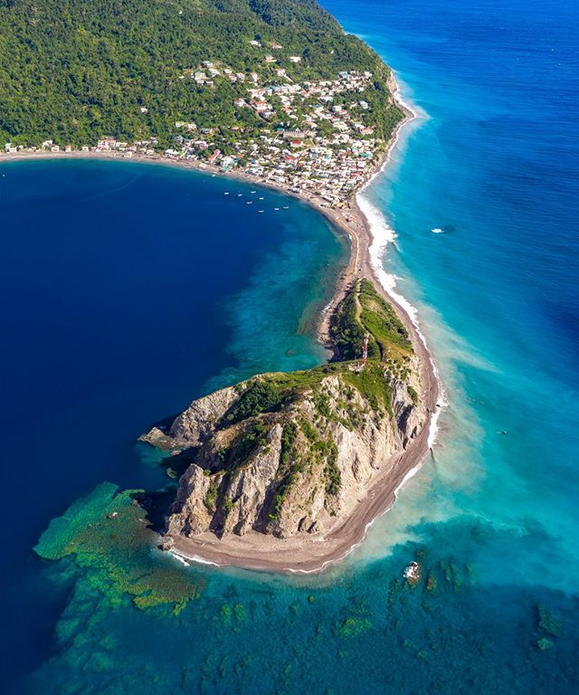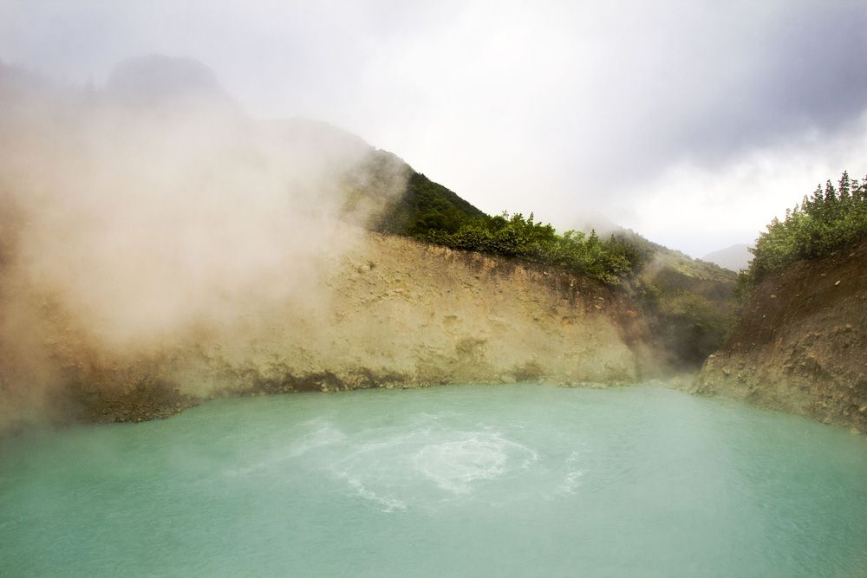

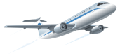Travel Advisory

- All flights depart from London Gatwick Airport (am).
- Carriers: Virgin Atlantic, TUI Airways and British Airways
- Flight Schedule: Operates 4 times per week!
- Stopover: All flights connect via Barbados and Antigua.
- Onward connection carrier: LIAT airlines.
- Same day arrival!
- Luggage will be tagged directly to DOM!
- Travel dates are dependent on the airline chosen.
- Season: June, July, August.

NHS Workers! 10% discount for bookings made by May 31^{st 2020!}
!
5% discount if you book by April 30th 2020!

Conclusion

The company will rely on brochures, posters, social media ads and Trip Advisor in order to convey the message across to the market audience. A small number of brochures will be printed and posted to potential customers and the majority of the brochure and posters distribution will be done via email to our existing clients. Photos, posters and discount promotions will be advertised via Facebook and Instagram by our Marketing team. Presently, there is a following for ETT on Trip Advisor as we are inundated with reviews left by previous customers, detailing about their experience. The above distribution methods will be costly but some strategic measures such as restricting the major brochure delivery to online as oppose to print as this will reduce the cost.
Esprit Travel and Tours strives to support all employees in performing their duties towards perfection. With support, the above measures and strategies implemented will aid in achieving the objective goals set out by the company as well as maintaining the company’s reputation of being one of the most formidable Tour Operators on the market.

Recommendations

It is imperative that staff adhere to the strategies and guidelines stipulated in this report. The various promotional materials and mediums stated should be utilised effectively in order to achieve maximum profit.

Appendices

Sunetra Roday, Archana Biwal, (2009), Tourism : Operations and Management

A Dictionary of Travel and Tourism Terminology, A. Beaver. CABI, 2005
The Tourism Society's Dictionary for Tourism Industry, V. R. Collins, ed. CABI, 2008
Richard Sharpley, (2006), Travel and Tourism
J. Alf Bennett, Johan Wilhelm Strydom, (2001), Introduction to Travel and Tourism Marketing

www.discoverdominica.com
www.kempinski.com
www.visitbritain.org

www.economywatch.com

www.pearsonschoolsandcolleges.co.uk

Student Statement:

By submitting this assignment, I confirm that this is my own work.

Student Signature | Jernita Esprit | Date | 21/04/20

For Tutor / Assessor Use Only
Total Marks
Marks Obtained
Percentage / Grade

