
Assignment Cover Sheet

Student Name: | Demi Tenisha Ashton
Student Number:
Course: | Child Phycology
Assignment NO:

Marking Criteria:
We expect the learners to write minimum one well expressed point in three lines against each allocated mark. This means one needs to write 15 lines with 5 well expressed points to get high grades for a 5 marks question.
For high grades use examples and illustrations where appropriate.
Please insert your completed assignment ( in word format) here:
Personality Development

- Describe personality development, process in Infancy?
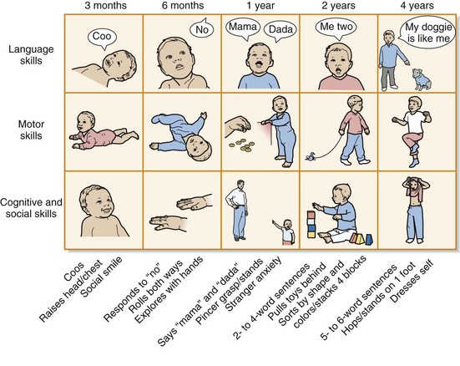
The Personality development process in Infancy consist of three main characters, which are physical changes, psychological changes, social growth and development. During the stage of infancy the young child begins to build knowledge about themselves. At this time the child physical changes becomes more visible such as sitting, crawling standing and walking. At 3 months a baby will begin to sit up without support. Parents are able to see this observation that physical development is taking place. Physiological (mental) change is also a part of the personality development process which involves the thought process of a child. Famous Phycologist Sigmund Freud had complex views surrounding mental change and the impact that it has on a child. Freud believed that a child’s character was based on a sex- related perspective. Freud was more interested in the emotional affect a child may have later on in life. Erik Erikson Theory was that children from 0-2 years of age are engaged in relationships, seeking to develop a sense of being loved and nurtured. Erikson was apprehensive with becoming competent in an area of life. If this stage isn’t handled well, the individual will feel a sense of mastery. As compared to adults character has a great poetical for development and change and can be very flexible amongst children.

- What are the features of positive parenting?
There are many different important roles that parents play in the supporting the development of their child, its vital that parents take the time to focus on the different stages so their child will feel understood and valued. From birth to the age of 3 years children are so dependent on their parents emotionally mentally and physically. As the child develops the parents continue to assist them in these fine stages of their young life. Children rely on their parents to feel safe and loved. Parents make the home that the child lives in comfortable, by doing this is will makes room for the child to gain a powerful base for maximum character development. Children are genuinely happy and confident when they feel a sense of happiness from within. Adolescence go through so many hormone changes from the ages of 12 -20 years, it’s so important for parents to be on –board and observe their teenagers as this is a time because they go through many different hormones changes. Parents do well when they are emotionally, mentally, physically active in their Child’s life. Children who feel confident enough to express how they feel to their parents really shows how much attention the parents give to their child. If a child faces rejection or hatred by their parents or peers this will lead to them feeling loneliness.

- What are common personality traits?
Frustrated or cheerful – Individual’s result to feeling frustration when something is blocking a person from their desired outcome. For example an Adolescent may result to frustration when they don’t understand why they feel a certain way. A Child may become frustrated when their parents have said they can’t have something such a buying a toy or going out. Whereas as a child being cheerful is expressing a happy emotions. This emotion will be exposed when a child feels happy about something such as being up from school by their grandparents or going on a field trip with school.
Extravert – friendly and fun loving – A person who is out going, fun, enjoyable and bold. An extravert is usually socially involved and confident being around people. Extravert people are unreserved and tend not to isolate themselves and social events. People with these personalities are joyful and outgoing, normally confident in life and have a positive approach on social interaction. These types of people are also more willing to be open about different matters and will express their feelings openly to those who are interested.
Introvert – An individual who is an introvert is usually a person who keeps themselves to themselves, isn’t really out going and finds peace just being alone. They are very reserved, meaning that they don’t express themselves freely as them have a shy character. Introverts tend to engage in conversations that are of interest to themselves and become reserved and shut down when they don’t feel comfortable in a situation.
Openness- A individual who is open minded, and creative. They are people who tend to think out the box. An individual who is open minded tends to be independent reliant on themselves. They have unconventional ideas and viewpoints. These people are more than happy to try new experiences that they haven’t tired previously.
Agreeableness - Individuals who have this in their personality are very soft hearted and tend to trust people easily. With this sort of personality trait this person will be friendly and tactful when dealing with situations. They get along with people very well and are open to having conversations with likeminded people. They are also usually very optimistic. The way they think is very positive, having a hope that something successful will happen later in life.
Conscientiousness – Individuals who set high goals for themselves, they are very dependent and organized. When planning they are thorough when going through things, well-structured and careful. These individuals tends to be very disciplined and high achieving. They don’t allow room for negativity in their thought process, holding a strong belief that there is a reason and a way for most things.
Emotional balance - Individuals who are emotionally balanced normally are calm and relaxed people. These individuals take their personal growth and wellbeing very seriously. Training there mind and body to adapt to any form of change is what they are capable of doing. In different situations Individuals whom are emotionally balanced don’t become overwhelmed with change in a bad situation. They humble themselves and become acceptant of the situation without having a judgmental approach. Emotional balanced is helped by emotional regulation and pain tolerance.


- Discuss the process of personality development?

In situations such as these, as we know it would affect adults and children. Adults may have a good understanding of how this has happened and dealing with it emotionally and mentally, whereas children will be affected emotionally, physically and mentally to a deeper extent, because what they may seem as normal has now changed. A child aged 5, may not understand losing their home and not having a secure place to go to in situations such as this. As this child develops how their behavior will change because there isn’t any normality and they don’t have a full understanding as to why this natural event has happened. So it’s only understandable that we see the reason as to why children are affected and why their character development will change. Children have to learn how to adapt to natural events occurring in their life which will comes as a shock to their development as it’s not what they would call the “Norm”. All of these different environmental changes do have an impact on a child’s development and it will affect a crucial part of the child’s personality which is called self-concept. The way the child’s peers view them has a deeper affect because it’s like an attack on them personally, hence why children at times feel the need to change to “fit it”. Parents play such a vital role in the development of their child’s personality, they assist the child in the development of self-concept, enabling the child’s confidence levels are raising making it easier to feel accepted by society.

Student Statement:

By submitting this assignment, I confirm that this is my own work.

Student Signature | Demi Tenisha Ashton | Date | 12/03/2019

For Tutor / Assessor Use Only
Total Marks
Marks Obtained
Percentage / Grade

